HALAL TOURISM AND SERVICE EXCELLENCE: KEY DRIVERS OF TOURIST SATISFACTION IN TANJUNG PINANG

Tasriani¹, Leny Novianti², Diana Eravia³, Fatimah Zuhra⁴
^{1,2,3}UIN Sultan Syarif Kasim Riau
Correspondent Author: fatimah.zuhra@uin-suska.ac.id,
tasriani@uin-suska.ac.id

Abstract
This study aims to analyze the influence of halal tourism attraction and service quality on tourist satisfaction in Tanjung Pinang City. The research uses a quantitative method with a survey approach. Data was collected through a questionnaire distributed to tourists visiting Tanjung Pinang. Multiple linear regression analysis was used to test the relationship between Halal Tourism Variables and Service Quality on Tourist Satisfaction. The influence of the halal tourism variable by 20% affects tourist satisfaction, while the quality of service affects the tourist satisfaction variable by 46%. The hypothesis test shows that halal tourism variables and service quality have a significant effect on tourist satisfaction with the result of a determination coefficient of 76.9%. This shows a considerable influence of halal tourism variables and service quality so that facilities and services in accordance with Islamic principles are very important in attracting and retaining tourists. Therefore, tourist destination managers and stakeholders in Tanjung Pinang need to focus on developing halal facilities and improving service quality to attract more tourists and ensure they have a satisfying experience.
Keywords: Halal Tourism, Service Quality, Tourist Satisfaction, Tanjung Pinang

INTRODUCTION
The halal industry is experiencing rapid development in several sectors, including: halal food, finance, tourism, travel, fashion, cosmetics and medicines, media and entertainment, as well as other sectors such as healthcare and education. In this case, the business potential of the halal industry in the world is very large. Currently, various countries, both Muslim and non-Muslim countries, are competing to work on the potential of sharia business. Based on the Global Islamic Report 2016-2017, the value of Muslim food and lifestyle sector expenditure in the world's halal sector reached US$ 1.9 trillion in 2017 and is expected to rise to US$ 3 trillion in 2021 (Kementerian Pariwisata, 2017).
It is also said that with the development of the halal industry today, business actors must also be more observant to see the space and gaps that can be processed as an opportunity to create customer satisfaction. The halal-based industry in Indonesia, which incidentally has the largest Muslim population in the world, is not seriously worked on so that it lags behind other countries whose citizens are mostly non-Muslims. Survey from Badan Pusat Statistik or BPS In 2010, the total national population reached more than 237 million people in 2010. As many as 85.1% of the total population embraces Islam. The large number of adherents of the Islamic religion naturally made the government issue Law No. 33 of 2014 concerning Halal Product Assurance to protect the interests of consumers who have the right to use products in accordance with Islamic law, both in terms of manufacturing materials, manufacturing processes to the packaging stage (Badan Pusat Statistik, 2010).
In 2019, it was stated that all products that enter, circulate and trade in Indonesian territory are required to have a halal certificate. This actually opens up strategic business opportunities for local businesses to expand the range of their products in the national and international markets. This is considering that foreign products that are not Muslim-majority countries may take a more complex way of obtaining halal assurance, in contrast to national producers who are familiar with halal requirements.
Indonesia has a great opportunity to develop halal industrial zones due to the large demand. Currently, the demand for halal products has begun to increase, especially for tourism, travel, hotels, food and beverages and cosmetics. The great potential that Indonesia has in terms of the halal industry has made the government fully committed to becoming a leader in the halal industry in the world.
Tourism is one of the important sectors that contribute to the economy of Tanjung Pinang City. With the increasing number of Muslim tourists, the concept of halal tourism is becoming more and more relevant. Halal tourism not only includes the availability of halal food, but also includes various other aspects such as sharia-compliant accommodation, places of worship, and other services that are in accordance with Islamic principles (Battour & Ismail, 2016).
Halal tourism has experienced rapid development in recent years. The halal lifestyle that is synonymous with Muslims has spread to various countries, even to countries with minority Muslim populations. In the research (Ab. Wahab & Kamarubahrin, 2019) said halal is a universal indicator for product quality assurance and living standards. Halal is usually only associated with food-related matters. However, Yusuf Qardhawi said that in Islam halal includes deeds and work or commonly called Muamalah.
Bohari et al. (Bohari, 2013) said that halal can be defined as a quality standard that is in accordance with Islamic Shariah law and is used in every activity carried out by the ummah. Halal products and services are chosen by Muslims as a form of compliance with Islamic Sharia law. Although halal is very related to Muslims, it does not mean that consumers of halal products only come from Muslims. Rahmatulloh (Rahmatulloh, 2021) mentioned the importance of nature management benefiting the community and halal tourism improving people's welfare. Putra et.al (Putra et al., 2016) also said that traditional values significantly affect customer satisfaction with halal goals and Islamic values only affect customer satisfaction under religiosity moderation.
In this case, Tanjung Pinang City is part of the Riau Islands province which is located on the international shipping route of the Malacca Strait, directly adjacent to Singapore and Malaysia, geographically the location of Tanjung Pinang is very strategic with easy access through domestic port waters making the Riau Islands a metropolitan city. The development of tourism in the city of Tanjung Pinang as a halal tourist destination is a response to the policy of the Ministry of Tourism which is currently launching the "Top 10 Muslim Friendly Destination" program in Indonesia which covers several provinces as tourist destinations, namely: Nangroe Aceh Darussalam, West Sumatra, Riau and Riau Islands, DKI Jakarta, West Java, Central Java, Yogyakarta, East Java, West Nusa Tenggara and South Sulawesi (Badan Pusat Statistik, 2017).
The Ministry of Tourism has selected Tanjung Pinang as one of the main entry gates for foreign Muslim tourists along with Bali and Jakarta. The determination of Great Batam (Cluster: Aceh, West Sumatera, Riau, and Riau Islands, is one of the implementations of the marketing strategy of halal tourist destinations in Indonesia to achieve the target of 20 million foreign tourists visiting Indonesia in 2019 (http://bps.go.id, 2019). The following is data on the number of foreign tourists who visit Tanjung Pinang every month from 2018 to 2022 (http://bps.go.id).
Halal tourism in Tanjung Pinang City is increasingly known for its potential to increase tourist satisfaction through quality service and compliance with Islamic values. The interaction between halal certification, service quality, and cultural elements significantly affects the overall experience of Muslim travelers. This synthesis explores the key factors that contribute to tourist satisfaction in this context.
In research (Saputri et al., 2023) on Islamic and halal facilities do not significantly determine tourist satisfaction and Islamic culture has a positive and significant role in determining tourist satisfaction. Wulandari et.al (Wulandari et al., 2023) also said that religiosity moderates the impact of halal tourism on tourist satisfaction and tourist satisfaction can increase national income and help tourism management. Meanwhile, in research (Haryeni & Yendra, 2024) said that Halal Certificates have a significant effect on Behavioral Intentions and Purpose Brands affect behavioral intentions that are moderated by goal satisfaction. This is supported by research conducted (Haryeni & Yendra, 2024) that halal certification assures Muslim tourists that food and services meet their religious requirements, fostering trust and satisfaction.
High-quality services, including separation of services for Muslim tourists, are essential for increasing satisfaction (Putra et al., 2016) Incorporating Islamic culture into service delivery can significantly improve the tourist experience, as cultural harmony resonates with Muslim visitors (Saputri et al., 2023). The level of religiosity among tourists moderates the relationship between Islamic values and satisfaction, suggesting that more religious tourists may have high expectations (Wulandari et al., 2023). Engaging with Islamic culture can lead to a more satisfying experience, thereby increasing overall satisfaction (Saputri et al., 2023). Conversely, some studies suggest that while halal facilities are essential, they may not always be directly related to tourist satisfaction, suggesting that other factors, such as cultural experience, may play a more significant role (Saputri et al., 2023). Therefore, in this study, the author wants to see firsthand the relationship between halal tourism that develops in Tanjung Pinang and tourist satisfaction, as well as the relationship between service quality and tourist satisfaction.

LITERATURE REVIEW
Definition of Tourism
The word tourism comes from two syllables, namely pari and tourism, pari means many, many times, in circles, while tourism means a trip or traveling that is done many times or around. According to Law No. 10 of 2009 concerning tourism, tourism is to improve the community's economy, labor force and reduce poverty.
Sedamayanti (Sedamayanti, 2013:7) said that tourism is a human activity that is carried out consciously that receives services alternately among people from other regions to temporarily seek satisfaction that is diverse and different from what he experienced, where he obtained a permanent job. Kodhyat in Spillane (1985) broadly defines tourism as a trip from one place to another that is temporary, carried out by individuals or groups, as an effort to find harmony and happiness with the environment in the social, cultural, natural, and scientific dimensions. A person can travel in various ways for different reasons as well. A trip is considered a tourist trip if it meets the three necessary requirements, namely it must be temporary, it must be voluntary in the sense that it does not occur because it is forced, It does not work that generates wages or payments.
The development of tourism will have a double effect on other sectors as well, such as folk crafts, furniture, textiles, and other activities whose products are needed to support the development of tourism (especially hotels and restaurants). From some of the definitions of Tourism above, it can be concluded that tourism is an activity related to travel for recreation that is carried out to a place outside of its temporary area in which the facilities needed by the government, the private sector, and the community around the tourist attraction environment have been provided.
According to Yoeti (2008) the benefits and satisfaction of traveling are determined by two interrelated factors, namely: Tourist resources, which are everything in the tourist destination area which is an attraction so that people want to come to visit a tourist destination area. Tourist service is all facilities that can be used and activities that can be carried out that are provided by other companies commercially.
The tourism system shows that tourism is within the physical, technological, social, cultural, economic and political environment. This system involves two types of areas, namely the producing area and the receiving area. Part of the generating area consists of ticketing services, tour operators, and travel agents, coupled with marketing and promotional activities from the competition of the destination area. Transport and communication channels that connect parts of the tourism system through air, land and water transport that carry tourists to/from all three parts. Meanwhile, the receiving area provides the functions of accommodation, catering, beverages, entertainment industry, tourist objects and attractions, shopping places and tourist services.
Suwarjoko (Suwarjoko, 2007) said that the scope of tourism is also inseparable from matters related to tourism. For example, tourist attractions, tourist attractions, areas that are tourist attractions, tourists and others. Tourists are people who do tourist activities. Tourism as a human social activity, as a travel or traveling activity also has different characteristics from other social activities. Therefore, the characteristics of tourism can be seen from various social aspects in society. For example, cultural and social aspects.
Sociologically, tourism has characteristics as a place activity to relax, namely travel is synonymous with vacationing in another area or taking advantage of free time to be free from work that must be done. Tourism relations occur because of the temporary movement of humans. While the places and tourist attractions enjoyed by tourists are tourism places that have nothing to do with work and also tourists earn income in the places visited, tourism as a place for new socialization.
Halal Tourism
Halal tourism in the perspective of the community in general is in the form of pilgrimage tours to eat ulama, mosques, historical relics, Umrah, Hajj and others. Actually, halal tourism is not only pilgrimage tourism but tourism is a new style of world tourism which can be in the form of natural tourism, cultural tourism, and artificial tourism which are all framed in Islamic values. Tourism activities are activities aimed at humans to pay attention to the surrounding environment, the people around us in terms of their habits/customs to pay attention to everything solely to increase our faith in Allah SWT. This is in accordance with the words of Allah SWT QS. Al-Ankabut: 19:20 which means "Say: "Walk on the face of the earth, then notice how Allah created (man) from the beginning, then Allah made him once more. Indeed, Allah is Almighty over all things”.
Where Safar is intended to contemplate the beauty of Allah SWT's creation, enjoy the beauty of the great nature as a driver of the human soul to increase faith in the oneness of Allah SWT and motivate to fulfill life obligations. Furthermore, it is also explained in QS. Ar-Rum: 30:9 which means:
أَوَلَمْ يَسِيرُوا۟ فِى ٱلْأَرْضِ فَيَنظُرُوا۟ كَيْفَ كَانَ عَـٰقِبَةُ ٱلَّذِينَ مِن قَبْلِهِمْ ۚ كَانُوٓا۟ أَشَدَّ مِنْهُمْ قُوَّةًۭ وَأَثَارُوا۟ ٱلْأَرْضَ وَعَمَرُوهَآ أَكْثَرَ مِمَّا عَمَرُوهَا وَجَآءَتْهُمْ رُسُلُهُم بِٱلْبَيِّنَـٰتِ ۖ فَمَا كَانَ ٱللَّهُ لِيَظْلِمَهُمْ وَلَـٰكِن كَانُوٓا۟ أَنفُسَهُمْ يَظْلِمُونَ
That is: and did they not travel on the face of the earth and notice the consequences of those before them? They are stronger than they are and have cultivated the earth and prospered it more than they have prospered. And came to them their Apostles with tangible proofs. So Allah has not done any wrongdoing to them, but they are the ones who have done wrongful to themselves.

The above verse describes halal tourism as an activity that is supported by various facilities and services provided by the community, entrepreneurs, governments, and local governments that meet sharia provisions. Many people use halal tourism because of the universal characteristics of its products and services. Tourism products and services, attractions, and destinations in halal tourism are the same as tourism products, services, objects and destinations in general as long as they do not conflict with sharia values and ethics. So that halal tourism is not limited to religious tourism only.
The concept of halal tourism is a process of integrating Islamic values in an aspect of tourism activities. The value of Islamic sharia as a belief and trust embraced by Muslims is the basic reference in building tourism activities. Halal tourism considers the basic values of Muslims in its presentation, ranging from accommodation, restaurants, to tourist activities that always refer to Islamic norms.
Sofyan, (2013) defines halal tourism more broadly than religious tourism, namely tourism based on Islamic sharia values. As recommended by the Word Tourism Organization (WTO), sharia tourism consumers are not only Muslims but also non-Muslims who want to enjoy local wisdom. The concept of halal tourism can also be interpreted as a tourist activity based on worship and da'wah when Muslim tourists can travel and admire the results of the creation of Allah SWT by still carrying out the obligation to pray five times a day and all of this is well facilitated and away from everything that is forbidden by Him.
According to the Ministry of Tourism and Creative Economy and the Daily Management Board of the National Sharia Council of the Indonesian Ulema Council (DSN-MUI), it was also said by Sofyan (Sofyan, 2013: 25) halal tourism has the following general criteria, Oriented to the public good, Oriented to enlightenment, refreshment and tranquility, Avoiding polygamy and superstition, Avoiding vices, Maintaining behavior, ethics and noble values of humanity such as avoiding hedoic and immoral behavior, Maintaining trust, security and comfort, Universal and inclusive, Preserving the environment, Respecting socio-cultural values and local wisdom.
Eight factors of measuring halal tourism in terms of administration and management for all tourists which can be a characteristic in itself, namely Service to tourists must be in accordance with Muslim principles as a whole, Guides and staff must have discipline and respect Islamic principles, Organize all activities so that they do not conflict with Islamic principles, Buildings must be in accordance with Islamic principles, Restaurants must follow international standards of halal services, Transportation services must have security protection systems, There are places reserved for all Muslim tourists to carry out religious activities, Travel to places that do not contradict Islamic principles.
Tourism Satisfaction
Customer satisfaction is not easy to define. There are various kinds of definitions given by experts (Tjiptono, 2012) customer satisfaction is the customer's response to the evaluation of the perceived non-conformity between previous expectations (or other performance norms) and the actual performance of the product felt after its use. Kotler (2000:34), customer satisfaction is the level of a person's feelings after comparing the results he feels compared to his expectations. Sunarto (2003), defines customer satisfaction as a feeling of happiness or disappointment after comparing their perceptions/impressions to performance/expectations. If the performance meets expectations, the customer is satisfied.
If it exceeds expectations, customers are very satisfied. Stating the satisfaction of a customer can be seen from the level of customer acceptance obtained. According to Gaspersz (2005), it is stated that the factors that affect customer satisfaction and expectations consist of: "Needs and wants" related to things that the customer feels when he is trying to make a transaction with a service manufacturer. The concept and theory of customer satisfaction has developed rapidly and has been able to be classified into several approaches. One of the most popular approaches related to customer satisfaction is The Expectancy theory.
One of the keys to retaining visitors is to provide satisfaction. A company is said to be wise to measure its customer satisfaction on a regular basis. A number of methods are held to measure customer satisfaction directly. Respondents may also be given additional questions to gauge repurchase intent and allow recommending companies and brands to others (Kotler, 2007: 179). In relation to interest in revisiting, interest is a potential customer which means a customer who has come back and uses the service again.

RESEARCH METHOD
This study uses a type of quantitative data. Quantitative method is a research method that can be interpreted as a research method based on the philosophy of positivism, which is used to research on a certain population or sample, data collection using research instruments, quantitative data analysis with the aim of testing hypotheses that have been established (Sugiyono, 2012). The population in this study is tourists who visit Tanjungpinang City. The sampling technique used was purposive sampling with a total of 45 respondents. The data collection instrument uses a questionnaire consisting of three main parts: halal tourism attractions, service quality, and tourist satisfaction.
The location of this research was carried out in tourist attractions in Tanjung Pinang and Bintan, Riau Islands. One of the tourist attractions is Trikora Beach, Dolpin Beach in Bintan, Riau Islands. Data collection is nothing but a process of procurement of primary and secondary data for research purposes, providing questionnaires, and observing people and phenomena are the three main data collection methods in research.
In the process of observation or observation, the data obtained through the observation of events, as they are, are generally more reliable and free from respondent bias (Sekaran, 2006). Observations can be easily checked and controlled for their validity and reliability so that direct observation will provide convenience in research. Searching for secondary data that can be obtained from various sources, both from literature, articles, institutional data, and others that are considered relevant to the research. Collect primary data by distributing questionnaires to respondents who are members of the sample. A questionnaire is a list of questions to obtain data in the form of answers from respondents. Questionnaire is a data collection technique that is carried out by giving questions to respondents.
The frame of mind in a study needs to be presented if the research concerns two or more variables. Viewed from the type of variable relationship, namely a causal relationship, which is a variable that affects other variables. The framework of thinking will provide benefits in the form of the same perception between the researcher and the reader towards the researcher's line of thought, in order to form a logical research hypothesis. Based on the description of the theory explained about halal tourism and the theory about satisfaction, the frame of mind can be formulated as seen in the image below:
Figure 1. Researcher's Thinking Framework
Wisata
Halal (X1)

Kepuasan
Wisatawan (Y)

Kualitas
Layanan (X2)

Source: Research Processing Data, Year 2024.
Based on the background and research objectives The hypothesis of this study is as follows:
H1 | : | It is suspected that Halal Tourism has a partial effect on tourist satisfaction
H2 | : | It is suspected that the quality of service has a partial effect on tourist satisfaction
H3 | : | It is suspected that halal tourism and service quality simultaneously affect tourist satisfaction
The measurement of this research variable uses a likert scale with a scale of 1 to 5. Scale 1 Disagree (TS), Scale 2 Disagree (KS), 3 Agree Quite (CS), 4 Agree (S), and 5 Strongly Agree (SS). While the Operational Variables are as follows:
Tabel 1. Variabel Operasional dan Indikator Penelitian
Variable | Operational Definition | Indikator | Item
Independent Variabel (X1)
Halal tourism  (X1) | Sharia tourism in literature is equated with several terms such as Islamic tourism, halal travel, halal-friendly, Muslim Friendly Destination and others. Sharia tourism is money tourism serving vacations, and adjusting vacation styles according to the needs and demands of Muslim travelers (Nassar Mostafa & Reisinger, 2015) | Halal Food and Drinks | - Halal food is available  Halal drinks are available.
Halal tourism  (X1) |  | Means of worship | Prayer room worship facilities are available  Kept clean
Halal tourism  (X1) |  | Family-friendly accommodation | Safe lodging for tourists  Family-friendly accommodation
Halal tourism  (X1) |  | Accommodating health services and leisure services | Oriented to the benefit of the ummah  Existence of health services
Halal tourism  (X1) |  | No alcohol drinks are available | No alcoholic beverages
Halal tourism  (X1) |  | The existence of Muslim employees | Appear polite and attractive and respect Islamic principles  There are Muslim employees
Halal tourism  (X1) |  | Traveler-Friendly Destinations | Service to tourists must be consistent with Muslim principles as a whole
Quality of Service  (X2) | Quality of service indicates an overall intangible evaluation that offers objectives, core services and all supporting services that facilitate the use of services, such as accommodation, transportation, health care and communication that can meet customer expectations (Nassar, 2015) | Physical quality of facilities | Physical quality of facilities
Quality of Service  (X2) |  | Service to Muslim Guests | Good guest service to Muslim guests  Friendly guest service
Quality of Service  (X2) |  | Easy travel | Ease of Travel to Tourist Attractions
Quality of Service  (X2) |  | Easy access to services | Ease of Access to Emergency Services to Tourist Attractions
Variable dependencies (Y)
Traveler Satisfaction  (Y) | Tourist satisfaction If someone compares the results they feel with their expectations, customers will feel satisfied if the results of their evaluation show that the products they use are of high quality. Customers will feel satisfied when what they do  Get it right  With expectations (Sunarto, 2003) | Interested in visiting | The attraction of tourists to revisit
Traveler Satisfaction  (Y) |  | Recommend | There is a promotion to his relatives to visit tourist attractions
Traveler Satisfaction  (Y) |  | Facilities | Clean and safe facilities for tourists
Traveler Satisfaction  (Y) |  | Service | Improving services to tourists  the existence of services by sharia principles
Source: Research Processing Data, Year 2024.

RESULT AND DISCUSSION

Characteristics Responden

This study involved 45 respondents who were tourists who visited tourist attractions in Tanjung Pinang and Bintan, Riau Islands. The demographic characteristics of the respondents are as follows: Of the 45 respondents, 66.7% are women and 33.3% are men.

Figure 2. Respondent Characteristics by Gender
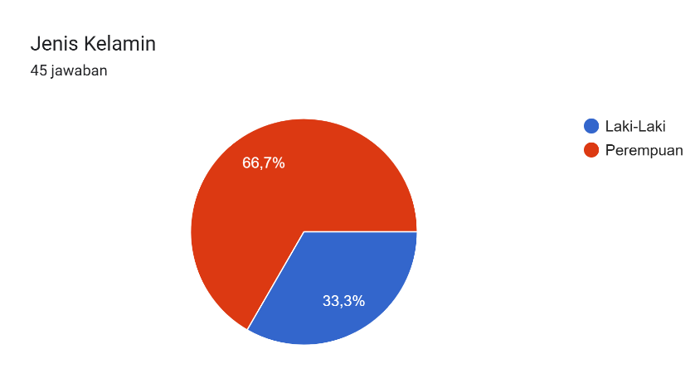

Source: Research Processing Data, Year 2024.

Meanwhile, based on the Education Level, it turns out that out of 45 respondents, only 44 respondents filled the Education Level. The results of 52.3% of respondents with Bachelor's education, 40.9% of respondents with High school education, and the remaining 6.8% of other educated respondents.

Figure 3. Characteristics of Respondents by Education
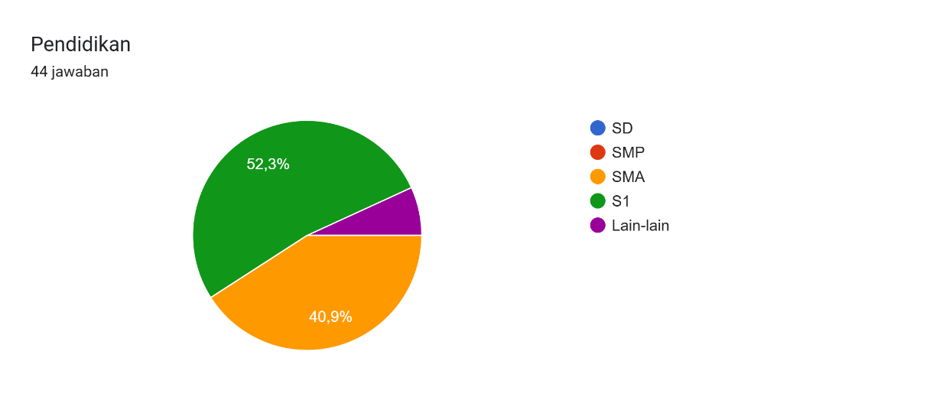

Source: Research Processing Data, Year 2024.

Table 2. Results of Statistical Descriptive Analysis
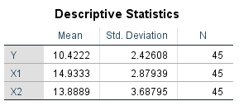

Source: Research Processing Data, Year 2024.

Based on the results of statistical descriptive analysis from 45 respondents, the average tourist satisfaction data is around 10.42 with a standard deviation of 2.42, while for the halal tourism variable, the average data is 14.93 with a standard deviation of 2.87 and for the service quality variable, the average data is around 13.88 with a standard deviation of 3.68. The small standard deviation shows good data conditions and not widespread distribution, forming a good model.

Descriptive Analysis of Halal Tourism Variables
The following are the results of the recapitulation of respondents' answers with halal tourism variables.
Table 3. Recapitulation of Respondents' Answers to Halal Tourism Variables
No | Statement | SS | S | KS | TS | STS | Jumlah
1. | Halal Food and Beverages Available | 5 | 35 | 0 | 0 | 0 | 40
Persentase |  | 12.5% | 87.5% | - | - | - | 100%
2. | Available Places of Worship (Mushola) | 18 | 14 | 8 | 0 | 0 | 40
Persentase |  | 45% | 35% | 20% |  |  | 100%
3. | Tourist attractions are kept clean | 10 | 25 | 5 | 0 | 0 | 40
Persentase |  | 25% | 62.5% | 12.5% | - | - | 100%
4. | Family-friendly accommodation/accommodation available | 8 | 28 | 4 | 0 | 0 | 40
Persentase |  | 20% | 70% | 10% | - | - | 100%
5. | No alcoholic beverages | 6 | 34 | 0 | 0 | 0 | 40
Persentase |  | 15% | 85% | - | - | - | 100%
6. | There are Muslim employees who look polite and attractive | 10 | 30 | 0 | 0 | 0 | 40
Persentase |  | 25% | 75% | - | - | - | 100%
Source: Research Processing Data, Year 2024.

Based on the processing of descriptive data, 87.5% answered yes to the question "the availability of halal food and beverages in the tourist attraction", while 12.5% answered very agree. In the question "availability of places of worship or prayer rooms", 45% answered strongly agree, while 35% answered yes and 20% answered disagreed. For the question "tourist attractions are kept clean", 25% answered very agree, 62.5% answered yes while 12.5% answered disagree.
In the next question "there is a family-friendly lodging accommodation available", it turned out that 20% answered strongly agree, 70% answered yes and 10% answered disagreed. Furthermore, for the question "there are no alcoholic beverages", 15% answered very much, 85% answered yes. The last question "there are Muslim employees who look polite and attractive", 25% answered very agree, 75% answered yes.

Descriptive Analysis with Quality of Service Variables
The following are the results of the recapitulation of respondents' answers with the Service Quality variable.
Table 4. Recapitulation of Respondents' answers on the Service Quality variable
No | Pernyataan | SS | S | KS | TS | STS | Jumlah
1. | Good quality facilities available | 15 | 25 | 0 | 0 | 0 | 40
Persentase |  | 37.5% | 62.5% | - | - | - | 100%
2. | Good friendly guest service | 16 | 24 | 0 | 0 | 0 | 40
Persentase |  | 40% | 60% | - | - | - | 100%
3. | There are facilities to get to tourist attractions | 14 | 20 | 6 | 0 | 0 | 40
Persentase |  | 35% | 50% | 16% | - | - | 100%
4. | There is easy access to emergency services to tourist attractions | 0 | 34 | 6 | 0 | 0 | 40
Persentase |  | - | 85% | 15% | - | - | 100%
Jumlah
Persentase
Source: Research Processing Data, Year 2024.
In the service quality variable, including "good quality facilities are available", then 37.5% answered strongly agree, 62.5% answered yes. The next question is "good and friendly guest service", 40% answered very much agree and 60% answered yes. In the question "there are facilities to get to tourist attractions", 35% answered very agree, 50% agreed and 16% answered disagreed because in some places there are still difficulties in road access to tourist attractions. The last question "there is easy access to emergency services to tourist attractions", 85% answered yes and 15% answered disagreed.

Descriptive Analysis with Tourist Satisfaction Variables
The following are the results of the recapitulation of respondents' answers with the variable of Tourist Satisfaction.
Tabel 5. Rekapitulasi Jawaban Responden Pada Variabel Kepuasan Wisatawan
No | Pernyataan | SS | S | KS | TS | STS | Jumlah
1. | I am interested in this tourist attraction | 6 | 34 | 0 | 0 | 0 | 40
Persentase |  | 15% | 85% | - | - | - | 100%
2. | I am interested in visiting this place again in the future. | 7 | 28 | 5 | 0 | 0 | 40
Persentase |  | 17.5% | 70% | 12.5 | - | - | 100%
3. | Saya akan merekomendasikan tempat wisata ini ke orang-orang terdekat. | 8 | 32 | 0 | 0 | 0 | 40
Persentase |  | 20% | 80% | - | - | - | 100%
4. | Saya menyukai fasilitas yang bersih dan aman di tempat wisata ini | 7 | 31 | 2 | 0 | 0 | 40
Persentase |  | 17.5% | 77.5% | 5% | - | - | 100%
5. | Karyawan tempat wisata melakukan pelayanan yang baik | 10 | 28 | 2 | 0 | 0 | 40
Persentase |  | 25% | 70% | 5% | - | - | 100%
Jumlah
Persentase
Sumber: Data Pengolahan Penelitian, Tahun 2024.

The last variable in this study is tourist satisfaction, from the results of the descriptive analysis, the result is that 15% answered very much in agreement with the question I am interested in this tourist attraction, and 85% agreed. The second question I am interested in visiting in the future is that 17.5% strongly agree and 70% answer yes, 12.5% disagree. The next question is that I will recommend this tourist spot to the people closest to me so 20% answered very much agree and 80% answered yes. For the question I like the clean and safe facilities in this tourist attraction, 17.5% answered very agree, 77.5% answered yes and 5% answered disagree. The last question was that the employees of tourist attractions did a good service, 25% answered strongly agree and 70% answered yes while 5% answered disapprove.

Classic Acoustics Test
Normality Test
The normality test was carried out to see whether the residual value of the data moved in normal distribution or not. This can be seen by looking at the Normal Probability Plot graph, which is by comparing the cumulative distribution of the actual data with the cumulative distribution of the normal distribution. A normal distribution is depicted with a straight diagonal line from the bottom left to the top right. The results of the normality test in this study are illustrated in the figure below:
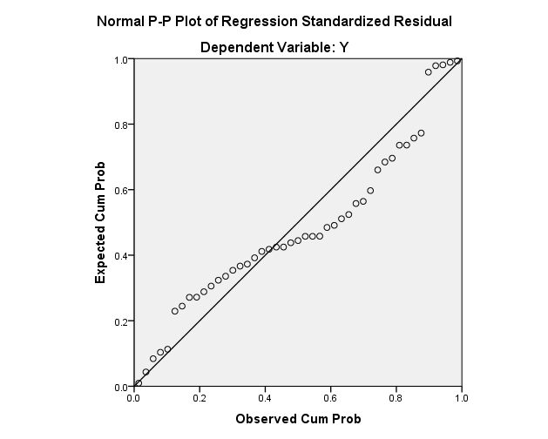

Sumber: Data Pengolahan Penelitian, Tahun 2024.
Gambar 4. Rekapitulasi Hasil Uji Multikolineritas
Multicollinearity Test
The multicollinearity test aims to test whether the regression model is found to have a correlation between each of the independent variables. If the tolerance value > 0.10 in VIF ≤ 10, then multicollinearity does not occur. The results of this study show that the VIF value and tolerance value are as follows. From the results of the table above, the halal tourism variables and Service Quality do not have multicollinearity, because they have met the assumption value of tolerance and VIF with a tolerance value of > 0.10, which is 0.549 in VIF ≤ 10, which is 1.820.
Tabel 6. Rekapitulasi Uji Multikolineritas
Model |  | Collinealrity Staltistics
 |  | Toleralnce | VIF
1 | (Constalnt)
1 | Wisata Halal | 0,549 | 1,820
1 | Kualitas Layanan | 0,549 | 1,820
al. Dependent Valrialble: Kepuasan Wisatawan
Sumber : Daltal Olalhaln Penelitian, Tahun 2024
Heteroscedasticity Test
Heteroscedasticity testing is carried out to see the value of variance between Y values, whether they are the same or heterogeneous (Suharyadi, 2016). Heteroscedasticity Testing by looking at data distribution.

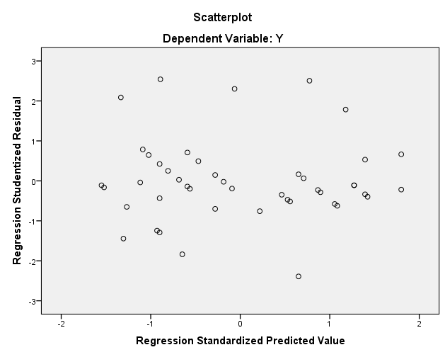

Sumber: Data Pengolahan Penelitian, Tahun 2024.
Gambar 5. Rekapitulasi Hasil Uji Heteroskedastisitas
Uji Autokorelasi
Autocorrelation testing is a correlation or relationship that occurs between members of a series of observations that are carried out in a datime series at different times. Autocorrelation detection can be seen by looking at the Durbin-Watson magnitude. To see the existence of an autocorrelation value, the Durbin-Watson test is carried out with the following criteria: If the Durbin-Watson value is below -2, then there is a positive autocorrelation. In the results of this study, there is no autocorrelation value.

Multiple Linear Regression Analysis
Based on the results of multiple linear regression analysis, the following results or models are obtained:
$$Y=a+b_{1}x_{1}+b_{2}x_{2}$$
With Captions:
Y | = | Traveler Satisfaction
$$a$$ | = | Konstanta
$$b_{1}, b_{2}$$ | = | Koefisien Regresi
$$X1$$ | = | Halal Tourism
$$X2$$ | = | Quality of Service
Tabel 7. Rekapitulasi Hasil Koefisien Regresi
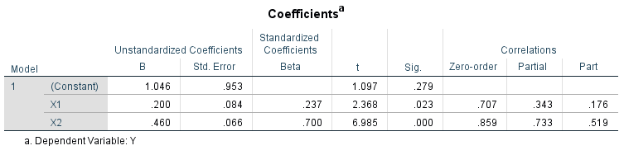

Sumber: Data Pengolahan Penelitian, Tahun 2024.

The results of multiple linear regression conducted by the researcher, the regression equation is obtained as follows:
$$Y=1.046+0,200 x_{1}+0, 460 x_{2}+e$$
The meaning of the above equation is that if all independent variables, namely halal tourism () and service quality () are constant or equal to zero, then tourist satisfaction is worth 1.046. Meanwhile, the regression coefficient value of the halal tourism variable is 0.200, this states that the influence between halal and tourist satisfaction is 20%. Meanwhile, the value of the regression coefficient of the service quality variable of 0.460 states that the influence between service quality and tourist satisfaction is 46%. The error value is a random variable and has a probability distribution that represents all factors that have an influence on Y but are not included in this study or equation$X_{1}X_{2}$.
T-Test
To find out whether the partially influential independent variable has a real effect or not, the t-test or t-student is used. Or in other words, the t-test wants to see whether the individually influential independent variable has a significant relationship or not to the bound variable (Suharyadi, 2016). With a significance level of 5% and a 2-way test, the criteria of a variable will have a significant influence if t-count ˃ t-table.
So in this study, the halal tourism variable is known to have a t-count value (2.368) ˃ t-table (2.021), this shows that halal tourism has an influence on tourist satisfaction, but because the significance value of 0.23 is greater than 0.05, the influence of halal tourism on tourist satisfaction is not too significant. However, in the service quality variable, the value of t-count (6.985) ˃ t-table (2.021) with a significance level of 0.00 is less than 0.05, meaning it is rejected and accepted. So it can be concluded that the quality of service and significantly affects tourist satisfaction$H_{0}H_{1}$.

F-Test
Another hypothesis test is the F-test which is used to find out how much independent variables together affect dependent variables. One way that can be used is to compare the significant value of F with the test level (5%) so that it can be known whether it is accepted or rejected. If the significant value of F ˂ the test level, then the conclusion is rejected and accepted$H_{0}H_{0}H_{0}$ (Suharyadi, 2016).
Tabel 8. Rekapitulasi Hasil Koefisien Regresi
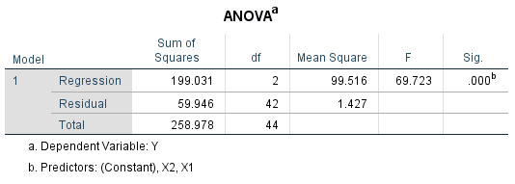

Sumber: Data Pengolahan Penelitian, Tahun 2024
In this study, it can be seen that the Significance value of F is 0.00000690 which is less than 5%, so the conclusion is rejected and accepted, there is a significant influence between the independent variables together affecting the dependent.$H_{0}H_{0}$

Coefficient of Determination Test
The determination coefficient test is used to measure how far the model is able to explain the variation of dependent variables. The values of the determination coefficient are zero and one. If the value of R2 is small, the ability of the dependent variables is very small, but if the value of R2 is close to 1, then the independent variables provide almost all the information needed to predict the variation of the dependent variable.
Tabel 9. Rekapitulasi Hasil Koefisien Regresi
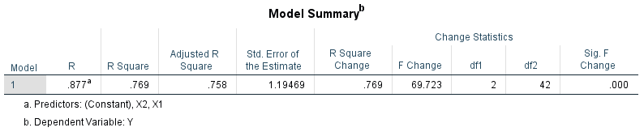

Sumber: Data Pengolahan Penelitian, Tahun 2024
In Table 8 above, it is shown that the R2 value is 0.769 or 76.9%, this shows that the halal tourism variable and the overall service quality have an influence of 76.9% on the tourist satisfaction variable. While the remaining 23.1% was influenced by other variables that were not studied in this study.

Discussion
The Influence of Halal Tourism on Tourist Satisfaction
This study aims to see the compatibility between Halal Tourism and Service Excellence on Tourist Satisfaction in Tanjung Pinang City. In the hypothesis that has been determined that there is an influence of halal tourism on the satisfaction of tourists visiting Tanjung Pinang. Based on the results of the T Test (Hypothesis Test) in this study, it was obtained that the halal tourism variable was known to have a t-count value (2.368) ˃ t-table (2.021) this shows that halal tourism has an influence on tourist satisfaction, but because the significance value of 0.23 is greater than 0.05, it can be said that the halal tourism variable has an effect on tourist satisfaction but the influence is not significant.
This finding is relevant to the results of observations in several tourist sites in the city of Tanjung Pinang, Riau Islands when this study was carried out where most or average tourists who were respondents were local tourists. The concept of halal tourism from the perspective of the community is generally in the form of religious tourism such as visiting historical heritage mosques, pilgrimages to the graves of clerics and so on. In fact, halal tourism is not just a pilgrimage, but a new style of world tourism which can be in the form of natural tourism, cultural tourism, and artificial tourism based on Islamic values. Halal tourism is generally defined as tourism products and services that include all tourist needs ranging from accommodation, restaurant services, the availability of halal food and beverages, including clean and comfortable worship facilities as the main element. The concept of halal and in accordance with Islamic sharia is not only applied to food, but also to all aspects of the products offered. Even including the warm and pleasant attitude and welcome of the local community.

The Effect of Service Quality on Tourist Satisfaction
The next hypothesis test result is to test the suitability of service quality variables to tourist satisfaction. The results of the study showed that in the service quality variable, the value of t-count (6.985) ˃ t-table (2.021) with a significance level of 0.00 was less than 0.05, meaning that it was rejected and accepted. So it can be concluded that service quality has a significant effect on tourist satisfaction. $H_{0}H_{1}$
This finding is relevant to the results of observations in the field which show that the average tourist destination in the city of Tanjung Pinang has tried to provide services and comfort for visitors. Especially the ease of access to tourist sites, the availability of adequate facilities such as a hotel with a bath and clean toilets including prayer room facilities. There is also a typical culinary tour of Tanjung Pinang with friendly and friendly service to visitors. A pleasant travel experience certainly encourages a high level of satisfaction for tourists.

The Influence of Halal Tourism and Service Quality on Tourist Satisfaction
The next discussion is to test the suitability of whether halal tourism variables and service quality simultaneously affect tourist satisfaction. After conducting a simultaneous test, it was shown that the Significance value of F was 0.00000690 which was less than 5%, meaning that it was rejected and accepted, then it can be concluded that the two variables, namely halal tourism and service quality, have a significant effect on tourist satisfaction. The results of the above research are relevant to the findings of researchers in the field where the concept or potential of halal tourism in the city of Tanjung Pinang has been implemented which is supported by the quality of service in accordance with visitor expectations so that these two variables encourage the creation of a level of satisfaction for visitors or tourists in Tanjung Pinang.

CONCLUSION
The attractiveness of halal tourism and the quality of service to tourist satisfaction in Tanjung Pinang City. Based on the results of the data analysis obtained, it can be concluded that the attraction of halal tourism has a positive and significant influence on tourist satisfaction. Tourists are satisfied with the various halal facilities available, including halal restaurants, sharia hotels, and easily accessible places of worship. This shows that facilities and services that are in accordance with Islamic principles are very important in attracting and retaining Muslim tourists.
Service quality also has a positive and significant influence on tourist satisfaction. Service quality elements such as staff friendliness and professionalism, facility cleanliness, and speed of service play an important role in increasing tourist satisfaction. The high quality of service ensures that tourists have a satisfying experience during their visit. So the conclusion of this study is that to increase tourist satisfaction in Tanjung Pinang City, tourist destination managers must focus on improving halal tourism attraction and service quality. The development of more halal facilities and improved service quality can attract more tourists and ensure they have a pleasant and satisfying experience. Meanwhile, the implications of Halal Tourism Development are that tourist destination managers must continue to develop and promote halal tourism facilities to meet the needs of Muslim tourists. Improving the Quality of Training and staff development to improve friendliness, professionalism, and maintaining cleanliness and efficiency of services should be a priority.

BIBLIOGRAPHY

Alquran dan Hadits
Ab. Wahab, N., & Kamarubahrin, A. F. (2019). Halal Industry: Are The Businesses Fully Awake? Journal of Fatwa Management and Research, 21–35. https://doi.org/10.33102/jfatwa.vol16no1.216
Ali, F., Amin, M., & Cobanoglu, C. (2016). An integrated model of service experience, emotions, satisfaction, and price acceptance: An empirical analysis in the Chinese hospitality industry. Journal of Hospitality Marketing & Management, 25(4), 449-475.
Battour, M., & Ismail, M. N. (2016). Halal tourism: Concepts, practises, challenges and future. Tourism Management Perspectives, 19, 150-154.
Bohari, A. M., Cheng, W. H., & Fuad, N. 2013. An Analysis on the Competitiveness of Halal Food Industry in Malaysia: An Approach of SWOT and ICT Strategy. Malaysia Journal of Society and Space, 9 (1)
Buhalis, D, & Cooper,C, 1998, Small and medium sized tourism enterprises st the detinssiun, Embrancing and managing change in tourism: internasional ase stidies, 393
Gillani, S. H., Ijaz, F., & Khan, M. M. 2016. Role of Islamic Financial Institutions in Promotion of Pakistan Halal Food Industry. Islamic Banking and Finance Review, 3 (1)
Haryeni, H., & Yendra, N. (2024). Dampak Halal Certification, Dan Destination Brand Terhadap Behavioural Intention: Efek Mediasi Tourist Satisfaction. Jurnal Ekonomika Dan Bisnis, 4(4), Article 4. https://doi.org/10.47233/jebs.v4i2.1839
Jaelani A. (2017). Halal tourism industry in Indonesia: Potential and prospects.Working Paper Maret 2017. https://mpra.ub.uni-muenchen.de/76237/
Kovjanic G. 2014. Islamic Tourism as a Factor of the Middle East. Turizam. 18 (1)
Kotler, Philip. (2007). Manajemen Pemasaran, Analisis Perencanaan. Pengendalian, Prentice Hall, Edisi Bahasa Indonesia, Jakarta. : PT. Salemba Empat.
Lalu Adi Permadi dkk., “Persepsi Dan Sikap Masyarakat Terhadap Rencana Dikembangkannya Wisata Syariah (Halal Tourism) Di Provinsi Nusa Tenggara Barat,” AMWALUNA 2, no. 1 (31 Januari 2018): 39, https://doi.org/10.29313/amwaluna.v2i1.3275.g2151.
Munirah L, Ismail H, 2012, Muslim Tourists‟ Typologi in Malaysia: Perspectives and Challenges. Proceedings of the Tourism and Hospitality International Conference. Malaysia: Department of Urban and Regional Planning, Faculty of Built Environment.
Pratiwi, Ade E. 2016. Analisis Pasar Wisata Syariah di Kota Yogyakarta. Jurnal
Puguh Suharso. (2009). Metode Penelitian Kuantitatif untuk Bisnis: Pendekatan Filosofi dan Praktis. Jakarta: PT Indexs.
Purbawisesa, dan Gusti Adi. (2014). Citra Destinasi Wisata daerah istimewa Yogyakarta dalam persepsi wisatawan nusantara dan penduduk lokal. Jurnal Universitas Sanata Dharma Yogyakarta.
Putra, E. H., Hati, S. R. H., & Daryanti, S. (2016). Understanding Muslim Customer Satisfaction with Halal Destinations: The Effects of Traditional and Islamic Values. European Proceedings of Social and Behavioural Sciences, Business&Economics-BE-ci 2016. https://doi.org/10.15405/epsbs.2016.11.02.16
Qardhawi, M. Y, 1993, Halal dan Haram dalam Islam, PT. Bina Ilmu
Rahmatulloh, M. S. (2021). Pengembangan Destinasi Wisata Halal (Halal Tourism) dalam Meningkatkan Kesejahteraan Masyarakat. Anida (Aktualisasi Nuansa Ilmu Dakwah), 21(2), Article 2. https://doi.org/10.15575/anida.v21i2.16185
Riyanto Sofyan, 2013. Prospek Bisnis Pariwisata Syariah. Jakarta. Buku Republika Indrawan, Rully dan Poppy Yuniawati. (2014). Metodelogi Penelitian, Bandung. Refika Aditama.
Riduwan. (2004). Metode dan Tekhnik Penulisan Tesis. Bandung: Alfabeta.
Riyanto Sofyan. (2013). Bisnis Ekonomi Syariah Mengapa Tidak. Jakarta: PT. Gramedia Utama.
Razzaq, S., Hall, C. M., & Prayag, G. (2016). The capacity of New Zealand to accommodate the halal tourism market–or not. Tourism Management Perspectives, 18, 92-97.
Santoso. S. (2000). Buku Latihan SPSS Statistik Paramatik. Jakarta: Alex Media Komputindo Gramedia.
Saputri, R., Maszudi, E., & Hamid, R. S. (2023). Islamic Tourism: Peran Islamic Facilities, Halal, Islamic Culture Dalam Menentukan Kepuasan Wisatawan. Jesya (Jurnal Ekonomi Dan Ekonomi Syariah), 6(2), Article 2. https://doi.org/10.36778/jesya.v6i2.1062
Suharyadi., & Purwanto, S.K. (2016). Statistik Untuk Ekonomi dan Keuangan Modern. Jakarta: Salemba Empat.
Wulandari, A., Marcelino, D., Baharta, E., & Taufiq, R. (2023). RELIGIUSITY MODERATED HALAL TOURISM AS THE ANTECEDENT OF TOURIST SATISFACTION IN BANDUNG. TRIKONOMIKA, 22(1), Article 1. https://doi.org/10.23969/trikonomika.v22i1.5070

