KINDERGARTEN: Journal of Islamic Early Childhood Education
p-ISSN: 2621-0339 |e-ISSN: 2621-0770, hal. 1-13
Vol. 6, No. 1, April 2023
DOI: http://dx.doi.org/10.24014/kjiece.v6i1.22326

Interactive Multimedia's Learning In Institutions of Early Childhood Education

Zonalisa Fhatri¹, M Iqbal Arrosyad²
PIAUD, Institut Agama Islam Negeri Syaikh Abdurrahman Siddik Bangka Belitung
e-mail corresponden: zonalisa_fhatri@yahoo.com

ABSTRAK. Penelitian ini dilatarbelakangi oleh kurangnya penggunaan multimedia dalam pembelajaran dan perlunya pemahaman akan pentingnya penggunaan multimedia dalam pembelajaran. Penelitian ini bertujuan untuk menjelaskan secara detail penggunaan multimedia interaktif dalam pembelajaran anak usia dini di Lembaga Pendidikan Anak Usia Dini Kabupaten Bangka Tengah. Penelitian ini menggunakan metode penelitian kualitatif yang dianalisis secara deskriptif. Penelitian ini akan dilakukan di Kabupaten Bangka Tengah yaitu Taman Kanak-Kanak Hidayatul Al Athfal, dan Pendidikan Anak Usia Dini Al-Iman Manunggal. Data sekunder dalam penelitian ini terkait dokumentasi yang berkaitan dengan masalah penelitian, seperti seperangkat rencana pelaksanaan pembelajaran harian, rencana pelaksanaan pembelajaran mingguan, program semester, program tahunan, lembar penilaian, dan dokumen lain yang dianggap penting. Teknik pengumpulan data menggunakan wawancara, observasi, dan dokumentasi. Uji keabsahan data menggunakan teknik triangulasi data. Hasil penelitian ini berupa penggunaan multimedia interaktif di Pendidikan Anak Usia Dini Al-Iman Manunggal dan Tamak Kanak-Kanak Hidayatul Al Athfal dilaksanakan secara terjadwal sesuai dengan kurikulum yang digunakan. dan Bentuk Multimedia Interaktif di Pendidikan Anak Usia Dini Al-Iman Manunggal dan Tamak Kanak-Kanak Hidayatul Al Athfal meliputi berbasis audio, visual, dan audio visual.

Kata Kunci: Multimedia Interaktif, Pembelajaran Anak Usia Dini

ABSTRACT. This research is motivated by the lack of use of multimedia in learning and the need to understand the importance of using multimedia in learning. This study aims to explain in detail the use of interactive multimedia in early childhood learning at the Early Childhood Education Institute in Central Bangka Regency. This study uses qualitative research methods which are analyzed descriptively. This research will be conducted in Central Bangka Regency, namely Hidayatul Al Athfal Kindergarten, and Al-Iman Manunggal Early Childhood Education. Secondary data in this study related to documentation related to research problems, such as a set of daily learning implementation plans, weekly learning implementation plans, semester programs, annual programs, assessment sheets, and other documents that are considered important. Data collection techniques using interviews, observation, and documentation. Test the validity of the data using data triangulation techniques. The results of this study are the use of interactive multimedia in Al-Iman Manunggal Early Childhood Education and Hidayatul Al Athfal Childhood Education carried out on a scheduled basis according to the curriculum used. and Forms of Interactive Multimedia in Early Childhood Education Al-Iman Manunggal and Hidayatul Al Athfal's Childhood Greed include audio, Visual And Audio Visual Based

Keywords: Interactive Multimedia, Early Childhood Learning

INTRODUCTION
Learning media in kindergarten is a tool in the learning process that can attract the attention and skills of students to be able to learn more enjoyably. (Disnawati & Haning, 2019) explains that media is anything that can be used to channel messages from senders to recipients so that they can stimulate children's thoughts, feelings, concerns and interests, and attention in such a way that the learning process occurs. In line with that, (Pratiwi et al., 2014) states that learning media are everything such as tools, environment, and all forms of activity that are conditioned to increase knowledge, change attitudes and instill skills in everyone who uses them. In addition, learning media is also interpreted as an auxiliary material in the delivery of subject matter (Arrosyad & Nugroho, 2022). So learning media has a very important role in the learning process for children in kindergarten so that they can better understand, feel, and develop attention, abilities, and skills toward the learning material conveyed by the teacher in class. In addition, learning is more fun and children can learn while playing, according to the learning principles that must be applied in kindergarten. The media in question are infocus, learning videos, interactive music, and technology-based games.
Multimedia is derived from two words, namely multi and media. Multi means many, while the media means a means of communication to provide information. So multimedia is a means of media that combines text, images, audio, video, and animation. The use of multimedia in learning is an effort to create a creative and innovative learning atmosphere. Multimedia offers many learning opportunities. As the results of research by (Arnada & Putra, 2018) Although there have been many developments in learning multimedia for early childhood, it has not been followed by significant use of multimedia in learning. Based on the results of observations in several Early Childhood Education institutions in Central Bangka Regency, including: Hidayatul Al Athfal Kindergarten, Al-Iman Manunggal. The application of interactive multimedia has various techniques and ways of delivery. Interactive multimedia media applied in learning is very helpful in describing learning themes for children, such as making children more focused on listening, more enthusiastic, easy to understand, and providing a fun and enjoyable learning experience. On the other hand, the application of multimedia is not all comprehensive, due to limited teacher information and limited procurement.
The availability of learning media in each different educational institution, of course, has its own reasons or needs or abilities. So to shape the behavior and motivation of children in learning, a learning media is designed that adapts to children's needs, such as interactive multimedia. Based on the background above, researchers are interested in raising a study entitled Utilization of Interactive Multimedia in Early Childhood Learning at Early Childhood Education Institutions, Central Bangka Regency.

METHOD
Based on the data source, this research is field research (Dr. H. Zuchri Abdussamad, S.I.K., 2021) and (Utama, 2017), Field research is one method of collecting data in qualitative research that does not require in-depth knowledge of the literature used and certain abilities on the part of the researcher, namely research where data collection is carried out in the field, while the locations in this study include: Hidayatul Al Athfal Kindergarten, Al-Iman Manunggal Early Childhood Education. This study uses qualitative research methods which are analyzed descriptively. Zainal Arifin quotes Bodgan and Taylor in his book Educational Research; The New Method and Paradigm, which argues that qualitative research is a research procedure that produces descriptive data in the form of written or spoken words from people and observed behavior.
This research will be carried out in Central Bangka Regency, namely at Hidayatul Al Athfal Kindergarten, Al-Iman Manunggal Early Childhood Education. Sources of data in this study using primary and secondary data sources. Primary data sources involve school principals, class teachers, or other stakeholders related to research. While the secondary data in this study related to documentation related to research problems, such as a set of RPPH lesson plans, RPPM, semester programs, annual programs, assessment sheets, and other documents that are considered important.
Data collection techniques are systematic and standard procedures for obtaining the necessary data. There is always a relationship between data collection methods and research problems to be solved, problems give direction and influence data collection methods (Suryadilaga, 2012). Data collection methods in this study using interviews and documentation. Interviews are conversations with a specific purpose. The conversation was carried out by two parties, namely the interviewer and the interviewee. While structured interview in practice the interviewer brings guidelines which are outlines of the things being asked so that the direction of the questions can be focused on the problem under study (Arikunto Suharsimi, 2013).
The interview technique in this study was a structured interview technique, by preparing a set of question instruments to be asked. Besides that, they also brought other equipment in the form of recording equipment, writing instruments, notebooks, and cameras, to help researchers get more accurate information. sources of information (informants) in this interview were school principals and teachers who teach at Hidayatul Al Athfal Kindergarten, PAUD AL-Iman Manunggal. According to, (Dr. H. Zuchri Abdussamad, S.I.K., 2021) observation is an observation that is made deliberately, and systematically regarding social phenomena with psychological symptoms and then recorded. In this study, researchers made observations about the process of using interactive multimedia in early childhood learning at PAUD institutions in Central Bangka Regency. Researchers used participatory observation at Hidayatul Al Athfal Kindergarten, AL-Iman Manunggal PAUD, and in-depth interviews with teachers and school principals at the study site.
Documentation is defined as an effort to obtain data by collecting information from documents, archives, news, photographs, and other things that are considered important and support the implementation of research. The forms of documents used by researchers are photos of media photo training activities, research activities, lesson plan documents, and assessment sheets. Meanwhile, according to (Khoiron, 2019), meaning of triangulation is: Triangulation is broadly defined by Denzin (1978-291) as "the combination of methodologies in the study of the same phenomenon". Triangulation is a data collection technique that combines various data collection techniques and existing data sources (Arrosyad & Sugiarti, 2020). Data analysis techniques are used to search for and compile data obtained from interviews, field notes, and documentation in a systematic way by categorizing data that is considered important then a conclusion is drawn (Arikunto Suharsimi, 2013). In analyzing the data, a qualitative descriptive method was used which consisted of three activities, namely data reduction, data display, and concluding activities.
In this data reduction process, the researcher selects data from interviews, observations, and documentation studies, focusing on data that is more interesting, important, useful, and new. interviews were used to teach teachers, observations were made to observe and record important things in the application of learning media, and documentation was carried out in the school environment and what media were used in learning. Data that is deemed unimportant is removed. Based on these considerations, these data are then grouped into various categories that are determined as the research focus and become data that has significant value findings and theory development. After the data is reduced, the next step is presenting the data. In this stage, the researcher will present the data according to the data obtained, then classify it based on the core themes to make it easier to conclude. The last step is concluding. After the data is in the form of narrative text, a conclusion is drawn regarding the Utilization of Interactive Multimedia in Early Childhood Learning at PAUD Institutions, Central Bangka Regency. But if the conclusions put forward at the initial stage are supported by valid and consistent evidence when the researcher returns to the field to collect data, then the conclusions put forward are credible (Dr. H. Zuchri Abdussamad, S.I.K., 2021).

RESULTS AND DISCUSSION
- Utilization of Interactive Multimedia at Early Childhood Education Al-Iman Manunggal and Kindergarten Hidayatul Al Athfal
Early Childhood Education Al-Iman Manunggal is located in Manunggal Hamlet, RT 08, Beluluk Village, Pangkalan Baru District, Central Bangka Regency. The vision of this school is: Forming Devoted Children, Noble, Independent, Caring, Fellow, Love Culture, and Character. Meanwhile, this vision is manifested in the following indicators: Pious Children: carry out worship according to Islamic teachings, can read prayers, shake hands, and give and return greetings. Noble character appreciates friends, likes to help, often shares, tolerance, and respects diversity. Independent, carrying out daily activities without asking for help, not dependent on others, having self-confidence, being responsible, and having initiative. Care for each other; respect those who are older, and love those who are younger. love culture; enjoy the culture of Bangka Belitung, dancing, playing rubber seeds, and playing tops. character; love the motherland, learn actively, love to help anyone, and creative.
Furthermore, the mission of Al-Iman Manunggal is realized through playing, learning, and habituation activities both at home and at school in terms of Organizing learning that fosters faithful behavior. Carry out learning that fosters noble character. Providing learning that gets used to being independent, playing and they learn through LITERATION and STEAM activities. Help develop a caring attitude to the environment. Create a sense of pride in their own regional culture. Carry out teacher competency improvement and educational staff. Create a sense of pride in their own regional culture. Collaborate with both government and private parties to carry out the learning process. Based on the explanation from the head of the school, Mrs. Sumiyati, S.Pd, on July 28, 2022, the number of educators in this school is 6 people including the principal, while the number of students is 47 children. The age category of students in this school is from 4-6 years old, which are grouped into group A (4-5 years old) and group B (5-6 years old). Currently, groups A and B each have 2 classes, namely class A1 (6 children), A2 (13 children), B1 (14 children), and B2 (14 children).
The curriculum currently used is still the K13 curriculum. Related examples of RPPM lesson planning, RPPH, and assessment (attached). As for daily activities and routine activities at Early Childhood Education Al-Iman Manunggal. The Al-Iman Manunggal Early Childhood Education activity schedule starts at 07.30-11.00 WIB. Before 06.45 the picket teacher was already present at the school on duty to clean up the school environment and welcome the children. Before 07-30 all the teachers had arrived at school, so when the children arrived at school all the teachers had already gathered. Exactly at 07.30 WIB, the children had done their morning journals in the schoolyard before going to class.
After that, the children were directed by the teacher according to their respective groups to enter the class. After the child has sat down quietly the class will begin by praying first and then singing. After finishing the prayer the teacher asked for the news and encouraged the children. after the prayer and singing activities were finished the children did not immediately carry out learning activities but did play activities so that children were happy in class. After carrying out motor stimulation, it will be continued with opening learning activities by asking for numbers, letters, and names of fruits, and Continued with the core activity, namely restarting learning activities with centers (themes, sub-themes, and sub-sub-themes) according to the theme on the day it slowly and repeatedly. The teacher explains to the children to follow the activities that have been prepared by the teacher in the classroom. When finished, the children may collect their work. Then pray after studying. At 10.00-10.30, the children will have lunch and play freely, then at 10.30-11.00 the activities will be recalling material that has been studied this morning in the form of question and answer activities and discussing tomorrow's theme, or it could also be filled with children's extracurricular activities.
Learning media that are often used in general in schools are in the form of manual and digital (Diana et al., 2021). For the use of technology-based multimedia only in certain activities. Based on an interview with the school principal on August 8, 2022, explained that: “There are manual media in our school but sometimes digital, depending on the theme and material. Like gymnastics, we use music and sometimes a laptop, that's what has been used in activities so far. Sometimes our teachers also use it in storytelling, but in learning we still use regular media, Thank God, we already have a TV, and current sound system, ma'am”.
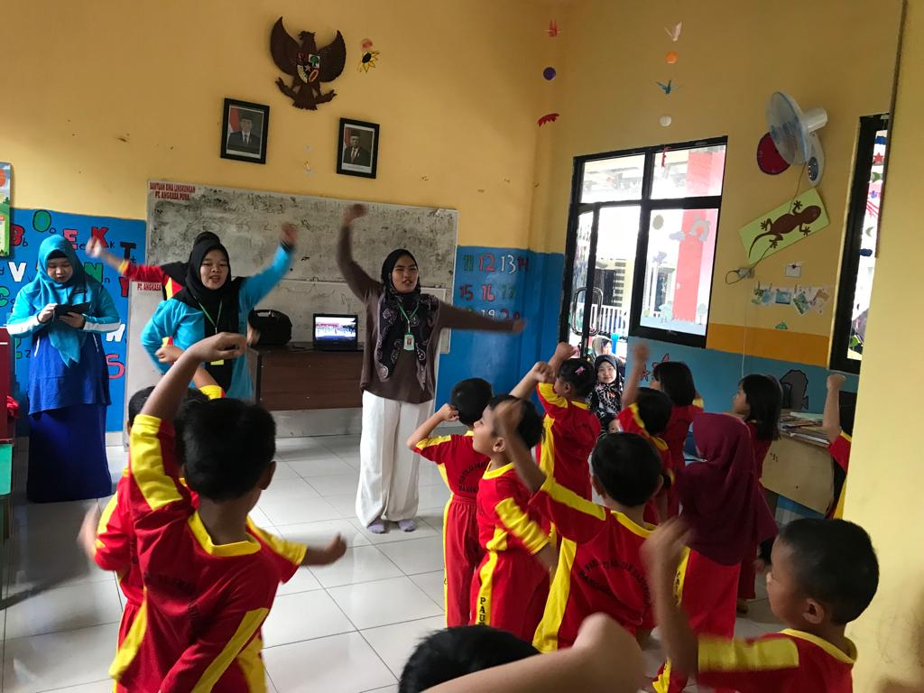
Ficture 2.
Teachers and children in healthy exercise activities using audio-visual media

Learning or activities that often utilize audio-visual in PAUD Al Iman Manunggal are physical-motor learning, especially group exercise activities. This routine activity is carried out every Friday morning at 08.00-09.00 WIB.
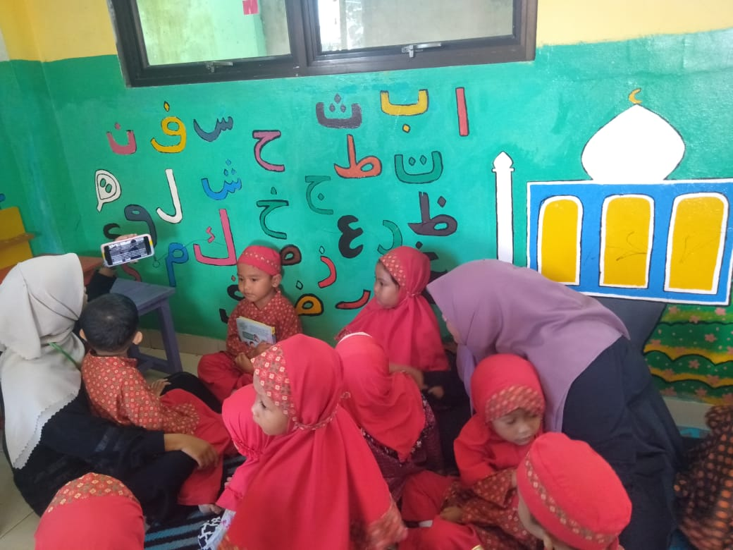
Ficture 3.
In storytelling activities the teacher uses an android to explain the material

The picture above is a documentation of storytelling activities. Usually, story telling activities use props or manual media, but this school has started occasionally using audio visuals to show children about story material that has been described by the teacher.
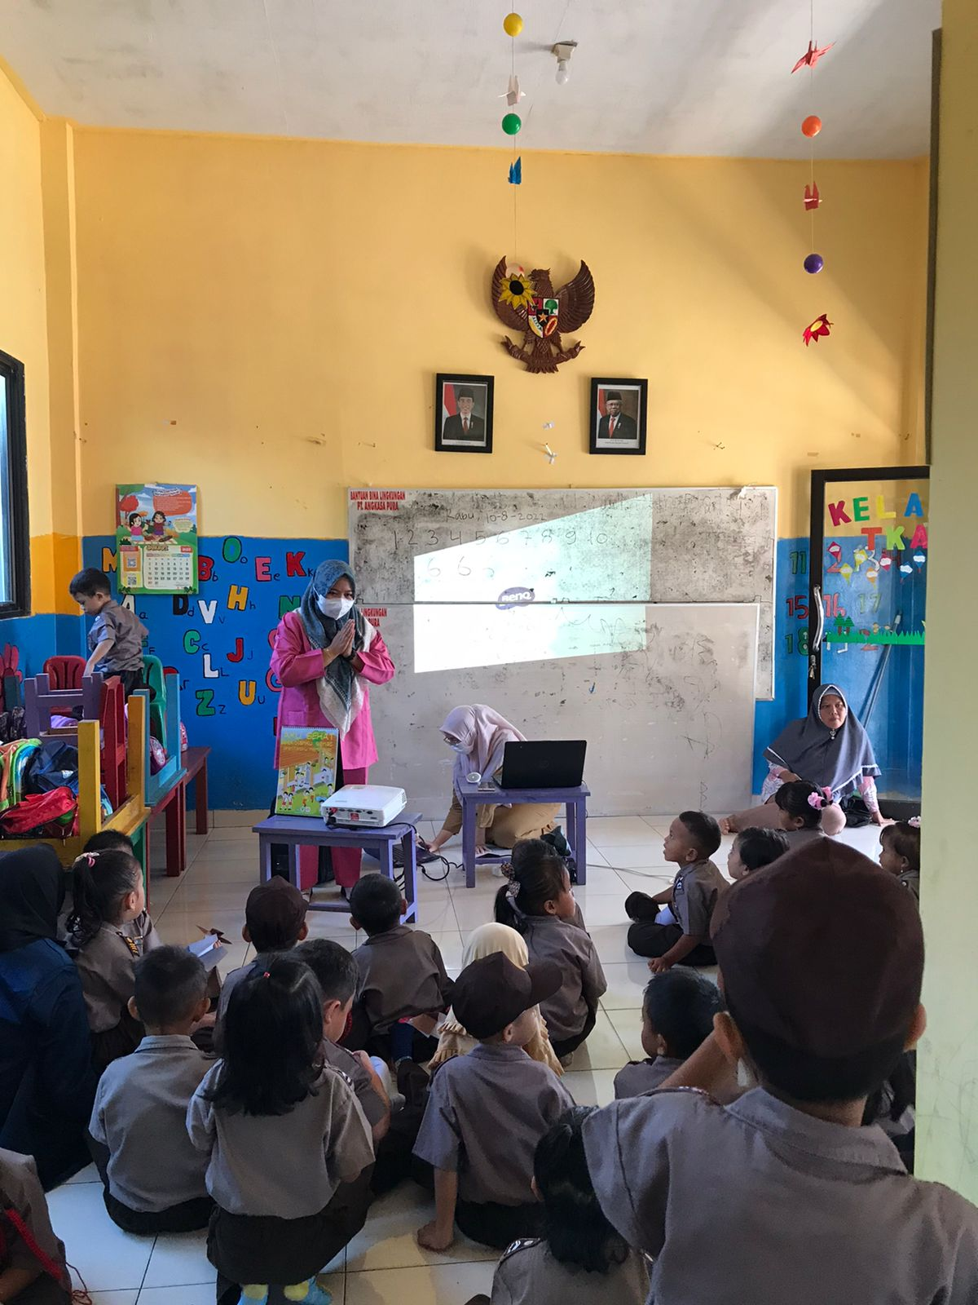
Ficture 4.
Hand washing demonstration

The material on how to rub and wash hands properly is explained by the teacher by demonstrating directly, then followed by video examples so that the children are more enthusiastic about listening. Because colorful and moving pictures make children more interested and concentrate longer. The use of learning media is intended to assist teachers in delivering the material being taught and also assist students in understanding the material. Using multimedia-based learning media can integrate media into the learning process (Siregar & Hatika, 2021), and will help educators create interactive presentation patterns (Victorian et al., 2021).
The benefits of interactive multimedia explained by (Indartiwi et al., 2020) in their journal are as follows: first, magnifying objects that are very small and invisible to the eye, such as germs, bacteria, electrons, and others (Indartiwi et al., 2020). Second, reducing very large objects that are impossible to bring to school, such as elephants, high-rise buildings, mountains, and others (Oliver, 2019). Third, presents objects or events that are complex, and complicated and take place sooner or later, such as the human body system, the operation of a machine, the circulation of the planet Mars, the development of flowers, and others (Arosyad & Nugroho, 2019). Hidayatul Al Athfal Kindergarten is located on Jalan Musi Rela, Postal Code 33171, Beluluk Village, Pangkalan Baru District, Central Bangka Regency. "Creating a generation that is healthy, has faith, is smart, cheerful, and has character." While the mission of this school includes: Building the potential of early childhood, forming children's character based on religious and Pancasila teachings, Creating a generation that is physically and mentally healthy, and training early childhood creativity.
The Hidayat Al Athfal Kindergarten curriculum is structured by carrying out Islamic values ​​as the basis for developing the character of students. Character values ​​developed include leadership, honesty, creativity, discipline, hard work, independence, responsibility, and fondness for reading. The application of values ​​is carried out through routine habituation that is applied while the child is in the Hidayatu Al Athfal Kindergarten unit. In managing fun, creative, and participatory learning activities, Hidayatul Al Athfal Kindergarten applies a group learning model strategy, where groups of children play in one day with 4 activities that contain various activities that cover 6 aspects of child development. The groups implemented were group A (3-4 years), group B1 (5-6 years), and group B2 (4-5 years). The routine activities of Hidayatul Al Athfal Kindergarten in Beluluk Village are as follows: Practice of Islamic Teachings. Read the prayer at the beginning and end of the lesson. Make it a habit to say hello before learning starts and ends. Cultivating Good Attitude. Maintain the cleanliness of the school together between students and teachers. Maintain personal health, namely examination of teeth, nails, hair, and mouth (in collaboration with related agencies/Puskesmas) and cleanliness of clothes. Brushing teeth together every Friday morning after eating. Maintain health by doing morning exercises together every Friday at 08.00 WIB. Throw garbage in its place. Clean up toys after playing. Cultivating Morals and Attitudes. Cultivating kissing the teacher's hand. Enter school at 07.30 and go home at 11.00
Obey the rules and follow the rules at school such as wearing a uniform, namely wearing Army uniforms on Mondays and Tuesdays, Muslim uniforms on Wednesdays and Thursdays, and Sports uniforms on Fridays. The number of educators in this kindergarten is 6 people, and students in group A (age 4-5 years) are 19 children, and group B (age 5-6) also 19 children.
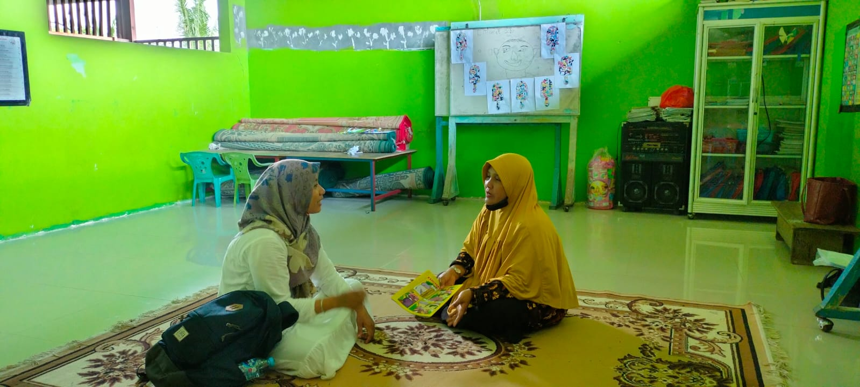
Ficture 5.
Interview with Nora's mother (homeroom teacher)

Based on the results of an interview with Mrs. Nora the homeroom teacher for group A as well as the school treasurer, she explained that: "In our lessons, we just use ordinary media, ma'am, sometimes the teacher makes it himself, sometimes he uses media available at school, for technology media, he only uses speakers or a sound system during gymnastics activities. There is a TV and even then it has been broken for a long time, it's just for display, Mom.” Based on an interview with Nora's mother, she informed that in Hidayatul Al Athfal Kindergarten there is still very little learning that uses digital media/technology. Learning is usually assisted by manual media made by the teacher. Except for gymnastic activities on Fridays that use sound system media.

Forms of Interactive Multimedia at PAUD Al-Iman Manunggal and TK Hidayatul Al Athfal
- Audio-based
Audio media is often used at Hidayatul Al-Athfal Kindergarten in morning exercise activities and listening to the national anthem on the August 17th commemoration. Meanwhile, PAUD Al-Iman Manunggal they have used audio-visual media in their exercise activities, which are supported by the availability of infrastructure.
Audio media is media that convey the contents of a message that can only be received by the sense of hearing (Nugroho & Iqbal Arrosyad, 2020). Messages conveyed through audio media are in the form of auditive symbols in the form of words, music, and sound effects. Like other learning media, the purpose of this audio media is to stimulate children's thoughts, feelings, attention, and willingness to learn the contents of teaching material messages. This audio media must be audible or able to be heard, namely following the frequency and intensity of noise that can reasonably be received by the human sense of hearing (Nugroho & Arrosyad, 2020)
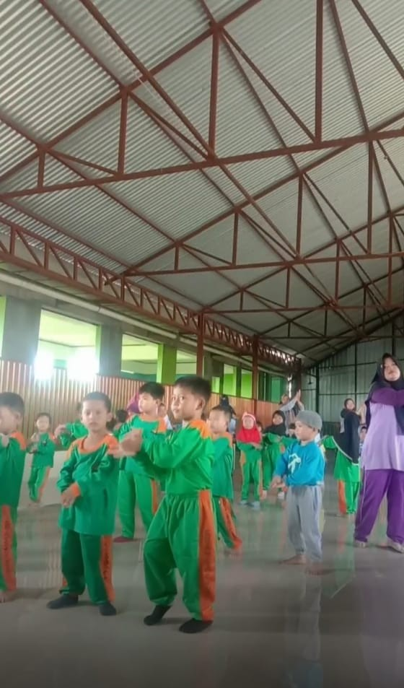
Ficture 6.
Gymnastics activities at Hidayatul Al-Athfal Kindergarten using the Audia sound system

Visual-based media is used to rely solely on students' sense of sight (Jabali et al., 2020), with this media the learning experience experienced by students is highly dependent on their visual abilities, several types of visual media include a. Print media such as books, modules, journals, maps, pictures, and posters. Reality media such as the surrounding environment and so on (Sasmita, 2017). Based on the results of interviews with the school principal and PAUD Al-Iman Manunggal teachers, in their learning, they adapt to the theme, because the learning system is thematic. Furthermore, the media used utilizes existing facilities at school, and skilled teachers make their own. The examples of media used are story books, coloring sketches, and pictures according to the theme. For example, the theme of the profession, and the images chosen are also by the theme of the profession, such as teachers, doctors, police, pilots, farmers, fishermen, nurses, and so on. Likewise, with storytelling and coloring activities, the images/visual media used are all adapted to that theme. The following will explain examples of the use of image media in PAUD
Al-Iman Manunggal:


Ficture 7. Tiger animal

Animal. Tiger theme/sub-theme: Animals / Tigers, For Age: 5-6 Years, Discussion Topic: mentioning the type of animal, For Developmental Aspects: Religious Values ​​Social Emotional Cognitive Physical Motoric Language arts. Tiger: The largest cat species. Characteristics: Distinctive striped fur, in the form of dark vertical stripes of orange fur, with white fur underneath. Habitat: ranging from lowland forest to mountain forest and also lives in many places that are not protected. Tiger diet: eats meat. Benefits of tigers: if tigers are not there, herbivore animals will reproduce uncontrollably, which means it will damage plants in the forest. Aspects that can be taken from this theme are Religious Moral Values: Recognizing animals as God's creations, Physical Motor: Developing children's mind power. Cognitive: Recognize the number of letters s-i-n-g-a. The benefits of roses: for health, namely showing excess weight and reducing stress.
Similar to PAUD AL-Iman, Hidayatul Al-Athfal Kindergarten often uses visual media in their learning activities. The visual media used are storybooks, worksheets, and pictures that match the day's learning material or theme. The examples of learning using picture media in Hidayatul Al-Athfal Kindergarten, are as follows: Theme: Myself, Sub-theme: Five Senses, Age: 4-5 Years, Topic of Discussion: Through the theme myself, the five-senses sub-theme, children can get to know all kinds of five senses through ms. words, such as ears, eyes, nose, tongue, and skin. In addition, children can also recognize the functions of the five senses, such as recognizing various tastes (bitter, sweet, sour, salty), recognizing various types of touch (coarse, smooth, slippery, sharp, hot, cold), types of smell (rotten, fragrant, fishy), familiar with various sounds (loud, soft, loud, shrill), and familiar with types of vision (clear, blurry, far, near, glare, dark, bright). Through Ms. word, children can connect images of the five senses and their function
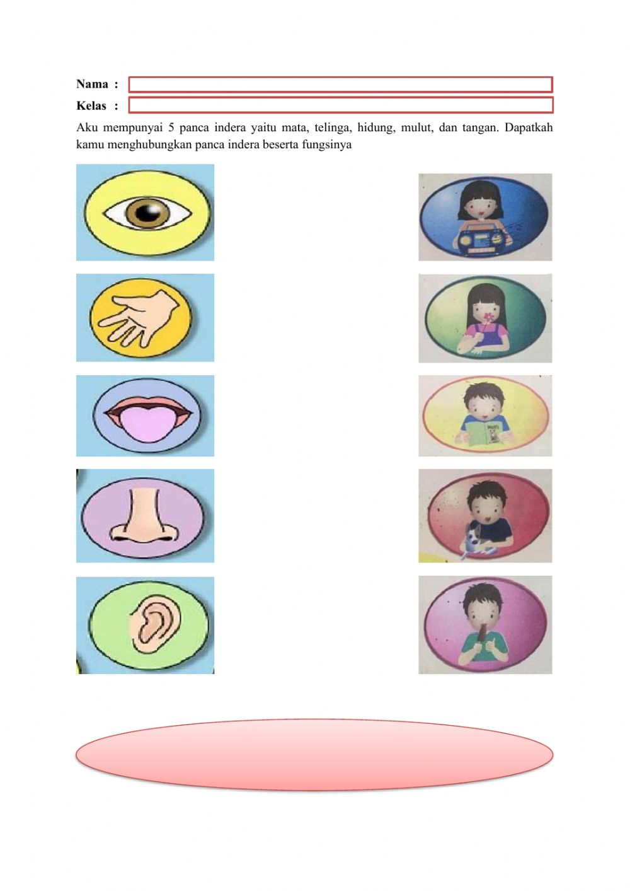
Picture 8. The five senses and their functions

Development Aspect:
1. Cognitive: recognize the types and functions of the five senses.
2. Fine motor: connecting images of the five senses and their functions.
Theme: My family
Subtheme: Family Members
Age: 5-6 Years
Topic of Discussion: Through the theme of my family, the sub-theme of family members, children can find out the names of family members, such as grandparents, mothers, fathers, brothers and sisters. Through Ms. word children can bold the dotted lines on the names of family members and children can also write by imitating the names of family members who have been bolded.
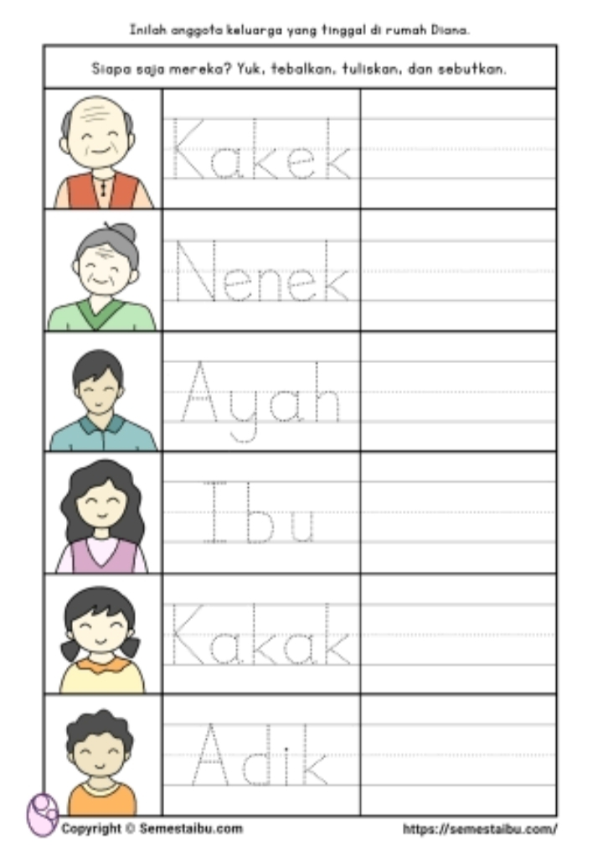
Picture 9. Bold letters of family members

Development Aspect:
1. Cognitive: knowing the names of family members.
2. Fine motor: write and bold the names of family members.
Theme: My Environment
Subtheme: My house
Age: 5-6 Years

The topic of Discussion: Through the theme of my environment, the sub-theme of my house, children can find out the parts of the house such as roofs, doors, windows, walls, and so on. Children can also recognize the shape of various parts of the house such as triangles, rectangles, rectangles, circles, and others. In addition, children can recognize colors. Developmental Aspects: 1. Cognitive: knowing the parts of the house, knowing the shape of the parts of the house. 2. Art: knowing colors. Audio-visual is a type of media used in learning activities by involving hearing and sight as well as in an activity or process (Rahmalah et al., 2019). Messages and information that can be channeled through this media can be in the form of verbal and nonverbal messages that rely on both sight and hearing, for example, films, videos, TV programs, and others.
Based on the results of observations and interviews at Hidayatul Al-Athfal Kindergarten and Al-Iman Manunggal PAUD, the researchers concluded that the use of audio-visual media in early childhood learning was only at Al-Iman PAUD, because these schools already had facilities in the form of televisions, laptops, and use android as well. Meanwhile, Hidayatul Al-Athfal Kindergarten has not been supported by supporting facilities, coupled with teacher constraints in its application. In addition, the application of multimedia learning is very influential in the implementation of learning as children are more enthusiastic when using music media, picture media and game media.

CONCLUSION

Learning or activities that often utilize audio-visual multimedia in paud al iman manunggal are physical-motor learning, especially joint exercise activities, and storytelling activities, as well as material on how to rub and wash hands. Whereas in hidayatul al athfal kindergarten it is still very rare to learn using digital media/technology. Learning is usually assisted by manual media made by the teacher. Except for gymnastic activities on fridays that use sound system media. Multimedia forms in hidayatul al-athfal kindergarten and al-iman manunggal paud: audio media is often used in hidayatul al-athfal kindergarten during morning exercise activities and listening to the national anthem on the august 17 anniversary. Meanwhile, paud al-iman manunggal they have used audio-visual media in their exercise activities, which are supported by the availability of infrastructure. The use of media in these two schools adapts to the theme because the learning system is thematic. Furthermore, the media used utilizes existing facilities at school, and skilled teachers make their own. The examples of media used are story books, coloring sketches, and pictures according to the theme. The use of audio-visual media in early childhood learning is only in paud al-iman, because this school already has facilities in the form of television, and laptops, and utilizes android as well. Meanwhile, hidayatul al-athfal kindergarten has not been supported by supporting facilities, coupled with teacher constraints in its application.

REferenCES
Arikunto Suharsimi. (2013). Research Procedures A Practice Approach. In Jakarta: Rineka Cipta (p. 172). http://r2kn.litbang.kemkes.go.id:8080/handle/123456789/62880
Arnada, E. Z., & Putra, R. W. (2018). Implementation of Interactive Multimedia in Early Childhood Education Nurul Hikmah as Learning Media. Jurnal Idealis, 1(5), 393–400.
Arosyad, I., & Nugroho, F. (2019). Learning Strategy Teaching Materials in Elementary Schools Based on Remote Learning. Intishar Publishing Bumirejo.
Arrosyad, M. I., & Sugiarti, S. (2020). The Traces of the Awakening of the Oldest Muhammadiyah Elementary School in Serumpun Sebalai. Tarbawy : Jurnal Pendidikan Islam, 7(1), 33–41. https://doi.org/10.32923/tarbawy.v7i1.1176
Diana, D., Seprina, I., & Kunang, S. O. (2021). Online Storage Management Training (Cloud Storage) for SMP Al-Hamidiyah Palembang Teachers. Jurnal Pengabdian Pada …, 6(4), 1259–1267. https://doi.org/10.30653/002.202164.841
Disnawati, H., & Haning, F. O. (2019). Workshop on Using Garbage and Used Goods Based Learning Media for MIN TTU Teachers. Bakti Cendana. https://doi.org/10.32938/bc.v2i2.280
Dr. H. Zuchri Abdussamad, S.I.K., M. S. (2021). Qualitative Research Methods. CV. syakir Media Press.
Indartiwi, A., Wulandari, J., & Novela, T. (2020). The Role of Interactive Media in Learning in the Industrial Revolution Era 4.0. Prosiding Konferensi Pendidikan Nasional “Strategi Dan Implementasi Pendidikan Karakter Pada Era Revolusi Industri 4.0,” 2(1), 28–31. https://bit.ly/3vhcWFW
Jabali, S. G., Supriyono, S., & Nugraheni, P. (2020). Development of Ethnomatematics-Based Visual Novel Game Media to Improve Conceptual Understanding of Algebra Material. Alifmatika: Jurnal Pendidikan dan Pembelajaran Matematika, 2(2), 185–198. https://doi.org/10.35316/alifmatika.2020.v2i2.185-198
Khoiron, A. K. & A. M. (2019). Qualitative Research Methods. Lembaga Pendidikan Sukarno Pressindo (LPSP).
Nugroho, F., & Arrosyad, M. I. (2020). Learning multimedia development using articulate storyline for students. International Journal of Elementary Education, 4(4), 575–579.
Nugroho, F., & Iqbal Arrosyad, M. (2020). Moodle Multimedia Development in Web-based Integrative Thematic Learning for Class IV Elementary Students. Cendekiawan, 2(1), 49–63. https://doi.org/10.35438/cendekiawan.v2i1.177
Oliver, J. (2019). Chapter II Review of Application Libraries. Hilos Tensados, 1, 1–476. http://repository.potensi-utama.ac.id/jspui/bitstream/123456789/2990/6/BAB II.pdf
Pratiwi, ni pt. sri, Asri, I. G. A. agung sri, & Putra, D. B. K. N. semara. (2014). THE INFLUENCE OF BRAIN-BASED LEARNING WITH THE ASSISTANCE OF MEDIA DIORAMA ON LEARNING OUTCOMES OF IPS CLASS OF VSD VIII SUKAWATI STUDENTS IN THE ACADEMIC YEAR OF 2013/2014. Jurnal Mimbar PGSD.
Rahmalah, P. Z., Astuti, P., Pramessetyaningrum, L., & Susan, S. (2019). The Effect of Using Gadgets on the Formation of Early Childhood Character. Prosiding Seminar Nasional Lppm Ump, 0(0), 302–310. https://semnaslppm.ump.ac.id/index.php/semnaslppm/article/view/52/52%0Ahttps://semnaslppm.ump.ac.id/index.php/semnaslppm/article/view/52
Sasmita, S. (2017). The Use of History Smart Quartet Card Game Media (KKPS) in an Effort to Increase Activities and Learning Outcomes in Class X IPA 7 SMA Negeri 1 Surakarta Odd Semester 2017/2018 Academic Year. Jurnal Artefak, 4(2), 119. https://doi.org/10.25157/ja.v4i2.905
Siregar, P. S., & Hatika, R. G. (2021). HOTs-Based Question Making Training Using Socrative at MA Nurul Iman Mahato. Jurnal Pengabdian Pada Masyarakat, 6(4), 1213–1218. https://doi.org/10.30653/002.202164.810
Suryadilaga, M. A. (2012). Sharia Hadith Methodology. Yogyakarta: SUKA-Press UIN Sunan Kalijaga.
Utama, A. A. (2017). Muhammadiyah in Sumbawa Regency, West Nusa Tenggara, 1940-2014. Profetika, 18(1), 18–26.
Victorian, A. R., Aryanti, S., Yusfi, H., Solahuddin, S., & Bayu, W. I. (2021). Perspectives of Prospective Physical Education Teachers on Online Learning During the Covid-19 Pandemic. JOSSAE : Journal of Sport Science and Education, 6(1), 94. https://doi.org/10.26740/jossae.v6n1.p94-106

