Graphical Abstract
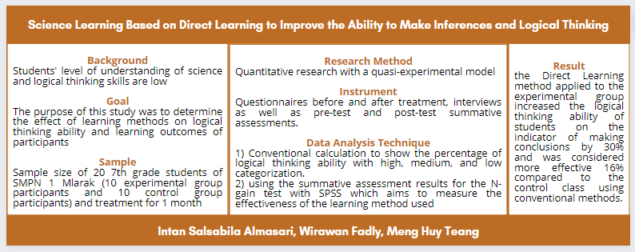

Highlights
This study found that 1) The learning method used influences students' understanding; 2) Learners' comprehension skills have an influence on logical thinking skills, not the other way around; 3) The Direct Learning learning method has less influence on the sample of this study but is better than the conventional method.

Paired T Test (Supporting Table 7)
EXPERIMENT GROUP
Paired Samples Statistics
 |  | Mean | N | Std. Deviation | Std. Error Mean
Pair 1 | Pretest | 42.5000 | 10 | 20.71634 | 6.55108
Pair 1 | Posttest | 64.7000 | 10 | 19.32212 | 6.11019

Paired Samples Correlations
 |  | N | Correlation | Sig.
Pair 1 | Pretest & Posttest | 10 | .954 | .000

Paired Samples Test
 |  | Paired Differences
 |  | Mean | Std. Deviation | Std. Error Mean | 95% Confidence Interval of the Difference
 |  |  |  |  | Lower
Pair 1 | Pretest - Posttest | -22.20000 | 6.21468 | 1.96525 | -26.64571

Paired Samples Test
 |  | Paired Differences | t | df | Sig. (2-tailed)
 |  | 95% Confidence Interval of the Difference | t | df | Sig. (2-tailed)
 |  | Upper | t | df | Sig. (2-tailed)
Pair 1 | Pretest - Posttest | -17.75429 | -11.296 | 9 | .000

CONTROL GROUP
Paired Samples Statistics
 |  | Mean | N | Std. Deviation | Std. Error Mean
Pair 1 | Pretest | 41.0000 | 10 | 19.55050 | 6.18241
Pair 1 | Posttest | 55.2000 | 10 | 23.63049 | 7.47262

Paired Samples Correlations
 |  | N | Correlation | Sig.
Pair 1 | Pretest & Posttest | 10 | .929 | .000

Paired Samples Test
 |  | Paired Differences
 |  | Mean | Std. Deviation | Std. Error Mean | 95% Confidence Interval of the Difference
 |  |  |  |  | Lower
Pair 1 | Pretest - Posttest | -14.20000 | 9.06520 | 2.86667 | -20.68485

Paired Samples Test
 |  | Paired Differences | t | df | Sig. (2-tailed)
 |  | 95% Confidence Interval of the Difference | t | df | Sig. (2-tailed)
 |  | Upper | t | df | Sig. (2-tailed)
Pair 1 | Pretest - Posttest | -7.71515 | -4.953 | 9 | .001

N-Gain Test (Supporting Table 8)
Case Processing Summary
 | Group | Cases
 | Group | Valid |  | Missing |  | Total
 | Group | N | Percent | N | Percent | N | Percent
persen | Experiment | 10 | 100.0% | 0 | 0.0% | 10 | 100.0%
persen | Control | 10 | 100.0% | 0 | 0.0% | 10 | 100.0%

Descriptives
 | Group |  |  | Statistic | Std. Error
persen | Experiment | Mean |  | 46.9774 | 6.38776
persen | Experiment | 95% Confidence Interval for Mean | Lower Bound | 32.5273
persen | Experiment | 95% Confidence Interval for Mean | Upper Bound | 61.4275
persen | Experiment | 5% Trimmed Mean |  | 46.3241
persen | Experiment | Median |  | 45.0000
persen | Experiment | Variance |  | 408.035
persen | Experiment | Std. Deviation |  | 20.19987
persen | Experiment | Minimum |  | 20.00
persen | Experiment | Maximum |  | 85.71
persen | Experiment | Range |  | 65.71
persen | Experiment | Interquartile Range |  | 29.60
persen | Experiment | Skewness |  | .591 | .687
persen | Experiment | Kurtosis |  | -.180 | 1.334
persen | Control | Mean |  | 31.1143 | 8.75438
persen | Control | 95% Confidence Interval for Mean | Lower Bound | 11.3105
persen | Control | 95% Confidence Interval for Mean | Upper Bound | 50.9181
persen | Control | 5% Trimmed Mean |  | 28.7302
persen | Control | Median |  | 24.3333
persen | Control | Variance |  | 766.392
persen | Control | Std. Deviation |  | 27.68378
persen | Control | Minimum |  | 8.00
persen | Control | Maximum |  | 97.14
persen | Control | Range |  | 89.14
persen | Control | Interquartile Range |  | 28.00
persen | Control | Skewness |  | 1.828 | .687
persen | Control | Kurtosis |  | 3.227 | 1.334

