
Journal of Natural Science and Integration
Available online at:
http://ejournal.uin-suska.ac.id/index.php/JNSI
DOI: 10.24014/jnsi.v4i2.11445
P-ISSN: 2620-4967|E-ISSN: 2620-5092
Vol. 2, No. 2, October 2019, pp 1-3
ANALYSIS OF THE UTILIZATION OF AUDIO-VISUAL MEDIA AS A BASIC STUDY OF CONTROL SYSTEM INTEGRATION FOR LEARNING MEDIA
Rian Vebrianto^{1*}, Radeswandri², Musa Tahir³, Yovita⁴ & Irfan Andi Gafur³
¹Universitas Islam Negeri Sultan Syarif Kasim, Riau, Indonesia
² Universitas Terbuka, Indonesia
³ Universitas Islam Negeri Sultan Syarif Kasim, Riau, Indonesia
⁴ Universitas Terbuka, Indonesia
⁵ Universitas Islam Negeri Sultan Syarif Kasim, Riau, Indonesia

*Correspondence Author: rian.vebrianto@uin-suska.ac.id
Received: Accpeted: Published:
ABSTRACT
Implementation of Educational or Disruptive Technology has been carried out by various educational institutions, formally or non-formally to achieve the expected learning outcomes. However, there are still weaknesses in the ability of educators to use technology in the teaching and learning process so these achievements have not been accurately mapped. This study aimed to carry out a literature review analysis on the application of learning technology, the usefulness of teaching media, and obstacles to the implementation of educational technology. This study used a cross-sectional survey design with a total sample of 116 people consisting of lecturers, educators, and students (student teachers). The data collection technique included an online questionnaire consisting of multiple-choice questions and a brief description of the implementation of disruptive technology. The data obtained were analyzed descriptively qualitatively and the indicators assessed included relevance, educator ability, ease of use, availability, and usefulness. From the results of the study, it can be concluded that the utilization of visual media has been used by various Educators and Students, however, they have not been able to develop audio-visual media from the results of Industry 4.0 technology.
Keywords: Disruptive Technology, Utilization, Obstacles, Industry 4.0 technology
INTRODUCTION
Misunderstandings of learning materials are problems that always occur in the teaching and learning processes in schools. This is due to the weak ability of educators to understand the basic concepts of the materials being taught such as a lack of understanding of data, graphics, visuals, and texts which are abstract—so, they are always associated with everyday contextual systems, even though they have nothing to do with it. (Mieke, Sari, & Winarti, 2019; Riti, Sar'iyyah, & Bito, 2022) explain that misunderstandings of concepts, also known as misconceptions, are resulted from the delivery of inappropriate concepts by educators. Misconceptions arise in students due to misunderstandings of educators’ concepts so they have fatal implications for students. This is as evidenced by (Amalia, 2018; Ariyastuti & Yuliawati, 2017) that, it was found that the presentation of misconceptions in the participants was very high. Misconceptions do not only occur as a result of wrong concepts conveyed by educators but are also from the textbooks of students. This is as explained by (Purwaningrum, 2021) that, it was found 10 misconceptions in the textbooks of students. Therefore, minimizing misconceptions (Desstya, Sayekti, Abduh, & Sukartono, 2021), takes the responsibility of educators to overcome and reduce them by using various methods, strategies, or appropriate teaching media.
Educators are expected to be able to develop various efforts to prevent misunderstandings of materials being taught so these materials can be more contextual and not ambiguous. However, several studies still show that educators have not been able to develop new ideas so their weaknesses are still found. Several studies that have been carried out state some educator weaknesses, among others, (Mohammad Ismail et al., 2022) an inability to design learning according to the curriculum, (Suparmi, 2022) an inability to develop appropriate and creative learning tools, (Anggraito, Iswari, Priyono, Purwantoyo, & Pukan, 2021; Basir, Kusmaryono, Maharani, & Ubaidah, 2021) a lack of mastery of the material, and (M Ismail, Zubair, Herianto, & Alqadri, 2019; Wahid & Saputra, 2021) a lack of understanding or developing teaching media. Educators also have not been able to reflect on their teachings as expressed by (Al-Shudaifat, 2020) and learning innovation (Li, Zhang, & Sang, 2022). Thus one alternative effort that can be done to overcome misunderstandings is by using learning media.
Good learning media is following the changing times of education so as to produce an appropriate disruptive technology. However, (Munawaroh, 2021) explains that the ability of educators to make teaching media is still limited. Also, (Arthana, Mahayanti, Tirtayani, Astawan, & Jayanta, 2019) explain that some educators have used teaching media from the internet, but these media are not yet in accordance with the contents of the materials being taught to students. Even though currently the world of education has entered the era of Industry 4.0 technology which emphasizes electronic learning (E-learning). As put forward by (Ayunda, Rahmat, & Diana, 2019; Bakhri, 2021; Rindawati, Khosyi'Atunnisa, & Herlambang, 2021) through voice note chat learning (Maysaroh, Gunawan, & Nadya, 2022) and other media that can be maximally used simultaneously without the limitation of space and time. (Rakasiwi & Fernandez, 2021) thus educators will later produce students who have soft skills and hard skills to support the Sustainable Development Goals (SDGs).
Based on this description, a study was conducted to determine the extent to which educators understand the learning media and digital technology that have been used. So the results obtained will provide distributions to agents of change in prospective educators who are more reliable, and information regarding the efforts needed to improve learning media in schools.
METHODOLOGY
This study was conducted using a ToolPak-based descriptive analysis design that included two stages of analysis. The first stage was collecting survey data including questionnaire sheets, observation sheets, and interview sheets for educators and students consisting of 116 people.
Data analysis performed was as follows
- Data of Questionnaire Sheet
Questionnaire sheets were distributed to educators and students to find out the learning media commonly used in the teaching and learning processes. If more than 50% of educators stating the difficulty in using media and 50% of students stating the educators do not use media or the media used are unsuitable with the concepts, then the next development trial will be carried out.
- Data of Interview Sheet
Interview sheets were given to students using a random sampling method and also given to educators to find out which learning media they really liked so that a media planning dashboard can be designed.
- Data of Observation Sheet
Observation sheets were filled with several components that become problems, one of which was the ability of educators to use learning technology and student modalities. If the N visual modality of students is more dominant, then the media design that will be made is adjusted to the expected abilities.
The second stage was designing a media development model that is close to disruptive technology or Industry 4.0 technology with appropriate application features and utilizes digital media to make it easier for students to master concepts by cultivating literacy.

Research Samples
In this study, 64 educators and 52 students were involved using a stratified sampling method at schools in Pekanbaru and the border of Pekanbaru-Kampar. This study aimed to ascertain and find out which teaching media have been used, as well as the population of which schools have implemented the use of digital media that are closer to Industry 4.0 technology.
Data Analysis Procedures
The data obtained were analyzed descriptively qualitatively using the ToolPak with the Cross-Sectional Survey method, while the follow-up of the data results by 4 experts (lecturers) was analyzed using the Lawshe's formula. If the data results are dominated by Fair, Good, and Very Good categories, then further testing of the importance of the media is carried out using the following equation:
$$CVR=\frac{\left(Ne-\left(\frac{N}{2}\right)\right)}{\left(\frac{N}{2}\right)}$$
Note:
CVR = Content Validity Ratio (-1<CVR<1)
Ne = The number of Respondents stating Very Appropriate/Appropriate
N = Total Respondents
If CVR <0 ≤-1 then (the results are) Unimportant, but if CVR >0 ≥1 then (the results are) Very Important

Product Development

Table 1. Differences between Audio-visual and Audio-visual Control System Integration

INDICATORS | DIFFERENCE
INDICATORS | Audio-visual | Audio-visual Control System Integration
Image Display | Videos | Videos and 3D Slide Shows
Command Language | None | English
Submission Language | All Speak | All Speak
Usage Mode | Manual | Autmatic (Voice Mode)
Keyboard Usage | Manual | Automatic
Mouse Use | Manual | Automatic
Network Mode | Offline | Offline and Online

Based on Table 1, it is shown that the Audio-visual media and Contol System Integration of Industry 4.0 technology have different characteristics where the Contol System Integration is superior to Audio-visual media in terms of more real image displays in the form of 3D Slide Shows, can be operated with voice commands without pressing buttons on the mouse and keyboard, the usage mode can be done with only voice without the need for manual typing, and the network mode can be either online or offline. The distinctive description between the two is that the Contol System Integration requires additional applications such as the JARVIS application which can recognize recorded voice commands, or voice control recognition as seen in the following Figure 1.

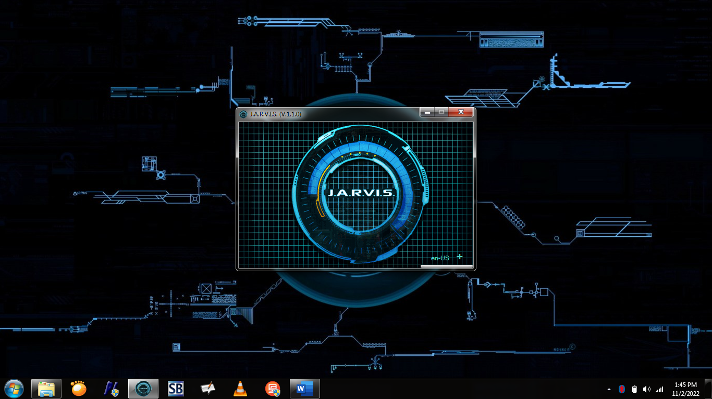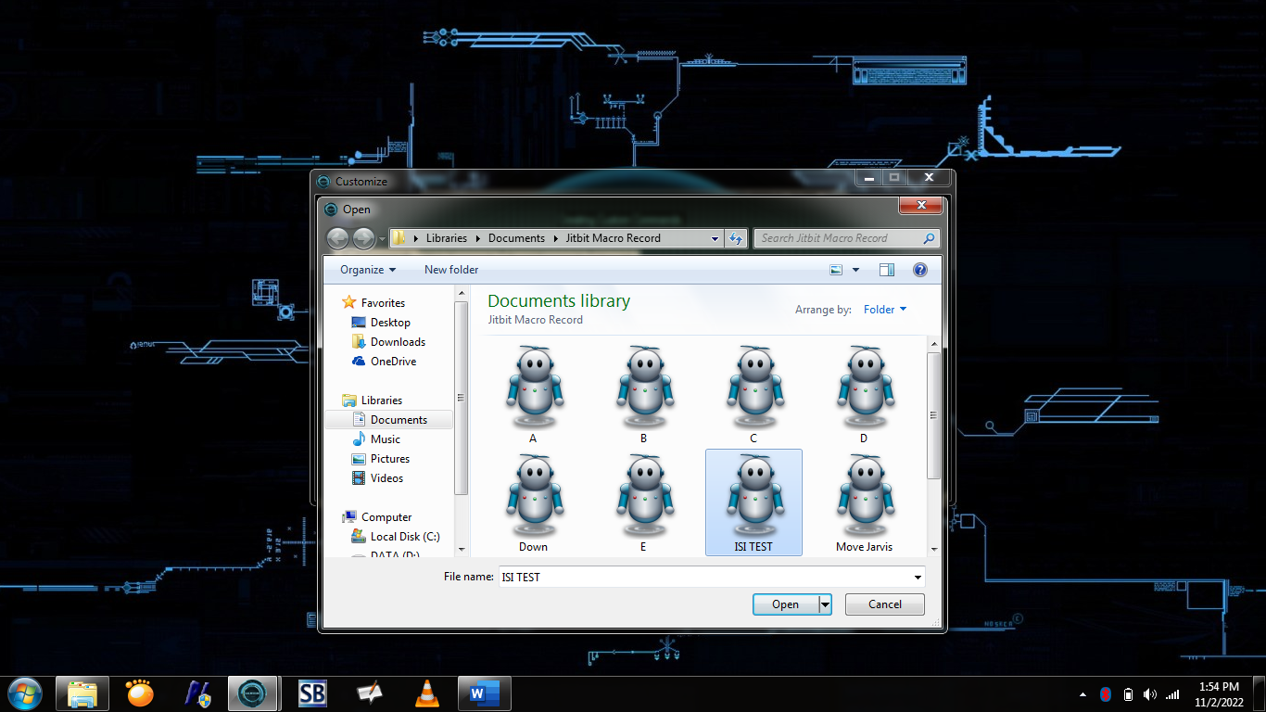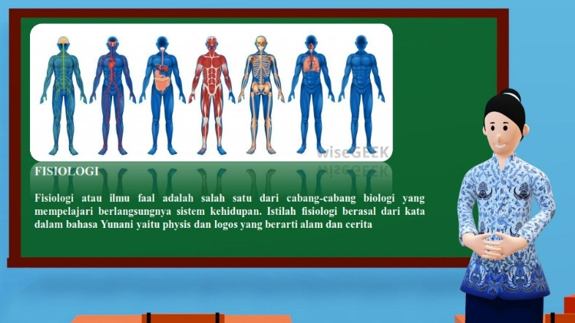
Figure 1. Control System Application and Audio-visual Display

Figure 1 is a presentation display that has been integrated with the control system, so it can explain material in the form of audio-visual and PC movements assisted by the Jitbit Macro Recorder application. With the control system application, the mechanism for operating the application on a PC or laptop is automatic and can be done with only voice commands to operate its performance.
RESULT AND DISCUSSION
The initial study was carried out by paying attention to 4 main aspects including (1) experience in developing learning media, (2) basic knowledge of audio-visual control technology, (3) learning conditions at school, and (4) difficulty in understanding the terms in material concepts. The data analysis that has been done is presented in the following Figure 1.

Figure 2. Learning Media Integration in Schools

Based on Figure 2, it is shown that the Development indicator by educators and students obtained a score of 100%, by stating that educators and students have tried and used learning media that have been provided from various sources on the internet. In the Experience indicator, the score by educators is 97% while the score by students is 100%, by stating that educators have attended training in using instructional media and students have used the media that has been used. In the Implementation Indicator, the score by educators is 100% while the score by students is 97%, by stating that educators have not been able to apply teaching media that they have made themselves and students have never applied digital literacy in the learning process. In the Difficulty indicator, the score by educators is 100% while the score by students is 95%, by stating that educators are still having difficulty making their own learning media and students do not understand the various icons or toolbars of online learning media. The results of the analysis of knowledge of audio-visual control technology are presented in the following Figure 3.

Figure 3. Basic Knowledge of Audio-visual Control Technology

Based on Figure 3, it is shown that educators and students do not know about the Understanding and Use of Audio-visual media using Control System Integration of Industry 4.0 technology, which can be seen in the Understanding and Use Indicators, which obtained a score of 100% for each. Even though the Digitization indicator shows that educators and students prefer digital learning, with a score by educators of 94% and a score by students of 97%. After obtaining data on the understanding of Audio-visual Control Technology, an analysis was carried out on Learning Conditions in several schools based on the samples obtained. The results of the analysis are presented in the following Figure 4.

Figure 4. Classroom Learning Conditions in Schools

Based on Figure 4, it is shown that the Ease of Use Indicator by educators and students obtained scores of 87% and 65% respectively. Educators state that learning media make it easier for them to convey materials, but some students state that learning media still do not make it easier for them to understand the materials. In the Suitability indicator, the scores by students are divided into 62% and 48%, by stating that 62% students agree and 48% students disagree that the media used are suitable with the materials being taught. In the Participation indicator, educators state that only 47% of students participate in the teaching and learning process while students state that 52% of them participate in the teaching and learning process. In the Conducive indicator, the score by educators is 57% while the score by students is 60% on conducive learning conditions. In the Effectiveness indicator, educators state that 40% of media is effective in increasing the understanding of students while students state that only 15% of the media used help to facilitate their understanding. Further analysis was carried out to find out the weaknesses of the students in understanding the terms in thematic learning. The results of the analysis are presented in the following Figure 5.

Figure 5. Difficulty in Understanding the Terms in Thematic Learning

Based on Figure 5, it is shown that the presentation of difficulty in understanding materials (the terms in thematic learning) by students is found in the Text indicator, with a score of 42%. Students state that they do not understand the terms they found in the text and educators rarely explain the meaning of these terms even though not all textbooks have a complete glossary. The difficulty in understanding materials by students is further found in the Histogram indicator, with a score of 18%, Figure indicator, with a score of 15%, Table indicator, with a score of 14%, and Graphic indicator, with a score of 11%. It can be concluded that the terms in the text are problems for students and it is common for misunderstanding or misconception of terms to occur in learning materials. Therefore, educators and students provide suggestions for the development of instructional media, which is presented in the following Table 2.

Table 2. Suggestions by Educators and Students
NO | SUGGESTION
1 | Application of audio-visual media that can display visuals in semi-real or virtual form
2 | To use a system control mechanism based on voice recognition to explain ambiguous terms in text
3 | Availability of adequate media and computer equipment
4 | Media development is not only on the appearance of images or visuals, but requires the development of offline media such as Google Assistant

Based on the presentation of Figures 1, 2, 3, 4 and 5, as well as the suggestions in Tables 1 and 2, it is necessary to have an audio-visual media design that is closer to Contol System Integration technology known as voice control recognition. The audio-visual media design on the basis of voice control is presented in the following Figure 6.
Source
Picture
Insert Pictures
Source
Videos
Insert Videos
to
Camtasia 9
Videos
Text
renderings
edit
MP4 videos
Hyperlinks Ex
output
Canva
Picture and Text
edit
Save
Images along with Text
Hyperlink to
Coumons Jarvis
1
2

Figure 6. Flow chart of the Development of Audio-visual Control System

Figure 6 is the mechanism of audio-visual media with the help of a voice control system including step 1, namely video sources that are self-made or obtained from the internet, edited using the Camtasia 9 application to enter text and music as desired. Then the videos are rendered to obtain videos in MP4 format. The videos are used as commands using a macro recording application. Step 2, namely image sources that are self-made or obtained from the internet, designed using the Canva application to enter text under the image. Then the images are saved in JPEG or PNG format. The images are used as commands using a macro recording application (similar to videos). These images and videos can already be entered into the voice command application, also known as JARVIS. Thus the resulting media has used voice control recognition mechanism with offline mode.
An analysis of questionnaire, observation, and interview sheets was carried out in the data results that has been presented using the following Lawshe's formula.
$$CVR=\frac{\left(Ne-\left(\frac{N}{2}\right)\right)}{\left(\frac{N}{2}\right)}$$
$$CVR=\frac{\left(4-\left(\frac{4}{2}\right)\right)}{\left(\frac{4}{2}\right)}$$
$$CVR=\frac{\left(4-\left(2\right)\right)}{\left(2\right)}$$

$$CVR=1$$

The calculation obtained a Content Validity Ratio (CVR) of 1. If CVR <0 ≤-1 then (the results are) Unimportant, but if CVR >0 ≥1 then (the results are) Very Important, so it can be concluded that the development of audio-visual media with a voice control recognition mechanism is very important in supporting the success of one of the results of Industry 4.0 technology, namely the control system in the world of Education.

DISCUSSION
Based on Figure 1, it can be concluded that educators already have experience in developing learning media that have been provided with various sources, and participate in learning media training according to their needs, but they still have difficulties in making learning media according to their own abilities and the characteristics of their students. Results of a study by (Feriadi, Kurniawati, & Zainul, 2022) state that learning media is still an obstacle to the implementation of the learning process, and (Akbar, Sa'dullah, & Syafi'i, 2022) state that there is still a lack of learning media.
Based on Figure 2, it can be concluded that educators and students have never used an offline digital technology for audio-visual control such as the Google Assistant mechanism. Even though educators find it easy to teach using digital technology and students prefer the application of disruptive technology. The purpose of implementing digital technology is to increase the learning interest of students, however (Saputro, Sari, & Winarsi, 2021) explain the inability to use instructional media can reduce the interest in reading of students, as well as (Mansur & Ramdlani, 2020) misunderstanding of the content of the message conveyed. (Suprianto, 2020) explains that the existence of audio-visual media can increase understanding of vocabularies that are difficult for educators to understand.
Based on Figure 3, it is shown how the learning conditions at school are, whether they have good supporting factors for using learning technology (or, not). The conditions of the study room is more conducive and the learning media tends to be easier to use, but difficulties are still found due to the ineffectiveness of the media used and the unsuitability with the learning material so that students are less active and participate. (Wahyuningsih, 2021) reveal that media development must look at the rationale or characteristics of students so that the concepts conveyed are easily accepted by students.
Based on Figure 4, it is necessary to develop learning media, such as an illustrated glossary, that can display terms in audio-visual form, but students prefer the appearance of an audio-visual glossary that can be commanded by voice, such as the offline Google Assistant mechanism. So educators should be able to carry out learning innovations. This is as expressed by (Fatmawati & Rizal, 2020) that the current millennial generation is more interested in learning by using instructional media, and is very suitable for auditory-dominated students (Nwajiuba & Onyeneke, 2022).
The application of audio-visual media based on a voice control system is a new change for educators to convey a more contextual concept. Only with the existence of audio-visual media, learning outcomes and educational goals of students (Taufik & Gaos, 2019; Tsaniyah, Hermawan, & Waluyo, 2021), group performance (Al-Athwary & Lasloum, 2021), communication (Fiadotava & Voolaid, 2021), productivity (Goian, Goian, & Biletska, 2021), creativity (Kisno, Wibawa, & Khaerudin, 2022) and motivation of students (Peña, Huisacayna, Talavera-Mendoza, & Serrano-Rodriguez, 2021) can be improved.
Audio-visual media, in addition to improving the learning outcomes (Azizah & Lufri, 2021), competence (Khumaedi, Widjanarko, Setiadi, & Setiyawan, 2021), easy understanding of students (Spring, Kostrzewa, Rios, & Ebling, 2022) and having a positive impact on the activities of students (Suryaman, Wiyatmi, Pujiono, & Kristiyani, 2021), can also increase the professionalism (Herayanti & Safitri, 2019), the creativity of educators (Tawil & Dahlan, 2021), facilitate educators (Kováčová & Jurková, 2022) and become the highest quality media (Pikoli & Lukum, 2021) that is very popular in the world of educational research (Ferreira, Lopes, Granado, Freitas, & Loureiro, 2021).

Experts strongly agree with the use of audio-visual media based on a voice control system to become a new applied technology in the teaching and learning process, especially thematic learning. (Tapilouw, Dewi, & Hastuti, 2021) explain that students preferred audio media in science learning, so with this system control, it will become future learning technology (Hou, Zou, Zhao, & Wang, 2019) that is safe and reliable (Zhao, Zhang, Zou, Xu, & Liu, 2021) and become new breakthroughs in the world of future technology (Xie, Hao, Zhang, & Wang, 2022)
CONCLUSION
Based on the analysis of the study carried out, it is concluded that difficulties in developing instructional media are still found in several schools, especially at the elementary school level, this is due to the inability of educators to innovate, combine learning technology, and understand the basic of the concepts of the materials being taught thus resulting in misunderstandings/misconceptions in both educators and students. Therefore, it is necessary to develop new learning technologies to minimize misunderstandings of the materials being taught by implementing a control system on audio-visual media.

REFERENCES
Akbar, M. A., Sa’dullah, A., & Syafi’i, I. (2022). Pengembangan Media Pembelajaran Multimedia Interaktif Menggunakan Articulate Storyline Pembelajaran Pai Smp Plus Hidayatul …. In Vicratina: Jurnal Pendidikan …. Retrieved from http://riset.unisma.ac.id/index.php/fai/article/view/17110%0Ahttp://riset.unisma.ac.id/index.php/fai/article/download/17110/12874
Al-Athwary, A. A. H., & Lasloum, N. M. (2021). Second language listening comprehension gain from aural vs. Audio-visual inputs: The case of efl arab learners. Journal of Language Teaching and Research, 12(6), 911–921. https://doi.org/10.17507/JLTR.1206.07
Al-Shudaifat, S. H. (2020). Action research as perceived by student-teachers in the field training program at Hashemite University/Jordan. International Journal of Higher Education, 9(3), 55–63. https://doi.org/10.5430/ijhe.v9n3p55
Amalia, F. Z. (2018). Analisis Miskonsepsi IPA Materi Sifat-sifat Cahaya Menggunakan Certainty Of Respons Index (CRI) Pada Kelas Di SDN Gunungjati Jabung-Malang. In Skripsi. Retrieved from http://180.250.177.156/1561/
Anggraito, Y. U., Iswari, R. I., Priyono, B., Purwantoyo, E., & Pukan, K. K. (2021). Improvement of high school biology teacher understanding on the national science competition subject through technical guidance. Journal of Physics: Conference Series, Vol. 1918. https://doi.org/10.1088/1742-6596/1918/5/052047
Ariyastuti, Y., & Yuliawati, F. (2017). Identifikasi Miskonsepsi Ipa Menggunakan Soal Esai Bagi Siswa Cerdas Istimewa Di Sd Muhammadiyah Condongcatur Sleman. Jurnal JPSD (Jurnal Pendidikan Sekolah Dasar), 4(1), 27. https://doi.org/10.26555/jpsd.v4i1.a9608
Arthana, I. K. R., Mahayanti, N. W. S., Tirtayani, L. A., Astawan, I. G., & Jayanta, I. N. L. (2019). Pelaksanaan p2m pengembangan media ajar inovatif dan Pemanfaatan aplikasi gamifikasi bagi guru SMK Negeri 1 Singaraja. Prosiding SENADIMAS Ke-4, pp. 1121–1126.
Ayunda, T. R., Rahmat, A., & Diana, S. (2019). Understanding photosynthesis videos: Students’ visual-spatial ability and cognitive activities in senior high school. AIP Conference Proceedings, Vol. 2120. https://doi.org/10.1063/1.5115713
Azizah, N., & Lufri. (2021). Effect of Collaboration the STAD with Audio Visual Media on IPA Knowledge Competencies of VII Class SMP Negeri 32 Padang. Journal of Physics: Conference Series, Vol. 1940. https://doi.org/10.1088/1742-6596/1940/1/012128
Bakhri, S. (2021). Persepsi Mahasiswa Terhadap Kualitas Sistem, Kualitas Informasi, dan Kualitas Layanan Elearning UIN Walisongo (Studi Kasus Mata Kuliah Manajemen Sistem Informasi). Walisongo Journal of Information Technology, 3(1), 49–58. https://doi.org/10.21580/wjit.2021.3.1.8666
Basir, M. A., Kusmaryono, I., Maharani, H. R., & Ubaidah, N. (2021). Pengembangan Kemahiran Pengajaran Matematika bagi Guru Sekolah Dasar di Gugus Indraprasta Kecamatan Semarang Tengah. E-Dimas: Jurnal Pengabdian Kepada Masyarakat, 12(2), 207–213. https://doi.org/10.26877/e-dimas.v12i2.3607
Desstya, A., Sayekti, I. C., Abduh, M., & Sukartono, S. (2021). Workshop Peningkatan Kompetensi Guru dalam Mereduksi Miskonsepsi IPA pada Siswa Sekolah Dasar. Surya Abdimas, 5(4), 493–502. https://doi.org/10.37729/abdimas.v5i4.1402
Fatmawati, Y., & Rizal, A. R. (2020). Peranan Model Pembelajaran Value Clarification Technique Berbantuan Media Audio Visual Pada Pembelajaran Ips Era Milenial. JISIP (Jurnal Ilmu Sosial Dan Pendidikan), 4(4). https://doi.org/10.36312/jisip.v4i4.1186
Feriadi, S., Kurniawati, F. M., & Zainul, M. (2022). Hambatan Komunikasi Pembelajaran Daring Dalam Motivasi Belajar Peserta Didik Ditengah Pandemi Covid 19 Studi Pada Smp Negeri 1 Loksado Sofyan. … Islam Kalimantan MAB. Retrieved from http://eprints.uniska-bjm.ac.id/9438/
Ferreira, M., Lopes, B., Granado, A., Freitas, H., & Loureiro, J. (2021). Audio-Visual Tools in Science Communication: The Video Abstract in Ecology and Environmental Sciences. Frontiers in Communication, 6. https://doi.org/10.3389/fcomm.2021.596248
Fiadotava, A., & Voolaid, P. (2021). Constructing fandom at the time of corona crisis: The case studies of Estonian and Belarusian football clubs. Maetagused, Vol. 79, pp. 55–86. https://doi.org/10.7592/MT2021.79.FIADOTAVA_VOOLAID
Goian, V., Goian, O., & Biletska, T. (2021). Management Priorities of Audiovisual Student Projects During the COVID-Crisis. International Journal of Emerging Technologies in Learning, 16(10), 35–53. https://doi.org/10.3991/ijet.v16i10.19679
Herayanti, L., & Safitri, B. R. A. (2019). Pembelajaran Mendesain Rumah Menggunakan Media Audio Visual Dengan Memanfaatkan Bandicam. Jurnal Pendidikan Fisika Dan Teknologi, Vol. 5, pp. 305–309. https://doi.org/10.29303/jpft.v5i2.1429
Hou, C. M., Zou, B., Zhao, Y. C., & Wang, P. (2019). A review of control methods for inverters parallel operation. ACM International Conference Proceeding Series. https://doi.org/10.1145/3386415.3387037
Ismail, M., Rispawati, R., Herianto, E., Yuliatin, Y., Sawaludin, S., & Basariah, B. (2022). Sosialisasi Penyusunan RPP Yang Mendukung Program Merdeka Belajar Bagi Guru-Guru PPKN SMPN Se-Kabupaten Lombok Barat. Jurnal Pengabdian Inovasi Masyarakat Indonesia, 1(1), 39–42. https://doi.org/10.29303/jpimi.v1i1.714
Ismail, M., Zubair, M., Herianto, E., & Alqadri, B. (2019). Pelatihan Pengembangan Metode Pembelajaran Inovatif Pada Guru-Guru Ma/M.Ts Pondok Pesantren Al Raisyiah Sekarbela Mataram. Prosiding Seminar …, 11–12. Retrieved from http://jurnalfkip.unram.ac.id/index.php/PSN/article/view/2476
Khumaedi, M., Widjanarko, D., Setiadi, R., & Setiyawan, A. (2021). Evaluating the impact of audio-visual media on learning outcomes of drawing orthographic projections. International Journal of Education and Practice, 9(3), 613–624. https://doi.org/10.18488/journal.61.2021.93.613.624
Kisno, Wibawa, B., & Khaerudin. (2022). Digital Storytelling for Early Childhood Creativity: Diffusion of Innovation “3-D Coloring Quiver Application Based on Augmented Reality Technology in Children’s Creativity Development". International Journal of Online and Biomedical Engineering, 18(10), 26–42. https://doi.org/10.3991/ijoe.v18i10.32845
Kováčová, M., & Jurková, V. (2022). Learning German through moving pictures? On the use of audio-visual media in upper secondary education in Slovakia from the teacher’s perspective. Acta Facultatis Philosophicae Universitatis Ostravienis Studia Germanistica, 2022(30), 113–126. https://doi.org/10.15452/StudiaGermanistica.2022.30.0008
Li, W., Zhang, J., & Sang, Z. (2022). “I just want them to learn.” The intended role of Teacher’s Book shaped by its writer’s understanding of the local EFL teachers. Frontiers in Psychology, 13. https://doi.org/10.3389/fpsyg.2022.969403
Manshur, U., & Ramdlani, M. (2020). Media Audio Visual Dalam Pembelajaran Pai. Al Murabbi, Vol. 5, pp. 1–8. https://doi.org/10.35891/amb.v5i1.1854
Maysaroh, Y., Gunawan, C., & Nadya, A. (2022). Analisis Komunikasi Kelompok Dalam Komunitas Virtual Di Sosial Pada Komunitas RevoU. Jurnal Ilmu Sosial Dan Pendidikan (JISIP), 6(2), 2598–9944. Retrieved from http://ejournal.mandalanursa.org/index.php/JISIP/article/view/3062
Mieke, L. T., Sari, W. W., & Winarti, E. (2019). Miskonsepsi IPA biologi pada guru kelas IV sekolah dasar. Symposium of Biology Education (Symbion), 2. https://doi.org/10.26555/symbion.3524
Munawaroh, Y. (2021). Pengembangan Media Pembelajaran Pop Up Book Berbasis Berfikir Kreatif Peserta Didik Pada Materi Biologi Kelas Xi Sekolah Menengah Atas Skripsi Diajukan untuk Melengkapi Tugas-Tugas dan Memenuhi Syarat-Syarat Guna Mendapatkan Gelar Sarjana S1 dalam Ilmu. Retrieved from http://repository.radenintan.ac.id/14405/
Nwajiuba, C. A., & Onyeneke, R. U. (2022). Understanding the Z-generation learner for contemporary teaching in Nigerian universities. Journal of Applied Research in Higher Education. https://doi.org/10.1108/JARHE-05-2022-0148
Peña, C. M. L., Huisacayna, M. V. P., Talavera-Mendoza, F., & Serrano-Rodriguez, R. (2021). Interactive and Ubiquitous Audiovisual Media in Solving Verbal Arithmetic Problems. Proceedings - 11th International Conference on Virtual Campus, JICV 2021. https://doi.org/10.1109/JICV53222.2021.9600421
Pikoli, M., & Lukum, A. (2021). Development of audio-visual learning media integrating character education in chemistry learning to facilitate conceptual change and character strengthening of high school students. Journal of Physics: Conference Series, Vol. 1968. https://doi.org/10.1088/1742-6596/1968/1/012007
Purwaningrum, I. (2021). Analisis Miskonsepsi IPA Pada Buku Siswa Kelas IV Tema 7 Tahun 2017 Karya Henny Kusumawati. In Jurnal Kependidikan. Retrieved from http://eprints.ums.ac.id/id/eprint/91737
Rakasiwi, S. D., & Fernandez, D. (2021). Persepsi Siswa Terhadap Pelaksanaan Proses Belajar Mengajar Berbasis IT dalam Kondisi Pandemi Covid-19 di SMK Negeri 1 Sumatera Barat. MSI Transaction on Education, 2(2), 67–76. https://doi.org/10.46574/mted.v2i2.52
Rindawati, R., Khosyi’Atunnisa, S., & Herlambang, R. (2021). Pemanfaatan Tik Dalam Pengembangan Sumber Dan Media Pembelajaran Di Era Society 5.1. Jurnal FATEKSA: Jurnal Teknologi Dan Rekayasa, 6(2), 24–31. Retrieved from https://uswim.e-journal.id/fateksa/article/view/263
Riti, T. N., Sar’iyyah, N., & Bito, G. S. (2022). Identifikasi Miskonsepsi Ipa Materi Tentang Sifat-Sifat Cahaya Menggunakan Certainty of Respons Index (Cri) Pada Siswa Kelas V Sd Katolik St. Theresia Ende 3. Prima Magistra: Jurnal Ilmiah Kependidikan, 3(3), 342–349. https://doi.org/10.37478/jpm.v3i3.1939
Saputro, K. A., Sari, C. K., & Winarsi, S. (2021). Peningkatan Keterampilan Membaca Dengan Menggunakan Media Audio Visual Di Sekolah Dasar. Edukatif : Jurnal Ilmu Pendidikan, 3(5), 1910–1917. Retrieved from https://edukatif.org/index.php/edukatif/article/view/690
Spring, N., Kostrzewa, M., Rios, A., & Ebling, S. (2022). Ensembling and Score-Based Filtering in Sentence Alignment for Automatic Simplification of German Texts. Lecture Notes in Computer Science (Including Subseries Lecture Notes in Artificial Intelligence and Lecture Notes in Bioinformatics), pp. 137–149. https://doi.org/10.1007/978-3-031-05028-2_8
Suparmi. (2022). Peningkatan keterampilan dasar mengajar guru melalui supervisi klinis di SD negeri wonokerso kecamatan pakisaji kabupaten Malang tahun 2020. Wawasan Pendidikan, 2(1), 246–253. Retrieved from http://journal.upgris.ac.id/index.php/wp/article/view/11471
Suprianto, E. (2020). Implementasi Media Audio Visual untuk Meningkatkan Kemampuan Menulis Teks Eksplanasi. Trapsila: Jurnal Pendidikan Dasar, 1(02), 22. https://doi.org/10.30742/tpd.v1i02.810
Suryaman, M., Wiyatmi, Pujiono, S., & Kristiyani, A. (2021). Redefining language and literature learning in the transformation era. Indonesian Journal of Applied Linguistics, 10(3), 687–696. https://doi.org/10.17509/ijal.v10i3.31755
Tapilouw, M. C., Dewi, L., & Hastuti, S. P. (2021). Entering 21stcentury skills: Teacher and junior high school student’s perspective about science learning media’ scope. Journal of Physics: Conference Series, Vol. 1957. https://doi.org/10.1088/1742-6596/1957/1/012035
Taufik, M. S., & Gaos, M. G. (2019). Peningkatan Hasil Belajar Dribbling Sepakbola Dengan Penggunaan Media Audio Visual. Jp.Jok (Jurnal Pendidikan Jasmani, Olahraga Dan Kesehatan), 3(1), 43–54. https://doi.org/10.33503/jp.jok.v3i1.540
Tawil, M., & Dahlan, A. (2021). Application of Interactive Audio Visual Media to Improve Students’ Creative Thinking Skill. Journal of Physics: Conference Series, Vol. 1752. https://doi.org/10.1088/1742-6596/1752/1/012076
Tsaniyah, W. R., Hermawan, I., & Waluyo, K. E. (2021). Implementasi Media Audio Visual pada Hasil Belajar Mata Pelajaran Pendidikan Agama Islam. Edukatif : Jurnal Ilmu Pendidikan, 3(5), 2796–2802. Retrieved from https://www.edukatif.org/index.php/edukatif/article/view/994
Wahid, R., & Saputra, D. S. (2021). Peningkatan Profesionalitas Guru Melalui Pemanfaatan Media Pembelajaran Berbasis Videoscribe. Massagi: Masyarakat Multiliterasi Pedagodi. Retrieved from https://ejournal.multiliterasi.com/index.php/mmp/article/view/7
Wahyuningsih, I. (2021). Pengembangan Media Pembelajaran Busy Book Pada Mata Pelajaran Matematika Materi Penjumlahan Dan Pengurangan Kelas 1 SD. Retrieved from https://repository.unugiri.ac.id/id/eprint/703/
Xie, G., Hao, S., Zhang, P., & Wang, N. (2022). Research and Implementation of Intelligent Home Pension System Based on Speech and Semantic Recognition. Advances in Multimedia, 2022. https://doi.org/10.1155/2022/6141295
Zhao, W., Zhang, H., Zou, S., Xu, K., & Liu, C. (2021). Overview of vehicle steer-by-wire system control technologies. Journal of Automotive Safety and Energy, Vol. 12, pp. 18–34. https://doi.org/10.3969/j.issn.1674-8484.2021.01.002.

