Appendix C. Statistical Data Analysis
- Descriptive Analysis
Descriptive Analysis Post-Test Pre-Test Experimental & Control Class
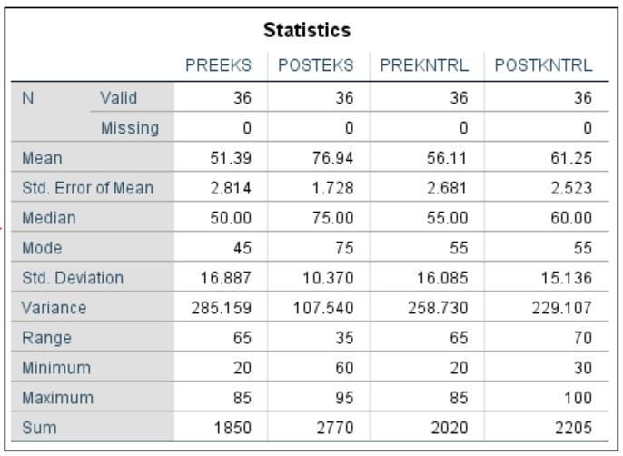
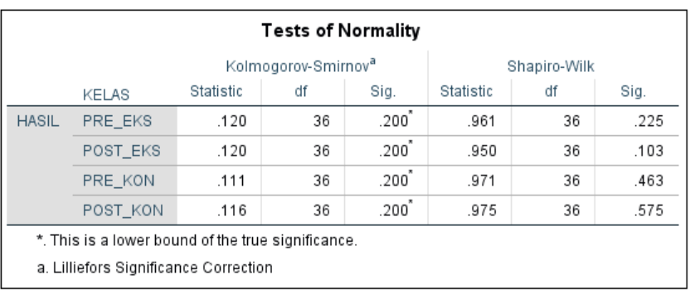
- Normality Test

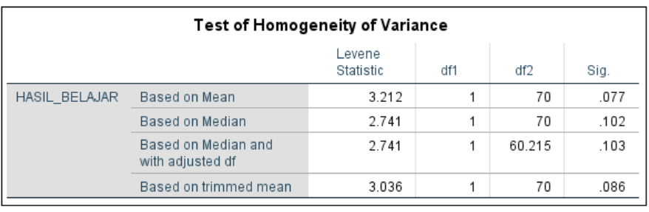
- Homogeneity Test

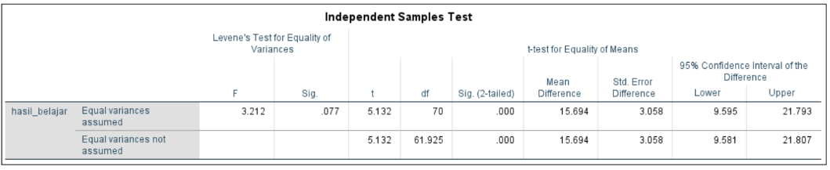
- Hypothesis Analysis (Independent Sample T-Test)

