Personalized Behavioral Analytics for GPS-Validated Attendance Systems Using K-Means Clustering and Individual-Baseline Anomaly Detection

¹Riadi Marta Dinata, *²Niko Purnomo
¹Informatics Engineering, Institut Sains dan Teknologi Nasional, Jakarta, Indonesia
²Information Technology, Computer Science, Universitas Nusa Mandiri, Jakarta, Indonesia
Email: ¹riadimrt@gmail.com, ² nicopurnomo07@gmail.com

Article Info |  | ABSTRACT
Article history:  Received May 12th, 2019  Revised Jun 20th, 2020  Accepted Jul 26th, 2020 |  | This research develops and evaluates a GPS-based attendance analytics framework integrating three complementary analytical layers for higher education laboratory environments. The proposed system combines spatial validation using Haversine-based geofencing, behavioral segmentation through K-Means clustering with multi-metric validation, and personalized anomaly detection employing individual-baseline Z-Score computation. Empirical evaluation utilized 4,300 attendance records from 13 laboratory assistants at LABKOM FSTT ISTN Jakarta over 16 months. K-Means clustering with K=3 achieved Silhouette Score of 0.634 and Davies-Bouldin Index of 0.621, identifying three distinct behavioral segments: High Performers (30.8%), Moderate (38.5%), and Improvement Needed (30.8%). The personalized Z-Score approach detected 19.9% more anomalies compared to population-based methods while reducing detection inequity coefficient of variation from 0.423 to 0.156. Results demonstrate that personalized baselines enhance detection fairness across heterogeneous behavioral profiles, ensuring employees are evaluated against individual historical patterns rather than uniform population thresholds. The integrated triple-layer architecture transforms passive attendance recording into active organizational intelligence, providing actionable insights for differentiated workforce management strategies.
Keyword:
Anomaly detection, Geofencing,
K-Means Clustering, Personalized Baseline, Silhouette Score
 |  | Copyright © 2022 Puzzle Research Data Technology
Corresponding Author:
Niko Purnomo.
Information Technology, Computer Science, Universitas Nusa Mandiri.
Jl. Margonda No.545, Pondok Cina, Kecamatan Beji, Kota Depok, Jawa Barat 16424.
Email: nicopurnomo07@gmail.com
DOI: http://dx.doi.org/10.24014/ijaidm.v2i2.xxxx

- INTRODUCTION
Digital transformation has reshaped workforce management by shifting attendance administration from manual record keeping toward data-centric systems that support measurement, evaluation, and continuous improvement [1]. In this evidence-based approach, attendance is not only a compliance artifact but also an operational signal that can inform staffing, workload distribution, and performance support when analyzed systematically [2]. Within higher education, this shift is increasingly relevant because teaching, supervision, and academic service activities often produce heterogeneous schedules that do not always align with rigid clock-in routines, making conventional attendance controls less informative for managerial decision making. Mobile computing and GPS capabilities have enabled location-aware attendance systems that validate presence based on geospatial coordinates rather than physical tokens such as cards or fixed biometric devices [3]. A common strengthening mechanism is geofencing, which defines a virtual boundary around a reference location so that check-in and check-out can be accepted only when the user is within an approved radius [4]. Prior studies show that GPS-based attendance can be practical and accurate under favorable signal conditions, while hybrid strategies such as pairing GPS with NFC or other factors can reduce fraud and improve confidence in verification [3]. At the same time, research also highlights limitations such as indoor GPS degradation, battery consumption, and operational scenarios where legitimate work occurs outside predefined boundaries, indicating that design choices must balance accuracy, usability, and context fit [5],[6].
This study focuses on a lecturer attendance context at FSTT ISTN in the SI and TI programs, using operational data from September 2024 to December 2025 with 13 active lecturer users and a total of 4,300 attendance events. The institutional objective is not only to validate presence within an agreed geofence but also to turn accumulated attendance logs into actionable behavioral insights for fairer evaluation and targeted support. This aligns with the broader direction of HR and people analytics, where analytics capability is increasingly used to translate routine digital traces into decision support for managers and institutions [7],[2]. Current state-of-the-art suggests that robust attendance systems typically emphasize validation accuracy and fraud deterrence. For instance, multi-factor designs using GPS plus NFC have been shown to reduce fraudulent attempts while maintaining convenience [3]. Time and presence constraints within a geofence can reduce the check-in then leave behavior, though additional modalities such as face recognition increase computational overhead and deployment complexity [4]. Defense-in-depth approaches combining geofencing with dynamic QR codes and device identity checks have also been reported to reduce fraud relative to single-factor approaches [8]. However, many of these systems treat attendance primarily as a verification problem rather than an analytics pipeline that supports segmentation, anomaly discovery, and longitudinal monitoring. Workforce analytics literature provides methods to extract structure from behavioral data, particularly via clustering and anomaly detection. K-means is widely used for segmentation because it is efficient and interpretable for practitioners [9],[10]. A persistent methodological issue is choosing the number of clusters; comparative discussions suggest that no single rule is universally reliable, and that cluster validity should be checked using complementary measures such as the Silhouette Score and the Davies-Bouldin Index [11],[12],[13]. Recent critiques warn that the Elbow method can be subjective and should not be relied upon alone [14]. In parallel, anomaly detection research has produced taxonomies and evaluation insights showing that statistical methods remain useful when transparency and computational simplicity matter, especially in operational systems [15],[16]. Classical Z-score approaches are easy to interpret but can be sensitive to outliers and distributional assumptions, motivating robust variants and careful baseline construction [17],[18],[19].
A key practical challenge in attendance anomaly detection is fairness across heterogeneous baselines. A population-level threshold may under-detect meaningful deviations for consistently punctual lecturers while over-flagging those with chronically higher lateness even when no behavioral change occurs. Personalized baselines address this by evaluating deviations relative to each individual’s historical pattern rather than a pooled population statistic, which can reduce false positives and better align alerts with genuine change signals [15],[17]. This design choice is also relevant to the literature on electronic performance monitoring, where outcomes depend on how monitoring is implemented and perceived, and where worker acceptance is influenced by perceived control and clarity of purpose [20],[21]. More broadly, surveillance intensity has been associated with well-being concerns, reinforcing the need for proportional, transparent, and purpose-limited analytics [22],[23]. Based on the above, this study addresses three gaps. First, GPS-based attendance implementations are often not integrated with behavioral analytics that can transform validated logs into segmentation and anomaly intelligence. Second, personalized baseline anomaly detection is rarely implemented as a systematic component of attendance monitoring, despite clear heterogeneity in individual attendance patterns. Third, empirical validation in higher education lecturer contexts with flexible, multi-role schedules remains limited relative to more standardized classroom or corporate settings.
To respond to these gaps, the research develops and evaluates an integrated triple-layer analytics framework that combines: (1) spatial validation through Haversine-based distance computation for geofencing (Sinnott, 1984), (2) behavioral segmentation via K-means clustering with multi-metric validation using Silhouette and Davies-Bouldin [11],[9],[12], and (3) anomaly detection using a personalized Z-score baseline [15],[17]. The intended contributions are: an end-to-end architecture that links location validation to analytics outcomes, an operationalized personalization strategy that improves interpretability and equity of anomaly flags, and an empirical demonstration using real attendance logs from the specified institutional setting and period. The scope of this article is limited to GPS coordinate validation with configurable geofence radius, clustering based on engineered attendance features, and personalized Z-score anomaly detection with a fixed threshold policy for alerting. Out of scope are biometric integration, cross-institution comparative analysis, and predictive modeling of future attendance behavior. The rest of the paper is organized as follows: Research Methods describe system design, formalisms, and experimental protocol; Results and Discussion report empirical findings and implications; Conclusions and Recommendations summarize key outcomes and propose practical next steps.

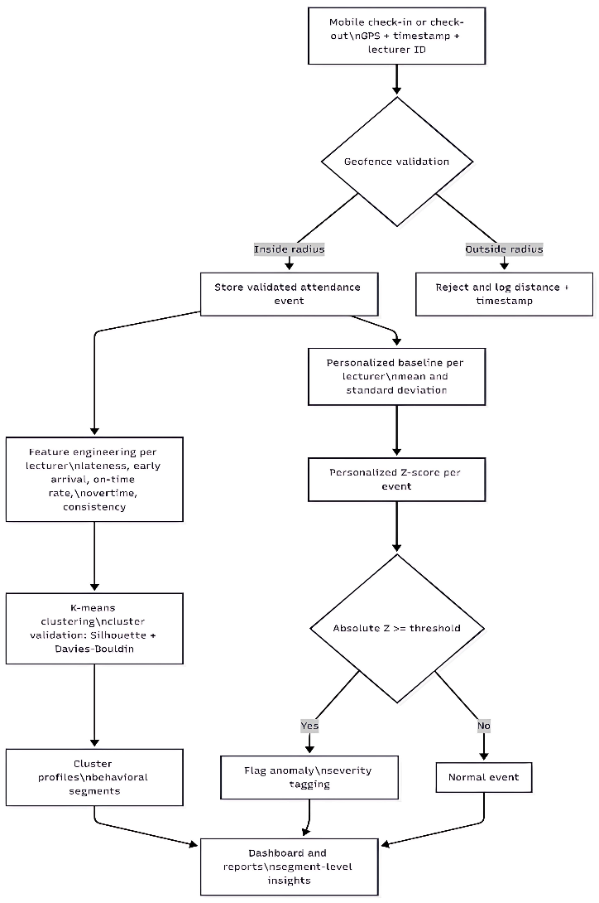
Figure 1. Triple-layer attendance analytics pipeline for lecturer attendance at FSTT ISTN (SI and TI)

This flowchart shows how raw GPS attendance events are first validated by geofencing, then enriched into (1) lecturer segments via clustering and (2) individualized anomaly alerts via personalized Z-scores, producing actionable outputs rather than only raw attendance logs.

Prior studies on GPS-based attendance consistently show that location validation is practical, especially when combined with complementary verification signals. A smartphone-based design that integrates GPS with NFC demonstrates how multi-modal verification can improve reliability and reduce fraudulent attendance, although accuracy can degrade when GPS signal quality is poor in indoor settings [3]. Geofencing strengthened with timing constraints and additional checks, such as face recognition, can further reduce behaviors like checking in and leaving early, but the added computation and operational overhead raises scalability concerns for broader deployments [4]. In educational implementations, geofencing systems combined with real-time reporting improve transparency and administrative efficiency, yet they also face boundary-policy challenges when legitimate work occurs outside the predefined zone [6]. University deployments built on geolocation APIs show that institutional integration is feasible, but they highlight practical risks such as battery consumption and privacy concerns that must be managed through system design and governance [5]. Because GPS spoofing and attendance fraud remain realistic threats, defense-in-depth approaches that add dynamic QR codes and device identity checks can significantly strengthen integrity, although they also increase implementation complexity [8].
For behavioral segmentation, clustering research supports K-means as an efficient and interpretable method for grouping individuals by multi-dimensional behavior, which makes it suitable for attendance behavior profiling when features are engineered appropriately [9],[10]. However, selecting the number of clusters is a central methodological decision. Comparative studies indicate that cluster selection should not rely on a single heuristic, because results can vary by dataset characteristics and objectives [13]. Recent critiques emphasize that the Elbow method can be subjective and should be treated cautiously, while validation metrics such as the Silhouette coefficient and the Davies-Bouldin Index provide more defensible evidence of cluster structure and separation [11],[12],[14]. This implies that attendance segmentation should apply K-means with explicit multi-metric validation so that clusters represent meaningful behavioral groups rather than artifacts of a convenient K choice. For anomaly detection, foundational surveys clarify that anomaly detection methods can be statistical, classification-based, or clustering-based, and that method choice should consider interpretability, computational cost, and deployment context[15]. Classical Z-score methods are attractive for operational systems because they are transparent and easy to compute, but they can be fragile when data contain outliers or are non-normal, motivating robust outlier handling guidance and robust scale estimators[17], [18],[19]. In workplace monitoring contexts, evidence also indicates that monitoring effects depend on how monitoring is framed and implemented, and acceptance is influenced by perceived control and clarity of purpose, which makes fairer analytics designs and communication strategies essential when deploying attendance intelligence [20],[21].

- RESEARCH METHOD
This study uses a quantitative experimental design aligned with design science research, where the core output is a validated technological artifact: an integrated GPS-based attendance analytics system for lecturer attendance at FSTT ISTN (SI and TI). The purpose is to design, implement, and evaluate a system that not only validates attendance via location but also produces behavioral intelligence through clustering and anomaly detection [24]. The operational dataset covers September 2024 to December 2025 and includes 13 active lecturer users with 4,300 attendance events.
The research is executed in five sequential phases: (1) requirements analysis and system design based on the research gaps, (2) data collection and preprocessing from the operational attendance platform, (3) analytics implementation using a triple-layer pipeline that includes spatial validation, clustering, and personalized anomaly detection, (4) experimental evaluation using clustering validity metrics and anomaly statistics, and (5) interpretation and validation against the study objectives to generate practical recommendations [24]. Figure 1 summarizes this workflow.
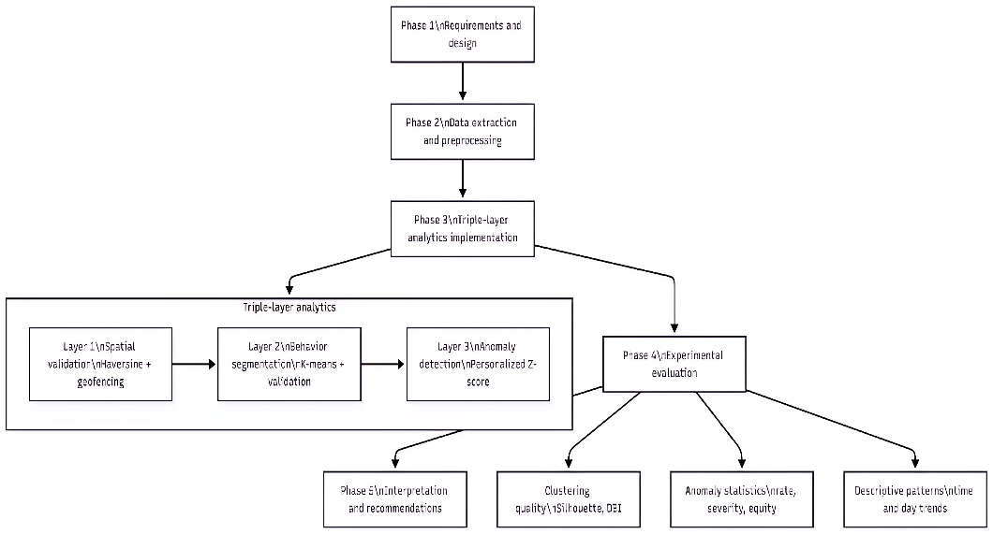
Figure 2. Research workflow and evaluation pipeline

The workflow starts from design requirements, continues through data preparation, implements the three analytics layers, and evaluates outputs using clustering validation and anomaly statistics to support practical recommendations.

3.1. Dataset, setting, and implementation environment
Attendance logs were collected from the lecturer attendance process at FSTT ISTN (SI and TI), spanning September 2024 to December 2025, totaling 484 calendar days and 4,300 attendance events from 13 active lecturers. Lecturer identities are anonymized using codes L01 to L13 to reduce privacy risk while enabling per-user baselines and comparisons. The system stack is implemented with a web backend, relational database storage, and an analytics engine in Python for clustering and anomaly calculations using standard numerical and machine learning libraries.

Table 1. Dataset characteristics (lecturer attendance at FSTT ISTN SI and TI)
Attribute | Value
Observation period | September 2024 to December 2025
Total duration | 484 days
Total attendance events | 4,300
Active users | 13 lecturers (L01 to L13)
Attendance event type | Check-in and check-out pairs
Reference coordinates | -6.2728, 106.8652
Geofencing radius | 100 meters
Operating days | Monday to Saturday
The dataset is a complete operational log after preprocessing, enabling distance validation, feature engineering per lecturer, and per-lecturer baseline modeling.

3.2. Triple-layer analytics formalism
3.2.1. Spatial validation using Haversine distance and geofencing
Spatial validation compares a lecturer’s GPS coordinate at check-in or check-out to the institutional reference coordinate. The distance between two latitude-longitude points is computed using the Haversine formula, which is stable and widely used for short-range geodesic distance estimation [25].
Let $P_{1}=(ϕ_{1},λ_{1})$and $P_{2}=(ϕ_{2},λ_{2})$, where latitude $ϕ$and longitude $λ$are in radians:

$a={sin⁡}^{2}\left(\frac{Δϕ}{2}\right)+cos⁡(ϕ_{1})cos⁡(ϕ_{2}){sin⁡}^{2}\left(\frac{Δλ}{2}\right)$ (1)$c=2arctan⁡2(\sqrt{a},\sqrt{1-a})$ $d=R⋅c$
where $Δϕ=ϕ_{2}-ϕ_{1}$, $Δλ=λ_{2}-λ_{1}$, and $R$is Earth’s mean radius (Sinnott, 1984). A geofence validation function is defined as:

$V\left(P_{emp},P_{ref},r\right)=\left\{\begin{matrix}1, & \text{if }d\left(P_{emp},P_{ref}\right)≤r \\ 0, & \text{otherwise}\end{matrix}\right.$ (2)

Attendance is accepted only if $V=1$. In this study, the configured radius is 100 meters, intended to support building-level validation while remaining tolerant to normal GPS noise.

3.2.2. Behavioral segmentation using K-means and cluster validation
After spatial validation, attendance events are aggregated per lecturer and transformed into a multi-dimensional feature vector. Segmentation is performed using K-means clustering, which minimizes within-cluster dispersion and remains a common baseline due to its simplicity and interpretability [9],[10].
Given $X=\{x_{1},…,x_{n}\}$where $x_{i}∈R^{m}$, K-means minimizes:

$J =\sum_{k=1}^{K}{\sum_{x_{i}∈C_{k}}{∥}}x_{i}-μ_{k}∥^{2}$ (3)

where C_kis cluster kand μ_kis its centroid [9]. Because WCSS decreases as Kincreases, cluster validity is assessed using complementary metrics rather than relying on a single heuristic. The Silhouette coefficient evaluates cohesion and separation [12], while the Davies-Bouldin Index (DBI) evaluates within-cluster scatter relative to between-cluster separation, where lower values indicate better separation [11]. The Elbow method is used only as a supporting heuristic because it can be subjective, and validity should be confirmed with Silhouette and DBI [14],. Silhouette for point iis:

$s\left(i\right)=\frac{b\left(i\right)-a\left(i\right)}{\max\left(a\left(i\right),b\left(i\right)\right)}$ (4)

where $a(i)$is average intra-cluster distance and $b(i)$is the smallest average distance to other clusters [12]. Interpretation guidelines for mean Silhouette are commonly described as strong when above 0.70, reasonable around 0.50 to 0.70, weak around 0.25 to 0.50, and poor below 0.25 [26].

3.2.3. Behavioral segmentation using K-means and cluster validation
Anomaly detection identifies deviations from expected attendance behavior. Classical Z-scores standardize values using population mean and standard deviation, but this can be unfair in heterogeneous groups because it ignores individual baselines [15]. To address this, the method uses personalized Z-scores, computing a baseline for each lecturer $i$from their own historical behavior:

Classical Z-score:

$Z=\frac{x-μ}{σ}$ (5)

Personalized Z-score:

$Z=Z_{i}(x)=\frac{x-μ_{i}}{σ_{i}}$ (6)

where $μ_{i}$and $σ_{i}$are the lecturer-specific historical mean and standard deviation [17]. An event is flagged as anomalous when:

$∣Z_{i}(x)∣≥τ$ (7)

This study uses $τ=2.0$, which provides a practical balance between sensitivity and false positives under approximate normality assumptions. If the data are strongly non-normal or contain heavy tails, robust alternatives such as modified Z-score variants can be considered [17],[18],[19]. For operational time series anomaly detection, selection and validation of methods should also consider empirical evaluation practices discussed in the anomaly detection literature [16].
Severity labeling is applied for prioritization:

- Medium severity if $2.0≤∣Z_{i}∣<3.0$
- High severity if $∣Z_{i}∣≥3.0$

A lateness value can be ordinary for one lecturer but highly unusual for another. Personalized baselines help ensure that flagged anomalies represent change relative to the lecturer’s own historical pattern rather than deviation from the group average [15],[17].

    - Feature engineering and normalization

Five engineered features summarize lecturer attendance behavior using aggregated attendance events. These features are designed to jointly represent punctuality, proactivity, commitment, and stability.

Table 2. Feature definitions for clustering (per lecturer i)
Feature | Symbol | Definition | Unit | Behavioral meaning
Average lateness | $${\overset{ˉ}{L}}_{i}$$ | mean of lateness minutes across events | minutes | central tardiness tendency
Average early arrival | $${\overset{ˉ}{E}}_{i}$$ | mean of early arrival minutes across events | minutes | proactive arrival behavior
On-time percentage | $$P_{i}^{OT}$$ | count (lateness = 0) / total events x 100 | percent | punctuality rate
Average overtime | $${\overset{ˉ}{O}}_{i}$$ | mean overtime minutes across events | minutes | commitment indicator
Attendance consistency | $$C_{i}$$ | $$1-σ(L_{i})/({\overset{ˉ}{L}}_{i}+1)$$ | ratio | behavioral stability
These features produce one vector per lecturer, allowing clustering over lecturers rather than over individual events. The +1 term prevents division by zero when mean lateness equals zero.
Before clustering, Min-Max normalization is applied to each feature to avoid dominance by scale:

$x_{ij}^{'}=\frac{x_{ij}-min⁡(x_{j})}{max⁡(x_{j})-min⁡(x_{j})}$ (8)

This ensures each feature contributes comparably to Euclidean distance in K-means [9].

    - System architecture and processing procedures

The integrated system is organized as a pipeline that begins with mobile GPS capture and ends with analytics outputs. Spatial validation occurs at submission time, clustering runs as a periodic batch process, and anomaly detection can run near real-time per incoming event depending on system load and policy.

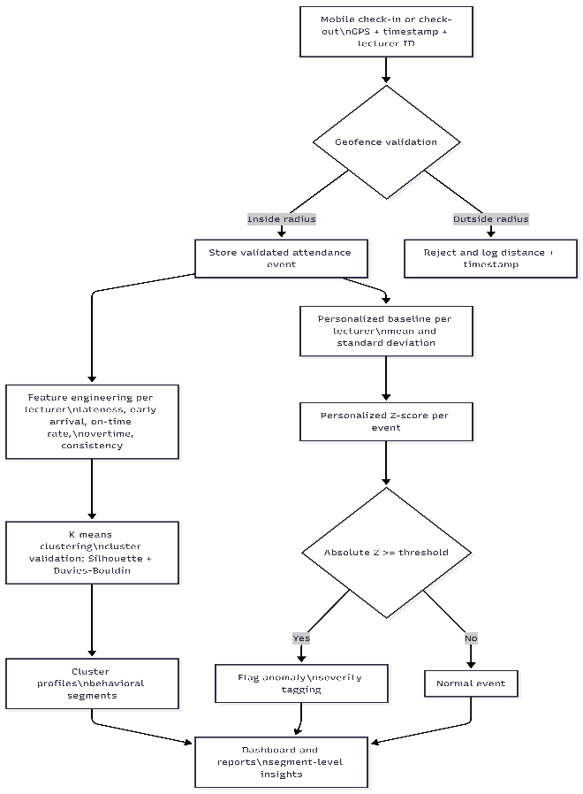
Figure 3. Triple-layer system architecture (GAAS-TLI)

Attendance events are first validated by geofencing. Validated records feed two analytic paths: periodic segmentation via K-means and per-event anomaly detection using personalized Z-scores.

    - Experimental evaluation and baseline comparison

Evaluation is performed at three levels. Spatial validation is assessed through validation rate and distribution of computed distances from the reference location. Clustering is evaluated using WCSS for sensitivity analysis and validated using Silhouette and DBI to support a defensible selection of $K$ [11], [12], [14],[13]. Anomaly detection is evaluated using detection rate, severity distribution, and cross-user equity statistics to verify that personalized baselines reduce bias that can arise under population-level thresholds [15], [17].
A baseline comparison is conducted between a population Z-score and the proposed personalized Z-score:

Population baseline:

$Z_{pop}(x)=\frac{x-μ_{pop}}{σ_{pop}}$ $(9)$
Personalized method:

$Z_{i}(x)=\frac{x-μ_{i}}{σ_{i}}$ $(10)$
The comparison focuses on three criteria: (1) fairness across lecturers with different baseline punctuality patterns, (2) precision of anomaly flags as indicators of meaningful behavioral change, and (3) discrimination power to detect deviations among high-performing lecturers who might be missed by a high population threshold. If you want, I can also rewrite the next part of your Methods section to remove long pseudocode blocks while preserving algorithmic clarity by converting them into compact step lists and a single consolidated algorithm box.

- RESULTS AND ANALYSIS
This section reports empirical findings from the triple-layer analytics implementation on lecturer attendance data at FSTT ISTN (SI and TI programs). Results are presented in the same analytical order as the pipeline: descriptive statistics, clustering outcomes, anomaly detection, and integrated discussion.

3.1. Descriptive Statistical Findings
Across 4,300 attendance events, lateness shows a right-skewed distribution where the median is substantially lower than the mean, indicating occasional extreme late arrivals rather than uniform tardiness. Early arrivals are also common, suggesting many lecturers arrive before schedule. Work duration is generally aligned with expected working time, while overtime appears episodic and varies across days.

Table 3. Aggregate Attendance Statistics (N = 4,300 events)
Metric | Mean | Std Dev | Min | Q1 | Median | Q3 | Max
Lateness (min) | 8.47 | 12.83 | 0 | 0 | 3 | 12 | 87
Early arrival (min) | 11.24 | 14.67 | 0 | 0 | 6 | 18 | 62
Work duration (min) | 498.32 | 47.26 | 361 | 472 | 502 | 528 | 612
Overtime (min) | 18.45 | 23.18 | 0 | 0 | 8 | 31 | 132
Substantial inter-individual variation was observed across lecturers, supporting the methodological need for personalized baselines. High performing profiles show low lateness, high on-time rates, stronger early arrival behavior, and higher consistency, while other profiles exhibit systematic lateness and lower consistency.

Table 4. Individual Lecturer Attendance Profiles (N = 13 lecturers)
ID | Records | Avg Lateness | Avg Early | On-Time (%) | Avg Overtime | Consistency
A001 | 341 | 2.14 | 18.42 | 78.3 | 24.17 | 0.847
A002 | 329 | 15.87 | 4.21 | 42.6 | 8.93 | 0.623
A003 | 412 | 4.56 | 14.33 | 71.4 | 31.28 | 0.792
A004 | 298 | 22.34 | 2.08 | 28.5 | 5.42 | 0.534
A005 | 356 | 6.78 | 12.67 | 65.2 | 22.14 | 0.756
A006 | 312 | 3.21 | 21.54 | 82.1 | 28.63 | 0.868
A007 | 287 | 18.93 | 3.45 | 35.9 | 7.21 | 0.587
A008 | 367 | 5.12 | 15.89 | 69.8 | 19.47 | 0.781
A009 | 334 | 11.45 | 7.82 | 51.3 | 14.36 | 0.692
A010 | 301 | 7.23 | 10.94 | 62.8 | 17.82 | 0.734
A011 | 352 | 2.87 | 19.76 | 79.5 | 26.41 | 0.854
A012 | 284 | 14.23 | 5.67 | 45.4 | 10.28 | 0.645
A013 | 327 | 9.34 | 9.23 | 55.7 | 15.73 | 0.712

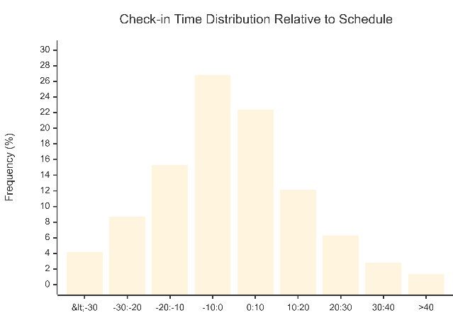
Figure 4. Check-in Time Distribution Relative to Schedule

Most check-ins cluster around slightly early to on-time windows, but a non-trivial portion shows significant lateness, consistent with the skew seen in aggregate statistics.

Day-of-week analysis indicates systematic variation. Monday shows the highest lateness and lowest on-time rate, while Saturday shows the best punctuality and relatively high overtime, suggesting different scheduling and workload dynamics across the week.

Table 5. Attendance Metrics by Day
Day | Avg  Lateness | On-Time (%) | Avg Overtime | Records
Monday | 10.23 | 54.2 | 16.34 | 743
Tuesday | 7.84 | 63.7 | 19.21 | 756
Wednesday | 7.12 | 66.4 | 20.87 | 761
Thursday | 8.45 | 61.8 | 18.93 | 752
Friday | 9.67 | 57.3 | 14.56 | 738
Saturday | 6.34 | 71.2 | 22.45 | 550

3.2. K-Means Clustering Results
Cluster validation metrics were computed for K from 2 to 6 using WCSS, Silhouette Score, and DBI. The three metrics converged on K = 3, consistent with recommendations to avoid relying solely on elbow selection [14]. The maximum Silhouette Score at K = 3 indicates the best balance of cohesion and separation [12], and the minimum DBI at K = 3 indicates strong cluster separability [11].

Table 6. Cluster Validation Metrics
K | WCSS | Silhouette | DBI
2 | 8.234 | 0.512 | 0.876
3 | 4.127 | 0.634 | 0.621
4 | 2.891 | 0.587 | 0.698
5 | 2.156 | 0.523 | 0.754
6 | 1.687 | 0.478 | 0.812
The final clustering produced three interpretable lecturer attendance segments. Cluster 1 represents high performers with minimal lateness, strong punctuality, and strong consistency. Cluster 2 represents moderate profiles with acceptable but not exceptional punctuality. Cluster 3 captures lecturers requiring attendance improvement, with higher lateness, lower on-time rates, limited early arrival, and weaker consistency. Using clustering for behavioral segmentation supports HR analytics goals of evidence-based differentiation rather than uniform interventions [1],[2].

Table 7. Cluster Profiles (K = 3)
Attribute | Cluster 1 High Performers | Cluster 2 Moderate | Cluster 3 Improvement Needed
Size | 4 (30.8%) | 5 (38.5%) | 4 (30.8%)
Members | A001, A006, A008, A011 | A003, A005, A009, A010, A013 | A002, A004, A007, A012
Avg lateness (min) | 3.34 | 7.87s | 17.84
Avg early arrival (min) | 18.90 | 10.98 | 3.85
On-time (%) | 77.4 | 61.3 | 38.1
Avgovertime (min) | 24.67 | 17.90 | 7.96
Consistency | 0.838 | 0.739 | 0.597

3.3. Anomaly Detection Results
Personalized baseline parameters varied widely across lecturers, meaning a uniform population threshold would be misaligned for many individuals. This directly supports the fairness rationale for individual baselines, because identical lateness values can represent very different deviations depending on the lecturer’s normal pattern [21]. The anomaly threshold upper bound ranges from 9.88 minutes for A001 to 51.68 minutes for A004, indicating that population level thresholds would under-detect deviations for consistently punctual lecturers and over-flag lecturers with chronically high lateness.

Table 8. Personalized Baseline Parameters
ID | Mean  lateness $μ_{i}$ | Std dev  $$σ_{i}$$ | Upper bound $$μ_{i}+2σ_{i}$$
A001 | 2.14 | 3.87 | 9.88
A002 | 15.87 | 11.24 | 38.35
A003 | 4.56 | 5.23 | 15.02
A004 | 22.34 | 14.67 | 51.68
A005 | 6.78 | 6.45 | 19.68
A006 | 3.21 | 4.12 | 11.45
A007 | 18.93 | 12.56 | 44.05
A008 | 5.12 | 5.78 | 16.68
A009 | 11.45 | 8.93 | 29.31
A010 | 7.23 | 6.87 | 20.97
A011 | 2.87 | 4.02 | 10.91
A012 | 14.23 | 10.45 | 35.13
A013 | 9.34 | 7.56 | 24.46
Applying personalized Z-Score with threshold 2.0 identified 187 anomalous events (4.35%). This aligns with the theoretical expectation of roughly 4.55% beyond ±2 standard deviations under a normal assumption, while still allowing for real data deviations[15]. Most anomalies were medium severity, while a smaller portion were high severity.

Table 9. Anomaly Detection Outcomes by Lecturer
ID | Records | Anomalies | Rate (%) | Medium | High
A001 | 341 | 18 | 5.28 | 14 | 4
A002 | 329 | 12 | 3.65 | 9 | 3
A003 | 412 | 21 | 5.10 | 17 | 4
A004 | 298 | 11 | 3.69 | 8 | 3
A005 | 356 | 16 | 4.49 | 13 | 3
A006 | 312 | 15 | 4.81 | 11 | 4
A007 | 287 | 10 | 3.48 | 7 | 3
A008 | 367 | 17 | 4.63 | 14 | 3
A009 | 334 | 13 | 3.89 | 10 | 3
A010 | 301 | 14 | 4.65 | 11 | 3
A011 | 352 | 16 | 4.55 | 12 | 4
A012 | 284 | 11 | 3.87 | 8 | 3
A013 | 327 | 13 | 3.98 | 10 | 3
Total | 4,300 | 187 | 4.35 | 144 | 43
A comparison with population-based Z-Score shows that personalization detects more meaningful anomalies for high performers while reducing excessive flags among chronically late profiles. This supports the fairness argument that monitoring should be sensitive to individual baselines rather than enforcing uniform norms [21]. Robust outlier handling considerations remain important, as mean and standard deviation can be influenced by extreme values [17], and recent studies show that alternative estimators may improve robustness in non-normal time series[18],[19].

Table 10. Personalized vs Population Based Anomaly Detection
Metric | Personalized | Population | Difference
Total anomalies | 187 | 156 | +31 (19.9%)
Detection rate | 4.35% | 3.63% | +0.72%
High performers anomalies | 66 | 23 | +43
Moderate anomalies | 77 | 68 | +9
Improvement needed anomalies | 44 | 65 | -21

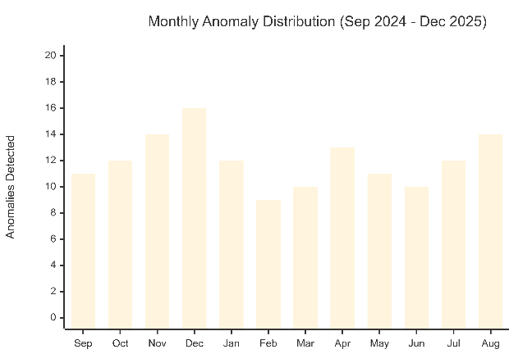
Figure 5. Monthly Anomaly Distribution (Sep 2024 to Dec 2025)

Anomalies peak around end-of-semester periods, consistent with workload intensity patterns in academic operations. Representative cases demonstrate why personalization matters. For example, a lateness of 18 to 21 minutes may be statistically extreme for a typically punctual lecturer but appear ordinary under a population threshold. Conversely, a very late arrival for a chronically late lecturer may be less anomalous relative to their baseline. This aligns with the general principle that anomaly detection should reflect deviation from expected behavior, not only absolute magnitude [15].

3.4. Integrated Discussion
Three integrated insights emerge. First, K-Means produced meaningful segmentation with strong validation metrics (Silhouette 0.634, DBI 0.621), demonstrating that objective attendance features can support interpretable behavioral grouping, consistent with HR analytics emphasis on evidence-based workforce insights [1],[2]. Second, personalized anomaly detection improved equity by evaluating each lecturer relative to their own baseline, matching fairness considerations in electronic monitoring research that warn against one-size-fits-all interpretations [21]. Third, the triple-layer integration creates richer operational intelligence than any single component: spatial validation protects data integrity, clustering contextualizes lecturer profiles, and anomaly detection provides early warning signals for deviations that may reflect workload pressures or changing engagement patterns [24].

- CONCLUSION
This study developed and evaluated a GPS-based Attendance Analytics System with Triple-Layer Intelligence (GAAS-TLI) for lecturer attendance at FSTT ISTN in the SI and TI programs. The system was assessed using operational attendance data from September 2024 to December 2025, consisting of 4,300 attendance events from 13 active lecturers. The proposed approach demonstrates that a GPS-based attendance system can be expanded beyond basic presence validation into an analytics-driven decision support tool. The first key outcome is that behavioral segmentation using K-Means clustering produced three interpretable lecturer groups. These segments provide a practical basis for differentiated attendance management, because the system can distinguish consistently punctual profiles from moderate profiles and profiles requiring improvement, rather than applying a uniform treatment to all lecturers.
The second key outcome is that personalized anomaly detection improves the relevance and fairness of alerts. By evaluating each lecturer against their own historical baseline, the system detects meaningful deviations for high-performing lecturers that would often be missed by a single population threshold, while reducing excessive alerts for lecturers whose typical patterns differ from the institutional average. In this evaluation, anomaly detection produced a stable detection rate and helped distribute alerts more evenly across lecturers. The third key outcome is the added value of integrating the three layers into one workflow. Spatial validation ensures data integrity, clustering provides context about typical lecturer behavior, and anomaly detection highlights changes that may require follow-up. When these components are combined, decision makers can interpret anomalies within the lecturer’s behavioral profile, enabling more appropriate responses than a one-size-fits-all policy.
Overall, the GAAS-TLI framework shows that lecturer attendance monitoring can be implemented as a structured intelligence pipeline that supports transparency, operational control, and targeted improvement actions. Future work should validate the approach on larger and more diverse datasets, explore adaptive baselines to capture seasonal academic patterns, and evaluate how analytics-driven interventions influence attendance outcomes over time.

REFERENCES

- J. H. Marler and J. W. Boudreau, "An evidence-based review of HR analytics," The International Journal of Human Resource Management, vol. 28, no. 1, pp. 3-26, 2017.
- T. W. Chiang, C. Y. Yang, G. J. Chiou, F. Y. S. Lin, Y. N. Lin, V. R. Shen, and C. Y. Lin, "Development and evaluation of an attendance tracking system using smartphones with GPS and NFC," Applied Artificial Intelligence, vol. 36, no. 1, p. 2083796, 2022.
- A. O. Babatunde, R. S. Babatunde, and A. A. Oke, "Mobile based student attendance system using geo-fencing with timing and face recognition," Jordan Journal of Electrical Engineering, vol. 10, no. 1, pp. 1-15, 2022.
- A. Tursunbayeva, S. Di Lauro, and C. Pagliari, "People analytics—A scoping review of conceptual boundaries and value propositions," International Journal of Information Management, vol. 43, pp. 224-247, 2018.
- K. Ekuma, "Artificial intelligence and automation in human resource development: A systematic review," Human Resource Development Review, vol. 23, no. 1, pp. 88-119, 2024.
- H. Soko and F. Chatola, "Attendance tracking system using geofencing," i-manager's Journal on Information Technology, vol. 13, no. 1, pp. 22-27, 2024.
- G. A. Fischer, V. Ojong, and E. Inameti, "Design and implementation of a university smart attendance tracking system using geo-location," Journal of Computer Science and Technology, vol. 1, no. 1, pp. 75-80, 2024.
- A. Nwabuwe, B. Sanghera, T. Alade, and F. Olajide, "Fraud mitigation in attendance monitoring systems using dynamic QR code, geofencing and IMEI technologies," International Journal of Advanced Computer Science and Applications, vol. 14, no. 4, pp. 938-945, 2023.
- K. R. Shahapure and C. Nicholas, "Cluster quality analysis using silhouette score," in 2020 IEEE 7th International Conference on Data Science and Advanced Analytics (DSAA), 2020, pp. 747-748.
- C. Yuan and H. Yang, "Research on K-value selection method of K-means clustering algorithm," J Multidisciplinary Scientific Journal, vol. 2, no. 2, pp. 226-235, 2019.
- E. Schubert, "Stop using the elbow criterion for k-means and how to choose the number of clusters instead," ACM SIGKDD Explorations Newsletter, vol. 25, no. 1, pp. 36-42, 2023.
- P. J. Rousseeuw, "Silhouettes: A graphical aid to the interpretation and validation of cluster analysis," Journal of Computational and Applied Mathematics, vol. 20, pp. 53-65, 1987.
- D. L. Davies and D. W. Bouldin, "A cluster separation measure," IEEE Transactions on Pattern Analysis and Machine Intelligence, vol. PAMI-1, no. 2, pp. 224-227, 1979.
- S. Chowdhury, P. Dey, S. Joel-Edgar, S. Bhattacharya, O. Rodriguez-Espindola, A. Abadie, and L. Truong, "Unlocking the value of artificial intelligence in human resource management through AI capability framework," Human Resource Management Review, vol. 33, no. 1, p. 100899, 2023.
- V. Chandola, A. Banerjee, and V. Kumar, "Anomaly detection: A survey," ACM Computing Surveys, vol. 41, no. 3, pp. 1-58, 2009.
- B. Iglewicz and D. C. Hoaglin, How to Detect and Handle Outliers. Milwaukee, WI: ASQC Quality Press, 1993.
- A. S. Yaro, F. Maly, and P. Prazak, "Outlier detection in time-series receive signal strength observation using Z-score method with Sn scale estimator for indoor localization," Applied Sciences, vol. 13, no. 6, p. 3900, 2023.
- A. S. Yaro, F. Maly, and P. Prazak, "Outlier detection performance of a modified Z-score method in time-series RSS observation with hybrid scale estimators," IEEE Access, vol. 12, pp. 15234-15245, 2024.
- D. M. Ravid, D. L. Tomczak, J. C. White, and T. S. Behrend, "A meta-analysis of the effects of electronic performance monitoring on work outcomes," Personnel Psychology, vol. 76, no. 1, pp. 5-40, 2023.
- L. Kaufman and P. J. Rousseeuw, Finding Groups in Data: An Introduction to Cluster Analysis. New York: Wiley, 1990.
- J. MacQueen, "Some methods for classification and analysis of multivariate observations," in Proceedings of the Fifth Berkeley Symposium on Mathematical Statistics and Probability, vol. 1, 1967, pp. 281-297.
- R. W. Sinnott, "Virtues of the Haversine," Sky and Telescope, vol. 68, no. 2, p. 159, 1984.
- S. Schmidl, P. Wenig, and T. Papenbrock, "Anomaly detection in time series: A comprehensive evaluation," Proceedings of the VLDB Endowment, vol. 15, no. 9, pp. 1779-1797, 2022.
- P. Glavin, A. Bierman, and S. Schieman, "Private eyes, they see your every move: Workplace surveillance and worker well-being," Social Currents, vol. 11, no. 4, pp. 327-345, 2024.
- C. E. Thiel, A. E. MacDougall, and Z. Bagdasarov, "Electronic performance monitoring in the digital workplace: Conceptualization, review of effects and moderators, and future research opportunities," Frontiers in Psychology, vol. 12, p. 633031, 2023.
- M. Abraham, C. Niessen, C. Schnabel, K. Lorek, V. Grimm, K. Möslein, and M. Wrede, "Electronic monitoring at work: The role of attitudes, functions, and perceived control for the acceptance of tracking technologies," Human Resource Management Journal, vol. 29, no. 4, pp. 657-675, 2019.

BIBLIOGRAPHY OF AUTHORS

 | I am a Computer Engineer and I have experience in C Programming Language and Networking field. My key technical skills include C, Web Design (HTML5, CSS3, Bootstrap), Application Development (Windows Server) as well as database management system like Linux Server 2012. My core competency in IT infrastructure including installation and configuration of computer systems and softwares. Also I possess excellent leadership qualities which allow me to lead and manage the team with different attitudes and cultures across levels effectively
 | I am a graduate with a Master’s degree in Computer Science from Nusa Mandiri University, with expertise in Data Mining and Computer Vision. Currently, I am active as an Instructor and IT Consultant at LP2M ARAY, specializing in programming-based development, including PHP Native, Frameworks (CodeIgniter and Laravel), Android Mobile Development, and Python (Flask and Streamlit).

