Development of a Mental Health Identification

Pattern Model for Generation Z with Random Forest, SVM, and Logistic Regression Approaches

¹Sri Retnowati, ²Siti Aisyah
^{1,2}Data Science Program Study, Universitas Insan Cita Indonesia
Email: ¹sriretnowati919@gmail.com, ²aisyah.uici@gmail.com

Article Info |  | ABSTRACT
Article history:  Received May 12th, 2019  Revised Jun 20th, 2020  Accepted Jul 26th, 2020 |  | Mental health issues such as stress, anxiety, and trauma have become significant challenges, particularly among Generation Z. The lack of effective early detection tools has hindered efforts to address these problems promptly and accurately. This study aims to develop a machine learning-based classification model to detect potential mental health conditions using standardized psychological instruments: DASS-21, STAI, and ACE. Data was collected from 733 youth aged 17–24, with 212 participants showing signs of risk. After cleaning and preprocessing, 58 features were retained from an initial 92. Several machine learning models—Logistic Regression, Support Vector Machine (SVM), and Random Forest—were tested using class balancing techniques such as SMOTE and class weighting. Evaluation metrics included accuracy, recall, precision, F1-score, and ROC AUC. Logistic Regression achieved the highest performance, with 94% accuracy, 100% recall, 82% precision, and an F1-score of 0.90. The ROC AUC reached 99.5%, indicating excellent discriminative power. This research highlights the effectiveness of machine learning in providing early detection of mental health conditions and supports its integration into scalable, technology-based mental health screening tools, especially for youth populations at risk.
Keyword:
Mental
Generation Z
Random Forest
SVM
Logistic Regression

 |  | Copyright © 2022 Puzzle Research Data Technology
Corresponding Author: (10 pt)
Third Author,
Departement of Electrical and Computer Engineering,
National Chung Cheng University,
168 University Road, Minhsiung Township, Chiayi County 62102, Taiwan, ROC.
Email: thirdauthor@uin-suska.ac.id
DOI: http://dx.doi.org/10.24014/ijaidm.v2i2.xxxx (10 pt)

- INTRODUCTION
Mental illness is one of the most pressing global health issues in the modern era. More than 300 million people, or about 4.4% of the world's population, struggle with depression [1]. A recent survey from Indonesia National Adolescent Mental Health Survey (I-NAMHS) found that around 5.5% of adolescents aged 10-17 years were diagnosed with a mental disorder in the past 12 months, while around one-third had at least one mental health problem [2]. Indonesia's population at the end of 2022 reached 277.75 million, with a dominant adolescent age group. This group falls into the category of adolescents and productive age [3]. In the Indonesian context, the population is dominated by Generation Z, which is at high risk of experiencing mental health problems due to increasingly complex academic, social, and digital environmental pressures [4].
However, despite the growing recognition of the importance of addressing the mental health of this generation, traditional approaches to handling mental health issues are often ineffective and insufficiently responsive to contemporary developments. One of the main obstacles is the lack of objective and efficient detection tools to identify mental health disorders in Generation Z at an early stage. Therefore, innovative solutions are needed that can provide more accurate and faster results. The big data-based approach with a machine learning classification model is a solution for detecting mental health problems in the younger generation in real time. Methods such as Random Forest, Support Vector Machine (SVM), and Logistic Regression are used in this study, which aims to develop a model that can analyze mental health data that is more accurate and faster regarding a person's mental health condition. Based on the research results, in the initial stage, 523 respondent data were collected, but only 2 (0.38%) were at risk, resulting in a very unbalanced class distribution. The data was then increased to 733 with 212 respondents at risk (≈30%), making it more representative. Of the 92 variables, after cleaning and feature selection, 58 variables remained.
Three algorithms were used: Logistic Regression, SVM, and Random Forest with SMOTE and class_weight techniques to overcome the imbalance. The test results showed an accuracy of 93–94%, recall of 100%, and an F1 Score of 0.90. Logistic Regression was chosen as the best model because it balanced accuracy, stability, and complexity.
Mental illnesses such as stress, trauma, and anxiety are the highest factors that damage mental health. Stress measurements and heart rate variability (HRV) metrics were used to evaluate changes in psychological stress [5]. A meta-analysis and literature review were conducted to determine the relationship between stress and heart rate variability (HRV) as an indicator of psychological stress [6]. Mental health disorders such as stress, trauma, and anxiety are also serious and growing problems, especially among Generation Z. Various factors such as academic pressure, economic uncertainty, and high exposure to social media cause high levels of stress and anxiety among adolescents and young adults [7]. This situation is exacerbated by limited access to mental health services, a shortage of professionals, and the persistent stigma surrounding those with psychological disorders. Data from the Sample Registration System compiled by the National Institute of Health Research and Development in 2016 revealed that approximately 1,800 people commit suicide each year, highlighting the urgency for a more systematic approach to addressing this issue. Various approaches have been developed, one of which uses Artificial Intelligence (AI) such as chatbots and machine learning algorithms to predict mental disorders [8], [9], [10], and [11].
However, the main problem faced in identifying mental health conditions in Generation Z is the limitation in early detection. Conventional methods such as standard questionnaires are often not accurate enough, besides that the factors that affect the mental health of this generation are very diverse and difficult to measure using traditional approaches. In this era of digitalization, data technology can provide a more effective solution. One approach that can be used is machine learning, which can analyze large data sets to identify patterns that may not be easily visible to humans. Herefore, the Random Forest, Support Vector Machine (SVM), and Logistic Regression approaches were chosen for their ability to handle complex data and provide more accurate diagnoses. Therefore, approaches based on Random Forest, Support Vector Machine (SVM), and Logistic Regression were chosen for their ability to handle complex data and provide more accurate diagnoses.
This study aims to develop a machine learning model that can classify mental illnesses such as stress, trauma, and anxiety. One of the main issues to be addressed in this research is how machine learning models can effectively classify these mental conditions. In this regard, the research will explore the use of data that can help the model distinguish the symptoms of each mental illness. However, collecting accurate and representative data for model training also poses significant challenges, including limitations in obtaining valid personal data, as well as variations in how individuals express or show their symptoms. Furthermore, this research will also evaluate how accurately machine learning models can identify these mental conditions, taking into account various factors that can affect the level of accuracy, such as the quality and diversity of the data used.
This research is important for identifying mental health issues, particularly among Generation Z, by leveraging the sophistication of current technology, namely Machine Learning. Therefore, various Machine Learning algorithms were tested to predict students' mental well-being by exploring the use of health behavior data [12]. Furthermore, Machine Learning also helps improve healthcare services by focusing more on patient care rather than searching for or inputting information [13]. Patient mental health can be measured validly using several psychological measurement approaches with the Depression, Anxiety, and Stress Scale (DASS 21) questionnaire. The results of this measurement can describe an individual's mental health condition validly [14].

- RESEARCH METHOD
This study uses the Supervised Machine Learning classification model method, which has several stages. The stages of the study are shown in the Flowchart in Figure 1.
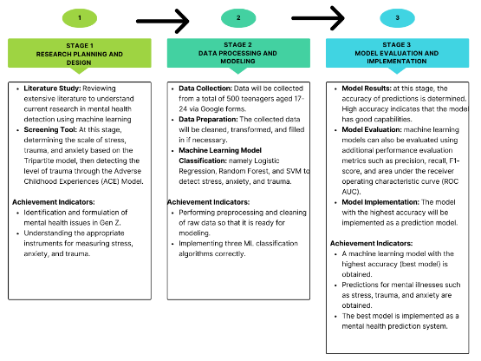
Figure 1. Research method diagram

Materials
Conducting an extensive literature review to understand the latest research in mental health detection using machine learning. The questionnaire measurement method using a valid instrument approach is described as follows:
    - The Depression, Anxiety, and Stress Scale - DASS-21 aims to assess and distinguish symptoms of anxiety and depression, based on the Tripartite Model [15],[16]. It consists of 21 items, with participants responding using a 4-point Likert scale. Regarding psychometric studies, the DASS 21 has been tested and confirmed, with adequate levels of internal consistency found for each factor [16].
    - Psychological Modeling to detect anxiety levels. The Spielberger State-Trait Anxiety Inventory (STAI) is a 40-item self-report measure of anxiety using a 4-point Likert-type scale for each item [18]. The total score for each scale ranges from 20 to 80, with higher scores indicating more severe anxiety levels. The 4-point scale for T anxiety is: 1) almost never, 2) sometimes, 3) often, 4) almost always [17].
    - Psychological Modeling to detect trauma levels through the Adverse Childhood Experiences (ACE) Model to evaluate negative experiences during childhood and their impact on physical and mental health in adulthood. The ACE questionnaire consists of 10 questions. The total score can range from 0 (no traumatic experiences) to 10 [18].

Participants
In collecting data, the author faced a major challenge, namely limitations in obtaining valid personal data and variations in the way individuals expressed or showed their symptoms. However, to overcome this problem, we conducted a direct survey of 500 young people aged 17-24. Each participant was then given three questionnaires to measure stress, anxiety, and trauma levels as tools to assess their symptoms. The collected data was structured in Excel format.

Tasks and Methods
A sub-section Methods should describe how materials are manipulated, how data are analyzed, which metrics are used, how measures and calculations are done, etc. When participants are involved in the experiments, Methods section may include two sub-sections: Tasks and Design and Analysis, Tasks section would include a description of what the participants did during the experiment. Design and Analysis would detail all that done by researchers.
    - Data Preparation
At this stage, the collected data is cleaned, then the text data will be transformed into numerical data (encoding). For empty data, data filling (imputation) will be carried out before the data is used by the model.
    - Machine Learning Model Development
The collected data will be analyzed using a machine learning model. Several machine learning models such as Logistic Regression, Random Forest, and Support Vector Machine (SVM) will be used to classify stress, anxiety, and trauma levels in this study. The following is an explanation of machine learning models: - Random Forest is a type of ensemble model consisting of several independent Decision Trees. Each Decision Tree is built using a random subset of the training data and a random subset of features. - Logistic Regression is a model that uses a logistic function to find a linear relationship between input variables and the probability that the target variable takes a certain value. – SVM is a model that will find a hyperplane with a feature space that separates as many target classes as possible with a maximum margin.
    - Model Results
One of the main aspects of machine learning model results is prediction accuracy [19]. High accuracy indicates that the model has a good ability to learn patterns from training data and apply them accurately to new data. Accuracy is calculated in equation (1).

$Acuitas=\frac{Number of correct predictions}{Total number of samples}×100\%$ (1)
    - Model Evaluation
In addition to accuracy, machine learning models are also evaluated using performance evaluation metrics such as precision, sensitivity (recall), specificity, F1 score, and area under the ROC curve AUC Curve and Confusion Matrix. In the confusion matrix above, there are four main cells shown in Figure 2.

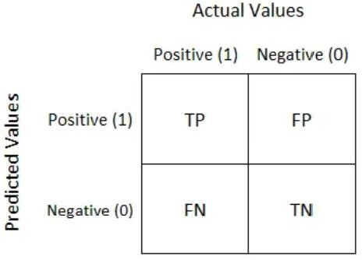

Figure 2. Confusion Matrix
Here is an explanation of the confusion matrix (evaluation matrix) above. True Positive (TP): The number of samples that are correctly predicted as positive by the model. False Negative (FN): The number of samples that are incorrectly predicted as negative by the model when they should be positive. False Positive (FP): The number of samples that are incorrectly predicted as positive by the model when they should be negative. True Negative (TN): The number of samples correctly predicted as negative by the model [20]. From the confusion matrix, you can calculate various performance evaluation metrics such as accuracy in equation (2), precision in equation (3), recall in equation (4), and F1-score in equation (5). Here are the formulas for these metrics:
$Acuitas=\frac{TP+TN}{TP+FN+FP+TN}$ (2)

$Precision=\frac{TP}{TP+FP}$ (3)

$Recall \left(sensitivity\right)=\frac{TP}{TP+FN}$ (4)

$F1-Score=2×\frac{Precision×Recall}{Precision+Recall}$ (5)
The following is an explanation of the ROC AUC evaluation matrix that evaluates the performance of the classification model along with an image depicting the ROC curve. True Positive Rate (TPR) and False Positive Rate (FPR). TPR, also known as sensitivity, is the proportion of positive classes that are correctly predicted as positive by the model. It is calculated in equation (6):

$TPR=\frac{TP}{TP+FN}$ (6)
FPR is the proportion of negative classes that are incorrectly predicted as positive by the model. It is calculated as in equation (7):
$FPR=\frac{FP}{FP+TN}$ (7)
- RESULTS AND ANALYSIS
  - Materials
Conducting an extensive literature review to understand the latest research in mental health detection using machine learning. The questionnaire measurement method using a valid instrument approach is described as follows: The Depression, Anxiety, and Stress Scale - DASS-21 aims to assess and distinguish symptoms of anxiety and depression, based on the Tripartite Model [15]. It consists of 21 items, with participants responding using a 4-point Likert scale. Regarding psychometric studies, the DASS 21 has been tested and confirmed, with adequate levels of internal consistency found for each factor [16]. Psychological Modeling to detect anxiety levels. The Spielberger State-Trait Anxiety Inventory (STAI) is a 40-item self-report measure of anxiety using a 4-point Likert-type scale for each item [17]. The total score for each scale ranges from 20 to 80, with higher scores indicating more severe anxiety levels. The 4-point scale for T anxiety is: 1) almost never, 2) sometimes, 3) often, 4) almost always. Psychological Modeling to detect trauma levels through the Adverse Childhood Experiences (ACE) Model to evaluate negative experiences during childhood and their impact on physical and mental health in adulthood. The ACE questionnaire consists of 10 questions. The total score can range from 0 (no traumatic experiences) to 10 [18].
  - Participants
In collecting data, the author faced a major challenge, namely limitations in obtaining valid personal data and variations in the way individuals expressed or showed their symptoms. However, to overcome this problem, we conducted a direct survey of 523 young people aged 17-24. Each participant was then given three questionnaires to measure stress, anxiety, and trauma levels as tools to assess their symptoms. The collected data was structured in Excel format.
  - Methods
    - Data Collection
This study adopted a quantitative computational approach to develop a supervised machine learning classification model for mental health detection. Data were collected through standardized online questionnaires distributed to a sample of 733 individuals aged 17–24. The participants were recruited via Google Forms and partnered psychological clinics, including Bunda Lucy Adolescent Counseling Center and the UICI Counseling Center. Three validated psychological instruments were administered: the Depression Anxiety Stress Scale (DASS-21), State-Trait Anxiety Inventory (STAI), and Adverse Childhood Experiences (ACE) questionnaire. The dataset included 92 variables spanning psychological scores and demographic data such as age, gender, education, employment status, and province of residence.
    - Data Preparation (Understanding and Cleaning the Data)
Initial analysis revealed an imbalanced dataset: only 2 out of 523 respondents (0.38%) were identified as at-risk. To address this, additional data were collected to achieve a more balanced class distribution resulting in 733 respondents, with 212 (29%) categorized as at-risk.
The dataset included mixed data types: float, integer, and categorical string variables. After removing irrelevant and duplicate columns, 58 features were retained. Missing values were handled using mean imputation for numeric variables. Variables with consistent values across a single class or high multicollinearity were reviewed for potential removal.
    - Data Transformation
Categorical variables (e.g., gender, occupation, residence type) were transformed using one-hot encoding. Employment status was encoded into four categories: Unemployed (0), Employed (1), Student (2), and University Student (3). Gender was encoded as Male (0) and Female (1), and residence was categorized as Living Alone (0), With Friends (1), or With Family (2).
    - Data Visualization (Bar Chart Analysis)
Gender Distribution
As shown in the first chart, female respondents had a higher total count (n=465) compared to males (n=268). Among females, 117 individuals (25.2%) were categorized as at risk, while 95 males (35.4%) were identified as at risk. This suggests a relatively higher proportion of mental health risk among male respondents despite a smaller total number.
Occupation Distribution
The second chart highlights a significant difference among occupation groups. Employed individuals exhibited the highest proportion of at-risk respondents (186 out of 255; ~73%), indicating substantial mental health vulnerability in this group. In contrast, high school students had almost no representation in the at-risk category, suggesting potential resilience or underreporting among this subgroup.
Major Category Distribution
The third chart compares technical and non-technical majors. Respondents from non-technical majors dominate the dataset (459 not at-risk, 157 at-risk), but the technical group showed a relatively high risk ratio, with 55 out of 117 (47%) classified as at risk. This implies mental health concerns are prevalent across academic disciplines, but more proportionally distributed among technical majors.
Current Residence Distribution
In the fourth chart, those living alone (59 out of 97; ~60.8%) and sharing a room with a friend (almost equally distributed between classes) showed higher vulnerability compared to those living with family, where the majority (465) were not at risk. This trend underscores the potential protective effect of familial support on mental well-being.
Province Distribution
The final chart shows mental health risk across three provinces. Central Java had the highest total number of respondents (395), with 98 (24.8%) at risk. West Java, despite a smaller sample, exhibited the highest at-risk ratio (61 out of 146; ~41.8%), highlighting potential regional variation in mental health dynamics.
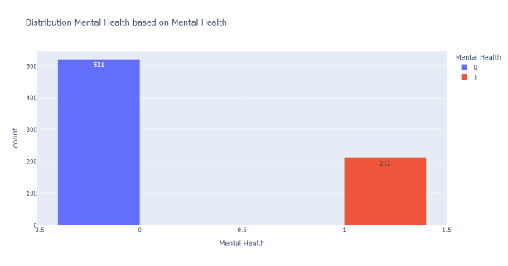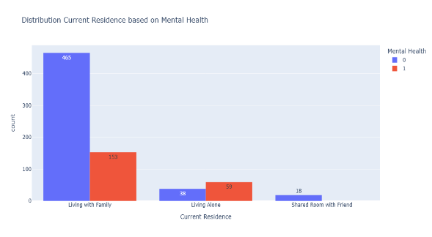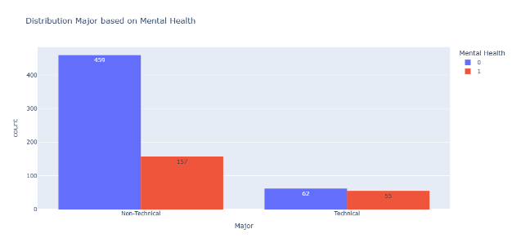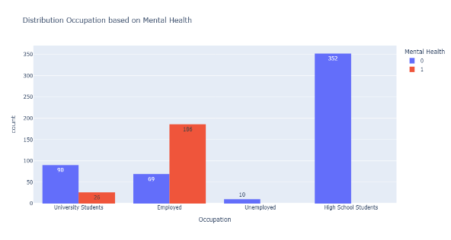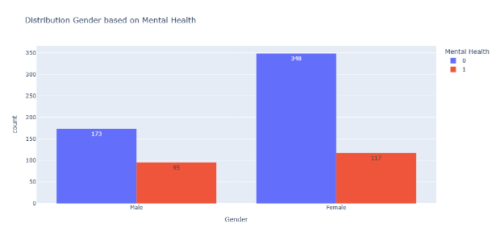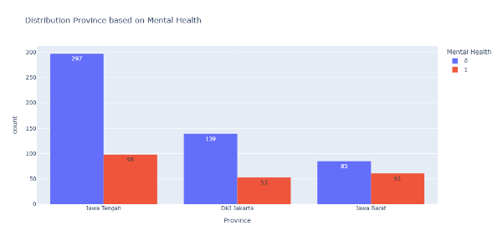

Figure 3. Data Distribution

  - Machine Learning Model Building
- Modeling Approach
To address the classification task of identifying mental health risk, three supervised machine learning algorithms were utilized: Logistic Regression, Support Vector Machine (SVM), and Random Forest. These models were selected based on their proven robustness and interpretability in psychological and behavioral classification tasks. Given the highly imbalanced nature of the dataset, the Synthetic Minority Oversampling Technique (SMOTE) was applied to augment the minority class and prevent model bias. Additionally, class weighting was employed as a complementary strategy. This mechanism assigns greater weight to the minority (at-risk) class, so that misclassifications in this class are penalized more heavily than those in the majority class.
- Building Model
The model works is as follows.
Step 1 : Prepare the feature matrix X dan target Y. Use data that is free from leakage.
Step 2 : Split the dataset becoming 70% for training and 30% for testing.
Step 3 : Perform cross-validation on the training set.
Step 4 : Impute missing values, apply scaling, and use SMOTE because the data are imbalanced.
Step 5 : Perform hyperparameter tuning with GridSearchCV and set class_weight = “balanced” to handle class imbalance. The parameters are searched over the following ranges. After tuning, the best model uses a regularization value C = 0.0008
Step 6 : Train the model by fitting Xtrain, Ytrain using the best parameters.

- Model Results
Table 1. Comparation of Model Results
Model | Akurasi | Training Akurasi | Tes Akurasi | Akurasi | Training Akurasi | Tes Akurasi | ROC_AUC
Logistic Regression | 0.936 | 0.954 | 0.936 | 0.936 | 0.954 | 0.936 | 0.995
SVM | 0.936 | 0.970 | 0.936 | 0.936 | 0.970 | 0.936 | 0.994
Random Forest | 0.932 | 0.953 | 0.932 | 0.932 | 0.953 | 0.932 | 0.995

The table compares the performance of three machine learning models: Logistic Regression, Support Vector Machine (SVM), and Random Forest. All models exhibit high performance across multiple evaluation metrics, including Accuracy, Precision, Recall, F1 Score, and ROC AUC.
Accuracy: Logistic Regression and SVM both achieve the highest overall accuracy of 0.936, while Random Forest is slightly lower at 0.932.
Training vs. Test Accuracy: SVM has the highest training accuracy at 0.970, which may suggest a slight overfitting compared to its test accuracy (0.936). Logistic Regression shows a smaller gap between training (0.954) and test accuracy (0.936), indicating better generalization. Random Forest has a training accuracy of 0.953 and test accuracy of 0.932, also reflecting good generalization.
Precision and Recall: All models reach a perfect recall score of 1.0, which means they are highly effective in identifying all relevant positive cases. However, the precision varies slightly: Logistic Regression and SVM have a precision of 0.821, Random Forest has a slightly lower precision at 0.810.
F1 Score: Logistic Regression and SVM again perform equally well with an F1 score of 0.901, while Random Forest is marginally lower at 0.895.
ROC AUC: All models perform excellently in terms of ROC AUC, with values very close to 1.0. Logistic Regression and Random Forest share the highest ROC AUC of 0.995, while SVM is just slightly behind at 0.994.

- Model Evaluation

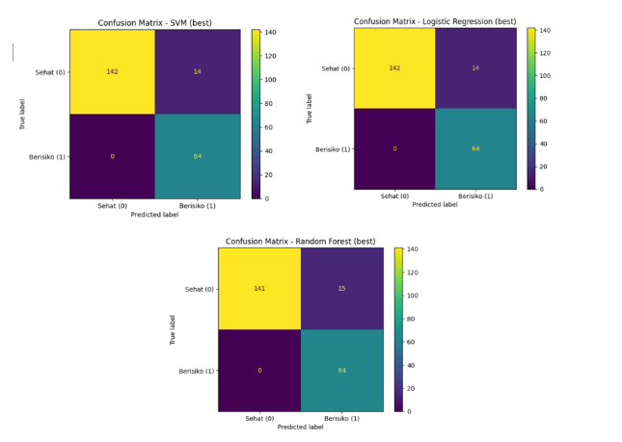

Figure 4. Confusion Matrix of All Models
All three models demonstrate excellent classification capabilities, particularly in detecting "At-Risk" (Beresiko) cases, with a perfect recall score of 1.0 and no false negatives. This is especially crucial in medical contexts or early warning systems, where failing to detect at-risk cases can have severe consequences. However, a notable difference lies in the number of false positives, where "Healthy" (Sehat) cases are incorrectly classified as "At-Risk." Both Logistic Regression and SVM produce 14 false positives, while Random Forest results in 15. This difference impacts the precision and F1-score, where Logistic Regression and SVM slightly outperform Random Forest. Considering the overall confusion matrix results, it can be concluded that Logistic Regression and SVM are more optimal in balancing accurate risk detection while minimizing false alarms. Random Forest remains competitive but tends to produce slightly more misclassifications for the "Healthy" class.
The performance of three classification models Logistic Regression, Support Vector Machine (SVM), and Random Forest was evaluated using standard metrics. Table 1 summarizes the evaluation results. All models achieved high accuracy, with Logistic Regression and SVM showing the highest test accuracy (0.936), and Random Forest slightly lower (0.932). All models recorded a recall of 1.0, indicating no "At-Risk" cases were misclassified.
However, differences were observed in precision and F1-score. Logistic Regression and SVM achieved a precision of 0.821 and F1-score of 0.901, while Random Forest showed slightly lower values (precision = 0.810, F1 = 0.895). ROC AUC values were high across all models (>0.99), suggesting excellent classification performance. Confusion matrix analysis confirmed these results. Logistic Regression and SVM produced 14 false positives, while Random Forest produced 15. No false negatives occurred in any model. No unexpected results were observed, but the consistently perfect recall across all models highlights their reliability in identifying at-risk cases, a key consideration in risk-sensitive domains.

- CONCLUSION
Among the three models evaluated, Logistic Regression demonstrated the best overall performance by achieving high accuracy, perfect recall, and the lowest number of false positives alongside SVM. While SVM showed similar results, Logistic Regression offered a better balance between training and testing performance, indicating stronger generalization. Therefore, Logistic Regression is considered the most optimal model for accurately detecting at-risk individuals while minimizing false alarms. Future work should focus on validating this model with larger and more diverse datasets.

REFERENCES

[1] W. H. Organization, “Depression and Other Common Mental Disorders: Global Health Estimates,” WHO Press, 2023.
[2] I. M. of Health, “Indonesia National Adolescent Mental Health Survey (I-NAMHS),” Jakarta Kementeri. Kesehat. RI., 2022.
[3] B. P. Statistik, “Statistik Indonesia 2023: Keadaan Penduduk Indonesia,” Jakarta BPS, 2023.
[4] W. K. Twenge, J. M., Spitzberg, B. H., & Campbell, “Less in-person social interaction with peers among U.S. adolescents in the 21st century and links to loneliness.,” J. Soc. Pers. Relat., vol. 36, no. 6, pp. 1892–1913, 2019.
[5] S. Immanuel, M. N. Teferra, M. Baumert, and N. Bidargaddi, “Heart Rate Variability for Evaluating Psychological Stress Changes in Healthy Adults: A Scoping Review,” Neuropsychobiology, vol. 82, no. 4, pp. 187–202, 2023, doi: 10.1159/000530376.
[6] H. G. Kim, E. J. Cheon, D. S. Bai, Y. H. Lee, and B. H. Koo, “Stress and heart rate variability: A meta-analysis and review of the literature,” Psychiatry Investig., vol. 15, no. 3, pp. 235–245, 2018, doi: 10.30773/pi.2017.08.17.
[7] K. Shimada, “The Role of Artificial Intelligence in Mental Health: A Review,” Sci. Insights, vol. 43, no. 5, pp. 1119–1127, 2023, doi: 10.15354/si.23.re820.
[8] U. S. Reddy, A. V. Thota, and A. Dharun, “Machine Learning Techniques for Stress Prediction in Working Employees,” 2018 IEEE Int. Conf. Comput. Intell. Comput. Res. ICCIC 2018, no. June, 2018, doi: 10.1109/ICCIC.2018.8782395.
[9] M. Wilckens and M. Hall, “Can Well-Being Be Predicted? A Machine Learning Approach,” SSRN Electron. J., no. December, 2015, doi: 10.2139/ssrn.2562051.
[10] Z. Ahmed, K. Mohamed, S. Zeeshan, and X. Q. Dong, “Artificial intelligence with multi-functional machine learning platform development for better healthcare and precision medicine,” Database, vol. 2020, pp. 1–35, 2020, doi: 10.1093/database/baaa010.
[11] E. Oparina et al., “Human Wellbeing and Machine Learning,” pp. 1–33, 2022, [Online]. Available: http://arxiv.org/abs/2206.00574
[12] H. Abdul Rahman et al., “Machine Learning-Based Prediction of Mental Well-Being Using Health Behavior Data from University Students,” Bioengineering, vol. 10, no. 5, pp. 1–13, 2023, doi: 10.3390/bioengineering10050575.
[13] M. Javaid, A. Haleem, R. Pratap Singh, R. Suman, and S. Rab, “Significance of machine learning in healthcare: Features, pillars and applications,” Int. J. Intell. Networks, vol. 3, no. February, pp. 58–73, 2022, doi: 10.1016/j.ijin.2022.05.002.
[14] A. Priya, S. Garg, and N. P. Tigga, “Predicting Anxiety, Depression and Stress in Modern Life using Machine Learning Algorithms,” Procedia Comput. Sci., vol. 167, no. 2019, pp. 1258–1267, 2020, doi: 10.1016/j.procs.2020.03.442.
[15] P. F. Lovibond, S. H., & Lovibond, “Depression anxiety stress scales,” Psychol. Assess., 1995.
[16] S. H. Lovibond, P. F., & Lovibond, “The structure of negative emotional states: Comparison of the Depression Anxiety Stress Scales (DASS) with the Beck Depression and Anxiety Inventories,” Behav. Res. Ther., vol. 33, no. 3, pp. 335–343, 1995.
[17] D. S. Spielberger, C. D., Gonzalez-Reigosa, F., Martinez-Urrutia, A., Natalicio, L. F., & Natalicio, “The state-trait anxiety inventory,” Rev. Interam. Psicol. J. Psychol., vol. 5, no. 3, 1971.
[18] S. Barnett, M. L., Sheldrick, R. C., Liu, S. R., Kia-Keating, M., & Negriff, “Implications of adverse childhood experiences screening on behavioral health services: A scoping review and systems modeling analysis,” Am. Psychol., vol. 76, no. 2, p. 364, 2021.
[19] I. R. Lina et al., “Jurnal Computer Science and Information Technology ( CoSciTech ) Metode K-Nearest Neighbor Berbasis Forward Selection untuk Identifikasi Status Stunting pada K-Nearest Neighbor Method Based on Forward Selection to Identify Stunting Status in Toddlers,” vol. 5, no. 3, pp. 695–704, 2024.
[20] S. Aisyah, “Loan Status Prediction Using Decision Tree Classifier,” Power Elektron. J. Orang Elektro, vol. 13, no. 1, pp. 68–70, 2024, doi: 10.30591/polektro.v12i3.6591.

BIBLIOGRAPHY OF AUTHORS

 | Sri Retnowati, a lecturer at Universitas Insan Cita Indonesia. She holds a Master of Mathematics Education from Universitas Sebelas Maret, and a Bachelor of Mathematics Education from Universitas Muhammadiyah Purworejo. The author has conducted research in machine learning.
 | Siti Aisyah, Bachelor in Informatics Engineering from Politeknik Negeri Jakarta ( PNJ). She holds a ⁠Master of Big Data, University of Stirling , UK. The author is interested in research about Machine Learning, Deep Learning and Big Data Analysis.

