Real-Time Access Control System with YOLOv11-Based Face and Blink Detection

¹Namira Nur Rifani, ²RD. Kusumanto, ³Nyayu Latifah Husni
^{1,2,3}Electrical Engineering, State Polytechnic of Sriwijaya, Indonesia
Email: ¹namiranurrifani@gmail.com, ²rd.kusumanto@polsri.ac.id, ³nyayu_latifah@polsri.ac.id

Article Info |  | ABSTRACT
Article history:  Received May 12th, 2019  Revised Jun 20th, 2020  Accepted Jul 26th, 2020 |  | This study introduces a real-time smart access control system that integrates facial recognition and blink-based liveness detection to improve security and reduce the risk of spoofing. It employs two YOLOv11 models to identify facial regions and detect eye movements. Identity verification is performed by comparing facial embeddings using Euclidean distance. The facial dataset was collected privately, while blink data was sourced from a public dataset. Both datasets were annotated in YOLO format for model training. The face detection model achieved a precision and recall of 1.000, with mAP50 and mAP50-95 values of 0.995 and 0.885. The blink detection model recorded 0.977 precision, 0.981 recall, 0.985 mAP50, and 0.648 mAP50-95. Testing under various lighting conditions showed consistent recognition results based on distance measurement. The system was implemented through a browser-accessible interface that verifies users and stores each detection with snapshot documentation. The findings demonstrate the feasibility of building an efficient and lightweight biometric authentication solution that includes liveness verification.
Keyword:
Face Recognition
YOLOv11
Blink Detection
Liveness Detection
Smart Access
 |  | Copyright © 2022 Puzzle Research Data Technology
Corresponding Author:
Namira Nur Rifani,
Electrical Engineering, State Polytechnic of Sriwijaya,
Srijaya Negara Street, Palembang, South Sumatra, Indonesia.
Email: namiranurrifani@gmail.com
DOI: http://dx.doi.org/10.24014/ijaidm.v2i2.xxxx (10 pt)

- INTRODUCTION
Securing access to buildings such as offices, schools, and public facilities is essential for protecting people and assets. Conventional security tools like access cards and physical keys are becoming less reliable due to their vulnerability to being lost, duplicated, or stolen [1]. As stated by to Motwani et al. [2], these systems are prone to breaches, increasing the risk of unauthorized entry. Consequently, there is a growing shift toward identity-based authentication technologies that offer greater resilience and improved security in modern access control environments.
To address these vulnerabilities, biometric technologies have gained prominence as a more secure and identity-driven approach to access control. Among them, face recognition stands out due to its contactless nature, ease of integration, and minimal user effort during authentication. Facial features are now considered one of the most convenient and widely accepted biometric modalities, making face recognition an attractive solution for modern security infrastructures [3][4].
Several prior studies have applied face recognition within security systems, employing a range of algorithms and architectural designs, with diverse approaches demonstrating high accuracy and practical deployment outcomes. Various methods have been explored in previous research, ranging from classical techniques like Haar Cascade paired with LBP descriptors [5], to gradient-based techniques like HOG [6], and the integration of convolutional neural networks (CNN) with RFID [7]. Deep learning models also continue to evolve, as shown in a study that employed TensorFlow with convolutional layers for real-time classification, achieving over 96% precision in embedded scenarios [8]. IoT-based implementations leveraging ESP32-CAM and MTCNN have demonstrated average face recognition accuracy around 85% in home security scenarios [9]. Further advancements include a two-stage architecture that utilizes YOLOv8 for detecting both faces and license plates, followed by a Siamese Neural Network for verifying rider identity in surveillance settings, yielding an mAP of 0.85 and precision of 80% [10]. Additionally, although originally developed for object detection in remote sensing images, YOLOv11 has demonstrated robust performance by achieving 88.61% precision, 85.63% recall, and mAP scores above 86%, making it a promising candidate for real-time visual recognition tasks beyond its initial domain [11].
Despite its advantages, face recognition systems remain vulnerable to spoofing attacks, where unauthorized users attempt to deceive the system using printed photos, video replays, or digital displays. Several recent studies have emphasized the need for robust liveness detection to ensure the physical presence of the user. For example, Basurah et al. [12] implemented a facial expression–based liveness detection system using TensorFlow.js, which blocked photo-based spoofing by identifying real-time facial movements. To further enhance protection, Liu et al. [13] proposed combining facial feature analysis with liveness verification based on temporal consistency, while another approach used texture analysis to differentiate between live skin and printed images [14]. These diverse strategies highlight the ongoing challenges in securing biometric systems against spoofing and the critical role of liveness detection in strengthening access control frameworks.
To respond to the limitations of existing systems, this research introduces a face-based access control solution integrated with blink-driven liveness verification. Instead of relying on intricate facial expressions or motion-based analysis, the system utilizes a real-time dual-model design that incorporates YOLOv11 to detect both facial regions and eye activity. By requiring both identity recognition and evidence of physical presence through blinking, the system minimizes the risk of spoofing via static photos or screen displays. Identity verification is carried out using facial embeddings, while access events are recorded and communicated through a browser-based interface. The system aims to provide a fast, contactless, and secure method of authentication that is feasible for constrained computational environments.

- RESEARCH METHOD (10 PT)
This study was carried out using a development setup consisting of a laptop with 8GB of RAM and a 720p webcam, which served as the primary tools for data acquisition and testing. The system was designed to operate in real time, requiring lightweight yet reliable components that can function smoothly under limited hardware resources. To ensure clarity and systematic implementation, the research methodology was structured into multiple stages, from data collection and annotation to model training, evaluation, and deployment. Each stage is essential for building an access control framework that combines face recognition with blink-based liveness detection. A flowchart illustrating the entire process of real-time facial authentication and verification is presented in Figure 1.

Figure 1. Research Framework

2.1. YOLOv11
YOLOv11 represents the most recent advancement in the Ultralytics YOLO lineup for real-time object detection. It offers notable enhancements in detection precision, inference speed, and computational efficiency. As a refinement of previous YOLO models, YOLOv11 features architectural and training pipeline optimizations, enabling its adaptability across diverse computer vision applications [15].
Figure 2 shows that YOLOv11 is composed of three key components which are the backbone, neck, and head, forming a streamlined pipeline from input to final detection output. The backbone serves as the primary feature extractor and comprises several modules including Conv, C3K2, SPPF, and C2PSA. The Conv layer begins the process with basic feature extraction, followed by C3K2, a multibranch module designed to balance efficiency and representational power. The SPPF (Spatial Pyramid Pooling Fast) module integrates multiscale context through progressive max pooling, while C2PSA introduces pixel-level attention across spatial scales to enhance fine-grained localization and suppress background noise.
These refined feature maps are passed to the neck, which performs upsampling and feature concatenation to aggregate multiscale features. The neck also incorporates C3K2 again to ensure deep semantic fusion and richer contextual understanding. Finally, the head processes these features through parallel branches tailored for objects of different scales. Each branch performs classification and bounding box regression independently, producing the final detection outputs: class labels, bounding boxes, and confidence scores. Non-Maximum Suppression (NMS) is applied at the end to eliminate redundant detections [11].

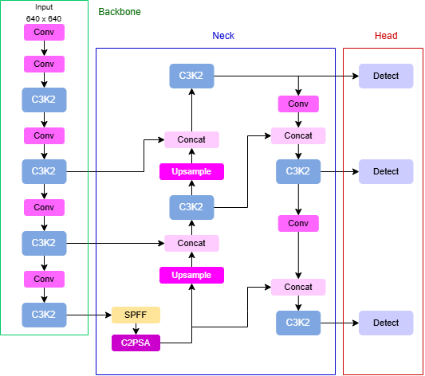

Figure 2. YOLOv11 Architecture [16]

2.2. Face Recognition
Face recognition is a process in computer vision that aims to identify or verify a person’s identity by analyzing unique patterns in their facial features. This technique transforms facial regions into numerical representations called embeddings, which can be matched against a stored database. Unlike classification tasks that assign labels, face recognition operates within an embedding space where similarity is measured by comparing vector distances between faces. The goal is to determine whether the detected face matches a stored identity with sufficient similarity.
The face_recognition function in the Dlib library follows a structured sequence of steps: it begins with face detection using CNN or HOG, followed by the localization of 68 facial landmarks such as the eyes, nose, and mouth. The detected face is then aligned using affine transformation to ensure consistent orientation. Next, facial features are extracted through a ResNet-based convolutional neural network [17] and encoded into a 128-dimensional embedding vector. Finally, face comparison is performed using Euclidean distance, where smaller values indicate higher similarity. These distance values typically range between 0 and 1, and a default threshold is applied to determine whether two embeddings represent the same identity [18][19].
This method was chosen due to its ability to operate without retraining, making it efficient for real-time systems. By relying on vector-based comparison instead of classification, the system can flexibly handle multiple identities.

2.3. Data Collection
Each dataset used in this study underwent task-specific preprocessing. For the face detection model, facial images were manually captured in varying conditions, including different lighting angles and backgrounds. The annotation process was carried out using the LabelImg tool [20], with a single class labeled as faces, following the YOLO format. The labeling interface and bounding box annotation can be seen in Figure 3.
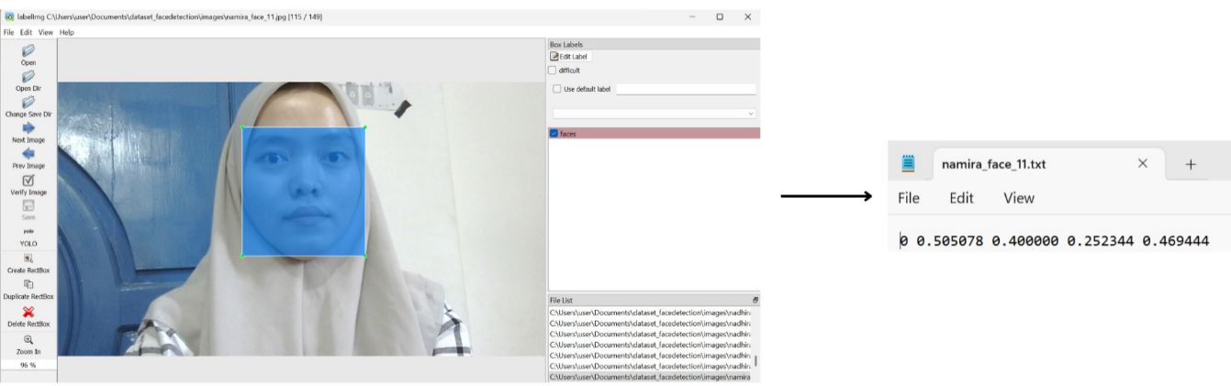
Figure 3. Face Bounding Box Annotation with LabelImg
The blink detection dataset was sourced from Roboflow and came pre-labeled in YOLO format. Annotations and folder structure were already compatible with the training pipeline, so the dataset was used without modification. It includes two object classes, "blink" and "attentive", which represent closed and open eyes respectively, as shown in Figure 4.
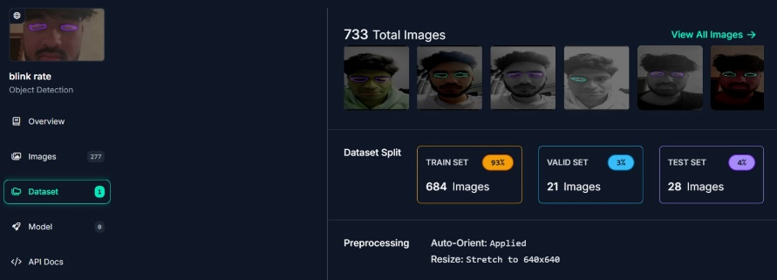
Figure 4. Blink Rate Dataset Roboflow
For face recognition, individual images were captured using a webcam in natural, unconstrained settings. Each image was then cropped to the face region using the detection model, and directly processed with the face_recognition library to generate a 128-dimensional embedding vector. These embeddings were stored as identity references [21], enabling real-time face matching without further training. The dataset structure is illustrated in Figure 5.

Figure 5. Cropped Face Images Used for Recognition

2.4. Model Evaluation
This study evaluates the model’s performance using four key indicators: precision, recall, mAP₅₀, and mAP₅₀-₉₅, each of which provides a distinct perspective on detection accuracy and reliability.
As described in Equation (1), precision is calculated by comparing the number of correctly predicted positive samples to the total number of predicted positives. This metric helps determine how well the model avoids false positives by identifying only relevant objects..
Meanwhile, recall, presented in Equation (2), measures how many actual positive instances were successfully detected. A high recall indicates that the model missed fewer target objects.
Mean Average Precision at IoU 0.5 (mAP₅₀), described in Equation (3), is the mean of the average precision (AP) values computed at an Intersection over Union (IoU) threshold of 0.5 for each class. It summarizes the trade-off between precision and recall at a moderate overlap threshold.
Meanwhile, mAP₅₀-₉₅, defined in Equation (4), evaluates the model across a wider range of IoU thresholds, from 0.5 to 0.95 in increments of 0.05. This metric provides a more rigorous and comprehensive assessment by accounting for varying degrees of localization accuracy, particularly in challenging scenarios.

$Precision= \frac{TP}{TP+FP}$ (1)
$Recall= \frac{TP}{TP+FN}$ (2)
${mAP}_{50} = \frac{1}{N}\sum_{i=1}^{N}{AP_{50,i}}$ (3)
${mAP}_{50-95}= \frac{1}{N}\sum_{i=1}^{N}{\frac{1}{K}\sum_{j=1}^{K}{AP_{i,j}}}$ (4)

To support these metrics, the following definitions apply [11] :
TP (True Positive): the number of positive objects correctly identified by the system.
FP (False Positive): the number of objects mistakenly predicted as positive.
FN (False Negative): the number of actual positives that the model failed to detect.
N: the total number of object categories evaluated.
APᵢ: the average precision score for class i, derived from the area under the precision-recall curve.
K: the total number of IoU thresholds used in mAP₅₀–₉₅, usually set from 0.5 to 0.95 in 0.05 increments.
APᵢⱼ: the average precision for class i at IoU threshold j, representing accuracy under specific overlap constraints.

2.5. System Planning
This system is deployed as a real-time web interface. As illustrated in Figure 6, the process begins with webcam activation to capture continuous video input. Each frame is analyzed using a YOLOv11-based face detection model to identify and crop the face region of interest. Once detected, the cropped face is simultaneously forwarded to two modules, face recognition and blink detection.
The recognition module generates a 128-dimensional vector using the face_recognition library and compares it against stored embeddings in the local database. Meanwhile, the blink detection model evaluates the eye region to determine liveness. If both recognition and liveness are verified, the system logs the event with a timestamp and captured image, then grants access. The entire workflow runs in real time and is accessible through a web interface.
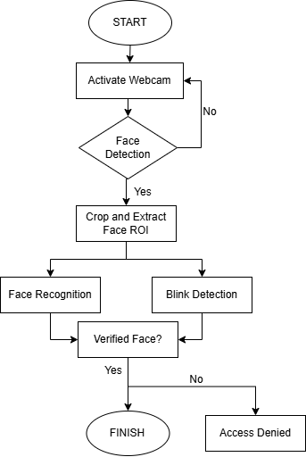
Figure 6. System Flowchart of Face and Blink-Based Access Verification

- RESULTS AND ANALYSIS
This section presents the experimental results and analysis of the proposed system. Evaluation is based on detection accuracy, robustness across lighting conditions, and system responsiveness during real-time deployment.
3.1. Result
To evaluate the performance of the implemented models, both the face detection and blink detection systems were trained and tested using the YOLOv11n architecture for 50 epochs. The training was conducted on an NVIDIA Tesla T4 GPU to ensure efficient computation.
The face detection algorithm was trained using a custom dataset consisting of 704 annotated facial images. To improve generalization, augmentation methods like horizontal mirroring and brightness adjustment were applied, followed by dividing the dataset into training and validation subsets. The resulting model delivered outstanding results, achieving 1.000 for both precision and recall, with mAP₅₀ reaching 0.995 and mAP₅₀–₉₀ recorded at 0.885. These metrics indicate a highly accurate and robust ability to detect facial regions from webcam input.
For the blink detection model, training was performed on an open-source Roboflow dataset annotated with two classes: attentive and blink. After 50 epochs of training, the model achieved a precision of 0.977, recall of 0.981, mAP₅₀ of 0.985, and mAP₅₀₋₉₀ of 0.648. The lower mAP₅₀₋₉₀ score reflects the increased difficulty of detecting smaller eye regions with higher IoU thresholds. The evaluation results for both models are shown in Table 1.

Table 1. YOLOv11 Evaluation Results
Model | Epoch | Precision | Recall | mAP₅₀ | mAP₅₀₋₉₀
Face Detection | 50 | 1 | 1 | 0.995 | 0.885
Blink Detection | 50 | 0.977 | 0.981 | 0.985 | 0.648

To evaluate the consistency of facial recognition under different lighting conditions, Euclidean distance values between the detected face embeddings and registered identity vectors were analyzed. The system assigns a similarity score based on this distance, where lower values indicate a stronger match.
Figure 7 shows the detection results captured under three different lighting conditions: bright, moderate, and low. In each scenario, the Euclidean distance between the detected face and the stored embedding remained within the acceptable threshold, with values of 0.28 for bright light, 0.34 for moderate light, and 0.44 for low light. Despite the variation in illumination, all values stayed well below the standard threshold of 0.6, indicating successful recognition.
The slight increase in distance under low-light conditions reflects reduced feature clarity but remains within acceptable bounds for verification. These findings confirm that the system is reliable and accurate even in suboptimal lighting conditions, demonstrating its robustness for real-world indoor environments where lighting consistency cannot always be ensured.
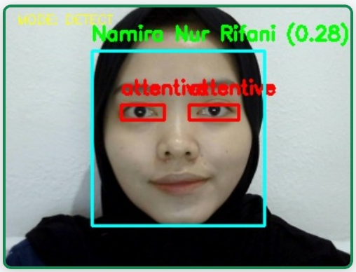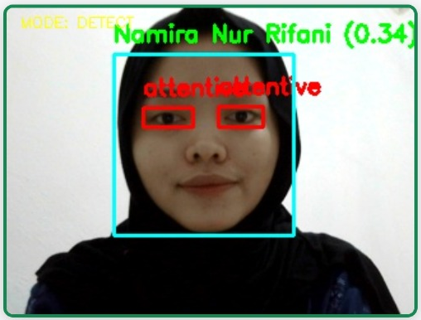
(a) (b)
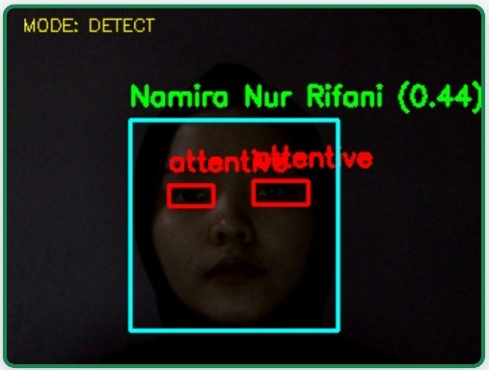
(c)
Figure 7. (a) Bright Light (b) Moderate Light (c) Low Light
3.2. Deployment
To demonstrate the system’s real-time functionality, a scenario was conducted where a registered user was detected and a valid blink was identified. As illustrated in Figure 8(a), the system successfully recognized the user’s face, confirmed liveness through blink detection, and granted access. The interface displayed the user’s name, marked both eyes as “blink,” and recorded a snapshot along with a timestamp. This confirms that the system can accurately perform dual verification in real-time conditions.
Figure 8(b) shows the detection history interface, which logs each access attempt with relevant details including the user’s name, time of detection, facial snapshot, and access result. This feature supports traceability and helps administrators review activity, monitor usage patterns, and perform post-event audits. The logging mechanism reinforces the system’s reliability and provides a transparent overview of user interactions.
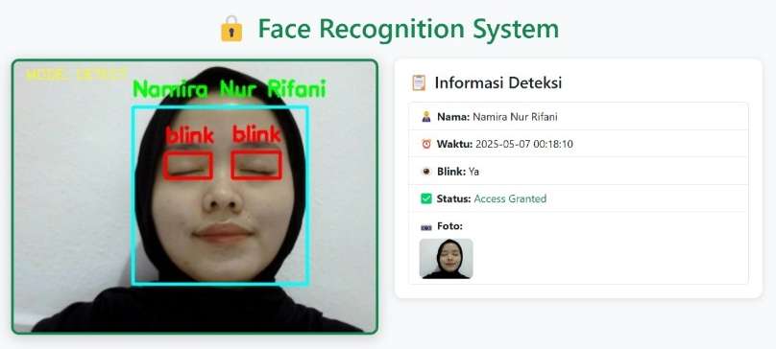
(a)

(b)
Figure 8. (a) Access Granted (b) Log History

- CONCLUSION
This research successfully demonstrates a real-time access control mechanism that combines facial embbedings and blink-based liveness verification powered by YOLOv11. The system performed well in both detection and verification tasks, showing strong accuracy metrics even under varying lighting conditions. Access was only granted when both identity and liveness were confirmed, reinforcing resistance against spoofing attacks. Additionally, the deployment of a web-based interface with automatic logging provides traceability and user transparency. This approach is practical and efficient for smart indoor environments and offers a solid foundation for future extensions, such as mobile integration or expansion to multi-modal biometric systems.

REFERENCES (10 PT)
[1] S. M. Arman, T. Yang, S. Shahed, A. Al Mazroa, A. Attiah, and L. Mohaisen, “A Comprehensive survey for privacy-preserving biometrics: Recent approaches, challenges, and future directions,” Comput. Mater. Contin., vol. 78, no. 2, pp. 2087–2110, 2024, doi: 10.32604/cmc.2024.047870.
[2] Y. Motwani, S. Seth, D. Dixit, A. Bagubali, and R. Rajesh, “Multifactor door locking systems: A review,” Elsevier, vol. 46, no. March, pp. 7973–7979, 2021, doi: 10.1016/j.matpr.2021.02.708.
[3] R. M. Ibrahim, M. M. Elkelany, and M. I. El-Afifi, “Trends in Biometric Authentication: A review,” Nile J. Commun. Comput. Sci., vol. 6, no. December, pp. 1–12, 2023, [Online]. Available: https://njccs.journals.ekb.eg
[4] A. I. Awad, A. Babu, E. Barka, and K. Shuaib, “AI-powered biometrics for Internet of Things security: A review and future vision,” J. Inf. Secur. Appl., vol. 82, no. March, p. 103748, 2024, doi: 10.1016/j.jisa.2024.103748.
[5] H. Hadi, H. Radiles, R. Susanti, and M. Mulyono, “Human Face Identification Using Haar Cascade Classifier and LBPH Based on Lighting Intensity,” Indones. J. Artif. Intell. Data Min., vol. 5, no. 1, p. 13, 2022, doi: 10.24014/ijaidm.v5i1.15245.
[6] F. M. Sarimole and A. E. Septianto, “Implementation of IoT-Based Facial Recognition for Home Security System Using Raspberry Pi and Mobile Application,” Int. J. Softw. Eng. Comput. Sci., vol. 4, no. 2, pp. 453–462, 2024, doi: 10.35870/ijsecs.v4i2.2554.
[7] D. P. Sari, M. A. C. Putra, and R. Kusumanto, “IMPLEMENTASI PENGENALAN WAJAH BERBASIS CNN DAN RFID UNTUK AREA AKSES AMAN DI FASILITAS RUANG,” J. Teliska, vol. 18, no. Ii, pp. 23–31, 2024.
[8] M. Beldi, “Face Recognition using Deep Learning and TensorFlow framework,” J. Comput. Sci. Inst., vol. 29, no. June, pp. 366–373, 2023.
[9] V. Gaikwad, D. Rathi, V. Rahangdale, R. Pandita, K. Rahate, and R. S. Rajpurohit, “Design and Implementation of IOT Based Face Detection and Recognition,” Data Sci. Intell. Comput. Tech., pp. 923–933, 2024, doi: 10.56155/978-81-955020-2-8-78.
[10] Y. Y. Pane et al., “Motorcycle License Plate and Driver Face Verification Using Siamese Neural Network Model,” vol. 8, no. 1, pp. 219–228, 2025.
[11] L. Deng, Y. Tan, D. Zhao, and S. Liu, “Research on object detection in remote sensing images based on improved horizontal target detection algorithm,” Earth Sci. Informatics, vol. 18, no. 3, pp. 1–25, 2025, doi: 10.1007/s12145-025-01814-z.
[12] M. Basurah, W. Swastika, and O. H. Kelana, “IMPLEMENTATION OF FACE RECOGNITION AND LIVENESS DETECTION SYSTEM USING TENSORFLOW.JS,” JIP (Jurnal Inform. Polinema), pp. 509–516, 2023.
[13] Y. Wei, I. K. D. Machica, C. E. Dumdumaya, J. C. T. Arroyo, and A. J. P. Delima, “Liveness Detection Based on Improved Convolutional Neural Network for Face Recognition Security,” Int. J. Emerg. Technol. Adv. Eng., vol. 12, no. 8, pp. 45–53, 2022, doi: 10.46338/ijetae0822_06.
[14] C. Gao, X. Li, F. Zhou, and S. Mu, “Face liveness detection based on the improved CnN with context and texture information,” Chinese J. Electron., vol. 28, no. 6, pp. 1092–1098, 2019, doi: 10.1049/cje.2019.07.012.
[15] A. F. Rasheed and M. Zarkoosh, “YOLOv11 Optimization for Efficient Resource Utilization,” 2024, [Online]. Available: http://arxiv.org/abs/2412.14790
[16] A. T. Khan and S. M. Jensen, “LEAF-Net: A Unified Framework for Leaf Extraction and Analysis in Multi-Crop Phenotyping Using YOLOv11,” Agric., vol. 15, no. 2, pp. 0–10, 2025, doi: 10.3390/agriculture15020196.
[17] K. He, X. Zhang, S. Ren, and J. Sun, “Deep residual learning for image recognition,” Proc. IEEE Comput. Soc. Conf. Comput. Vis. Pattern Recognit., vol. 2016-Decem, pp. 770–778, 2016, doi: 10.1109/CVPR.2016.90.
[18] A. A. F. Poeloemgam, Hendrawan, E. Mulyana, and W. Hermawan, “Web-based Face Detection and Recognition using YOLO and Dlib,” Proceeding 2023 17th Int. Conf. Telecommun. Syst. Serv. Appl. TSSA 2023, pp. 1–6, 2023, doi: 10.1109/TSSA59948.2023.10366984.
[19] D. Zhang, J. Li, and Z. Shan, “Implementation of Dlib deep learning face recognition technology,” Proc. - 2020 Int. Conf. Robot. Intell. Syst. ICRIS 2020, pp. 88–91, 2020, doi: 10.1109/ICRIS52159.2020.00030.
[20] B. Pande, K. Padamwar, S. Bhattacharya, S. Roshan, and M. Bhamare, “A Review of Image Annotation Tools for Object Detection,” Proc. - Int. Conf. Appl. Artif. Intell. Comput. ICAAIC 2022, no. Icaaic, pp. 976–982, 2022, doi: 10.1109/ICAAIC53929.2022.9792665.
[21] N. Passalis et al., “Leveraging Active Perception for Improving Embedding-based Deep Face Recognition,” 2021.

BIBLIOGRAPHY OF AUTHORS
 | Namira Nur Rifani, is a final-year undergraduate student in the Electrical Engineering Department at State Polytechnic of Sriwijaya, Indonesia.
 | Dr. RD. Kusumanto, S.T., M.M., is a lecturer in the Electrical Engineering Department at State Polytechnic of Sriwijaya, Indonesia.
 | Dr. Nyayu Latifah Husni, S.T., M.T., is a lecturer in the Electrical Engineering Department at State Polytechnic of Sriwijaya, Indonesia.

