Comparison of Recurrent Neural Network and Naive Bayes Algorithms in Identifying Stunting in Toddlers
¹Forentina Kerti P.S, ²Yisti Vita V, ³M Muharrom Al.M
^{1,2,3}Informatics Master of Informatics, Faculty of Computer Science, UPN "Veteran" East Java,
Jl. Rungkut Madya No.1, Mt. Anyar, Surabaya

Article Info |  | ABSTRACT
Article history:  Received May 12th, 2019  Revised Jun 20th, 2020  Accepted Jul 26th, 2020 |  | Stunting in toddlers is a critical health issue that requires serious attention due to its long-term impact on quality of life. This research aims to predict stunting status in toddlers using three classification methods. The stunting toddler dataset was obtained from the Kaggle platform. The model development process involves splitting the data into training, validation, and testing sets to measure the performance of each method. RNN and LSTM models are built sequentially, leveraging hidden states to capture temporal patterns in the data, while the Gaussian Naive Bayes employs a simpler probabilistic approach. Evaluation is conducted using accuracy metrics and Root Mean Square Error (RMSE) graphs to assess the generalization ability of each model. The research results show that the LSTM model achieved the best performance with an accuracy of 95%, followed by the RNN model with 93%. These two models excel due to their ability to capture complex data patterns. Meanwhile, the Gaussian Naive Bayes model achieved an accuracy of 72%, which is lower due to its limitations in handling complex data patterns. Based on the RMSE graphs, LSTM and RNN exhibited signs of overfitting at certain epochs, while Naive Bayes demonstrated stable performance and good handling of new data.
Keyword:
First keyword
Second keyword
Third keyword
Fourth keyword
Fifth keyword
 |  | Copyright © 2024 Puzzle Research Data Technology
Corresponding Author:
Third Author,
Departement of Electrical and Computer Engineering,
National Chung Cheng University,
168 University Road, Minhsiung Township, Chiayi County 62102, Taiwan, ROC.
Email: thirdauthor@uin-suska.ac.id
DOI: http://dx.doi.org/10.24014/ijaidm.v2i2.xxxx

- INTRODUCTION
Stunting is a health issue that affects the physical growth and brain development of toddlers due to chronic malnutrition. Beyond its impact on physical conditions, stunting can also reduce learning ability and individual productivity in the future. Therefore, early detection of stunting during toddlerhood is crucial to support prevention efforts. With its high prevalence in various countries, stunting has become a global health issue requiring a comprehensive approach in its management.
Advancements in information technology have enabled the application of artificial intelligence to support the healthcare sector. One focus area is health classification, including risk identification, disease diagnosis, and effective intervention planning. The implementation of this technology can help optimize resource allocation, avoid waste, and ensure better healthcare services, including supporting stunting prevention programs for toddlers.
Stunting detection, characterized by height below the standard for toddler age, must be conducted promptly. Modern technology facilitates the classification of this condition through faster and more accurate data analysis. Data classification techniques based on information technology can support health management by accelerating access to information and providing real-time early detection, allowing quick responses to public health trends.
In the context of this study, Data Mining techniques are used to classify stunting data in toddlers. Data Mining plays a significant role in extracting patterns from large and complex datasets, providing a foundation for better decision-making. This approach helps identify factors affecting stunting more deeply, supports prevention efforts, and enhances the effectiveness of health interventions.
This research compares two different algorithms in the classification process: Recurrent Neural Network (RNN) as part of Deep Learning and Naive Bayes from Machine Learning. RNN excels in analyzing temporal patterns and complex relationships in data, while Naive Bayes offers a simple yet effective approach by assuming feature independence. This comparison aims to evaluate the accuracy level of both methods in detecting stunting in toddlers.
Previous studies provide a theoretical foundation for this research. For instance, a study by Jatmiko et al. (2023) demonstrated the success of combining GRU and LSTM methods in detecting respiratory diseases with 75% training accuracy. Another study by Rachmad et al. (2022) showed that Gaussian Naive Bayes (GNB) achieved good accuracy in classifying stroke diseases.
Based on this review, the research aims to compare the RNN method with the LSTM approach and Naive Bayes using a Gaussian model in detecting stunting in toddlers. It is expected that this technology can provide efficient solutions and significantly reduce stunting prevalence.

- RESEARCH METHOD
In this study, a classification model using RNN, LSTM, and Gaussian Naive Bayes for Stunting Toddlers is developed, and the system design is structured as follows.

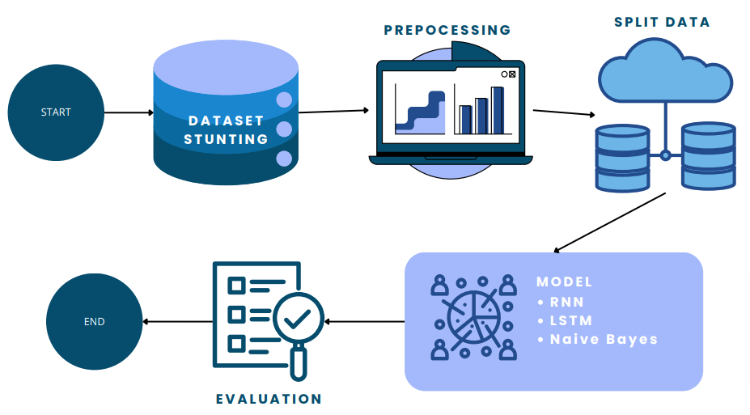
Figure 1 Flowchart System
2.1. Dataset
The data used in this study is the "Stunting Toddler" dataset from the Kaggle platform. This dataset consists of 6,500 entries with 8 variable columns, as described in Table 1.

Variabel/Atribut | Jenis Data
Gander | String
Age | Numeric
Birth Weight | Numeric
Birth Length | Numeric
Body Weight | Numeric
Body Length | Numeric
Breastfeeding | Kategoric
Stunting | Kategoric
2.2. Prepocessing
Data preprocessing in this study is the initial stage of processing the dataset. This ensures that the data used is more easily applied in the research process. Preprocessing also involves checking for missing or unrecorded data, making the research process smoother. Several steps are undertaken during the preprocessing stage.
- Label Encorder
Where three variables are converted into Boolean data types.
Gander Variabel | Breastfeeding  Variabel | Stunting Variabel | Jenis Data Bolean
Female | Yes | Yes | 1
Male | No | No | 0
- Calculation of statistical values for the stunting variable in relation to other variables, resulting in average values.
Variabel | Rata-Rrata Stunting Toodler | Rata-Rata Tidak Stunting Toodler
Usia | 24.4 | 26
Berat Lahir | 2.86 | 3.1
Panjang Lahir | 49 | 49.3
Berat Badan | 2.9 | 10.8
Tinggi Badan | 75.5 | 53
- Performing a Missing Value filter to ensure that the dataset variables have no missing (empty, unrecorded) values and all data is properly recorded.
2.3. Splitting Data
The next step is to split the data into two parts: training data and testing data. The training data is used to train the classification algorithm, while the testing data is used to evaluate the performance of the trained algorithm, especially when it encounters new data.

2.4. Klasifikasi Model
The first model proposed in this study is the Recurrent Neural Network (RNN). The process in this model will involve three units: the input unit, hidden unit, and output unit.
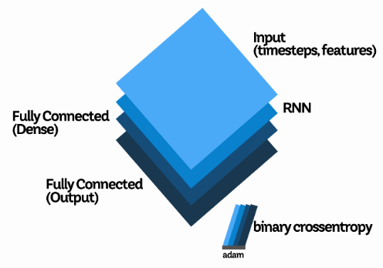
Figure 2 Algorithm RNN
The model is built sequentially, where the input has the format (‘timesteps’, ‘features’). The RNN cell processes the input sequentially, calculating the hidden state at each timestep and storing temporal information. Each hidden state is passed to the next timestep, forming a continuous memory flow. After the final hidden state is calculated, the information is passed to a Dense layer, which transforms it into a lower representation and generates probabilities for binary classification using a sigmoid activation. The formula used involves the hidden layer and output layer.
$$h_{t}=σ\left(W_{xh}x_{t}+ W_{hh}h_{t-1}+ b_{h}\right)$$
$$y_{t}= σ \left(W_{hy}h_{t}+b_{y}\right)$$
Finally, optimization is performed using the Adam optimizer to update the network weights based on the gradients calculated from the predictions and targets.

The second model in this study uses Long Short Term Memory (LSTM). The LSTM model is an advanced version of the RNN model.
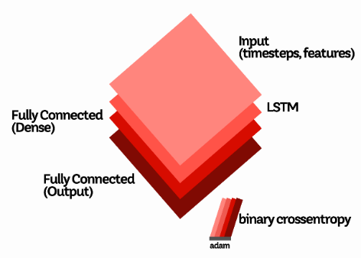
Figure 3 Algorithm LSTM
However, what differentiates the LSTM model is its more complex architecture with gates, consisting of the forget gate, input gate, and output gate. Each gate functions to control the flow of information within the network to capture long-term dependencies in sequential data. Weights for the input (W), hidden state (U), and bias (b) are also included for each gate.
$i_{t}$ = σ ( $W_{i}$ * $x_{t}+ U_{i}* h_{t-1}+b_{i}$)
$f_{t}= σ (W_{f}.\left[h_{t-1},x_{t}\right]+ b_{f}$)
c ̃_{t} = tanh (W_{c} * x_{t} + U_{c} * h_{t-1} + b_{c})
$O_{t}$ = σ ( $W_{o}$ * $x_{t}+ U_{o}* h_{t-1}+b_{o}$)
The final model, unlike the previous two, is a machine learning technique called Naive Bayes.
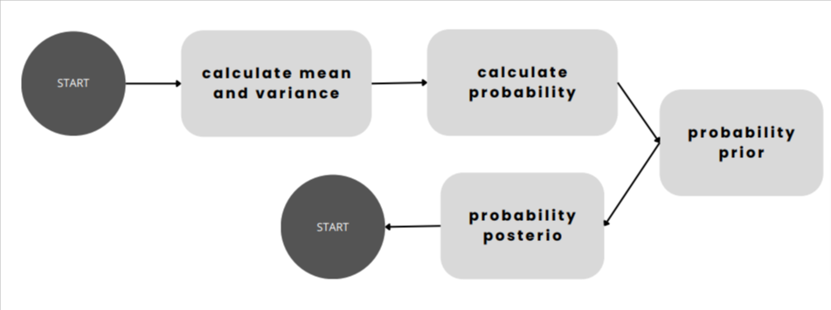
Figure 4 Algorithm Naive Bayes
Naive Bayes assumes that features follow a normal (Gaussian) distribution. Each feature in the Gaussian Naive Bayes model is calculated based on the mean (μC) and variance for each feature to determine the probability (P) in the prior probability (P(C)) and the posterior probability $(σ_{c,i}^{2}) .$
$$μC,i= \frac{1}{N_{c}}\sum_{j=1}^{N_{C}}{X_{j,i}}$$
$$P\left(X_{i} | C\right)=\frac{1}{\sqrt{2πσ^{2}C}} exp\left(\frac{(X_{i}-μc)^{2}}{2σ^{2}c}\right)$$
$$P\left(C\right)=\frac{number of class C samples}{total number of samples}$$
$$σ_{c,i}^{2}= \frac{1}{N_{C}}{\sum_{j=1}^{N_{C}}{(X_{j,i}}- μ_{C,i})}^{2}$$

2.5. Evaluasi
Model evaluation for classification can be performed using a confusion matrix, which provides a comprehensive overview of the model's performance in classifying data. The confusion matrix consists of four main components: True Positive (TP), True Negative (TN), False Positive (FP), and False Negative (FN). TP represents the number of correct predictions for the positive class, TN represents the number of correct predictions for the negative class, FP represents the number of incorrect predictions for the positive class, and FN represents the number of incorrect predictions for the negative class. The confusion matrix allows for the identification of specific errors made by the model. Additionally, evaluation can also be performed using Root Mean Square Error (RMSE). RMSE calculates the square root of the mean of squared errors, where the error is the difference between the values predicted by the model and the actual observed values.
$$RMSE=\sqrt{\frac{I}{n}\sum_{i=1}^{n}{{(y_{i}- {^y}_{i})}^{2} }}$$
- RESULTS AND ANALYSIS
The results of testing to compare the performance of the Recurrent Neural Network (RNN), Long Short Term Memory (LSTM) based on deep learning, and Naive Bayes, a simple probabilistic method, in detecting stunting in toddlers. The testing was conducted using a toddler-related dataset, which was divided into 70% training data and 30% testing data.
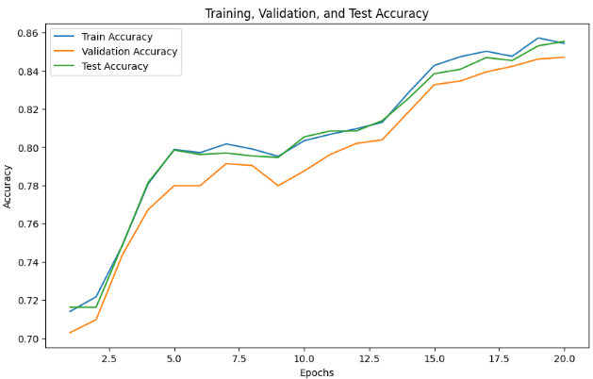  Figure 5 Model RNN | 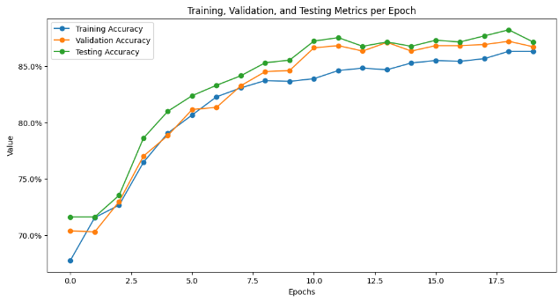  Figure 6 Model LSTM

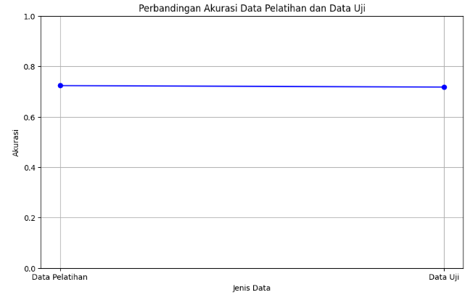
Figure 7 Model Naive Bayes
It can be concluded that each model has different characteristics and capabilities in handling the data. The Recurrent Neural Network (RNN) model shows an increase in accuracy on the test data as the epochs progress but starts to experience overfitting after the 15th epoch, indicating that the model struggles to generalize on new data. The Long Short-Term Memory (LSTM) model also shows signs of overfitting, where the accuracy on the test data increases significantly in the beginning but plateaus around 85% around the 10th epoch. This suggests that LSTM starts to memorize the training data. In contrast, the Naive Bayes model does not show signs of overfitting, with consistent accuracy performance between the training and test data. This indicates that Naive Bayes generalizes well to new data, making it a stable model for use with this dataset.
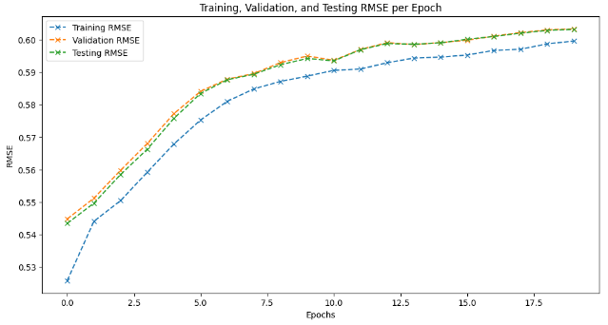  Figure 8 RMSE RNN | 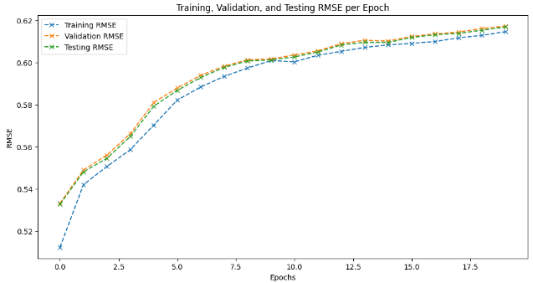  Figure 9 RMSE LSTM
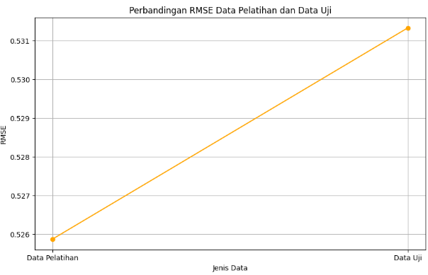
Figure 10 RMSE Naive Bayes
It can be concluded that the generalization ability of each model differs significantly. The Recurrent Neural Network (RNN) model shows a decrease in RMSE at the beginning of the training, but after several epochs, the RMSE starts to increase, indicating that the model is overfitting the training data and struggling to handle the test data effectively. The Long Short-Term Memory (LSTM) model also shows a rapid decrease in RMSE early in the training, but the RMSE tends to increase slowly after several epochs, suggesting that the model begins to lose its generalization ability as the epochs progress. In contrast, the Naive Bayes model shows stable performance, with nearly identical RMSE values between the training and test data. This indicates that Naive Bayes handles new data well without overfitting, making it a more reliable model for generalization.

Dataset | Epoch | Optimizer | Hasil Akurasi (%) | Hasil RMSE
RNN (Recurrent Neural Network) | 20 | Adaptive Moment Estimation | 85% | 0.44
RNN (Recurrent Neural Network) | 30 | Adaptive Moment Estimation | 92% | 0.44
RNN (Recurrent Neural Network) | 50 | Adaptive Moment Estimation | 93% | 0.44
LSTM (Long Short-Term) | 20 | Adaptive Moment Estimation | 87% | 0.45
LSTM (Long Short-Term) | 30 | Adaptive Moment Estimation | 94% | 0.45
LSTM (Long Short-Term) | 50 | Adaptive Moment Estimation | 95% | 0.45
Naive Bayes | - | - | 72% | 0.53

- CONCLUSION
Based on the evaluation of model performance, Long Short-Term Memory (LSTM) has proven to be superior in predicting the stunting status of toddlers, achieving the highest accuracy of 95% and a low, stable Root Mean Square Error (RMSE) ranging between 0.53 and 0.54 across training, validation, and testing data. This model demonstrates excellent generalization capability by minimizing prediction errors. Recurrent Neural Network (RNN) also performs comparably to LSTM, with an accuracy of 93% and a slightly higher RMSE ranging between 0.54 and 0.56, which still reflects a decent ability to handle complex data patterns. In contrast, Gaussian Naive Bayes only achieves an accuracy of 72% with a higher RMSE, indicating that the simple approach employed by this model is less effective for handling complex data. Therefore, the LSTM model is the best choice for classifying toddler stunting status, followed by RNN, while Gaussian Naive Bayes is more suitable for data with simpler patterns.

REFERENCES
[1] Ardianto, R., & Wibisono, S. K. (2023). Analisis Deep Learning Metode Convolutional Neural Network Dalam Klasifikasi Varietas Gandum. Jurnal Kolaboratif Sains(JKS), 6(12), 2081–2092. https://doi.org/10.56338/jks.v6i12.4938
[2] Farhah, A., Prasasti, A. L., & Paryasto, M. W. (2021). Implementasi Recurrent Neural Network dalam Memprediksi Kepadatan Restoran Berbasis LSTM. Jurnal Media Informatika Budidarma, 5(2), 524. https://doi.org/10.30865/mib.v5i2.2916
[3] Gusrialni Fitri, N., Adilya, S., & Azizi, F. (2023). Comparison of the Naive Bayes Classification System and C4.5 for the Diagnosis of Stroke Perbandingan Sistem Klasifikasi Naive Bayes dan C4.5 Untuk Diagnosa Penyakit stoke. SENTIMAS: Seminar Nasional Penelitian dan Pengabdian Masyarakat, 49–55.
[4] Herlianty, H., Setyawati, A., Lontaan, A., Limbong, T., Tyarini, I. A., & Putri, S. Z. (2023). Determinants Influence the Incidence of Stunting in Toddlers Aged 6-59 Months. Jurnal Edukasi Ilmiah Kesehatan, 1(2), 73–79. https://doi.org/10.61099/junedik.v1i2.18
[5] Iqbal, M., Hasmawati, & Romadhony, A. (2023). Implementation of Recurrent Neural Network (RNN) for Question Similarity Identification in Indonesian Language. Jurnal Online Informatika, 8(2), 213–221. https://doi.org/10.15575/join.v8i2.1138
[6] Jatmiko, A., Hendrawan, N. D., Affandi, A. S., & Susanto, D. S. (2023). Sistem Pendeteksi Jenis Penyakit Pernafasan Menggunakan Metode Gabungan GRU dan LSTM Melalui Suara Pasien dengan Gangguan Pernafasan. Jurnal Informatika Polinema, 9(4), 445–450. https://doi.org/10.33795/jip.v9i4.1407
[7] Kanagachidambaresan, G. R., Ruwali, A., Banerjee, D., & Prakash, K. B. (2021). Klasifikasi Malware Menggunakan MetodeRecurrent Neural Network. EAI/Springer Innovations in Communication and Computing, 23(3), 53–61.
[8] Kartini, M. I. I. A. N. (2021). Karakteristik Sumber Daya Manusia Era Digital (Perspektif KepeMimpinan, Motivasi dan Etos Kerja).
[9] Kohsasih, K. L., & Situmorang, Z. (2022). Comparative Analysis of C4.5 and Naïve Bayes Algorithms in Predicting Cerebrovascular Disease. Jurnal Informatika, 9(1), 13–17.
[10] Kusumastuti, R. D., Nurmala, N., Rouli, J., & Herdiansyah, H. (2022). Analyzing the factors that influence the seeking and sharing of information on the smart city digital platform: Empirical evidence from Indonesia. Technology in Society, 68, 101876. https://doi.org/10.1016/j.techsoc.2022.101876
[11] Naufal, Y., Putro, R., Afriansyah, A., & Bagaskara, R. (2024). Penggunaan Algoritma Gaussian Naïve Bayes & Decision Tree Untuk Klasifikasi Tingkat Kemenangan Pada Game Mobile Legends. JUKI : Jurnal Komputer dan Informatika, 6(1), 10–26.
[12] Nurillah Amalia, Kencana Sari, & Indri Yunita Suryaputri. (2016). Panjang Badan Lahir Pendek Sebagai Salah Satu FaktorDeterminan Keterlambatan Tumbuh KembangAnak Umur 6-23 Bulan di Kelurahan Jaticempaka,Kecamatan Pondok Gede, Kota Bekasi. Jurnal Ekologi Kesehatan, 3–9.
[13] Pramana, C. (2023). Buku Digital - KESEHATAN MASYARAKAT DI ERA SOCIETY 5 . 0 (Nomor August).
[14] Rachmad, D. U., Oktavianto, H., & Rahman, M. (2022). Perbandingan Metode K-Nearest Neighbor Dan Gaussian Naive Bayes Untuk Klasifikasi Penyakit Stroke. Jurnal Smart Teknologi, 3(4), 405–412.
[15] Selfi Tita Putri Sukarman. (2020). Hubungan Pola Asuh Orang Tua Dengan Kejadian Pernikahan Usia Dini. file:///C:/Users/VERA/Downloads/ASKEP_AGREGAT_ANAK_and_REMAJA_PRINT.docx, 7, 1–119.
[16] Setiawan, R., & Triayudi, A. (2022). Klasifikasi Status Gizi Balita Menggunakan Naïve Bayes dan K-Nearest Neighbor Berbasis Web. Jurnal Media Informatika Budidarma, 6(2), 777. https://doi.org/10.30865/mib.v6i2.3566
[17] Winanto, E. A., Kurniabudi, K., Sharipuddin, S., Wijaya, I. S., & Sandra, D. (2022). Deteksi Serangan pada Jaringan Kompleks IoT menggunakan Recurrent Neural Network. JURIKOM (Jurnal Riset Komputer), 9(6), 1996. https://doi.org/10.30865/jurikom.v9i6.5298
[18] Yolanda, D., Gunadi, K., & Setyati, E. (2020). Pengenalan Alfabet Bahasa Isyarat Tangan Secara Real-Time dengan Menggunakan Metode Convolutional Neural Network dan Recurrent Neural Network. Jurnal Infra, 8(1), 203–208. https://publication.petra.ac.id/index.php/teknik-informatika/article/view/9791
[19] Yudistira, N. (2021). Peran Big Data dan Deep Learning untuk Menyelesaikan Permasalahan Secara Komprehensif. EXPERT: Jurnal Manajemen Sistem Informasi dan Teknologi, 11(2), 78. https://doi.org/10.36448/expert.v11i2.2063
[20] Zakaria, P. S., Julianto, R., & Bernada, R. S. (2019). Implementasi Naive Bayes Menggunakan Python dalam Klasifikasi Data. Journal of Informatics, Information System, Software Engineering and Applications (INISTA), 1(2), 73–81.

BIBLIOGRAPHY OF AUTHORS

First author’s  Photo (3x4cm) | First Author, make in paragraph (9 pt)
Second author’s photo(3x4cm) | Second Author, make in paragraph (9 pt)
Thirth author’s photo(3x4cm) | Thirth Author, make in paragraph (9 pt)

