Stock Price Prediction Using XCEEMDAN –

Bidirectional LSTM – Attention Mechanism – Spline

¹Kelvin, ²Frans Mikael Sinaga
^{1,2}Informatics Engineering, Mikroskil University
Email: ¹kelvin.chen@mikroskil.ac.id, ²frans.mikael@mikroskil.ac.id

Article Info |  | ABSTRACT (10 PT)
Article history:  Received May 12th, 2019  Revised Jun 20th, 2020  Accepted Jul 26th, 2020 |  | The Attention Mechanism is recognized as an approach in machine learning that can effectively handle relationships between elements in a sequence of data compared to conventional models. However, the unique characteristics of stock data, including significant fluctuations, high dimensions, and non-linearity, present challenges in achieving high accuracy in predicting stock prices. The objective of this study is to address these challenges by enhancing the previous model, XCEEMDAN - Bidirectional LSTM - Spline, with the addition of an Attention Mechanism, resulting in XCEEMDAN - Bidirectional LSTM - Spline - Attention Model. The predicted data undergo normalization and pre-processing using XCEEMDAN, leading to the decomposition of data into high and low-frequency signals. The Attention Mechanism is then employed to process these high-frequency signals. Testing is conducted by comparing the performance of the proposed model, XCEEMDAN - Bidirectional LSTM - Spline - Attention Model, with the XCEEMDAN - Bidirectional LSTM - Spline model using identical parameters. The test results demonstrate that the proposed model achieves the lowest RMSE value of 0.5708777053, surpassing the average RMSE value of the XCEEMDAN - Bidirectional LSTM - Spline model, which is 0.5823726212. This approach is expected to make a significant contribution to the development of more reliable and efficient stock price prediction models, addressing the challenges encountered by previous models.
Keyword:
Stock Price Prediction,
XCEEMDAN,
Bidirectional LSTM,
Spline,
Attention Mechanism
 |  | Copyright © 2022 Puzzle Research Data Technology
Corresponding Author: (10 pt)
Kelvin,
Informatics Engineering,
Mikroskil University,
Email: kelvin.chen@mikroskil.ac.id
DOI: http://dx.doi.org/10.24014/ijaidm.v2i2.xxxx (10 pt)

- INTRODUCTION (10 PT)
Predicting stock prices involves attempting to forecast the future value of a company's shares or other financial instruments traded on the stock market. Accurate predictions in this field can lead to maximized profits for investors [1]. However, the stock market presents challenges due to its data characteristics, characterized by significant fluctuations, high dimensions, and non-linearity, making prediction difficult [2]. Various factors such as politics, economics, market trends, technological advancements, and investor behavior can influence changes in stock prices [3].
Recent advancements in stock price prediction involve combining signal processing techniques, machine learning models, and traditional stochastic models. Signal processing techniques are employed to manage irregular data (noise), machine learning models analyze time series patterns with high complexity, and traditional stochastic models handle time series patterns with low complexity. This combination facilitates the development of a comprehensive model that considers both backward and forward data [4].
P. Flandrin, E. Torres, and MA Colominas [5] introduced the Complete Ensemble Empirical Mode Decomposition with Adaptive Noise (CEEMDAN) technique for signal processing. CEEMDAN offers faster processing times compared to the Ensemble Empirical Mode Decomposition (EEMD) method and is capable of analyzing non-linear and non-stationary signals. M. Roondiwala, H. Patel, and S. Varma [6] utilized the Long Short Term Memory (LSTM) model for stock price prediction. However, LSTM has limitations in efficiently utilizing backward data dependence, which is addressed by Cao et al. [8] through the CEEMDAN-LSTM model, resulting in improved prediction accuracy.
Y. Xuan, Y. Yu, and K. Wu [9] proposed the Empirical Mode Decomposition - Long Short Term Memory - Cubic Spline Interpolation (EMD-LSTM-CSI) model, which exhibits faster processing times and enhanced stability in predicting stock prices. Their model outperforms other models such as Support Vector Machine (SVM), LSTM, Attention-based LSTM (LSTM-ATTE), EMD-LSTM, and EMD-LSTM-ATTE. Additionally, Teja, Tiwari, and Mohanty [10] compared signal processing methods and found CEEMDAN to yield superior statistical values.
R. De Luca Avila and G. De Bona [4] proposed the XCEEMDAN-LSTM-Spline model, which improves upon the CEEMDAN-LSTM model's prediction accuracy. Bidirectional LSTM models, as suggested by Siami-Namini et al. [10] and Jia et al. [2], offer enhanced predictive capabilities by capturing data context through traversal in both forward and backward directions. Hence, this study proposes a model utilizing XCEEMDAN-Bidirectional LSTM-Spline. Preprocessed data undergoes normalization and XCEEMDAN processing to manage chaotic data characteristics by controlling noise. Subsequently, an additional Bidirectional LSTM layer captures additional information, complemented by a Spline model to mitigate overfitting issues and improve stock price prediction accuracy.
Recent research has demonstrated the effectiveness of various approaches in stock price prediction. For instance, the study conducted by Kelvin et al. [18] proposed the XCEEMDAN-Bidirectional LSTM-Spline model, which integrates the XCEEMDAN preprocessing technique with Bidirectional LSTM and Spline models to enhance prediction accuracy. Additionally, another study by Zhang, J et al. [19] introduced the Stock Price Prediction Using CNN-BiLSTM-Attention Model, which leverages the Attention Mechanism to improve prediction outcomes.
The incorporation of the Attention Mechanism into stock price prediction models offers several advantages. Attention mechanisms allow models to focus on relevant parts of the input data, thereby capturing more intricate patterns and dependencies. By integrating the Attention Mechanism with the XCEEMDAN-Bidirectional LSTM-Spline model, we aim to further enhance the predictive capabilities by enabling the model to selectively attend to significant features in the input data, thereby improving its ability to capture complex relationships and fluctuations in stock prices. This integration underscores our rationale for combining the XCEEMDAN-Bidirectional LSTM-Spline model with the Attention Mechanism.
In particular, the Attention Mechanism has been widely recognized for its ability to effectively capture dependencies between elements in sequential data, making it a valuable addition to stock price prediction models. By incorporating attention mechanisms, the model can dynamically adjust its focus during the prediction process, allowing it to adaptively weigh the importance of different input features. This adaptive behavior enhances the model's ability to capture relevant information and improve prediction accuracy. Therefore, integrating the Attention Mechanism into the XCEEMDAN-Bidirectional LSTM-Spline model presents a promising avenue for further improving the performance of stock price prediction systems.

- RESEARCH METHOD
  - Stock Price Prediction
The stock market is where shares are bought, sold, and traded [3]. It has unique data features, like big changes, lots of data, and complexity, which make it hard to predict [2]. Changes in stock prices depend on supply and demand: if there are more sellers than buyers, prices generally go down; if there are more buyers than sellers, prices tend to rise [11].
Predicting stock prices means trying to guess what a company's shares or other financial assets will be worth in the future. Predicting prices has been important for a long time because it can lead to big profits [1]. Looking at trends over many years can help understand the ups and downs of the stock market, which are often unpredictable and complicated. Traditionally, there have been two main ways to predict stock prices [12]:
1. Technical analysis looks at past stock prices, such as opening and closing prices and trading volume, to guess future prices.
2. Qualitative analysis looks at external factors like a company's background, market conditions, and news from experts in finance.
3. Machine learning methods are also used for stock market analysis, especially when dealing with lots of data that's not straightforward. These methods can find hidden patterns and relationships in large data sets, often doing a better job than older methods.
Stock price prediction has changed over time. Older methods used probabilities, while newer methods use machine learning. There are different probabilistic models, like Autoregressive (AR), Autoregressive Moving Average (ARMA), Autoregressive Integrated Moving Average (ARIMA), Seasonal Autoregressive Integrated Moving Average (SARIMA), and Cubic Spline Interpolation (CSI) models. These models study how data behaves without assuming it follows a straight line or stays the same over time. The new model combines three things: ways to process data, machine learning models, and older probabilistic models. Processing data is important to prepare it for the model. One way to process data is called CEEMDAN, which can handle complex, changing signals. Machine learning and older probabilistic models are used to make predictions about stock prices [4]. The machine learning model to be employed in this research is Bidirectional LSTM, and additionally, the traditional stochastic model to be utilized is CSI. Moreover, this study will implement an attention mechanism on Bidirectional LSTM.

  - XCEEMDAN
Complete Ensemble Empirical Mode Decomposition with Adaptive Noise (CEEMDAN) represents a signal decomposition method that utilizes Fourier transform to effectively process nonlinear and non-stationary signals adaptively [8]. It builds upon the groundwork laid by NE Huang, Z. Shen, and SR Long [13] who introduced Empirical Mode Decomposition (EMD) for analyzing nonlinear data. EMD, at its core, can break down nonlinear and nonstationary data into multiple signals called Intrinsic Mode Functions (IMF) along with a residual signal. The presence of chaotic nonlinear data contributes to uncertainty and irregularity in observed data, where irregularities (or noise) in data measurements stem from accompanying processes or inaccuracies during the measurement process itself [14]. The primary stages of EMD include:
Step 1: Determine all maximum values of each original data $x\left(t\right),t=1,2,3,…,T;$
Step 2: Connects the minimum and maximum values locally to generate the undercover $x_{low}\left(t\right)$ and top cover $x_{up}\left(t\right)$
Step 3: Perform local average calculations with the formula:
$m\left(t\right)=\frac{x_{up}(t)+x_{low}(t)}{2}$ (1)
Step 4: Get the value of IMF 1 and residual with the formula::
${IMF}_{1}\left(t\right)=x\left(t\right)-m\left(t\right) and R_{1}\left(t\right)=m\left(t\right)$ (2)
Step 5: for all parts, if more than two maximum values of are found $for i=1,2,3,…,n,$ $R_{i}(t)$ maka kembali then go back to step 2 and calculate ${IMF}_{i}+1\left(t\right) and R_{i}+1(t)$.

EMD possesses the capability to manage non-stationary and nonlinear signals, yet it encounters an issue known as "Mixing mode". This phenomenon occurs when there are highly similar oscillations present in different modes or when modes exhibit vastly different amplitudes. To address this challenge, Ensemble Empirical Mode Decomposition (EEMD) was developed, aiming to substantially mitigate mode mixing within the EMD algorithm [15]. This is achieved by introducing Gaussian white noise to the signal using the following formula:
$x^{i}\left(t\right)=x\left(t\right)+w^{i}\left(t\right)$. (3)
However, the EEMD algorithm fails to completely eliminate Gaussian white noise post-signal reconstruction, leading to reconstruction errors. In response to this issue, CEEMDAN has been introduced as an enhanced iteration of EEMD [5]. CEEMDAN demonstrates superior efficacy in eliminating mode mixing, resulting in nearly negligible reconstruction errors and low computational complexity [8].
CEEMDAN will be employed specifically for exogenous features (X), which are factors influencing the price series to be predicted. For instance, if the dataset used for model training and testing includes stock prices such as open, high, low, close, and daily financial volume, where the close price represents the series to be predicted and the rest are considered exogenous features (X). The application of CEEMDAN to these exogenous features (X) is denoted as XCEEMDAN. The XCEEMDAN algorithm follows the steps outlined below:
Step 1: Decomposition of each x_{i}(n) = $x\left(n\right)+ε_{0}w^{i}\left(n\right)$ using EMD to get the first IMF mode with calculations The formula used is as follows:
$\tilde{{IMF}_{1}}=\left(n\right)=\frac{1}{I} \sum_{i=1}^{I}{{IMF}_{1}^{i}\left(n\right)=\overline{{IMF}_{1}}}(n)$ (4)
Step 2: Calculate the first residue with the following formula:
$r_{1}\left(n\right)=x\left(n\right)-\tilde{{IMF}_{1}}(n)$ (5)
Step 3: Calculate the decomposition of the first residue $r_{1}\left(n\right)+ε_{1}E_{1}\left(w^{i}\left(n\right)\right),with i=1, 2, …, I$.$ε_{1}$is the standard deviation of White Gaussian Noise. $\tilde{{IMF}_{2}}\left(n\right)$ can be broken down as follows:
$\tilde{{IMF}_{2}}\left(n\right)=\frac{1}{I}\sum_{i=1}^{I}{E_{1}\left(r_{1}\left(n\right)+ε_{0}E_{1}\left(W^{i}\left(n\right)\right)\right)}$ (6)
Step 4: Calculate the residual for IMF 2 with a value of K showing the resulting total k through the following calculation:
$r_{k}\left(n\right)=r_{k-1}\left(n\right)-\tilde{{IMF}_{k}}\left(n\right), k=2, 3,…, K$ (7)
Step 5: Calculate the decomposition $r_{k}\left(n\right)+ε_{k}E_{k}\left(w^{i}\left(n\right)\right),with i=1, 2, …, I$ then calculate the IMF ${\left(k+1\right)}^{th}$ can be calculated in the following way:
${IMF}_{k+1}\left(n\right)=\frac{1}{I}\sum_{i=1}^{I}{E_{1} } \left(r_{k}\left(n\right)+ε_{0}E_{k}\left(W^{i}\left(n\right)\right)\right)$ (8)
Step 6: Repeat steps 4 to 6 until the residue becomes a fixed function, so that the IMF cannot be extracted anymore Assume k dan $r_{k}(n)$ represent the total number of values in the final mode and residual. The input x(n) can be expressed as follows:
$x\left(n\right)=\sum_{k=1}^{k}{{\tilde{IMF}}_{k}}\left(n\right)+r_{k}(n)$ (9)

  - Bidirectional Long Short Term Memory (Bidirectional LSTM)
Bidirectional LSTM represents a variation of the Recurrent Neural Network (RNN), designed to address the issue of long-term dependency encountered in standard RNNs and LSTM models. By incorporating LSTM units in both forward and backward directions, Bidirectional LSTM gathers information from the data in both temporal directions simultaneously, thereby ensuring that potentially overlooked data is captured more effectively. The process begins with data preprocessing, followed by passing the input through the Bidirectional LSTM neural network layers, ultimately culminating in the prediction output, as depicted in Figure 1. In the forward layer, computations are executed from the initial time step to the final one, with the hidden layer's output persistently collected and stored. Conversely, in the backward layer, computations are reversed from the final time step to the initial one, capturing and storing the hidden layer's output at each time step. As illustrated in Figure 2, the six unique weights (w1, w2, w3, w4, w5, w6) are utilized repeatedly throughout the process: connecting the forward and backward hidden layers (w1, w3), connecting the hidden layer to itself (w2, w5), and connecting the forward and backward hidden layers to the output layer (w4, w6). The output layer combines the outputs from both the forward and backward layers to generate the final prediction result [2].
  Figure 1. Structure Diagram Bidirectional LSTM [2] | 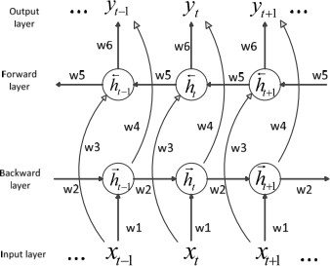  Figure 2. Bidirectional Neural Network LSTM [2]

The steps of the Bidirectional LSTM algorithm are as follows [2]:
Step 1: Calculate the input to the forward hidden layer using the following formula:
$\vec{h_{t}}= f(w_{1}x_{t}+w_{2}h_{t-1})$ (10)
Step 2: Calculate the input to the backward hidden layer using the following formula:
$\overset{⃖}{h_{t}}= f(w_{3}x_{t}+w_{5}h_{t+1})$ (11)
Step 3: Compute the output layer by combining the outputs from the forward and backward layers using the following formula
$o_{t}=g(w_{4}\vec{h_{t}}+w_{6}\overset{⃖}{h_{t}})$ (12)

where f is the activation function and g is the optimizer used.

  - Attention Mechanism
The concept of attention mechanism has its roots in the investigation of human visual perception. Conventional neural networks lack the ability to discern the significance of signals during information processing. Conversely, the attention mechanism enables the allocation of varying weights to different features, prioritizing crucial information with higher weights while disregarding less relevant data. This differentiated weight assignment enhances the efficiency of information processing, addressing the issue of information loss typically encountered with long sequences in LSTM models. Hence, integrating the attention mechanism could potentially enhance the accuracy of stock price predictions even further [19].

  - Cubic Spline Interpolation
Cubic spline interpolation is a method for creating smooth, connected curves through a set of points. It involves integrating cubic curves between each pair of adjacent points. This algorithm follows specific steps to achieve this interpolation [16]:
Step 1: Determine the paired point set$(x,y)$
Step 2: Determine the coefficient $a_{i }$using Equation
$S_{i }\left(x_{i }\right)= y_{i } , i=1,..,n-1$, where $a_{i}=y_{i }$ (13)
Step 3: Calculate the lower diagonal element and the upper diagonal element of a tridiagonal matrix using the equation $u_{i }=l_{i }=x_{i+1 }-x_{i }$, where $u_{0 }=l_{n }=0$
Step 4: Calculate the main diagonal elements ($m_{i })$ use Equality
${ m}_{i }=2(x_{i+1}- x_{i}+ x_{i}- x_{i-1})$ where $d_{0 }=d_{n }=1$ (14)
Step 5: Calculate vector elements using Equation $V$
${ v}_{i }=3 \left(\frac{y_{i+1}- y_{i}}{x_{i+1}-x_{i}}- \frac{y_{i}- y_{i-1}}{x_{i}-x_{i-1}}\right)$ where $v_{0 }=v_{n }=0$ (15)
Step 6: Arrange the elements into a tridiagonal matrix $l_{i }u_{i },m_{i } A$
Step 7: Define and solve the system of linear equations in the equations so that a vector is obtained which is a set of coefficients$AC=VCc$
Step 8: Calculate coefficient using Equation
$b_{i }=\frac{y_{i+1}- y_{i}}{x_{i+1}-x_{i}}- \frac{x_{i+1}-x_{i}}{3} (2c_{i}-c_{i+1})$ (16)
Step 9: Calculate coefficient using Equation
$d_{i }=\frac{c_{i+1}- c_{i}}{{3(x}_{i+1}-x_{i})}$ (17)
Step 10: Form a series of polynomial equations using the calculated elements and coefficients $a,b,c d$
Step 11: To extrapolate an observation point outside the range of known points, use the equation that is at the end closest to the value you want to find the value for.$xy$

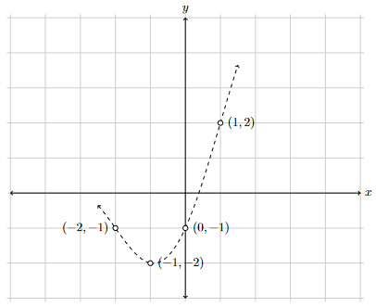
Figure 3. Four-point cubic spline interpolation [17]

This research methodology involves eight main stages. The initial stage entails reading the dataset, identifying target features, exogenous features, and determining the IMF threshold. Subsequently, in the second stage, the dataset is normalized to scale the data within a range of 0 to 1. The third stage involves preprocessing the data utilizing XCEEMDAN to generate IMF signals. Following this, in the fourth stage, the IMF signal frequencies are grouped based on the designated IMF threshold value. Moving on to the fifth stage, low-level IMF signals with high frequencies are forecasted using the Bidirectional LSTM model with the assistance of an attention mechanism, while high-level IMF signals with low frequencies are predicted using a spline model. These predicted IMF signals are then aggregated to derive the anticipated values of the target feature. Subsequently, testing is conducted to generate predictions for the target features, as illustrated in the flowchart depicted in Figure 4.
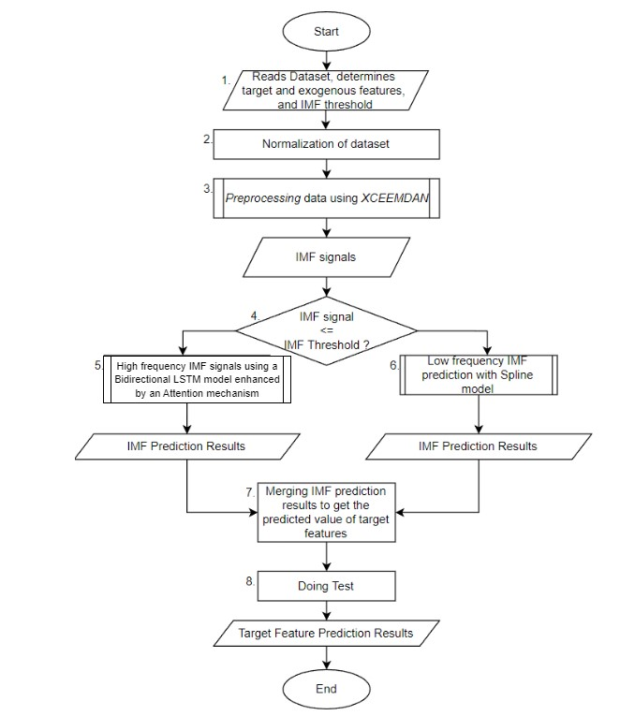
Figure 4. Research Method Flowchart

The adjusted closing stock price prediction is obtained by combining the overall prediction results of the IMF (recomposition) using the Bidirectional LSTM - Spline model enhanced with the attention mechanism. The predicted adjusted closing price will be compared with the actual adjusted closing price, namely by comparing the values of train_predicted with train_real, validation_predicted with validation_real, and test_predicted with test_real. The comparison graph between the predicted values of the adjusted close and the real values of PETR4 equity with the IMF 2 threshold value can be seen in Figure 5. The y-axis shows the predicted value of the adjusted close while the x-axis shows the time period.
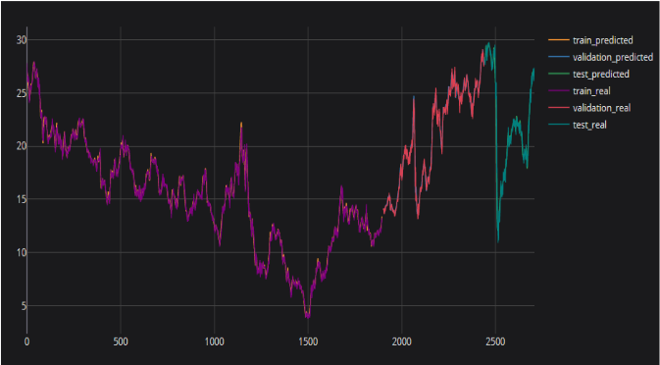
Figure 5. Comparison graph of the predicted value of adj close with the real value of PETR4 equity with the
IMF threshold value of 2

The problem-solving framework is presented in Figure 6. The process commences with data preprocessing using a signal processing technique known as CEEMDAN on exogenous features to process input data (XCEEMDAN). Subsequently, the output from XCEEMDAN is utilized as input for the LSTM-Spline model to predict stock prices. XCEEMDAN-LSTM-SPLINE demonstrates a performance increase of 65.233% for the average RMSE compared to the CEEMDAN-LSTM model. Previous research on the Bidirectional LSTM model used for stock price prediction shows an average accuracy increase of 37.78% compared to the LSTM model [4]. The XCEEMDAN-Bidirectional LSTM-Spline model successfully improves accuracy compared to the XCEEMDAN-LSTM-Spline model, as evidenced by a lower Root Mean Square Error (RMSE) value of 0.7929055 at the IMF 2 threshold [18]. The inclusion of the Attention mechanism in the model not only enhances information processing efficiency but also addresses information loss issues typically encountered in long sequences within LSTM models, making the model more robust and reliable in stock price prediction [19].
Based on these initial conditions, the intended research involves using XCEEMDAN for data preprocessing. The resulting output from XCEEMDAN is then used as input for Bidirectional LSTM-Spline, with the addition of the attention mechanism, to predict stock prices. This combination of four methods has not been tested for its ability to remember both backward and forward data and capture additional information supporting prediction results. The data used in this study is secondary data obtained from Yahoo Finance, comprising historical data on Brazilian equities PETR4, VALE3, BOVA11, ITUB4, BBDC4, B3SA3, BBAS3, ABEV3, MGLU3 from January 1, 2010, to December 31, 2023. The dataset is publicly available and accessible at the link https://finance.yahoo.com after removing gaps caused by weekends and holidays. The attributes used in this study are open, high, low, adj close, and volume, as these attributes are highly correlated with the output results of the adjusted close price. In this study, we compared the XCEEMDAN Bidirectional LSTM Spline model with the XCEMDAN - Bidirectional LSTM - Attention Mechanism - Spline model (the proposed model) at the IMF 2 threshold value. We have demonstrated that the performance of the proposed model is superior compared to the other models examined. This comparison is illustrated in Figure 6, which depicts the Problem Solving Framework
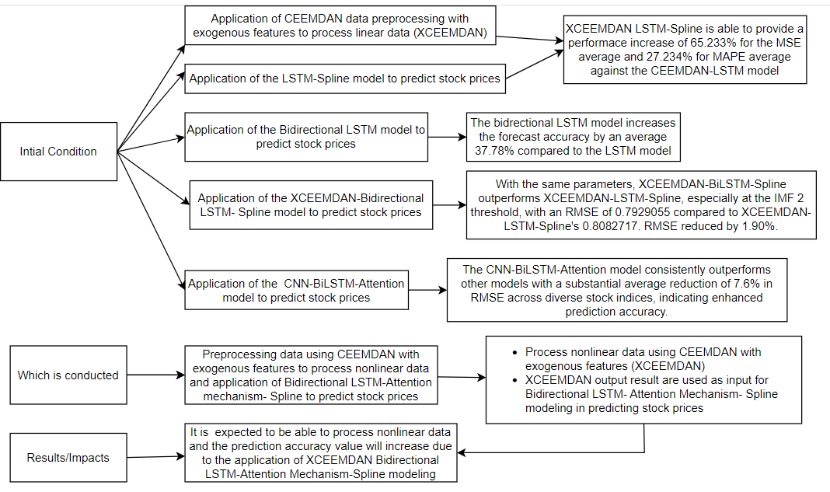
Figure 6. Problem Solving Framework

- RESULTS AND ANALYSIS
This test was conducted to compare which model has the lowest RMSE value in the PETR4, VALE3, BOVA11, ITUB4, BBDC4, B3SA3, BBAS3, ABEV3, MGLU3 datasets with the same parameters. The parameters used in testing this model can be seen in Table 1, and the results of the comparison of the performance of the tested models can be seen in Table 2. The XCEEMDAN-Bidirectional LSTM-Attention Mechanism-Spline model performed better at the IMF 2 threshold with an RMSE value of 0.5708777053 compared to the XCEEMDAN - Bidirectional LSTM - Spline model which has an RMSE value of
0. 5823726212. This difference indicates that the XCEEMDAN-Bidirectional LSTM-Attention Mechanism-Spline model has a higher level of accuracy in prediction compared to the XCEEMDAN - Bidirectional LSTM- Spline model.

Table 1. Parameters used in model testing with Threshold at IMF 2
Model | XCEEMDAN- Bidirectional LSTM – Spline | XCEEMDAN- Bidirectional LSTM – Attention Mechanism- Spline
Desc. | Kelvin et al.  (2022) | Proposed  model
Neuron | 128,64 | 128,64
Dense | 16,4,1 | 16,4,1
Start date | 1/1/2010 | 1/1/2010
End date | 31/12/2023 | 31/12/2023
Noise scale | 0.15 | 0.15
Noise seed | 3877415934 | 3877415934

Table 2. Parameters used in model testing with Threshold at IMF 2
Model | XCEEMDAN- Bidirectional LSTM – Spline | XCEEMDAN- Bidirectional LSTM – Attention Mechanism- Spline
Desc. | Kelvin et al.  (2022) | Proposed  model
PETR4 | 0.5295243582 | 0.5187685475
VALE3 | 1.330331274 | 1.340392813
BOVA11 | 1.338174056 | 1.264265789
ITUB4 | 0.3848225672 | 0.3776617867
BBDC4 | 0.3180853057 | 0.3117363035
B3SA3 | 0.3137688701 | 0.2999769985
BBAS3 | 0.7205406243 | 0.7161180332
ABEV3 | 0.163315958 | 0.1624699187
MGLU3 | 0.1427905777 | 0.1465091581
AVERAGE | 0.5823726212 | 0.5708777053

- CONCLUSION (10 PT)
Based on the test results and discussions conducted, it can be concluded that the testing using the same parameters on the XCEEMDAN-Bidirectional LSTM-Spline model indicates that the proposed model, namely XCEEMDAN-Bidirectional LSTM-Spline with attention mechanism, performs better at the IMF 2 threshold with an RMSE value of 0.5708777053 compared to the XCEEMDAN-Bidirectional LSTM-Spline model, which only has an RMSE value of 0.5823726212.

REFERENCES
- O. Hegazy, OS Soliman, and MA Salam, “A Machine Learning Model for Stock Market Prediction,” Int. J.
Comput. science. Telecommun., vol. 4, no. May 2014, pp. 17–23, 2014, [Online]. Available:
http://arxiv.org/abs/1402.7351.
- M. Jia, J. Huang, L. Pang, and Q. Zhao, “Analysis and Research on Stock Price of LSTM and Bidirectional
LSTM Neural Network,” in International Conference on Computer Engineering, Information Science &
Application Technology (ICCIA 2019) Analysis , 2019, vol. 90, no. Iccia, pp. 467–473, doi:10.2991/iccia-
19.2019.72.
- Z. Jin, Y. Yang, and Y. Liu, “Stock closing price prediction based on sentiment analysis and LSTM,” Neural
Comput. Appl., vol. 32, no. 13, pp. 9713–9729, 2020, doi:10.1007/s00521-019-04504-2.
- R. De Luca Avila and G. De Bona, “Financial Time Series Forecasting via CEEMDAN-LSTM with Exogenous
Features,” in Lecture Notes in Computer Science (including subseries Lecture Notes in Artificial Intelligence and
Lecture Notes in Bioinformatics), 2020, vol. 12320 LNAI, pp. 558–572, doi:10.1007/978-3-030-61380-8_38.
- P. Flandrin, E. Torres, and MA Colominas, “A COMPLETE ENSEMBLE EMPIRICAL MODE
DECOMPOSITION,” in IEEE International Conference on Acoustics, Speech and Signal Processing (ICASSP),
2011, pp. 4144–4147, doi:10.109/ICASSP.2011.5947265.
- M. Roondiwala, H. Patel, and S. Varma, “Predicting Stock Prices Using LSTM,” Int. J. Sci. Res., vol. 6, no. 4,
pp. 2319–7064, 2015, [Online]. Available: https://www.quandl.com/data/NSE.
- Z. Cui, R. Ke, Z. Pu, and Y. Wang, “Stacked bidirectional and unidirectional LSTM recurrent neural network for
network-wide traffic speed prediction,” arXiv, pp. 1–11, 2018
- J. Cao, Z. Li, and J. Li, “Financial time series forecasting model based on CEEMDAN and LSTM,” Phys. A
Stats. mech. its Appl., vol. 519, pp. 127–139, 2019, doi:10.1016/j.physa.2018.11.061.
- Y. Xuan, Y. Yu, and K. Wu, “Prediction of Short-term Stock Prices Based on EMD-LSTM-CSI Neural Network
Method,” IEEE Int. conf. Big Data Anal., pp. 135–139, 2020, doi:10.1109/ICBDA490404.2020.9101194.
- S. Siami-Namini, N. Tavakoli, and AS Namin, “The Performance of LSTM and BiLSTM in Forecasting Time
Series,” in Proceedings - 2019 IEEE International Conference on Big Data, Big Data 2019, 2019, pp. 3285–3292,
doi:10.109/BigData470990.2019.9005997.
- Zulfikar, Introduction to Capital Markets with a Statistical Approach. 2016.
- M. Vijh, D. Chandola, VA Tikkiwal, and A. Kumar, “Stock Closing Price Prediction using Machine Learning
Techniques,” Procedia Comput. Sci., vol. 167, no. 2019, pp. 599–606, 2020, doi:10.1016/j.procs.2020.03.326.
- NE Huang, Z. Shen, and SR Long, “A NEW VIEW OF NONLINEAR WATER WAVES : The Hilbert Spectrum
1,” 1999.
- M. Camilleri, “Forecasting Using Non-Linear Techniques In Time Series Analysis: An Overview Of Techniques
and Main Issues,” Univ. Malta Comput. science. soo. res. Work., pp. 19–28, 2004.
- Z. Wu and NE Huang, “Ensemble Empirical Mode Decomposition : A Noise Assisted Data Analysis Method,”
no. August, 2005.
- M. Rosidi, Numerical Method Using R for Environmental Engineering. 2019.
- I. James P. Howard, Computational Methods for Numerical Analysis with R. Taylor & Francis Group, LLC,
- Kelvin, Ronsen Purba, and Arwin Halim, "Stock Price Prediction Using XCEEMDAN-Bidirectional LSTM-Spline," Indonesian Journal of Artificial Intelligence and Data Mining (IJAIDM), vol. 5, no. 1, pp. 1-12, Mar. 2022, https://doi.org/10.24014/ijaidm.v5i1.14424.
- Zhang, J., Ye, L., & Lai, Y. (2023). Stock Price Prediction Using CNN-BiLSTM-Attention Model. Retrieved from https://doi.org/10.3390/math11091985

BIBLIOGRAPHY OF AUTHORS (10 PT)

 | Kelvin, S.Kom., M.Kom.,  Informatics Engineering  in Mikroskil University, Medan
 | Frans Mikael Sinaga, S.Kom., M.Kom.  Informatics Engineering  in Mikroskil University, Medan

