Evaluation of Support Vector Machine, Naive Bayes, Decision Tree, and Gradient Boosting Algorithms for Sentiment Analysis on ChatGPT Twitter Dataset

¹Salsabila Rabbani, ²Dea Safitri, ³Farida Try Puspa Siregar, ⁴Rahmaddeni, ⁵Lusiana Efrizoni
^{1,2,3,4,5}Departement of Informatics Engineering, STMIK Amik Riau, Jalan Purwodadi, Pekanbaru, Riau
Email: ¹201003182104@sar.ac.id, ²2010031802001@sar.ac.id, ³2010031802042@sar.ac.id, ⁴rahmaddeni@sar.ac.id, ⁵lusiana@stmik-amik-riau.co.id

Article Info |  | ABSTRACT
Article history:  Received May 12th, 2019  Revised Jun 20th, 2020  Accepted Jul 26th, 2020 |  | ChatGPT is a language model employed to produce text and engage in conversation with users. It serves as a tool for generating text and facilitating interactions in a conversational manner. The model was designed to provide relevant and useful responses based on the context of the ongoing conversation. By the increasing popularity of using ChatGPT, it makes it difficult for users to classify responses about the use of ChatGPT. Therefore, sentiment classification of ChatGPT is carried out. The dataset used is sourced from the kaggle website with a total of 20,000 data. The classification methods used in this research include Support Vector Machine (SVM), Naïve Bayes, Decision Tree, and Gradient Boosting. Through the research results, the Support Vector Machine algorithm had the highest accuracy value with 80% compared to other methods, when the data is divided by a ratio of 90:10. This research is expected to help developers and service providers to improve ChatGPT and understand user responses better.
Keyword:
Sentiment Analysis
Support Vector Machine
Naive Bayes
Decision Tree
Gradient Boosting

 |  | Copyright © 2022 Puzzle Research Data Technology
Corresponding Author:
Rahmaddeni,
Department of Informatics Engineering,
STMIK Amik Riau,
Jalan Purwodadi, Pekanbaru, Riau.
Email: rahmaddeni@sar.ac.id
DOI: http://dx.doi.org/10.24014/ijaidm.v2i2.xxxx (10 pt)

- INTRODUCTION
ChatGPT is an OpenAI-developed language model that utilizes the GPT (Generative Pre-trained Transformer) framework to generate natural and interactive text. The model has undergone thorough training using large volumes of data to generate coherent and contextually suitable replies [2]. ChatGPT possesses remarkable capabilities to advance academia and librarianship in novel ways, which elicit concerns and pique interest [7]. ChatGPT has become a trend in various fields today, especially in the field of technology. This is because ChatGPT has the capability to give accurate and thorough responses to a wide range of inquiries from humans, including the ability to rectify incorrect queries [8].
The use of online communication has become an ever-present thing in daily activities. The existence of information technology in the form of platforms that are developing very rapidly allows users to find information quickly and practically. One of the most famous social media platforms is Twitter, where users are able to share their thoughts, opinions, and experiences with the world. However, with the high volume of tweets, it is important for us to be able to analyze and understand user sentiment towards a particular topic or entity.
To determine whether sentiment text contains positive, negative, or neutral sentiment, sentiment classification is required. Sentiment classification is a methodology employed to recognize and categorize sentiments or opinions expressed in text [1]. In order to understand how Twitter users respond to ChatGPT, sentiment analysis can provide valuable insights in understanding users' views and getting feedback on their experiences with ChatGPT [3].
In this research, classification will be performed using 4 different algorithm models, namely Support Vector Machine (SVM), Naïve Bayes, Decision Tree, and Gradient Boosting. These four algorithms will be tested using data mining and Natural Language Processing (NLP) processing techniques. Furthermore, they will be combined with Feature Selection, namely K-Fold and Adaboost to help the model increase the accuracy rate. The text of tweets containing sentiment towards ChatGPT will be analyzed and classified into positive, neutral, and negative categories.
Feature Selection Adaboost works by combining several weak learners into one stronger model. Research [9] proves that Feature Selection Adaboost can increase the accuracy of the Naïve Bayes algorithm in every splitting data tested and the SVM algorithm outperforms with an accuracy rate of 82% with 90:10 data splitting.
In the context of feature selection, k-fold cross-validation can help in selecting the most informative or relevant subset of features to improve model performance. Research [4] comparing the performance of Naïve Bayes, Support Vector Machine (SVM), Random Forest, Neural Network, Decision Tree, and K-Nearest Neighbor (K-NN) algorithms using feature extraction selection between TF-IDF, Word2Vec, and Word Embedding (one hot encoding) shows the results of evaluating the performance of the TF-IDF feature extraction model with the SVM method is the highest by utilizing K-Fold cross-validation, an accuracy of 92.6% was achieved for datasets without labels, while labeled datasets obtained 80.3% accuracy.
The Support Vector Machine (SVM) model constructs a hyperplane that possesses the largest possible gap between two categories, so as to maximize the separation between positive and negative classes. In [5], a comparison was made between the Naïve Bayes, Decision Tree, and SVM models. Through the research results, the SVM method has better performance than Naïve Bayes and Decision Tree. The accuracy of the SVM model reached 83.33%, while Naïve Bayes reached 70%, and Decision Tree reached 79%.
Another research is about Sentiment Analysis of Indonesian Success with Naïve Bayes and Decision Tree methods by [6], The tweet analysis results using the Naïve Bayes technique indicated an accuracy rate of 83.00% with a variation of +/- 10.5% (micro average: 83.00%). Conversely, the Decision Tree approach yielded an accuracy rate of 77.00% with a variation of +/- 4.58% (micro average: 77.00%). Therefore, concluding the Naïve Bayes model outperforms the Decision Tree model.
Based on the results of some previous research, this study is expected to explore Twitter users' knowledge of ChatGPT. The analysis results can help developers and service providers to improve ChatGPT and understand users' responses better. This study can also determine which algorithm is most accurate for classifying tweet text.

- RESEARCH METHODS
The sentiment analysis research pertaining to ChatGPT involves a well-planned and systematic approach to address the problem effectively. The dataset, sourced from public opinions on Twitter, needs to be carefully selected to ensure its relevance to the problem at hand, as well as its adequacy in training and evaluating the model. In Figure 1, there is a sequence of steps: collecting data, then pre-processing the data, then splitting the data, by dividing the training data and test data. In the training data, the model classification and feature selection stages are carried out, after which the model evaluation stage is carried out, and ends with a conclusion from the comparison results of the four methods.
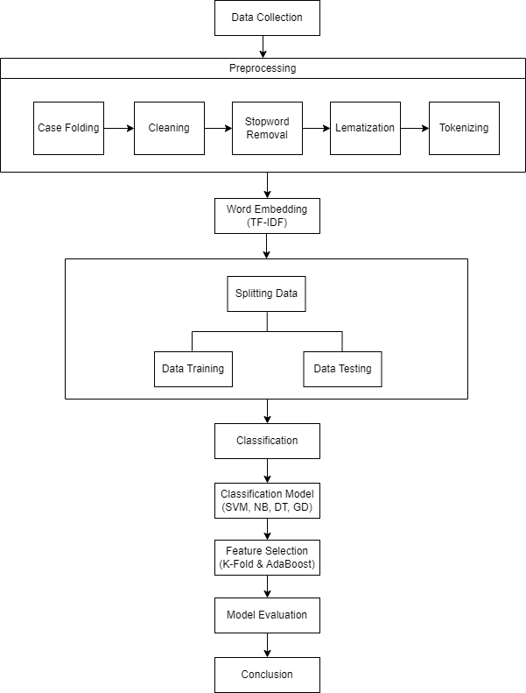
Figure 1. Research Methods
2.1 Data Collection
The research employs a collection of tweet information for analysis taken from the Twitter platform and obtained through the Kaggle data source. The amount of data used was 20,000 tweets. The keywords used to retrieve tweet data are phrases containing the phrase "ChatGPT''. Labeling of each data is done automatically and directly from the public Kaggle dataset, there are 3 labels given, namely negative, positive and neutral classes. Some of the libraries used in testing use the Python programming language through the Jupyter IDE, which includes pandas, numpy, nltk, matplotlib, and word cloud.

2.2 Preprocessing
The dataset collected is still in the form of unstructured data, so it is necessary to do preprocessing so that the data becomes more structured. The preprocessing process carried out in this study involves several stages, namely changing letters to lowercase letters (case folding), cleaning data (cleaning), filtering words (filtering) or stopword removal, restoring basic words (lemmatization), and separating words into tokens (tokenizing).
- The Case folding stage involves the process where capital letters are converted into lowercase letters as a whole [10].
- Cleaning stage is the stage of eliminating words that are not needed [10]. For example, numbers (1), word separators namely commas (,), periods (.), exclamation marks (!), and other punctuation marks. Tokenization is the act of dividing a provided text into separate words or phrases [11].
- Next is the filtering stage, where the selection of words that are considered important from the tokenization results is done [13]. Words that do not provide information such as the, is, a, and, are, etc., will be removed.
- Then Lemmatization will be utilized on the refined reviews, while stemming involves converting words to their root form to enhance model efficiency [14]. Example: helping, helped, helps will become help.
- Tokens are unique words that will be used as identification for sentiment clustering. Before tokenizing, the words in the tweet are separated using space characters. The tweet data is converted to lowercase before processing. Links, usernames, and symbols are removed, and spelling or writing errors are corrected to make the text more accurate.

2.3 Word Embedding
Word Embedding is a process that converts words into numerical representations (word vectors) [9]. The research applies the TF-IDF method on word embedding in documents. This technique converts text data into vectors, considering the proper word order. Each word in the corpus receives a numerical value through TF-IDF, indicating its significance in the collection [15]. These numerical values derived from TF-IDF are then utilized as input for a supervised learning classifier [16] to enable interpretation within the context of machine learning methods. To perform TF-IDF calculation using the Python Sklearn library, we can use TfidfVectorizer. Here is the word weighting formula.

W_{𝑖𝑗} = 𝑡𝑓_{𝑖𝑗} × log ($\frac{n}{df}$) (1)

Where Wij is the weight that determines the importance of a word or term, tfij is the term frequency which is the number of times the term appears, and ndf is the total document frequency of the term in the entire document collection.

2.4 Splitting Data
The data was split into training data and test data, consisting of three experiments conducted for data separation, namely:
- Training data consists of 70% and testing data of 30%.
- The training data consists of 80% and the testing data of 20%.
- Training data consists of 90% and testing data 10%.
2.4.1. Data Training
The utilization of training data for the purpose of training this research system is to enable the SVM, Naïve Bayes, Decision Tree, and Gradient Boosting classification methods to acquire the ability to categorize comments into negative, neutral, or positive. The training data plays a crucial role in familiarizing these classification methods with the patterns and characteristics of different types of comments, enabling them to learn and develop the necessary skills to accurately classify new comments.
2.4.2. Data Testing
After training the classification model, the subsequent phase involves assessing the effectiveness of the approach using a test dataset. The objective of this testing process is to evaluate the performance of SVM, Naïve Bayes, Decision Tree, and Gradient Boosting classification methods. This is accomplished by inputting new data into the model, which will then correctly categorize the new information as either negative, neutral, or positive.

2.5 Classification
This research attempts to apply four different classification methods to analyze sentiment on tweet data. The classification methods used are Support Vector Machine (SVM), Naïve Bayes, Decision Tree, and Gradient Boosting, which aims to compare and evaluate the performance of each method in classifying tweet sentiment.
2.5.1. Support Vector Machine
The SVM (Support Vector Machine) method relies on support vectors to separate classes of data that have different characteristics [17]. SVM tries to find the hyperplane that best separates tweet data with negative, neutral, and positive sentiments. SVM has a good ability to handle complex data and has advantages in handling cases with high feature dimensions. In this case, the general formula for linear SVM can be written as follows:

f(x) = sign(w.x + b) (2)

Where, f(x) is the prediction function, w is the hyperplane normal vector, x is the input feature vector, and b is the bias or intercept.

2.5.2. Naïve Bayes
The primary characteristic of Naïve Bayes is its ability to generate robust hypotheses by considering specific conditions or events [18]. This approach computes the conditional probability for each sentiment category by analyzing the occurrence of words in the training dataset. It then classifies new tweet data by assigning it to the category with the highest probability. Here is the equation:
P(C|X) = ($\frac{P(X|C) * P(C)}{P(X)}$) (3)

The equation (3) represents the conditional probability P(C|X), which is calculated as the product of the probability of event X occurring given that C has happened (P(X|C)) and the joint probability of C and X (P(C)P(X)). In other words, it determines the likelihood of event C happening given that event X has occurred.
2.5.3. Decision Tree
Decision Tree is a sequential model that combines a series of basic tests to classify data that uses numerical features in the dataset to divide the data into smaller subsets [19]. The decision tree is built by making decisions at each node based on features that divide the data into smaller subsets. The decision at each node is based on criteria such as entropy or information gain. In the Decision Tree algorithm, there are several formulas used to build and predict using decision trees. Here are some formulas related to Decision Tree:
- Gini Index, used to measure impurity at nodes in the decision tree.

Gini Index = 1 - Σ(p_i)^2 (4)

- Information Gain, used to measure the decrease in impurity resulting from dividing data based on a feature at each node. The Information Gain formula is:

Information Gain = Impurity before sharing - Impurity after sharing (5)

- Entropy, used to measure the impurity of the nodes in the decision tree. The Entropy formula is:
Entropy = -Σ(p_i * log2(p_i)) (6)

2.5.4. Gradient Boosting
The Gradient Boosting method is a classification method that combines several weak learner models into one stronger model [20]. This method iterates to improve model performance by focusing on the most difficult to predict samples. Gradient Boosting usually uses Decision Tree as a weak learner. Here are the formulas associated with Gradient Boosting in the context of classification:
- Initial phase, initialize the initial model prediction (F_0) as the average target value on the training data..
F_0 = argmin Σ(y - F_0)^2 (7)

- Iteration (t = 1, 2, ..., T), calculate the residual (r) as the difference between the actual target (y) and the current model prediction (F_t-1).

r = y - F_t-1 (8)

Build a weak learner (usually a Decision Tree) that will predict the residual r. Each weak learner is generated with respect to samples that are still difficult to predict. Update the model prediction by adding the weak learner prediction (h_t) multiplied by the learning rate (α).
F_t = F_t-1 + α * h_t (9)

The equation (9) represents the iterative process in which the model prediction (F_t) is updated by adding a weighted contribution from a new weak learner (h_t). This process is repeated until a specified number of iterations (T) is reached. The learning rate (α) determines the extent of each weak learner's impact on the overall model prediction.

2.6 Feature Selection
In feature selection, the most important and informative set of features is selected from the various features available in the dataset. The purpose of feature selection is to identify and retain those features that contribute most to predicting or classifying the target or variable of interest, while reducing complexity and noise that may be present in the dataset.
The feature selection used in the test is AdaBoost and K-Fold. This test was conducted to evaluate the effectiveness of AdaBoost and K-Fold feature selection in improving the accuracy of SVM, Naïve Bayes, Decision Tree, and Gradient Boosting algorithms.

2.8 Model Evaluation
Model testing is required to assess the effectiveness of four methods: SVM, Naïve Bayes, Decision Tree, and Gradient Boosting. In research evaluated using the accuracy value. The accuracy value is an evaluation matrix used to measure how well a classification or prediction model can provide correct results or match existing data. Accuracy describes the percentage of success of the model in predicting the right class or label.
To assess the effectiveness of Support Vector Machine (SVM), Naïve Bayes, Decision Tree, and Gradient Boosting algorithms utilizing AdaBoost and K-Fold, a confusion matrix table is employed to present the classification outcomes. Furthermore, during the model evaluation accuracy is computed to evaluate the classification methods for each class. These calculations are performed using the Python 3 programming language.
It measures the extent to which the model can correctly classify the data as a whole. In other words, accuracy describes the percentage of success the model has in predicting the correct class. The accuracy scores have a scale of zero to one, where higher values indicate better model performance.

Accuracy = $\frac{(Number of True Predictions)}{(Total Number of Data)}$ (10)

2.9 Conclusion
Based on the above steps, this research is expected to find the classification method that gives the best results in classifying tweet sentiment. The evaluation results will provide information on the relative performance of each classification method in terms of accuracy and their ability to classify sentiment into negative, neutral, or positive classes.

- RESULTS AND ANALYSIS
The raw data taken is 20,000 user tweets data against ChatGPT. The raw data will be preprocessed to reduce deviations in the data to be analyzed. The preprocessing stage in this study includes removing nulls, removing URLs and symbols, converting the entire text to lowercase, removing stopwords, converting words into their base words, and separating sentences into words.

Table 1. Preprocessing text results
Tweets | Cleaning | Stopword Removal | Lemmatization | Tokenizing
ChatGPT: Optimizing Language Models for Dialog... | chatgpt optimizing language models for dialogu... | chatgpt optimizing language models dialogue rk... | chatgpt optimize language model dialogue rkrygyyn | [chatgpt, optimize, language, model, dialogue,...
Try talking with ChatGPT, our new AI system wh... | try talking with chatgpt our new ai system whi... | try talking chatgpt new ai system optimized di... | try talk chatgpt new ai system optimize dialog... | [try, talk, chatgpt, new, ai, system, optimize...
ChatGPT: Optimizing Language Models for Dialog... | chatgpt optimizing language models for dialogu... | chatgpt optimizing language models dialogue gl... | chatgpt optimize language model dialogue glebm... | [chatgpt, optimize, language, model, dialogue,...

The next stage is to assign values to words in the text using TF-IDF which can help in determining the most relevant or meaningful words in determining the sentiment of a text.

Table 2. Result of word weighting with TF-IDF
Term Frequency | Inverse Document Frequency | TF-IDF
0 | 539 | 0,3849
0 | 842 | 0,19245
0 | 1262 | 0,19245
0 | 1269 | 0,19245
0 | 2688 | 0,19245
….. | ….. | …..
0 | 20405 | 0,19245
0 | 21451 | 0,19245
0 | 24611 | 0,19245
0 | 25765 | 0,19245
0 | 31425 | 0,19245

Next, implement the data into the Support Vector Machine, Naïve Bayes, Decision Tree, and Gradient Boosting models based on feature selection and data splitting ratios of 70:30, 80:20, and 90:10.

Table 3. Results of model comparison based on accuracy
Splitting Data | Without K-Fold Cross & Adaboost Validation |  |  |  | With K-Fold Cross Validation |  |  |  | Accuracy Improvement with AdaBoost
Splitting Data | SVM | NB | DT | GB | SVM | NB | DT | GB | SVM | NB | DT | GB
70 : 30 | 0,78 | 0,66 | 0,69 | 0,68 | 0,75 | 0,64 | 0,69 | 0,69 | 0,47 | 0,47 | 0,53 | 0,76
80 : 20 | 0,78 | 0,66 | 0,69 | 0,68 | 0,76 | 0,65 | 0,69 | 0,69 | 0,47 | 0,47 | 0,54 | 0,76
90 : 10 | 0,80 | 0,67 | 0,71 | 0,69 | 0,77 | 0,66 | 0,70 | 0,69 | 0,47 | 0,47 | 0,54 | 0,78
The table above shows that the SVM algorithm without using feature selection with 90:10 data splitting has the highest accuracy rate which reaches 80%. While the Gradient Boosting algorithm using K-fold feature selection experienced a performance increase of 1% and using Adaboost feature selection of 8-9%.
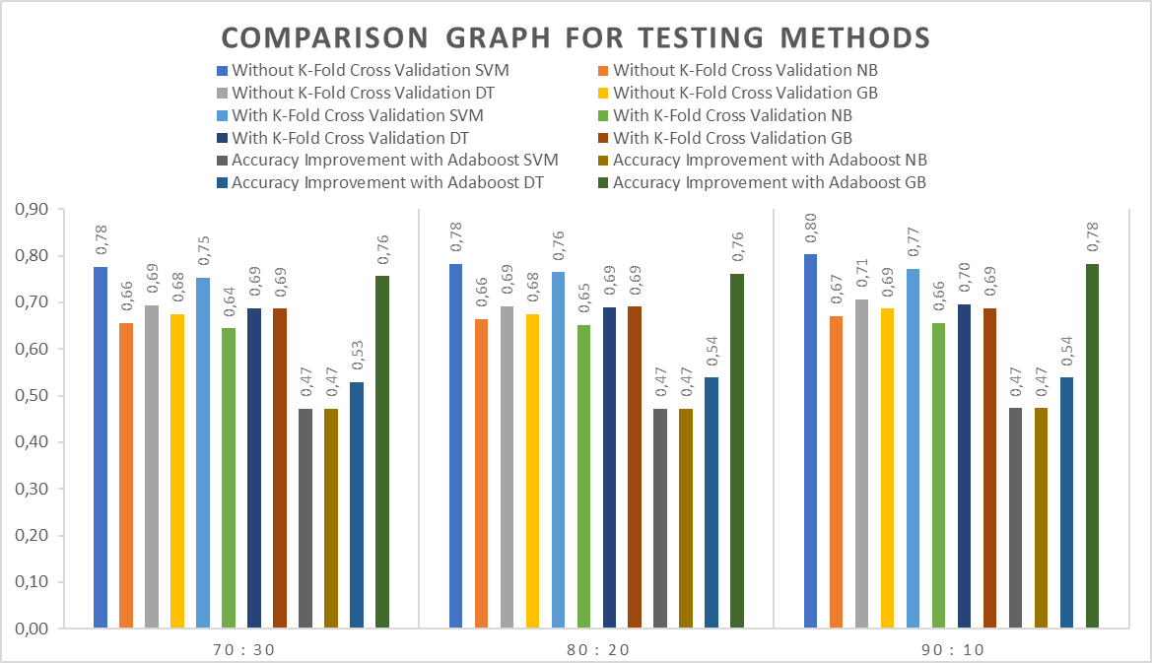
Figure 2. Comparison Chart of Testing Methods Based on Accuracy Results
Table 3 and Figure 6 above show the comparative accuracy results of Support Vector Machine, Naive Bayes, Decision Tree and Gradient Boosting methods on the dataset. In the test, the one that achieved the highest accuracy was Support Vector Machine with a data split of 90:10. The accuracy achieved is 80%.
The dataset contains negative, positive, and neutral sentiments. Each sentiment is visualized using Clouding Words for the frequency of words that appear frequently.
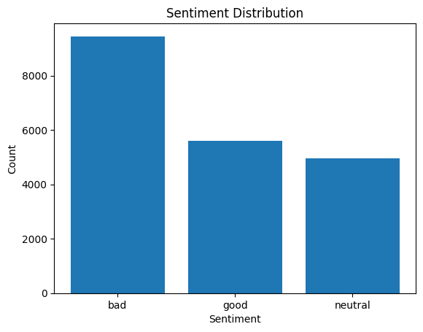
Figure 3. Visualization of ChatGPT sentiment chartbar
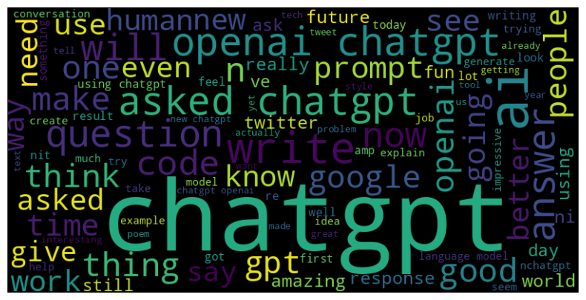
Figure 4. Clouding words for negative sentiment

In the dataset, there are 9448 sentiments labeled as negative, 5590 labeled as positive, and 4962 labeled as neutral. In Figure 4 is a visualization of the number of sentiments using a bar chart. From Figure 3 and Figure 4, it can be concluded that most twitter users give more negative responses to ChatGPT with the frequency of words that often appear in chatgpt.

- CONCLUSION
Based on the information preparing, testing and examination, it can be concluded that the ChatGPT dialect demonstrated has gotten a negative reaction by Twitter users. This can be seen from testing 20000 data there are 9448 data is a negative response. From the results of testing the 4 algorithms, namely, SVM, Naïve Bayes, Decision Tree, and Gradient Boosting, it shows that the SVM algorithm with 90:10 data splitting is the best algorithm for sentiment classification of ChatGPT analysis.
When utilizing Adaboost feature selection, the Gradient Boosting method model studies indicate an improvement in accuracy value in each splitting of data. This shows that Adaboost is a good feature selection for Gradient Boosting modeling. In addition, the best data splitting of ChatGPT sentiment classification is 90:10, because it has the best accuracy value of most of the models used.
Testing the Gradient Boosting algorithm using K-Fold feature selection shows an increase in accuracy. Although the increase is not as large as Adaboost, it shows that by selecting the optimal subset of features, the Gradient Boosting+K-Fold model can be more efficient and able to produce more accurate results than the original Gradient Boosting model.
Overall, this research shows that the SVM algorithm is the best technique with the highest accuracy value to classify ChatGPT sentiment. In addition, feature selection can improve the performance of Gradient Boosting algorithm in the dataset.

REFERENCES
- Parimala, M., Swarna Priya, R. M., Praveen Kumar Reddy, M., Lal Chowdhary, C., Kumar Poluru, R., & Khan, S. (2021). Spatiotemporal‐based sentiment analysis on tweets for risk assessment of event using deep learning approach. Software: Practice and Experience, 51(3), 550-570.
- George, A. S., & George, A. H. (2023). A review of ChatGPT AI's impact on several business sectors. Partners Universal International Innovation Journal, 1(1), 9-23.
- Juniarsih, S., Ripanti, E. F., & Pratama, E. E. (2020). Implementasi Naive Bayes Classifier pada Opinion Mining Berdasarkan Tweets Masyarakat Terkait Kinerja Presiden dalam Aspek Ekonomi. JUSTIN (Jurnal Sistem dan Teknologi Informasi), 8(3), 239-249.
- D. Marutho, Muljono, S. Rustad and Purwanto, "Sentiment Analysis Optimization Using Vader Lexicon on Machine Learning Approach," 2022 International Seminar on Intelligent Technology and Its Applications (ISITIA), Surabaya, Indonesia, 2022, pp. 98-103, doi: 10.1109/ISITIA56226.2022.9855341.
- Aldisa, R. T., & Maulana, P. (2022). Analisis Sentimen Opini Masyarakat Terhadap Vaksinasi Booster COVID-19 Dengan Perbandingan Metode Naive Bayes, Decision Tree dan SVM. Building of Informatics, Technology and Science (BITS), 4(1), 106-109.
- Ramadhan, M. A., & Wahyudin, M. I. (2022). Analisis Sentimen Mengenai Keberhasilan Indonesia di Ajang Thomas Cup 2020 (Studi Kasus Media Sosial Twitter) Menggunakan Metode Naïve Bayes dan Decision Tree. Jurnal JTIK (Jurnal Teknologi Informasi dan Komunikasi), 6(4), 505-511.
- Lund, B. D., & Wang, T. (2023). Chatting about ChatGPT: how may AI and GPT impact academia and libraries?. Library Hi Tech News, 40(3), 26-29.
- Zhong, Q., Ding, L., Liu, J., Du, B., & Tao, D. (2023). Can chatgpt understand too? a comparative study on chatgpt and fine-tuned bert. arXiv preprint arXiv:2302.10198.
- Rahmaddeni, & Akbar, F. (2021). Public Opinion on Covid-19 Vaccination in Indonesia: A Sentiment Analysis on Twitter. International Journal of Advanced Intelligence and Data Mining, 6(1), 8-17.
- Sidik, F., Suhada, I., Anwar, A. H., & Hasan, F. N. (2022). Analisis Sentimen Terhadap Pembelajaran Daring Dengan Algoritma Naive Bayes Classifier. Jurnal Linguistik Komputasional, 5(1), 34-43.
- A. S. Alammary, "Arabic Questions Classification Using Modified TF-IDF," in IEEE Access, vol. 9, pp. 95109-95122, 2021, doi: 10.1109/ACCESS.2021.3094115.
- M. S. Neethu and R. Rajasree, “Sentiment analysis in twitter using machine learning techniques,” in 2013 Fourth International Conference on Computing, Communications and Networking Technologies (ICCCNT), 2013, pp. 1–5.
- Khaira, U., Johanda, R., Utomo, P. E. P., & Suratno, T. (2020). Sentiment analysis of cyberbullying on twitter using SentiStrength. Indones. J. Artif. Intell. Data Min, 3(1), 21.
- S. Al-Saqqa, A. Awajan, and S. Ghoul, ‘‘Stemming effects on sentiment analysis using large arabic multi-domain resources,’’ in Proc. 6th Int. Conf. Social Netw. Anal., Manage. Secur. (SNAMS), Oct. 2019, pp. 211–216.
- S. Amin et al., "Recurrent Neural Networks With TF-IDF Embedding Technique for Detection and Classification in Tweets of Dengue Disease," in IEEE Access, vol. 8, pp. 131522-131533, 2020, doi: 10.1109/ACCESS.2020.3009058.
- S. Nirmal and T. Verma, ‘‘E-Mail spam detection and classification using SVM and feature Extraction,’’ Int. J. Advance Res., Ideas Innov. Technol., vol. 3, no. 3, pp. 1491–1495, 2017.
- M. O. Pratama et al., “The sentiment analysis of Indonesia commuter line using machine learning based on twitter data,” J. Phys. Conf. Ser., vol. 1193, no. 1, pp. 1–6, 2019, doi: 10.1088/1742-6596/1193/1/012029.
- Y. Findawati, I. R. I. Astutik, A. S. Fitroni, I. Indrawati, and N. Yuniasih, “Comparative analysis of Naïve Bayes, K Nearest Neighbor and C.45 method in weather forecast,” J. Phys. Conf. Ser., vol. 1402, p. 066046, Dec. 2019, doi: 10.1088/1742-6596/1402/6/066046.
- I. S. Damanik, A. P. Windarto, A. Wanto, S. R. Andani, and W. Saputra, “Decision Tree Optimization in C4. 5 Algorithm Using Genetic Algorithm,” in Journal of Physics: Conference Series, 2019, vol. 1255, no. 1, p. 012012.
- Yang, H., Luo, Y., Ren, X., Wu, M., He, X., Peng, B., et al. (2021). Risk Prediction of Diabetes: Big Data Mining with Fusion of Multifarious Physical Examination Indicators. Inf. Fusion 75, 140–149. doi:10.1016/j.inffus.2021.02.015.

BIBLIOGRAPHY OF AUTHORS

 | Salsabila Rabbani, a student of STMIK Amik Riau, majoring in Informatics Engineering who is interested in data science. The focus of research is machine learning, deep learning, and data mining.
 | Dea Safitri, a student at STMIK Amik Riau, majoring in Informatics Engineering with a concentration in artificial intelligence & Data Science. The focus of research is data mining, deep learning, machine learning, and natural language processing.
 | Farida Try Puspa Siregar, a third-year student of Informatics Engineering at STMIK Amik Riau. I am interested in the development of methods and techniques related to data analysis, machine learning, natural language processing, deep learning, and data mining.
 | Rahmaddeni was born in Padang and is currently a Lecturer in the Informatics Department at STMIK Amik Riau. Riau. He actively teaches in the field of Machine Learning and Data Mining. He holds a bachelor's degree in Informatics Engineering STMIK Amik Riau and S2 Informatics Engineering Universitas Putra Indonesia "YPTK" Padang. His research focus is Machine Learning and Data Mining.
 | Lusiana, born in Pekanbaru on October 20, 1970. Lecturer at STMIK Amik Riau in the Informatics Engineering study program. Research focuses on data science, machine learning, deep learning, data mining, natural language processing and software engineering. S1 at STMIK YPTK Padang (UPI YPTK Padang) with GPA = 3.58 Predicate "Best Graduate". S2 at STTI - Benarif Indonesia - Jakarta with GPA 3.80; Predicate "Cumlaude". S3 at UPI YPTK Padang with GPA 3.91 Predicate "Cumlaude" and "Best Graduate".

