Fuzzy Sugeno with Gain Compensator Based on Pole Placement for Controlling Coupled Water Tank System

¹Halim Mudia, ²Ahmad Faisal, ³Marhama Jelita
^{1’2’3}Departement of Electrical Engineering, State Islamic University of Sultan Syarif Kasim Riau
Email: ¹halim.mudia@uin-suska.ac.id, ²ahmad.faisal@uin-suska.ac.id, ³marhama.jelita@uin-suska.ac.id
Article Info |  | ABSTRACT
Article history: Received Feb 4th, 2022 Revised  Feb 10th, 2022 Accepted Mar 1th, 2022 |  | The control of liquid level in tanks is a classic problem in process industries. Most of the liquid will be processed by chemical or mixing treatment in the tanks. Because of that, the liquid level in the tanks must be regulated, so that in order for this system to work as we want, it needs a control strategy. Therefore, this research will use a control strategy using fuzzy sugeno with a gain compensator based on pole placement for controlling level of tank 2 in the coupled water tank system with setpoint is 10 centimeters at time 0 seconds and 8 centimeters given at time 1000 seconds. Wherein, the gain compensator based on pole placement is used to make the output system robust to changes in setpoint with zero steady-state error and fuzzy sugeno for faster time response. The results show that using the fuzzy sugeno with a gain compensator based on pole placement can follow setpoint given with 0 centimeters of steady-state error, 0% for overshoot, 44,6538 seconds for rising time, 62,2688 seconds for settling time and can follow setpoint changes in 58,8662 seconds.
Keyword:
Coupled Water Tank
Fuzzy
Sugeno
Pole Placement

 |  | Copyright © 2018 Puzzle Research of Data Technology
Corresponding Author:
Halim Mudia
Department of Electrical Engineering Faculty of Science and Technology
State Islamic University of Sultan Syarif Kasim Riau Soebrantas 155 Pekanbaru – Indonesia

INTRODUCTION
An important problem in the process industries is to keep the liquid level at the wished setpoint of value for two connected each other tanks fed by the pump. Because of the interaction between the tanks, designing control is kind of defying and many persons have to try given big attempts [1]. The coupled water tank system is described as the SISO process [2] and is hard to control because of its basic nonlinearity and the appearance of the relation between variables input-output [3].
Solution for that problem, the coupled water tank system requires an efficient and robust controller, and one of the robust controller designs is known as the pole placement method. This kind of liquid level system is used in many industries like thermal plants, steel industries, chemical industries, food processing industries, water treatment and purification, biochemical, etc [4], [5]. Almost all real-world control performances are typically defined by steady-state error, overshoot, rising time, and settling time [6].
In this research, the gain compensator based on the pole placement has been designed by exploring the bass-gura approach for type 1 servo systems (when the plant has no integer) by setting the state feedback poles like the closed-loop system fulfills the desired requirements. The design method of the state feedback compensator is based on the state-space model of the system. Therefore, the value related to setting all closed-loop poles requires computation and feedback of all the state variables of the system. Because of this, the pole placement technique is greatly dependent on the model accuracy of the system while a fuzzy logic-based controller doesn’t need it [7].
The novelty which offered for this research is combined 2 methods become 1 between the fuzzy sugeno and the gain compensator based on pole placement for controlling the coupled water tank system. Many attempts have already been made for controlling the liquid level of the coupled water tank system like in [8],

[9], [10], [11], [12], [13].

METHODOLOGY
This research is this paper will explain the mathematical modeling of coupled water tank system, gain compensator based on pole placement, fuzzy sugeno, results and analysis.

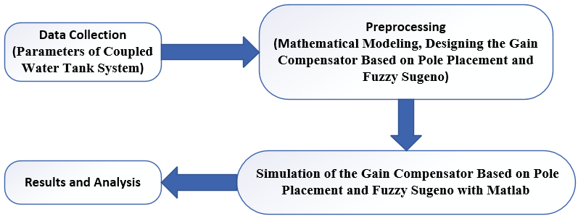
Figure 1. Research Design

Mathematical Modelling of The Coupled Water Tank System
The coupled water tank system is shown in Figure 2 for the experimental scale. It Consists of two tanks and pumps that function to pump water vertically [11]:

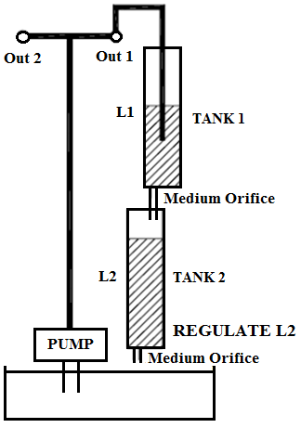
Figure 2. Coupled Water Tank System

The flow to tank 1 is:
$F_{1in}=K_{m}V_{p} {cm}^{3}/sec$ (1)
where $K_{m}$ is the constant pump and $V_{p}$ is the voltage applied to the pump. The outflow velocity is given
by the Bernauli equation for small orifices:
$V_{o}=\sqrt{2 g L_{1}} cm/sec$ (2)
where $g$ is the gravitational acceleration in cm/ sec² and $L_{1}$is the high of the water level in the tank 1 in cm.

The outflow rate is:
$F_{1in-}F_{1out}=K_{m}V_{p}-α_{1}\sqrt{2 g L_{1}} {cm}^{3}/sec$ (3)
Then the change in level of tank 1 is then given, where $A_{1}$is the diameter of the tank 1:
${\dot{L}}_{1}=-\frac{α_{1}}{A_{1}}\sqrt{\frac{g}{ 2 L_{10}}}L_{1}+\frac{K_{m}}{A_{1}}V_{p}$ (4)
The equation of tank 2 for inflows and outflows is:
${ F}_{1in}=α_{1}\sqrt{2 g L_{1}} {cm}^{3}/sec$ (5)
$F_{2out}=α_{2}\sqrt{2 g L_{2}} {cm}^{3}/sec$ (6)
Then the change in level of tank 2 is then given by:
${\dot{L}}_{2}=-\frac{α_{2}}{A_{2}}\sqrt{\frac{g}{ 2 L_{20}}}L_{2}+\frac{α_{1}}{A_{2}}\sqrt{\frac{g}{ 2 L_{10}}}L_{1}$ (7)
If $x_{1}=L_{1}$ and $x_{2}=L_{2}$ then equation state of system can write as:
${\dot{x}}_{1}=-\frac{α_{1}}{A_{1}}\sqrt{\frac{g}{ 2 L_{10}}}x_{1}+\frac{K_{m}}{A_{1}}V_{p}$ (8)
${\dot{x}}_{2}=-\frac{α_{2}}{A_{2}}\sqrt{\frac{g}{ 2 L_{20}}}x_{2}+\frac{α_{1}}{A_{2}}\sqrt{\frac{g}{ 2 L_{10}}}x_{1}$ (9)
and the parameter of equations (8) and (9), can we see in table 1:

Table 1. Parameters of The Coupled Water Tank System
Parameter | Symbol | Value | Units
Diameter of Tank 1 | A₁ | 15,5179 | cm²
Diameter of Tank 2 | A₂ | 15,5179 | cm²
Gravitational constant on Earth | g | 980 | cm/s²
Pump Constant | Km | 4,6 | cm³/s/V
Level Water of Tank 1 | L₂ | Compute | cm
Level Water of Tank 2 | L₁ | Compute | cm
Cross Section Area of Tank 1 | $$α_{1}$$ | 0,17813919765 | cm
Cross Section Area of Tank 2 | $$α_{2}$$ | 0,17813919765 | cm
Pump Voltage (max) | Vp | 22 | V
Tank 1 Height | L₁₀ | 15 | cm
Tank 2 Height | L₂₀ | 15 | cm

The linearization system form of equations (8) and (9) is:
$\dot{x}=Ax+Bu$ (10)
$y=Cx$ (11)
where:
A = $\left[\begin{matrix}-0.00656113 & 0 \\ 0.00656113 & -0.00656113\end{matrix}\right]$
B = $\left[\begin{matrix}0.296432 \\ 0\end{matrix}\right]$
C = $\left[\begin{matrix}1 & 0\end{matrix}\right]$

Design of The Coupled Water Tank System with Gain Compensator Based on Pole Placement and Fuzzy Sugeno

In this paper, we will explain two major components of this design system for controlling the level of the coupled water tank system, where the setpoint is 10 centimeters and 8 centimeters given at a time of 2000 seconds:

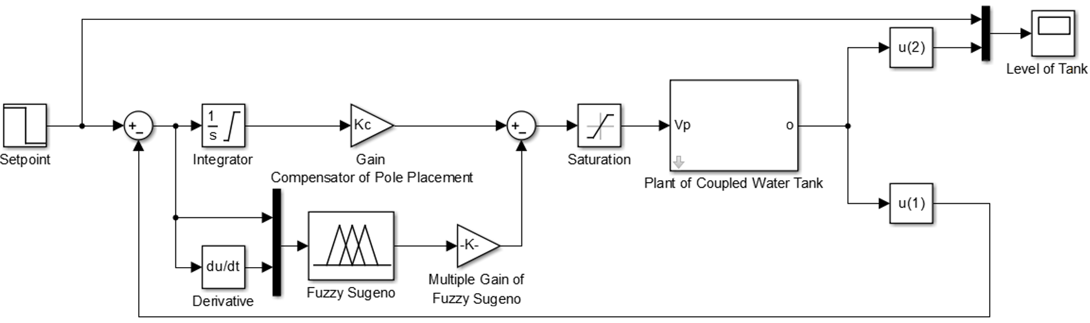
Figure 3. Design of The Coupled Water Tank System with Gain Compensator Based on Pole Placement
and Fuzzy Sugeno

where multiple gain of fuzzy sugeno regulated for make fast time response system

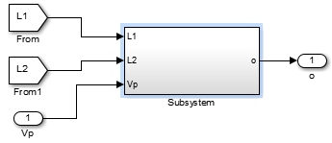
Figure 4. Design of Subsystem of The Coupled Water Tank System in Matlab

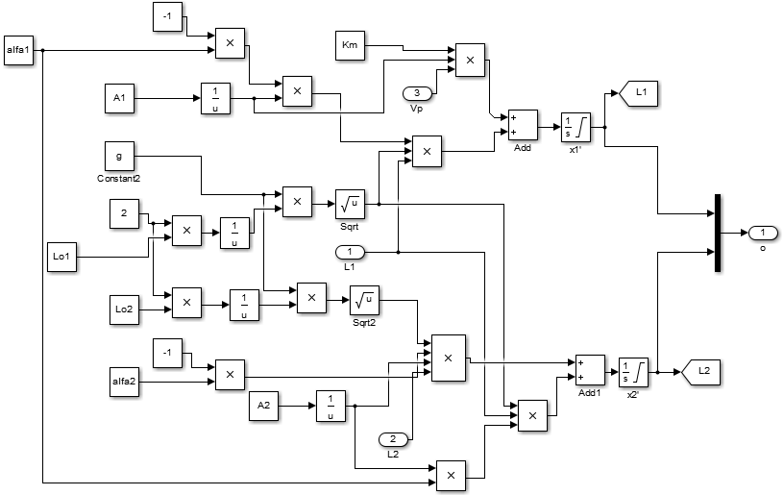
Figure 5. Design Inner of Subsystem of The Coupled Water Tank System in Matlab

and while for its design control:
- Design of The Gain Compensator Based on Pole Placement for Controlling Level of The Coupled Water Tank System
For design of Compensator Based on Pole Placement with method of Bass-Gura Approach and we can make it for 5 steps [14], [15]:

Step 1. Check the controllability condition:
$M=\left[\left.B\right|\right.\left.AB\right]$ (12)

if $M≠0$

hence, the system is controllable

Step 2. Form the characteristic polynomial for $\hat{A}$, where:
$\hat{A}=\left[\begin{matrix}A & 0 \\ -C & 0\end{matrix}\right]$ (13)

with
$\left|sI-\hat{A}\right|=s^{3}+a_{1}s^{2}+a_{2}s^{1}+a_{3}$ (14)

and determine the $a_{1}, a_{2},a_{3}$

Step 3. Find the Transformation matrix T. Where in this chase to find the compensator gain, therefore:
$\hat{M}=\left[\left.\hat{B}\right|\right.\left.\hat{A}\hat{B}\right|\left.{\hat{A}}^{2}\hat{B}\right]$ (15)
$W=\left[\begin{matrix}a_{2} & a_{1} & 1 \\ a_{1} & 1 & 0 \\ 1 & 0 & 0\end{matrix}\right]$ (16)

and

$T=\hat{M}W$ (17)

Step 4. Write the desired characteristic polynomial, the roots for first trial have been chosen to be:

$$s_{1}=-1+j\sqrt{3}$$

$$s_{2}=-1-j\sqrt{3}$$

$$s_{3}=- 0.01$$

for output to have maximum overshoot $±16\%$, so that $\left(s+1+j\sqrt{3}\right)\left(s+1-j\sqrt{3}\right)\left(s+0.01\right)=s^{3}+β_{1}s^{2}+β_{2}s^{1}+β_{3}$ (18)

and determine the $β_{1}, β_{2},β_{3}$

Step 5. The required state feedback gain and compensator gain are:
$K=\left[\left.\left(β_{3}-a_{3}\right)\right|\right.\left.\left(β_{2}-a_{2}\right)\right|\left.\left(β_{1}-a_{1}\right)\right]=\left[\left.K_{1}\right|\right.\left.K_{2}\right|\left.K_{c}\right]$ (19)
where $K_{1}and K_{2}$are the state feedback gain, and $K_{c}$is the gain compensator

- Design of Fuzzy Sugeno for Controlling Level of The Coupled Water Tank
For design of fuzzy sugeno to control level of the coupled water tank system is required 2 input (error: e and derivative error: de) and 1 ouput (control signal: u):

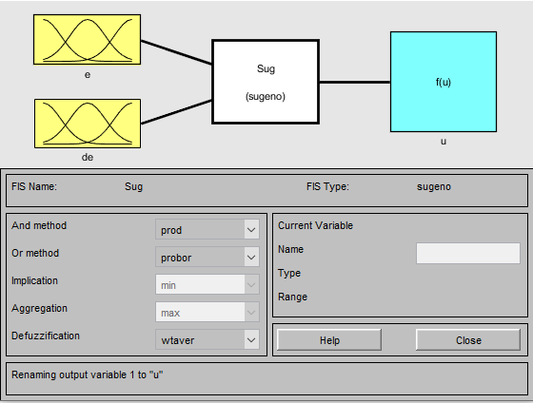
Figure 6. Design of Fuzzy Sugeno

Because fuzzy logic is based on h uman thinking and expert systems. We can choose 7 membership values, the type of its functions, and the margin that can be collected by our experience with this system. So we can choose the type and values of error (e), derivative (de), and control signal (de):

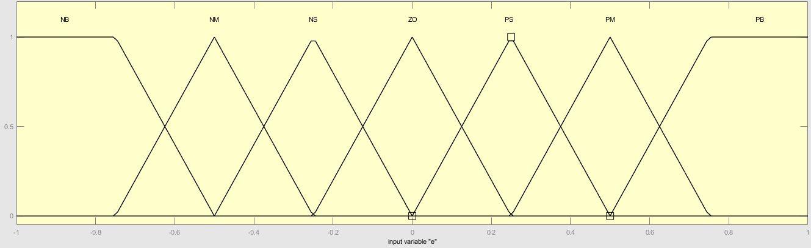

Figure 7. Error (e)

Figure 8. Derivative (de)

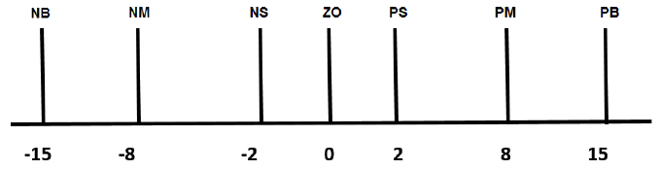
Figure 9. Control Signal (u)

and for rule base we use table of Mack Vicar Whelan:

Table 2. Mack Vicar Whelan for Fuzzy Sugeno
Control Signal (u) |  | Delta Error
 |  | NB | NM | NS | Z0 | PS | PM | PB
Error | NB | -15 | -15 | -15 | -15 | -8 | 2 | 0
Error | NM | -15 | -15 | -15 | -8 | 2 | 0 | 2
Error | NS | -15 | -15 | -8 | 2 | 0 | 2 | 8
Error | ZO | -15 | -8 | 2 | 0 | 2 | 8 | 15
Error | PS | -8 | 2 | 0 | 2 | 8 | 15 | 15
Error | PM | 2 | 0 | 2 | 8 | 15 | 15 | 15
Error | PB | 0 | 2 | 8 | 15 | 15 | 15 | 15

RESULTS AND ANALYSIS

In the course of testing the performance of the system, we can define a steady-state error, overshoot, rising time, and settling time with a setpoint of 10 centimeters.

  - Design of Open Loop (without method) of The Coupled Water Tank System

The response output system in figure 10 shows that without a method of control, the level of the coupled water tank can not produce a response output according to setpoint with a steady-state error is 20 centimeters, overshoot is 0%, rising time is 48,9867 seconds and settling time is 67,2920 seconds.

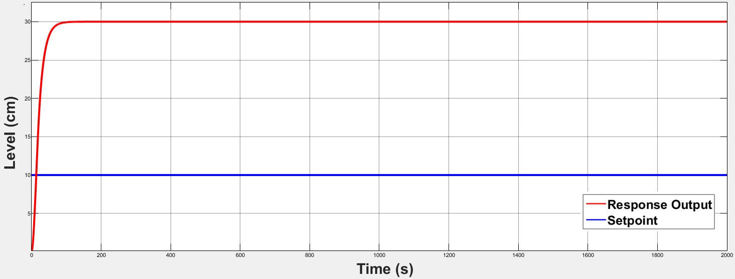
Figure 10. Response Output System for Level 2 in Tank 2 with Open Loop (without method)

  - Design of The Fuzzy Sugeno with Gain Compensator Based on Pole Placement for Controlling Level of The Coupled Water Tank System
In the response output system in figure 11, we can analyze that controlling level of Coupled Water Tank with the control method can make response output according to setpoint with steady-state error is 0 centimeters, overshoot is 0%, rising time is 44,6538 seconds, settling time is 62,2688 seconds and can follow setpoint changes in 58,8662 seconds.

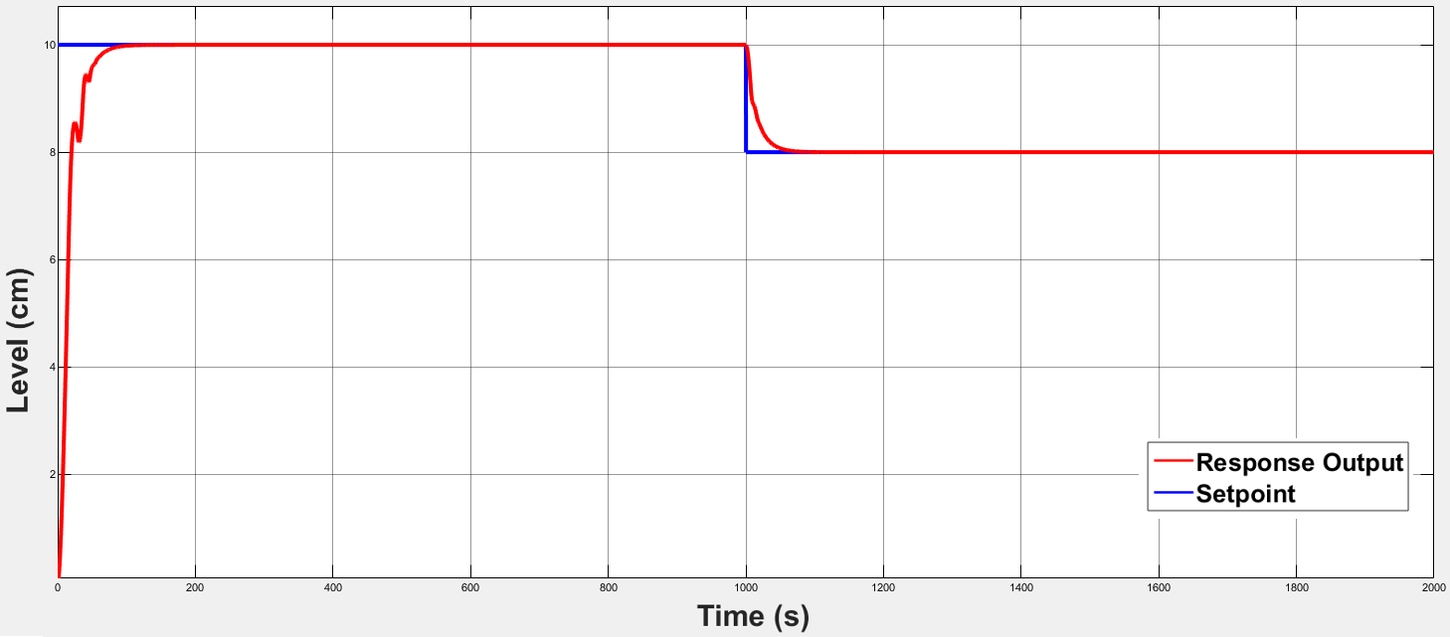

Figure 11. Response Output System for Level 2 in Tank 2 of The Fuzzy Sugeno with Gain Compensator Based on Pole Placement

CONCLUSION
It may be concluded from this paper, the outcome achieved from the fuzzy sugeno with gain compensator based on pole placement for controlling level 2 in tank 2 is better than open-loop (without method) with steady-state error is 0 centimeters, overshoot is 0%, rising time is 44,6538 seconds, settling time is 62,2688 seconds and can follow setpoint changes in 58,8662 seconds. Wherein for open-loop (without method) with a steady-state error is 20 centimeters, overshoot is 0%, rising time is 48,9867 seconds and settling time is 67,2920 seconds.

REFERENSI

Stephanopoulos G. Chemical Process Control: An Introduction to Theory and Practice. 1st Edition. Englewood Cliffs, New Jersey: Prentice Hall. 1984. 510-534.

Sankata B, Seshagiri S, Umesh C, Kamala K. Sliding Mode Control of Coupled Tanks using Conditional Integrators. IEEE Indian Control Conference. Hyderabad. 2016; 146-151.

Datta S, Nath U.M, Dey C. Design and Implementation of Decentralized IMC-PI Controllers for Real Time Coupled Tank Process. IEEE Michael Faraday IET International Summit. Kolkata. 2015; 93-98.

Boiocchi R, Mauricio-Iglesias M, Vangsgaard A.K, Gernaey K.V. Aeration Control by Monitoring the Microbiological Activity using Fuzzy Logic Diagnosis and Control: Application to a Complete Autotrophic Nitrogen Removal Reactor. Journal of Process Control. 2015; 30(1): 22-33.

Qi W, Liu J, Christofides P.D. A Distributed Control Framework for Smart Grid Development: Energy/Water System Optimal Operation and Electric Grid Integration. Journal of Process Control. 2015; 21(1): 1504-1516.
- Hur A, Sajjad A, Shahid Q. Sliding Mode Control of Coupled Tank Liquid Level Control System. IEEE 10th International Conference on Frontires of Information Technology. Islamabad. 2012; 325-330.
- Susendra S.P, Krishan K, Brotre B.A, Akbar S.A. Design of Fuzzy Lugic Based Controller with Pole Placement for the Control. Annual IEEE India Conference. New Delhi. 2015; 978-983.
- Abraham L, Senthilkumar, Selvakumar. Design of PI Controller using Characteristics Ratio Assignment Method for Coupled Tank SISO Process. International Journal of Computer Application. 2011; 25(9): 49-53.
- Saad M, Albagul A, Abueejela Y. Performance Comparison between PI and MRAC for Coupled Tank System. Journal of Automation and Control Engineering. 2014; 2(3): 316-321.
- Hafiz M.S, Kulkarni N.R. Perception on PSO, Fuzzy and Fuzzy-PID for Water Level Control of Coupled Tank System. IEEE Pune Section International Conference. Pune. 2019; 1-5.
- Halim M. Comparative Study of Mamdani-type and Sugeno-type Fuzzy Inference System for Coupled Water Tank. Indonesian Journal of Artificial Intelligence and Data Mining. 2020; 3(1): 39-44.
- Halim M. Radial Basis Function Neural Network Control for Coupled Water Tank. Indonesian Journal of Artificial Intelligence and Data Mining. 2020; 3(2): 64-70.

- Khalid M.U, Kadri M.B. Liquid Level Control of Nonlinear Coupled Tanks System using Linear Model Predictive Control. IEEE International Conference on Emerging. Islamabad. 2012; 291-295.

Bernard F. Advanced Control System Design. 1st Edition. Englewood Cliffs, New Jersey: Prentice Hall. 1994: 121-128.

Ogata K. Modern Control Engineering. Fourth Edition. Tehran: Aeeizh. 2002: 897-908.

BIBLIOGRAPHY OF AUTHORS

Halim Mudia was raised and born in Pakan Kamis, West Sumatera. He is a lecturer in Electrical Engineering at the State Islamic University of Sultan Syarif Kasim Riau. I completed a Masters's degree at the Sepuluh Nopember Institute of Technology (ITS) in 2015.


Ahmad Faizal was raised and born in Kampar, Riau. He is a lecturer in Electrical Engineering at

the State Islamic University of Sultan Syarif Kasim Riau. I completed a Masters's degree at the Sepuluh Nopember Institute of Technology (ITS) in 2013.
Marhama Jelita was raised and born in Ranah, Riau. She is a lecturer in electrical engineering at the State Islamic University of Sultan Syarif Kasim Riau. I completed a masters's degree at the Universiti Kebangsaan Malaysia (UKM) in 2012

