Educational Guidance and Counseling Development Jounal
p-ISSN:2615-3661|e-ISSN: 2615-8358
Vol. 1, No. 1, April2018, xxx – xxx

Pengaruh Konseling Kelompok Pendekatan CBT Dengan Teknik

SelfControlUntuk Mereduksi Kecanduan Media Sosial Tiktok
Rina Yulitri1, Sania Destia Putri2, Dasril3, Fadhilah Syafwar4
1,2,3,4Program studi bimbingan konseling, Universitas Islam Negeri Mahmud Yunus Batusangkar
e-mail: rinayulitri@uinmybatusangkar.ac.id

ABSTRAK.

Perkembangan media sosial membawa dampak signifikan terhadap kehidupan remaja, salah satunya berupa kecanduan penggunaan TikTok yang mengganggu kontrol diri, menurunkan produktivitas, dan memengaruhi keseimbangan akademik maupun sosial. Kondisi ini menuntut strategi intervensi yang tepat, salah satunya melalui layanan konseling kelompok berbasis Cognitive Behavior Therapy (CBT) dengan Teknik Self Control. Penelitian ini bertujuan untuk mengetahui pengaruh konseling kelompok pendekatan CBT dengan Teknik Self Control dalam mereduksi kecanduan media sosial TikTok pada siswa kelas X.E.1 SMAN 2 Lintau Buo. Penelitian menggunakan metode kuantitatif dengan desain eksperimen tipe one group pretest-posttest. Populasi penelitian adalah 32 siswa, dengan sampel purposive sebanyak 10 orang. Instrumen berupa skala kecanduan TikTok model Likert yang terdiri dari 32 item valid.Hasil analisis menunjukkan adanya pengaruh signifikan layanan konseling kelompok dengan teknik self control terhadap penurunan kecanduan TikTok. Nilai uji-t mengindikasikan hipotesis alternatif diterima, sedangkan uji N-gain menghasilkan rata-rata 0,31 yang termasuk kategori sedang. Dengan demikian, konseling kelompok pendekatan CBT dengan teknik self control terbukti efektif dalam mereduksi kecanduan media sosial TikTok pada siswa. Temuan ini memberikan implikasi praktis bagi konselor sekolah dalam merancang intervensi yang membantu siswa mengelola penggunaan media sosial secara lebih sehat dan produktif.

Kata kunci: Konseling Kelompok, Cognitive Behavior Therapy (CBT), Teknik Self Control, Kecanduan Media Sosial, TikTok

ABSTRACT

The development of social media has had a significant impact on adolescents' lives, one of which is addiction to using TikTok, which disrupts self-control, decreases productivity, and affects academic and social balance. This condition demands appropriate intervention strategies, one of which is through group counseling services based on Cognitive Behavior Therapy (CBT) with Self-Control techniques. This study aims to determine the effect of group counseling with a CBT approach using Self-Control techniques in reducing TikTok social media addiction among class X.E.1 students at SMAN 2 Lintau Buo. The research used a quantitative method with a one- group pretest-posttest experimental design. The research population was 32 students, with a purposive sample of 10 people. The instrument was a Likert-scale TikTok addiction scale consisting of 32 valid items. The analysis results showed a significant effect of group counseling services with self-control techniques on reducing TikTok addiction. The t-test value indicated the alternative hypothesis was accepted, while the N-gain test resulted in an average of 0.31, which falls into the medium category. Thus, group counseling with a CBT approach using self-control techniques is proven effective in reducing TikTok social media addiction among students. These findings provide practical implications for school counselors in designing interventions to help students manage social media use more healthily and productively.
Keywords: Group Counseling, Cognitive Behavior Therapy (CBT), Self-Control Techniques, Social Media Addiction, TikTok

INTRODUCTION
The development of digital technology has had a major impact on the social life, education, and lifestyle of adolescents. One prominent phenomenon is the increased use of social media, particularly the TikTok application, which is very popular among students. TikTok, as a short video sharing platform, does provide space for creativity, entertainment, and practical communication tools. However, excessive use often leads to addiction, which results in decreased productivity, weak self-control, and the emergence of problems in both academic and social spheres.
Sandra Ball-Rokeach and Melvin DeFleur (1976) stated that addiction is a behavior where a person becomes increasingly dependent on a medium to fulfill their needs, making that medium increasingly important to the individual. In the context of TikTok, the more someone depends on TikTok for entertainment, social interaction, or obtaining information, the harder it becomes for them to reduce their usage (Zaputri, 2021). The phenomenon of TikTok addiction among high school students becomes evident when their behavior shows high dependency, such as spending hours accessing the application, experiencing anxiety when disconnected, and using TikTok as an escape from academic pressure or personal problems. This condition disrupts the life balance of adolescents, reduces learning motivation, and diminishes their ability to manage time. On the other hand, social media should be utilized as a means for learning, communication, and self-development if used appropriately and controlled (Wulandari, 2021).
Previous research has identified the negative impacts of social media addiction, such as concentration disorders, declining academic achievement, and psychological problems. However, most studies emphasize the descriptive aspects of the impacts of addiction, while applicative intervention strategies in the school environment are still limited. This creates a research gap, namely the need for further study on the effectiveness of counseling services in reducing social media addiction, especially TikTok, through approaches proven capable of changing students' thinking patterns and behavior (Rifqi, 2020).
Group counseling with a Cognitive Behavior Therapy (CBT) approach using self-control techniques is considered relevant to address this problem. This approach helps students recognize irrational thought patterns underlying the addiction and then replace them with more adaptive patterns. According to Aaron T. Beck (1977), CBT is a counseling approach designed to solve clients' problems through cognitive restructuring and deviant behavior. According to Oemarjoedi (2003), the goal of CBT is to help clients challenge incorrect thoughts and emotions with contradictory evidence. Aaron T. Beck (2013) explains that for social media addiction, the CBT approach can be used to help students realize the negative impacts of excessive use, change their mindset regarding dependence on social media, and encourage them to develop healthier and more productive habits.
According to Chaplin (2014:461) in (Wulandari, 2021), self-control technique is the ability to guide one's own behavior, the ability to suppress impulses or impulsive behavior. Self-control techniques emphasize the individual's ability to control impulsive urges, regulate behavior, and practice self-management skills. Through group dynamics, students also gain social support and the opportunity to learn from the experiences of other members, making the change process more effective (Desi Ermayulis1, Masril 2, 2019).
Based on this background, this research focuses on analyzing the effect of group counseling with a CBT approach and self-control techniques in reducing TikTok addiction among class X.E.1 students at SMAN 2 Lintau Buo. The research analysis unit is the individuals who are members of the counseling group, aiming to determine the extent to which this service can reduce addiction levels and help students improve their ability to control themselves in using social media.

LITERATURE REVIEW
According to Aaron T. Beck, "Cognitive Behavior Therapy (CBT) is a counseling approach designed to solve clients' problems concerning current and deviant behavior. Cognitive Behavior Therapy (CBT) counseling is a theoretical model that links thoughts with emotions and behavior. The counseling process is based on the conceptualization or understanding of the client's specific beliefs and behavioral patterns. The expectation of Cognitive Behavior Therapy (CBT) is the emergence of restructuring of deviant cognition and belief systems to bring about changes in emotions and behavior for the better."
The Cognitive Behavior Therapy (CBT) approach with self-control techniques is a strategic choice because it can help students recognize faulty thoughts, replace them with more adaptive patterns, and train the ability to control impulsive urges. Its application in group counseling provides additional advantages in the form of social support, exchange of experiences, and collaborative learning among members (Rika Widianita, 2023). According to Albert Ellis (1955) in (Rohayati, 2020), there are four steps in the self-control technique when facing conflict. First, thinking about the impact of the action to be taken. Second, conducting internal dialogue to assess thoughts rationally. Third, arguing with oneself to avoid following negative urges. Fourth, considering the consequences of past actions as evaluation material. These steps help individuals control themselves more wisely.
Messina and Messina (in Gunarsa, 2009:22) state that self-control has several functions: a) Limiting the individual's attention towards others, b) Limiting the individual's desire to control others in their environment, c) Limiting the individual from negative behavior, d) Helping the individual to fulfill life needs in a balanced way.
The research framework begins with the phenomenon of TikTok addiction causing academic and social problems, identified as a result of weak self-control and negative thought patterns. Through group counseling based on CBT with self-control techniques, students are expected to reduce dependence on social media, increase self-regulation abilities, and improve the balance between academic activities, social life, and technology use.

METHODOLOGY
This research used a quantitative approach with a one-group pretest-posttest experimental design. This design was chosen because it can measure changes in the level of TikTok addiction among students before and after being given the treatment in the form of group counseling with a CBT approach using self-control techniques. This design is considered reliable as it allows for a direct comparison of the initial and final conditions of the research subjects within the same group.
The research population was all 32 students of class X.E.1 at SMAN 2 Lintau Buo. The sampling technique used purposive sampling, which is selection based on specific criteria relevant to the research objectives. From this population, 10 students with high levels of TikTok addiction who were willing to participate in the group counseling process were obtained. This technique was used so that the research subjects truly represent the problem condition being studied.
Data was collected using a TikTok addiction scale instrument arranged with a Likert model. This instrument consists of 32 statement items that have undergone content validity tests by experts and statistical reliability tests, making it suitable for measuring students' addiction

levels. Additionally, the data collection process was also supplemented with observation during counseling sessions to strengthen the understanding of group dynamics.
The main measure in this study was the TikTok addiction score obtained from the pretest and posttest results. Data analysis was conducted using a t-test to determine the significance of the difference before and after treatment, and N-gain calculation to assess the effectiveness of the intervention in low, medium, or high categories. The use of this combination of tests provides a valid and reliable basis for concluding the effect of group counseling with a CBT approach using self-control techniques on TikTok social media addiction.

FINDINGS
The research results show that group counseling with a CBT approach and self-control techniques had a significant effect on reducing TikTok social media addiction among class X.E.1 students at SMAN 2 Lintau Buo. A comparison of pretest and posttest scores showed a fairly clear decrease in the addiction level in the experimental group .
Table 1. Comparison of Pretest and Posttest Scores

Measurement  Stage | Average Score | Category
Pretest | 133,6 | High
Posttest | 101,7 | Medium

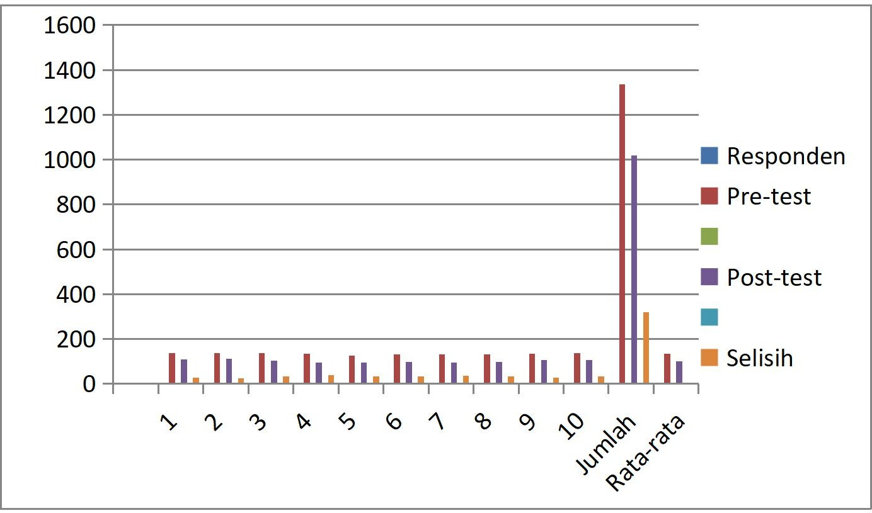

Based on the data in Table 1 above, it can be seen that the comparison of the pre- test score is 1336 with an average of 133.6, which falls into the high category. After the treatment, there was a decrease in the post-test score to 1017 with an average of 101.7, which falls into the medium category. It can be understood that group counseling services using a CBT approach with Self-Control techniques can reduce students' TikTok social media addiction.
The change in average score from 133.6 to 101.7 indicates a fairly significant decrease in the addiction level. The t-test results strengthen that there is a significant difference between the conditions before and after treatment, while the N-gain calculation resulted in an average of 0.31, which falls into the medium category. The interpretation of this finding is that group counseling services with a CBT approach and self-control techniques are influential in reducing TikTok

addiction. Students showed better ability to manage time, reduce usage intensity, and lower anxiety when not accessing the application (Husain, 2017).
The N-Gain approach measures the relative change between students' level of understanding before and after a learning process. By making this comparison, the N-Gain Test analysis is a method for measuring the effectiveness of learning by looking at the increase in student learning outcomes after participating in learning. This method calculates the difference between the pretest (test before Treatment) and posttest (test after Treatment) scores, which is then normalized so it can be compared with the ideal learning outcome (Sukarelawan et al., 2024).
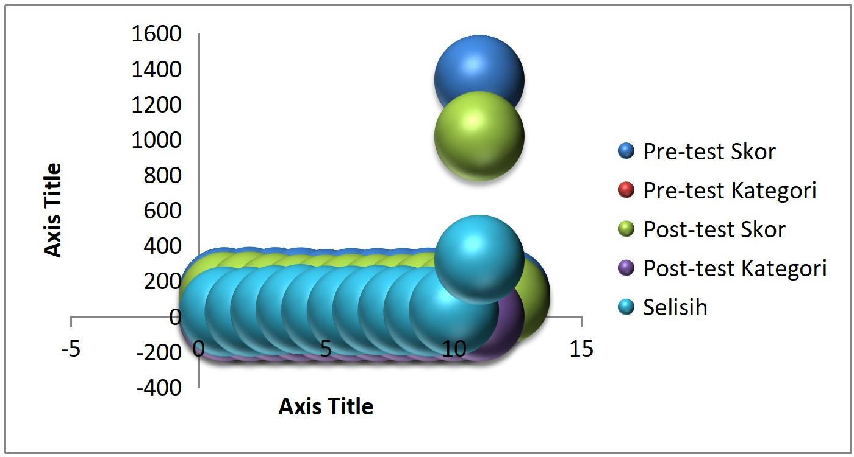

Furthermore, it can be seen from the N-Gain test. The data experienced a decrease of
0.31. So, if we look at the processing above and the Value 0.30 ≤ N-Gain ≤ 0.70 falls into the medium criteria. Thus, group counseling with Self-Control techniques in reducing TikTok social media addiction for students of X.E.1 SMAN 2 Lintau Buo experienced a decrease into the medium criteria, which is 0.31.

DISCUSSIONS
This study aimed to determine the effect of group counseling with a Cognitive Behavior Therapy (CBT) approach using self-control techniques on TikTok social media addiction among class X.E.1 students at SMAN 2 Lintau Buo. This research makes an important contribution to strengthening the literature on cognitive-behavioral-based counseling interventions in schools, especially in addressing the increasingly widespread phenomenon of digital addiction. The results show that school guidance and counseling services play a strategic role in helping students overcome behavioral problems related to social media use (Zaputri, 2021).
The analysis results showed a decrease in the average TikTok addiction score from 133.6 in the pretest (high category) to 101.7 in the posttest (medium category). The t-test proved a significant difference, while the N-gain calculation of 0.31 showed the intervention's effectiveness in the medium category. This finding aligns with the research hypothesis, namely that group counseling based on CBT with self-control techniques can reduce the students' addiction level.
This score decrease indicates that students were more able to control TikTok usage, reduce anxiety when disconnected, and balance entertainment needs with academic obligations. Thus, the research objective was empirically achieved. This finding strengthens the literature affirming the effectiveness of CBT in addressing addictive behaviors. CBT works by identifying irrational thought patterns that trigger problematic behavior and then replacing them with more

adaptive rational thought patterns. Self-control techniques, as an integral part of CBT, proved helpful for students in controlling impulsive urges.
Group counseling dynamics also supported behavioral change by providing a space for sharing experiences, building collective awareness, and strengthening student motivation through peer support. This is consistent with group counseling theory, which emphasizes the importance of social interaction in accelerating the change process (Firmansyah et al., 2023). However, the research results also show that the intervention's effectiveness is still in the medium category. This differs from several studies reporting high effectiveness for certain addictions. This difference can be explained by the students' social context, the strong influence of the digital environment, and the limited duration of the counseling conducted.
Although there was a decrease in addiction scores, some students still showed excessive TikTok usage behavior. This indicates that social media addiction is not only influenced by internal factors, such as thought patterns and self-control, but also by external factors such as peer influence, digital culture, and application algorithms designed to capture attention.
This finding confirms that psychological intervention alone is not enough. Support from the environment, parental supervision, school policies regarding gadget use, and digital literacy education are needed to strengthen the results of counseling interventions.
The theoretical implication of this research is expanding the understanding of the application of CBT with self-control techniques in the context of digital addiction. This research proves that counseling interventions are not only relevant for classic psychological problems but are also capable of addressing the challenges of the digital era. The practical implication of this research lies in the role of guidance and counseling teachers (Guru BK) and school counselors. The developed intervention model can serve as a guide in designing prevention and handling programs for social media addiction in schools. Furthermore, schools can use these research results as a basis for policies supporting academic productivity and students' psychological well- being.

REFERENCES
Desi Ermayulis1, Masril 2, dan E. H. (2019). Pengaruh Konseling Kelompok Menggunakan Pendekatan Cognitive Behavior Therapy untuk Meningkatkan Kontrol Diri Siswa.
Indonesian Journal of Counseling and Development, 01, 141–149.
Firmansyah, Y., Masril, M., Fitriani, W., Ardimen, A., & Irman, I. (2023). Pengaruh Layanan Konseling Kelompok Berbasis Regulasi Diri Dalam Meningkatkan Kedisiplinan Belajar Siswa. Jurnal Pendidikan Dan Konseling, 5(1), 4362–4367.
Husain, K. (2017). KONSELING KELOMPOK (Panduan Praktis Meningkatkan Kompetensi Sosial Siswa/Mahasiswa).
Kis, M., Fitriani, W., & Irawati, M. (2024). Analisis Dampak Penggunaan Aplikasi Tiktok Pada Remaja: A Systematic Literature Review. Counselia; Jurnal Bimbingan Konseling Pendidikan Islam, 5(1), 227–238. https://doi.org/10.31943/counselia.v5i1.90
Rifqi, B. (2020). Pengaruh kecanduan Gadged (smartphone) Terhadap Empati Mahasiswa Universitas Islam Negeri Maulana Ibrahim Malang. 1–121.
Rika Widianita, D. (2023). Pengaruh Pendekatan Cognitive Behavior Therapy (CBT ) Dalam Konseling Kelompok Terhadap siswa kecanduan Aplikasi Tik Tok. AT-TAWASSUTH:

Jurnal Ekonomi Islam, VIII(I), 1–19.
Sukarelawan, M. I., Indratno, T. K., & Ayu, S. M. (2024). N-Gain vs Stacking. Wulandari, I. (2021). Pengaruh Bimbingan Kelompok Melalui Teknik Self Control Untuk
Mngatasi Kebiasaan Membolos.
Zaputri, M. (2021). Dampak kecanduan media sosial tik tok terhadap perilaku belajar mahasiswa bimbingan dan konseling IAIN Batusangkar SKRIPSI Ditulis Sebagai Syarat untuk Memperoleh Gelar Sarjna (S-1). Jurnal Komunikasi, 1–59.

