Lampiran SPSS

Descriptive Statistics
 | N | Minimum | Maximum | Mean | Std. Deviation
Kemudahan | 100 | 8 | 20 | 13,59 | 3,029
Manfaat | 100 | 6 | 19 | 11,87 | 2,612
Penerimaan_Pengguna | 100 | 7 | 18 | 11,67 | 2,470
Valid N (listwise) | 100

- Kemudahan menggunkan E-Klaim BPJS Ketenagakerjaan

Reliability Statistics
Cronbach's Alpha | N of Items
,753 | 6

Item-Total Statistics
 | Scale Mean if Item Deleted | Scale Variance if Item Deleted | Corrected Item-Total Correlation | Cronbach's Alpha if Item Deleted
X1 | 11,17 | 6,143 | ,626 | ,679
X2 | 11,34 | 7,661 | ,285 | ,766
X3 | 11,61 | 6,523 | ,543 | ,704
X4 | 11,05 | 7,119 | ,344 | ,758
X5 | 11,61 | 6,523 | ,543 | ,704
X6 | 11,17 | 6,143 | ,626 | ,679

- Manfaat menggunkan E-Klaim BPJS Ketenagakerjaan

Reliability Statistics
Cronbach's Alpha | N of Items
,772 | 5

Item-Total Statistics
 | Scale Mean if Item Deleted | Scale Variance if Item Deleted | Corrected Item-Total Correlation | Cronbach's Alpha if Item Deleted
X1 | 9,41 | 4,689 | ,475 | ,755
X2 | 9,53 | 5,181 | ,441 | ,762
X3 | 9,51 | 3,848 | ,784 | ,637
X4 | 9,51 | 3,848 | ,784 | ,637
X5 | 9,52 | 5,505 | ,274 | ,811

- Penerimaan Penggunaan E-Klaim BPJS Ketenagakerjaan

Reliability Statistics
Cronbach's Alpha | N of Items
,783 | 5

Item-Total Statistics
 | Scale Mean if Item Deleted | Scale Variance if Item Deleted | Corrected Item-Total Correlation | Cronbach's Alpha if Item Deleted
Y1 | 9,68 | 4,119 | ,391 | ,814
Y2 | 9,26 | 3,689 | ,820 | ,656
Y3 | 9,30 | 4,273 | ,550 | ,746
Y4 | 9,26 | 3,689 | ,820 | ,656
Y5 | 9,18 | 4,816 | ,324 | ,811

Model Summary^{b}
Model | R | R Square | Adjusted R Square | Std. Error of the Estimate | Durbin-Watson
1 | ,752ª | ,566 | ,557 | 1,644 | 1,051
a. Predictors: (Constant), Manfaat, Kemudahan
b. Dependent Variable: Penerimaan_Pengguna

ANOVAª
Model |  | Sum of Squares | df | Mean Square | F | Sig.
1 | Regression | 342,043 | 2 | 171,021 | 63,301 | ,000^{b}
 | Residual | 262,067 | 97 | 2,702
 | Total | 604,110 | 99
a. Dependent Variable: Penerimaan_Pengguna
b. Predictors: (Constant), Manfaat, Kemudahan

Coefficientsª
Model |  | Unstandardized Coefficients |  | Standardized Coefficients | T | Sig. | Collinearity Statistics
 |  | B | Std. Error | Beta |  |  | Zero  orderpartial parttoleran |  |  |  | VIF
1 | (Constant) | 1,958 | ,952 |  | 2,057 | ,042
 | Kemudahan | ,074 | ,040 | ,178 | 1,856 | ,067 | .364 | .201 | .674 | ,929 | 1,076
 | Manfaat | ,267 | ,051 | ,503 | 5.256 | ,000 | .569 | -008 | .674 | ,929 | 1,076
a. Dependent Variable: Penerimaan_Pengguna

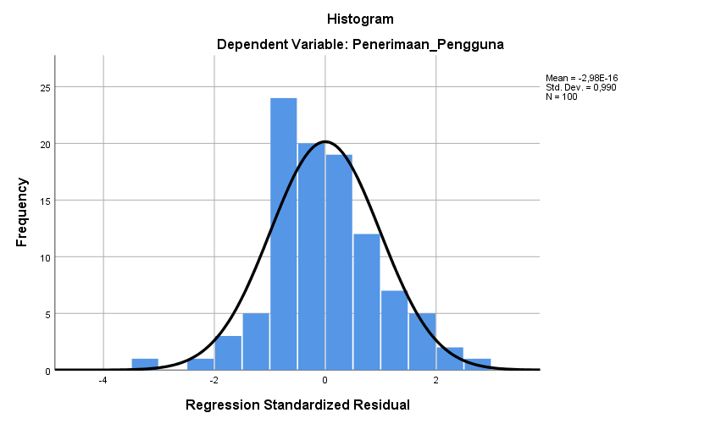

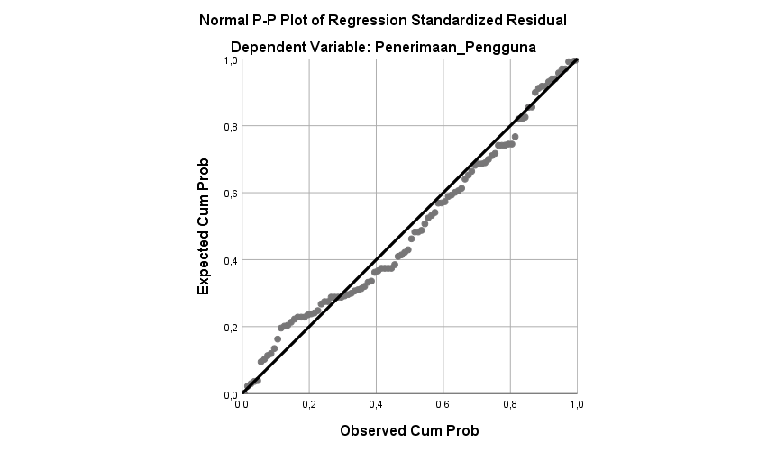

One-Sample Kolmogorov-Smirnov Test
 |  | Unstandardized Residual
N |  | 100
Normal Parameters^{a,b} | Mean | ,0000000
 | Std. Deviation | 1,62700504
Most Extreme Differences | Absolute | ,083
 | Positive | ,077
 | Negative | -,083
Test Statistic |  | ,083
Asymp. Sig. (2-tailed) |  | ,083^{c}
a. Test distribution is Normal.
b. Calculated from data.
c. Lilliefors Significance Correction.

