The Role of Interpersonal Communication Between Teachers and High School’s Students in Overcome Bullying Behavior

Mardhiyyah¹, Ghazaly Ama La Nora ², MA. Theresa Bringas Nardo³
¹Fikom, Universitas Mercu Buana, Jakarta
²Fikom, Universitas Mercu Buana, Jakarta
³ Tarlac Agricultural University, Philippines
E-mail: mardhiyyah@mercubuana.ac.id
Homor HP: 085828587511

Abstrak
Bullying adalah perilaku atau tindakan agresif yang melibatkan ketidakseimbangan kekuatan yang merugikan orang lain. Sebagian besar bullying terjadi di sekolah dan banyak data yang dapat membuktikan bahwa sekolah adalah penyumbang terbesar perilaku bullying. Luaran dari pengabdian kepada masyarakat ini adalah Mampu memberikan pemahaman tentang pentingnya menciptakan kondisi dan suasana sekolah yang baik dan nyaman bagi siswa agar terhindar dari perilaku bullying di sekolah. Pengabdian kepada masyarakat ini dilaksanakan dengan metode ceramah disertai penjelasan dan diskusi interaktif yang melibatkan seluruh peserta. Pelaksanaan Pengabdian kepada Masyarakat ini berjalan dengan baik dan lancar. Faktor keberhasilan kegiatan Pengabdian Masyarakat di MAN 10 Jakarta ini adalah antusiasme peserta dalam menerima materi dan penyampaian materi yang komunikatif oleh para Narasumber. Sedangkan kendala dalam kegiatan ini adalah belum tersedianya nara sumber yang kredibel dan terbatasnya waktu untuk melaksanakan Kegiatan.
Kata Kunci: Komunikasi interpersonal, SMA, Perundungan

Abstract
Bullying is aggressive behavior or action that involves an imbalance of power that is detrimental to others. Most bullying occurs at school and a lot of data can prove that schools are the biggest contributors to bullying behavior. The output of this community services is Being able to provide an understanding of the importance of creating conditions and a good and comfortable school atmosphere for students to avoid bullying behavior at school. This community services held with lecture method accompanied by an explanation and interactive discussion involving all participants. The implementation of this Community Service is going well and smoothly. The success factor of this Community Service activities at MAN 10 Jakarta is the enthusiasm of participants in receiving material and communicative material delivery by the Speakers. While the obstacle in this activity is the unavailability of credible resource persons and the limited time to carry out the Activity.
Keywords: Interpersonal Communication, High School, Bullying
Introductions
Bullying is aggressive behavior or action that involves an imbalance of power that is detrimental to others. This aggressive behavior can be done repeatedly and causes serious problems in the bullied. Based on the official website of Stop Bullying United States, actions categorized as harassment are aggressive and contain an imbalance of strength and repetition. This power imbalance is defined as people who use their strengths such as physical strength, embarrassing access to information, or popularity to control or harm others.
There are many types of bullying that children and adults can experience. Broadly speaking, bullying can be divided into several types, along with the types of bullying or harassment that need to be watched out for. First, physical bullying, that is, oppression carried out by involving physical means such as hurting someone's body that can cause short-term and long-term effects. Physical bullying includes hitting, kicking, pinching, pushing, and destroying other people's belongings. Second, verbal bullying is intimidation that involves words whether written or spoken. Verbal abuse includes teasing, calling inappropriate names, mocking, insulting, and threatening.
Third, social bullying is oppression that results in damage to one's reputation or relationships. This social intimidation includes lying, spreading negative rumors, humiliating someone, and isolating someone. The fourth, cyberbullying or harassment in cyberspace. Harassment in cyberspace is a bullying behavior carried out using digital technology.This bullying in cyberspace includes uploading inappropriate images or videos, spreading gossip online, and using other people's information on social media.
Fifth, Sexual Bullying. Quoted from Very Well Family, sexual bullying is a dangerous and sexually embarrassing act. Sexual intimidation includes calling on sexual or cat-calling names, vulgar gestures, touching and pornographic material(Gracivia et al., 2019) .
Bullying behavior is currently the most widely practiced by students. Examples include mocking, mocking, and even encouraging, hitting and using other acts of violence. For the perpetrators of bullying, things like that are pleasing to him and can satisfy his feelings, and as a form of indicating the existence that he has power in school. But for victims, bullying behavior is very unpleasant and disturbs their lives, not only life in school but also in life outside of school. It is also possible that the victim will be traumatized by the bullying he received so that there is a reluctance to return to school.
In other cases, schools are less affordable places for parents to supervise. So that students feel it will be more free to carry out bullying behavior without fearing that their behavior will be known by their parents. Most bullying behavior is done by older students and is done to younger classmates or students who are younger than the perpetrators, or better known as seniority. The seniors feel that they hold power in the school and the juniors must respect them. They will carry out this bullying with the excuse that their juniors must also feel what they once felt from their seniors. They do the bullying to younger classmates who are considered weak and cannot fight their behavior, because they also know that the victim will not report the behavior to the teacher.
KPAI found that the number of children who were victims of bullying in the school environment was (87.6%). Of the figures (87.6%), (29.9%) cases of bullying were committed by teachers, (42.1%) were committed by classmates, and (28.0%) were carried out by other classmates (Erika et al., 2017). The above data can prove that schools are the biggest contributors to bullying behavior.
Education and the provision of appropriate educational methods is a powerful way to develop a child's personality for the better. Surely this is not an easy thing to do. Development of children's character to be able to behave as well as possible, is something that is certainly expected by everyone, especially parents. Things that must be considered in educating and providing the most appropriate educational methods to be captured by children, must also pay attention to the value of communication. Communication within a group so that it can learn effectively, becomes very important. Ideas, knowledge, and opinions must be conveyed properly so that the process of providing information in it can be captured properly. Communication in organizations involving two people or better known as interpersonal communication skills. Based on research conducted by Robbins and Hunsaker (Matin et al., 2010), interpersonal communication consists of three dimensions which have their own components.
Interpersonal communication is a form of communication made verbally through words, non-verbal through expression, body language, even in the form of silence (Koide, 2003). The dimensions of interpersonal communication according to Robbins and Hunsaker are the presence of leadership, the process of communication, and motivation. These three dimensions involve the role of a person to be able to balance these three things so that the information provided can be conveyed as well as possible. Returning to the appropriate educational methods to be given to children, effective interpersonal communication is needed so that every learning to children in building good character can be achieved.
Seeing the phenomenon of these problems in Indonesian children, it is necessary to have a fundamental transformation in the system that can educate children for the better, one of them is through the interpersonal communication approach that teachers do in schools. The form of methods that really provide a space to share stories, creativity for children. Teachers can also be a motivator in increasing children's competence, so that children do not behave wrongly in finding their true identity.
This makes the process of providing education and building the character of children in schools not optimal. Children tend to go to school only as a fulfillment of their duties as a student, and instead do activities that are not good in interacting with their friends, one of which is bullying. Though these children should be expected to have a high enthusiasm to be active in school, show the best behavior possible, and foster their love for themselves as students and others who also have the same rights as them. Therefore the need for interpersonal communication that must be done by teachers in schools so that children are more comfortable to learn and actively participate in doing every activity, and socialize in school properly. Therefore, this service is important to do.
Activity Method
This community service uses the lecture method accompanied by an explanation and interactive discussion involving all participants. This lecture method is used with the intention that participants understand the role of interpersonal communication between teacher and student in avoiding bullying behavior at school.
The steps used in implementing this service program are as follows : Participants are given material about the dangers of bullying behavior ; Participants are given a description of cases that have occurred in connection with the dangers of bullying in schools; Participants are given an explanation of the role of interpersonal communication between teacher and student to avoid bullying behavior at school.
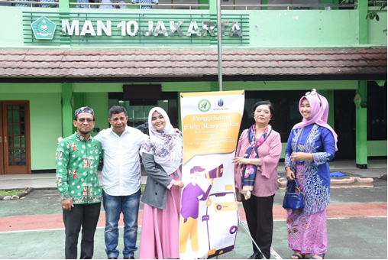
Picture 1. Implementer Team and Teacher of MAN 10 Jakarta
Evaluation is carried out during the activity process, through observing the course of the extension activities. At the material delivery stage, the evaluation is done by concluding the participants' understanding and seeing the activity of asking questions. The results of counseling are measured by the accuracy of participants in answering questions about the role of interpersonal communication between teachers and students to avoid bullying behavior in schools.

Result and Discussion
Result
The implementation of Community Service Activities on the Role of Interpersonal Communication between Teachers and High School Students in dealing with bully behavior is going well and smoothly. This activity was carried out on Thursday, February 20, 2020 at Madrasah Aliyah Negeri 10 Jakarta. This activity was attended by 31 participants who were students of MAN 10 Jakarta. Community Service Activities on the Role of Interpersonal Communication between Teachers and High School Students in responding to bullying behavior in Madrasah Aliyah Negeri 10 Jakarta is carried out in several stages, namely:

- Submission of Material
In this stage, the activity organizer gives material in the form of presentations to participants. The material presented is an explanation of the phenomenon of rampant bullying behavior in schools, explains the importance of interpersonal communication between teachers and students to overcome bully behavior, and the importance of building good and pleasant situations and conditions in schools to avoid bullying behavior.
Submission of material is supported by presentations using infocus and some video footage about bullying behavior at school. At this stage, participants are able to receive information and direction well and smoothly.
- Question and Answer / Interactive Discussion
After delivering the material about the Role of Interpersonal Communication between Teachers and High School Students in responding to bullying behavior, participants were given the opportunity to ask questions about the material that had been presented previously. This question and answer session was divided into 1 question session with 5 questioners.
Implementation of Community Service on the Role of Interpersonal Communication between Teachers and High School Students in responding to bullying behavior at MAN 10 Jakarta is very positive and leaves a deep impression on the implementers and participants of the activity. This is because, community service activities are carried out, such as being a pleasant active discussion. This can be seen from the active participants during the question and answer / interactive discussion with the implementer.
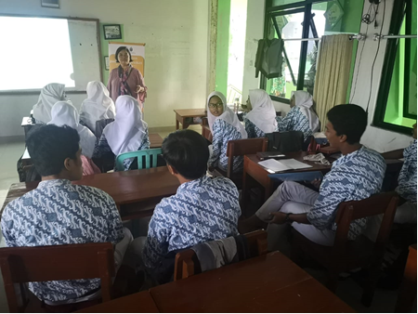
Picture 2. The view of community service implementation

Discussion
The success of community service regarding the role of interpersonal communication between teachers and high school students in responding to bullying behavior at MAN 10 Jakarta is influenced by several factors, namely:
- Enthusiasm of Participants with the material presented
The issue of the role of interpersonal communication between teachers and high school students in dealing with bully behavior is the basis for the emergence of high enthusiasm from the participants. The material delivered by the implementers was able to provide other insights for participants, because bullying behavior often occurs in schools and becomes a habit that is very difficult to break. Bullying is not always caused by physical, sometimes also caused by economic and cultural factors.
- How to deliver communicative material by the Speaker.
The communicative method of delivering material was also a success factor of this activity. The material presented is also equipped with a video, which explains the dangers of bully behavior at school.

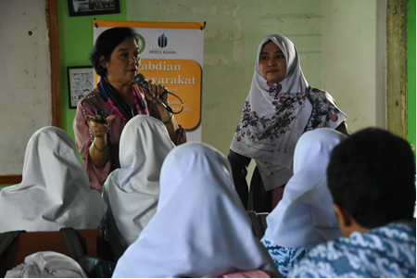
Picture 3. The speaker explained the materials of interpersonal communication

As for the obstacles in Community Service activities regarding the role of interpersonal communication between teachers and high school students in responding to bullying behavior at MAN 10 Jakarta are as follows:
- The unavailability of more credible sources
The absence of credible speakers in delivering the material is an inhibiting factor in this activity. Especially after seeing that participants were very enthusiastic in discussing the role of interpersonal communication between teachers and high school students in responding to bully behavior. Organizers should also invite related parties such as psychologists, so that the material presented will be more diverse and complete. As a result, the questions are answered 'improvise' according to the knowledge of the implementer of the activity.
- Limited time to carry out the Activities.
As explained above, that Community Service Activities that discuss the Role of Interpersonal Communication between Teachers and High School Students in addressing bully behavior at MAN 10 Jakarta generates active and positive discussions. The activity was filled with materials and evaluation of activities carried out with question and answer sessions which generated great enthusiasm from the participants. This then causes the implementation time of 1 (one) hour to be short and insufficient.
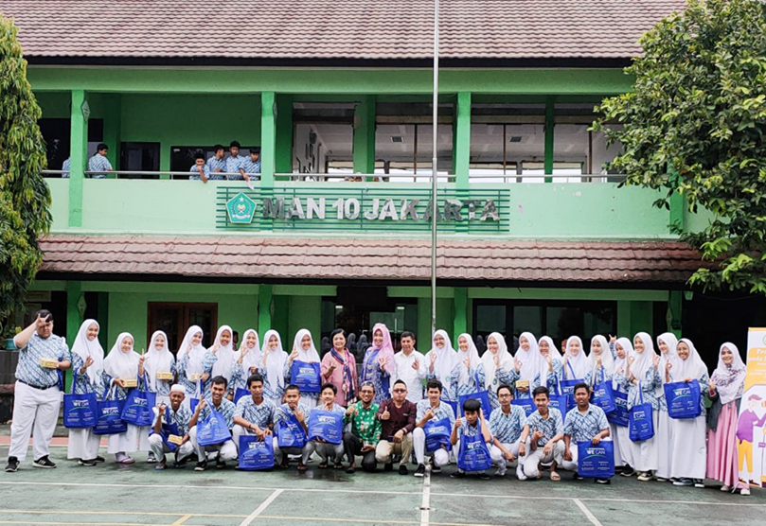
Picture 4. The Implementer Team and students of MAN 10 Jakarta
Conclusion and Suggestion
Conclusion
Based on the discussion above, it can be concluded that the success factor of Community Service activities that discusses the Role of Interpersonal Communication between Teachers and High School Students to avoid bullying behavior at MAN 10 Jakarta is the enthusiasm of participants in receiving material and communicative material delivery by the Speakers. While the obstacle in this activity is the unavailability of credible resource persons and the limited time to carry out the Activity.
Suggestion
To ensure the smoothness of Community Service activities that discuss the Role of Interpersonal Communication between Teachers and High School Students to avoid this bully behavior going forward, there are a few notes as follows:
- Bring in appropriate and credible resource persons in the implementation of training activities.
- Provides a slightly longer time to implement the activity (according to the conditions and enthusiasm of the activity participants.
- Increasing and increasing the number of achievement outcomes so that they can be more beneficial to the community.

Bibliography
Erika, K. A., Pertiwi, D. A., & Seniwati, T. (2017). Bullying Behaviour of Adolescents Based on Gender, Gang and Family. Jurnal Ners, 12(1), 126. https://doi.org/10.20473/jn.v12i1.4396
Gracivia, L., Https://www.cnnindonesia.com/gaya-hidup/20190411135109-260-385320/mengenal-jenis-jenis-bullying-atau-perundungan., B. artikel C. I. "Mengenal J. B. atau P. selengkapnya di sini:, & Https://app.cnnindonesia.com/, D. A. C. I. sekarang. (2019). Mengenal Jenis-jenis Bullying atau Perundungan Baca artikel CNN Indonesia “Mengenal Jenis-jenis Bullying atau Perundungan” selengkapnya di sini: https://www.cnnindonesia.com/gaya-hidup/20190411135109-260-385320/mengenal-jenis-jenis-bullying-atau-perundung. Https://Www.Cnnindonesia.Com/.
Koide, G. (2003). Verbal and non-verbal communication. Trends in the Sciences, 8(3), 28–31. https://doi.org/10.5363/tits.8.3_28
Matin, H. Z., Jandaghi, G., Karimi, F. H., & Hamidizadeh, A. (2010). Relationship between interpersonal communication skills and organizational commitment (Case study: Jahad keshavarzi and university of Qom, Iran). European Journal of Social Sciences, 13(3), 387–398.

