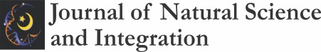 Journal of Natural Science and Integration

**Available online at:**

<http://ejournal.uin-suska.ac.id/index.php/JNSI>

**DOI:** [**10.24014/jnsi.v4i2.11445**](http://dx.doi.org/10.24014/jnsi.v4i2.11445)

P-ISSN: 2620-4967|E-ISSN: 2620-5092

Vol. 2, No. 2, October 2019, pp 1-3

Technology Augmented Reality Integration Hidrometereologi (TARIH) as Learning Media for Disaster

Firmanul Catur Wibowo1*, Lari Andres Sanjaya2, Dina Rahmi Darman3 Syifa Nabila Basyir4 and Andrea Fransiska Møller Gregersen5

1,2,4 Department of Physics Education, Universitas Negeri Jakarta, Indonesia

3 Department of Physics Education, Universitas Sultan Ageng Tirtayasa, Indonesia

5 Department of Science Education, Department of Science Education, University of Copenhagen, Denmark

*\*Correspondence Author:* [*fcwibowo@unj.ac.id*](mailto:fcwibowo@unj.ac.id)

[*lari@unj.ac.id*](mailto:lari@unj.ac.id)

[*dina_rd@untirta.ac.id*](mailto:dina_rd@untirta.ac.id)

Received: Accpeted: Published:

**ABSTRACT**

*Independent Learning is important to support problem solving skills and independent learning skills in physics learning that is integrated with disaster education. This is based on the potential for hydrometeorological disasters that occur in Indonesia, which is still high based on data from the Meteorology, Climatology and Geophysics Agency, especially floods and land subsidence. This study aims to develop Technology Augmented Reality Integration Hydrometereology (TARIH) as a learning media solution for disaster management from an early age to students due to land subsidence. The research method used in this study is the ADDIE Model which consists of the Analysis, Design, Develop, Implement, and Evaluate stages. The research subjects were 69 students aged 21-23 years at a university in Jakarta and Banten, Indonesia. The results of the study were based on the reliability test. Student responses to the implementation of TARIH as a learning medium for Hydrometereology, the reliability of the System Quality aspect was 0.69 and the mean was 4.43. Meanwhile, the reliability of the Information quality aspect is 0.43 and the mean is 4.39 and the reliability of the Service quality aspect is 0.74 and the mean is 4.45. based on the results of the study showed that the TARIH media was effective as a learning media solution for Disaster Management from an early age to students.*

**Keywords**: *Technology Augmented Reality Integration Hidrometereologi (TARIH), Learning Media, Early Disaster.*

**ABSTRAK**

*Independent Learning penting untuk mendukung keterampilan pemecahan masalah dan keterampilan belajar mandiri dalam pembelajaran fisika yang diintegrasikan dengan pendididikan kebencanaan. Hal ini didasarkan potensi bencana Hidrometeorologi yang terjadi di Indonesia masih tinggi berdasarkan data Badan Meteorologi Klimatologi dan Geofisika, khususnya bencana bencana banjir dan penurunan permukaan tanah. Penelitian ini bertujuan untuk mengembangankan Teknologi Augmented Reality Integration Hidrometereologi (TARIH) sebagai Solusi Media pembelajaran Penanganan Kebencanaan Sejak Dini Kepada mahasiswa akibat Penurunan Permukaan Tanah. Metode penelitian yang digunakan dalam penelitian ini adalah Model ADDIE yang teridiri dari tahapan Analysis (Analisis), Design (Desain), Develop (Pengembangan), Implement (Implementasi), dan Evaluate (Evaluasi). Subjek penelitian sejumlah 69 mahasiswa dengan usia 21-23 tahun di salah satu perguruan tinggi di Jakarta dan Banten, Indonesia. Hasil penelitian berdasarkan uji reabilitas Tanggapan mahasisswa terhadap implemetasi TARIH sebagai media pembelajaran Hidrometereologi reabilitas aspek System Quality sebesar 0.69 dan mean rata-rata 4.43. Sedangkan pada reabilitas aspek Information quality sebesar 0.43 dan mean rata-rata 4.39 dan pada reabilitas aspek Service quality sebesar 0.74 dan mean rata-rata 4.45. berdasarkan hasil penelitian menunjukkan bahwa media TARIH ini efektif sebagai Solusi Media pembelajaran Penanganan Kebencanaan Sejak Dini Kepada mahasiswa.*

**Kata kunci**: *Technology Augmented Reality Integration Hidrometereologi (TARIH), Learning Media, Early Disaster.*

INTRODUCTION

The swift development of science and technology provides significant changes to the development of the learning process (Chen, et al., 2018). The rapid development of science and technology encourages educators to innovate in learning, one of which is the use of learning media as an effort to improve the quality of physics education (Wijaya, et al., 2021). Physics is a science that examines the interaction between energy, is the basis of natural science obtained from the results of experiments and theory development. Physics is one of the areas of science education held to develop the ability to think analytically to solve problems related to the surrounding environment both qualitatively and quantitatively (Faridi, et al., 2021). In short, physics is a branch of natural science that can explain all phenomena that occur in life in this universe, including one in the marine field.

Hydrometeorological disasters are at risk when the weather is extreme, extreme weather itself is a result of global warming, climate change, so natural hazards are expected to increase (Diakakis, et al., 2021). Quoted from Movie Cultist, Hydrometeorology is a branch of meteorology and hydrology that studies the transfer of water and energy between the land surface and the lower atmosphere. Hydrometeorology is a natural disaster phenomenon or destructive process that occurs in the atmosphere (meterology), water (hydrology), or oceans (oceanography). Such disasters can cause loss of life, injury or other health impacts, property damage, loss of livelihoods and services, social and economic disruption, or environmental damage. Examples of hydrometeorological disasters are tropical cyclones, thunderstorms, hailstorms, extreme rainfall, floods, dew, and cold temperatures. Rainfall is rainfall that falls in a certain location with a high intensity exceeding the upper limit of rainfall usually within a certain time (minutes, hours, days, months). Extreme rainfall is triggered by the growth of massive convective clouds (cumulonimbus) that reach high in the atmosphere (Gernowo, & Sasongko, 2021). In addition to high-intensity rainfall, cumulonimbus clouds can also generally be accompanied by upheavals of strong winds, hail, and the potential for tornadoes. A strong wind is an increase in wind speed of more than 27.8 km/hour from an area of ​​higher air pressure to an area of ​​lower air pressure. If it happens suddenly or suddenly that it rains for a few seconds or minutes, it is called gusty which is related to the growth of cumulonimbus clouds.

Based on a short survey conducted by researchers on Physics subjects, especially the topic of environmental or physics that discusses disasters, lecturers more often apply remedial for students who have not achieved complete competence (Wang, et al., 2021). Unfortunately, students who have completed their competency achievement often do not get treatment from the lecturer. One of the causes of not implementing optimal learning according to the demands of the curriculum is the limited learning resources or teaching materials (Akala, 2021). So that teaching materials are needed, one of which is interactive media that can be used as teaching materials to implement strengthening programs, especially in physics concepts that discuss disasters so that students realize the importance of protecting the environment from hydrometerorological disasters.

In line with technological advances, currently needed teaching materials that can utilize technology that can combine real objects and virtual objects with a real external environment in real-time which is currently known as Augmented Reality (AR) (Zhang, et al., 2021). Augmented Reality is a technology that combines two-dimensional and or three-dimensional virtual objects into a real three-dimensional environment and then projects these virtual objects in real time. (Hamzah, et al., 2021). AR is currently experiencing rapid development and has touched various lives, one of which is in the world of education (Kencana, et al., 2021). The world of education is currently required to innovate and be creative with the aim of increasing effectiveness in learning and the quality of education, namely by using Augmented Reality. One of the advantages of AR is that it has attractive visuals, because it can display 3D objects that were previously abstract as if they were in a real environment (Wu, et al., 2022). The AR method has advantages from the interactive side because it uses a marker or marker to display certain 3D objects that are pointed at the camera. The addition of AR to textbooks can improve reader understanding. AR has the potential to attract, inspire, and motivate students, because users can explore and control from different perspectives. Because AR is the incorporation of virtual objects (text, images, and animations) into the real world, where users can explore the real world more attractively and more interestingly.

AR applications that have been developed as trans-transmitted banking media are the AR system for earthquake disaster response (Leebmann, 2004), Virtual/Augmented Reality for Disaster Risk Management (Velev, et al., 2019). Virtual and augmented reality applications for environmental science education and training (Sermet, & Demir, 2020). Dynamic visualization approach based on 3D printing and augmented reality (Zhang, et al., 2020). method of disaster scene loading under mobile augmented reality visualization (Ruan, & Kang, 2020). The augmented reality in geotechnical site inspection (Rodríguez, 2021). AR based Media to Improve Disaster Preparedness for Junior High School Students (Herowati, 2022).

However, many AR media have been developed for physics learning media, but AR learning media that have developed Augmented Reality Integration Hydrometereology (TARIH) Technology as a Solution for Early Disaster Management learning media have not been widely developed. Moreover, AR media can facilitate students to understand concepts, especially hydrometoerological disasters due to land subsidence. Therefore, researchers are interested in developing Augmented Reality Integration Hydrometereology (TARIH) Technology as a Learning Media Solution for Disaster Management from an Early Age to students due to Land Subsidence.

**METHODOLOGY**

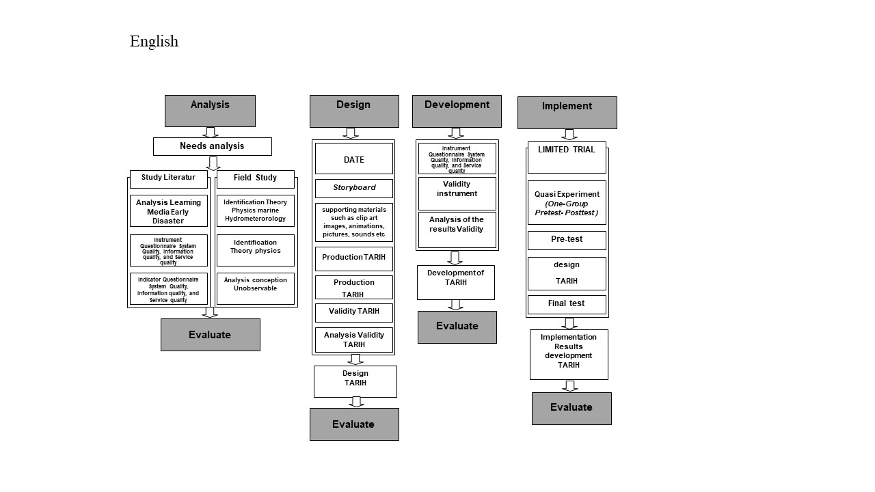The research method used in this study is the ADDIE Model which consists of the Analysis, Design, Develop, Implement, and Evaluate. The research subjects were 69 students aged 21-23 years at a university in Jakarta and Banten, Indonesia. The design of this research refers to several stages of the development research model. The ADDIE model is an abbreviation for the five stages of the development process (Richey, at al., 2019).

Figure 1. Research Design of Technology Augmented Reality Integration Hydrometereology (TARIH)

Based on Figure 1, information is obtained that TARIH was developed through the needs analysis stage and then a literature study on Augmented Reality-based Hydrometerorology Physics which will later be enriched with real-time animation and video displays. The next stage of design design aims to determine the design of TARIH and the appearance of the AR application interface that you want to develop. Furthermore, the development of TARIH Design and the final stage of User Trial to conduct TARIH trials on users.

The instrument used in this study adopted the modified results of research on the literature on the success of a digital media program. Starting from the aspects of performance, success, user satisfaction (Wang, et al., 2007). Based on the analysis, it is divided into 3 aspects in this study, namely System Quality as many as 7 questions, Information quality as many as 6 questions and Service quality as many as 2 questions. So that the total number of questions obtained is 15 items that represent the three dimensions that underlie the construction of TARIH as a learning medium.

In addition, the TARIH media also carried out content validation to see the accuracy or confidence that no important attributes or items were omitted, the researchers validated the success of the TARIH system with the help of three media experts consisting of 2 media experts and 1 professor. They were asked to review the initial list of research instrument items. The criteria used in this question instrument to measure the TARIH system as a criterion were developed using a five-point Likert-type scale, ranging from strongly disagree to strongly agree. For each question, the respondent is asked to choose one of the answers that are already available in the online form, so that the respondent does not experience difficulties.

Data processing using SPSS software was carried out to test the reliability of the developed TARIH media. The use of SPSS is to test Cronbach's Alpha Reliability. This test is carried out to measure a measure of the reliability of research instruments which has a value ranging from zero to one, where the minimum reliability level of Cronbach's Alpha (> 0.6). This test shows whether an instrument used to obtain information can be trusted to reveal information in the field as a data collection tool. The questionnaire is said to be reliable or reliable if someone's answer to the statement is consistent from time to time.

# ResuLT and DISCUSSION

**Date Development Results**

Augmented Reality Integration Hydrometereology (TARIH) Technology as a Learning Media Solution for Early Disaster Management For students due to land subsidence for easy scanning of the marker, the marker is placed in the marine physics module. Because hydrometerorilo part of marine physics. The module that has been developed uses word processing software, namely Microsoft Word and software for making designs, namely Adobe Illustrator. This module is in printed form with the following Module components. In the opening section of the module, there are several components, namely (1) the front cover of the module, (2) the francis page, (3) the module copyright page, (4) the introduction page, (5) instructions for using the module, (6) a table of contents, and (7) a concept map.

The first component in the form of the front cover of the TARIH module contains the main title of this module, namely “Marine Physics”. In addition, there are other elements in the module's cover, such as illustrations depicting the sea, names of authors, information that this module is equipped with Augmented Reality. The front cover of this module can be seen in more detail in Figure 2.

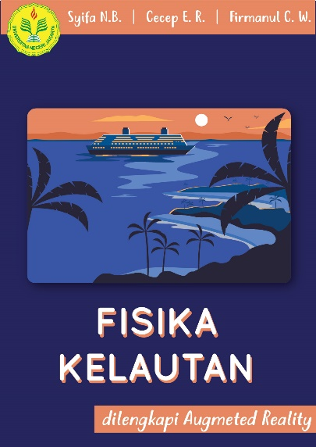

Figure 2. Front Cover Display of TARIH Module of Concept Marine Physics

The second component in the form of a Francis copyright page contains the main title of the Module, a statement that the Module is equipped with Augmented Reality, the names of the authors, and the origin of the institution. In the third component in the form of the Module copyright page, there is the title of the Module, the names of the authors, as well as a description of how many prints along with the month and year. In the fourth component in the form of an introduction page, there is an introduction from the author. In the fifth component in the form of instructions for using the module, there are ways to use the module, including where to download applications from this Marine Physics module. Instructions for using this module can be seen in more detail in Figure 3

Figure 3. Display of Instructions for Using the TARIH Module

The sixth component in the form of a table of contents contains a table of contents from the TARIH Module, the seventh component in the form of a concept map contains the overall concept map of this Module. This concept map includes chapter titles and sub-chapters of each material. The concept map of this module can be seen in more detail in Figure 4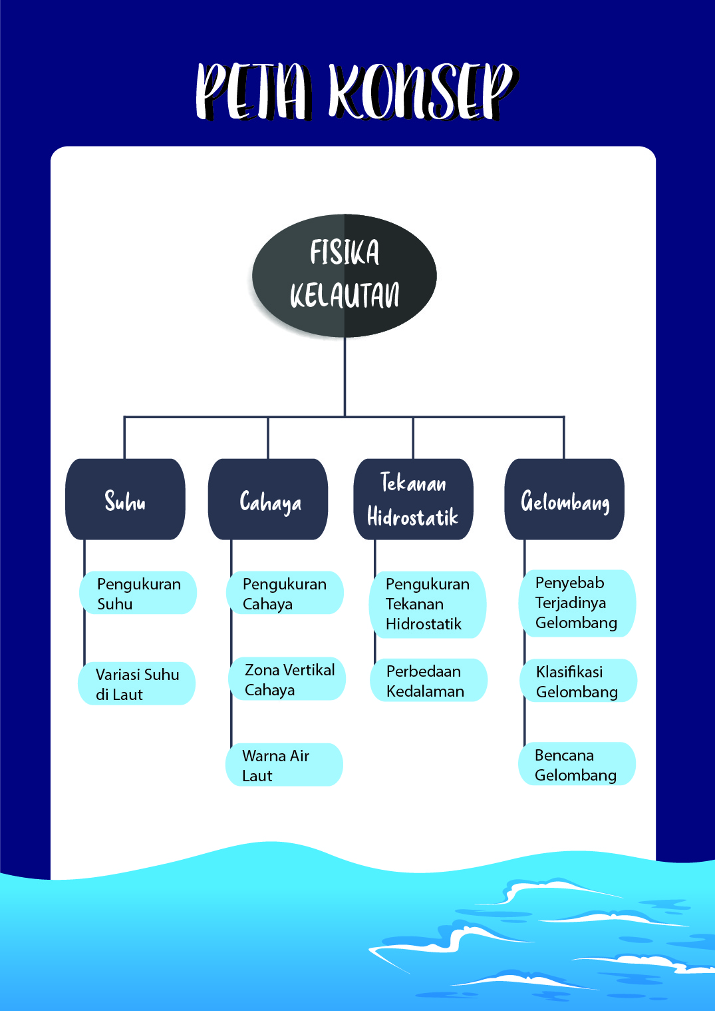

Hydrometeorological Concept

Figure 4. TARIH Module Concept Map

The core part of the Module, there are several components, namely (1) front cover of each chapter, (2) concept map, (3) material, and (4) summary. In the first component, which is the front cover of each chapter, there is a chapter title along with an illustration that represents it. The front cover of the chapter can be seen in more detail in Figure 5.

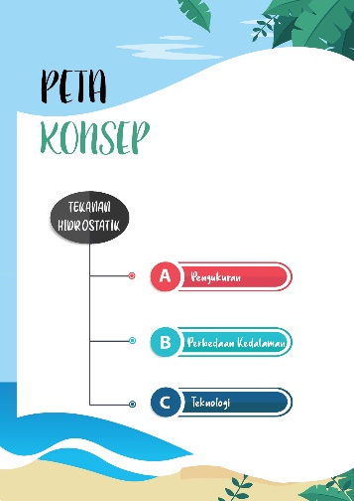

Figure 5. Display of the Hydrostatic Concept that can show the Hydrometereological process

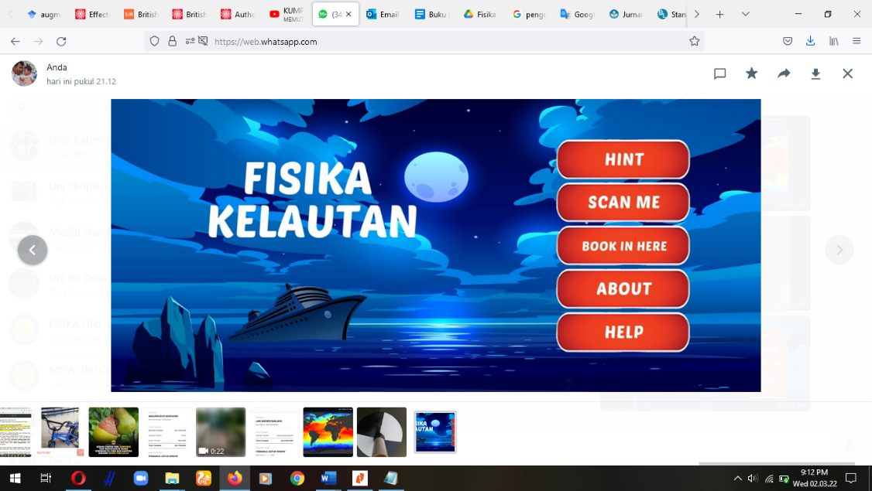The next core component is the product developed, namely Vuforia Augmented Reality (AR). Which shows 3D of Hydrometeorology. Hydrometereology display on the TARIH application which is incorporated in the concept of marine physics is shown in Figure 6.

Figure 6. Screenshot of TARIH application

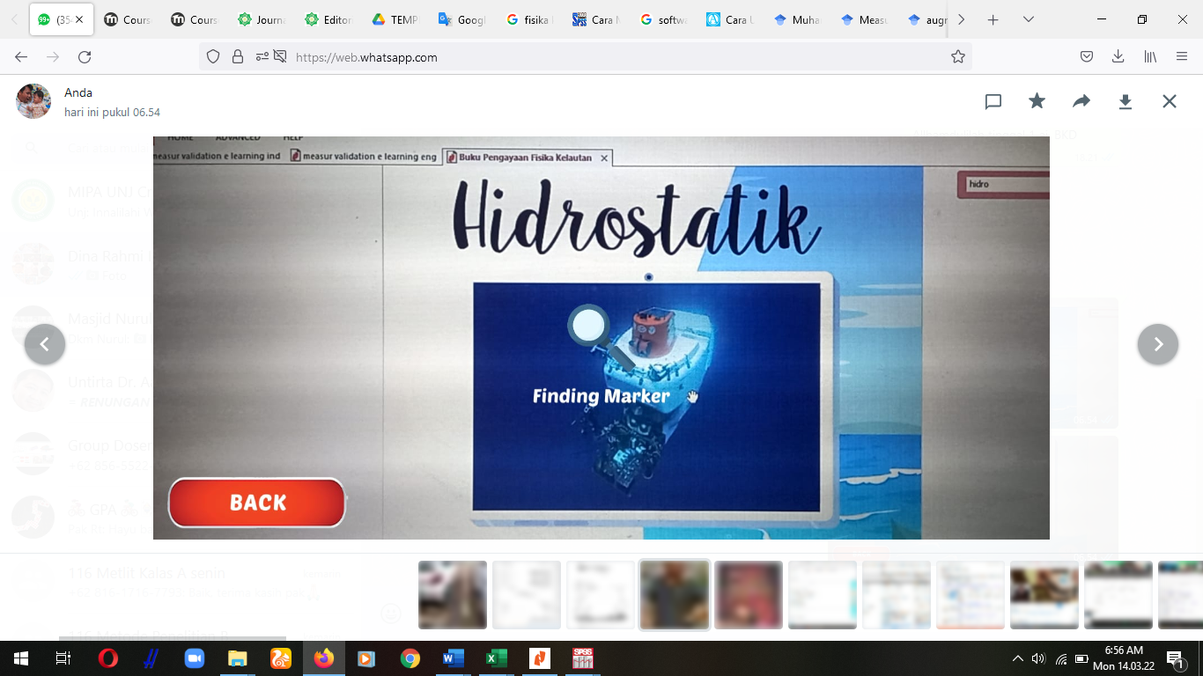The second component in the form of a concept map for each chapter is a concept map from that chapter. The concept map in the core is different from the concept map in the opening section. This is because the concept map in the core section is a concept map for one material, while the concept map in the opening section is a concept map for one module. The Scan Marker process and the search for hydrometeorological concept markers are shown in more detail in Figure 7.

Figure 7. TARIH in Scan Marker and search markers for hydrometeorological concept

The third component in the form of material contains material that will be discussed because a marker is found in it with the tone of the AR symbol. The display of the material after finding the marker can be seen in more detail in Figure 8.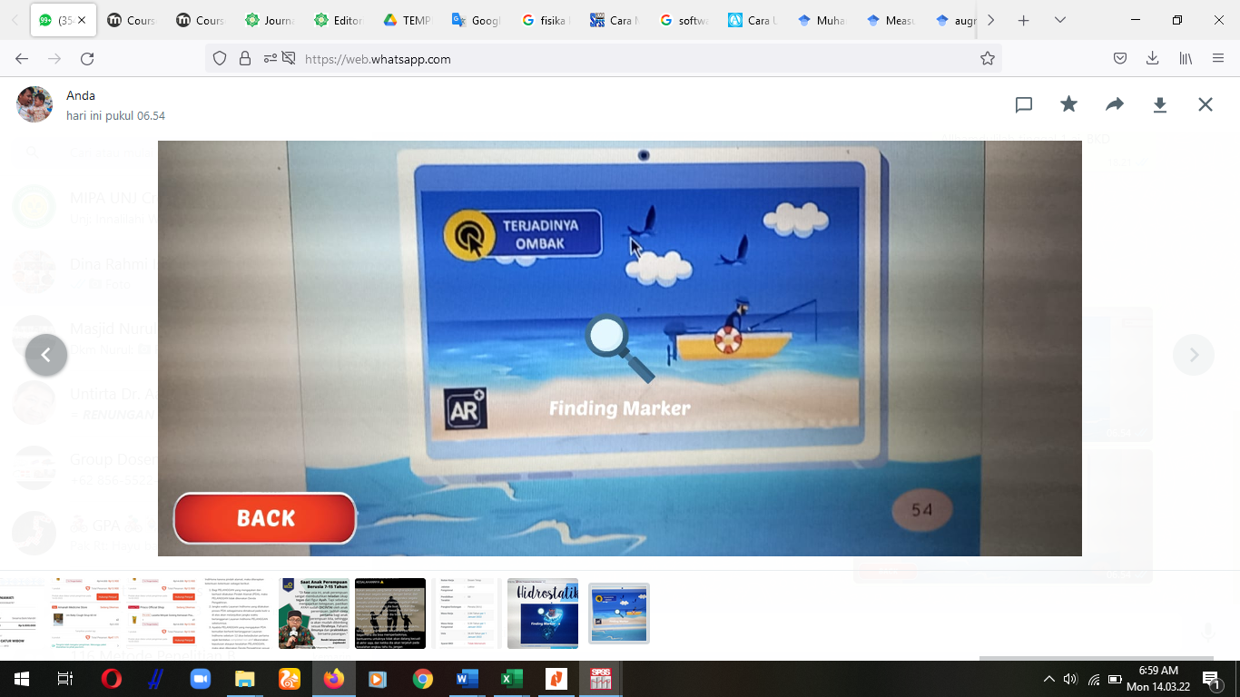

Figure 8. TARIH has found markers and is looking for hydrometeorological concept

After finding the AR marker, the students continued to study physics on the concept of disaster, especially the concept of hydrometeorology. Because this concept causes land subsidence in the Jakarta and Banten areas. This introduction to using TARIH media for students is a prefix to explain the importance of understanding hydrometeorology which must be understood in accordance with the demands of the 21st century, namely optimizing 3D digital media for learning. The results of the implementation of TARIH by students are shown in Figure 9.

Figure 9. Students are learning using TARIH the concept of hydrometeorology

The TARIH application that has been developed is used to scan markers or markers. Marker or markers have been integrated with Augmented Reality information. The application to scan the marker is called "Marine Physics" which is installed on the smartphone. How to use this application is to point the camera at the application to scan the markers contained in the module. Furthermore, the camera will display virtual information in the form of three-dimensional animation or three-dimensional video in real-time. This application has five interfaces with various functions. First, there is a "HINT" menu which contains instructions for using the application. Second, there is a “SCAN ME” menu which is a camera for scanning images. Third, there is a “BOOK IN HERE” menu which is used if the user wants to download the TARIH Module himself. Fourth, "ABOUT" which is a page that contains information about the application. Finally, there is a "HELP" menu which is a help page if you experience problems while operating the application. The display in this application can be seen in more detail in Figure 6.

**TARIH Reliability Test Results**

The results of the study were based on the reliability test. Student responses to the implementation of TARIH as a learning medium for Hydrometereology, the reliability of the System Quality aspect was 0.69 and the mean was 4.43. Meanwhile, the reliability of the Information quality aspect is 0.43 and the mean is 4.39 and the reliability of the Service quality aspect is 0.74 and the mean is 4.45. Reliability test using Cronbach alpha is a tool used to measure the consistency of the questionnaire which is an indicator of a variable or construct. A questionnaire is said to be reliable or reliable if someone's answer to a question is consistent or stable over time. Data Summary of the results of Student Responses to the Implementation of TARIH is shown in Table 1.

Table 1. Summary of the results of Student Responses to the Implementation of TARIH

|  |  |  |  |  |  |
| --- | --- | --- | --- | --- | --- |
| **No** | **Aspect** | | **Reliability** | **Corrected item-to-total correlation** | **Mean** |
| 1 | **System Quality** | | 0.69 |  | 4.43 |
| Q1 | The TARIH system provides high availability | 0.54 |
| Q2 | The TARIH system is easy to use | 0.57 |
| Q3 | The TARIH system is user-friendly | 0.50 |
| Q4 | The TARIH system provides interactive features between users and system | 0.51 |
| Q5 | The TARIH system provides a personalized information presentation | 0.74 |
| Q6 | The TARIH system has attractive features to appeal to the users | 0.79 |
| Q7 | The TARIH system provides high-speed information access | 0.73 |
| 2 | **Information quality** | | 0.43 |  | 4.39 |
| Q1 | The TARIH system provides information that is exactly what you need | 0.24 |
| Q2 | The TARIH system provides information you need at the right time | 0.22 |
| Q3 | The TARIH system provides information that is relevant to your job | 0.24 |
| Q4 | The TARIH system provides suﬃcient information | 0.40 |
| Q5 | The TARIH system provides information that is easy to understand | 0.55 |
| Q6 | The TARIH system provides up-to-date information | 0.51 |
| 3 | **Service quality** | | 0.74 |  | 4.45 |
| Q1 | The TARIH system provides a proper level of on-line assistance and explanation | 0.58 |
| Q2 | The TARIH system developers interact extensively with users during the development of the Early Disaster system | 0.58 |

Based on Table 1, information is obtained that Student Responses to the Implementation of TARIH have 3 aspects, namely, System Quality, Information quality, and Service quality. Aspects of System Quality with Reliability 0.69. this indicates that 0.69 > 0.60 then the student states that it is consistent and user friendly with the date. In addition, the average score of the System Quality aspect is 4.43 where the highest score is 5. It can be concluded that the TARIH system provides high availability, easy to use and user-friendly. This is in accordance with research that AR can make it easier for users to learn (Macariu, et al., 2020) and learn independently (Liono, et al., 2021).

Information quality aspect with Reliability 0.43. this indicates that 0.43 < 0.60 then the student states that he is less consistent in this aspect, this is because the first new student uses AR on the concept of disaster because AR is usually on the concept of basic physics. In addition, the average score for the Information quality aspect is 4.39 where the highest score is 5. It can be concluded that TARIH is exactly what you need, provides sufficient information, and the system provides information that is easy to understand. This is in accordance with research that AR can facilitate student understanding (Chytas, et al., 2022).

Service quality aspect with Reliability 0.74. this indicates that 0.74 > 0.60 then the student states that it is consistent, and this is the highest reliability value compared to other aspects. In addition, the average score for the System Quality aspect is 4.45 where the highest score is 5. It can be concluded that TARIH is system provides a proper level of on-line assistance and explanation and The TARIH can use the Early Disaster system. This is in accordance with research that AR can be used as teaching material or as an assistant in learning science and earth as well as for independent learning about the Early Disaster system (Ruan, & Kang, 2020). The success of TARIH is a multidimensional and interdependent construct, and it is therefore necessary to study the interrelationships between these dimensions. Therefore, based on the TARIH success model, it is necessary to examine further research efforts to explore and test the causal relationship between System Quality, Information quality, and Service quality.

## CONCLUSION

Disaster mitigation is an important part of the activities of the disaster management cycle, namely at the pre-disaster stage. It is these pre-disaster activities that are often forgotten, even though these pre-disaster activities are very important because what has been prepared at this stage is the capital in dealing with during and after disasters. In addition, there are still few learning media that can explain in 3D the hydrometeorological disaster process. Knowledge and understanding of hydrometeorological preparedness for students is expected to be able to make students more prepared in dealing with disasters to reduce the loss of life and property among students due to disaster events. Based on the research that has been done, the results of the study show that the developed TARIH is effective as a Media Solution for Disaster Management from an early age to students. Because TARIH is equipped with Augmented Reality technology to help display animations and videos that are difficult to understand into 3D objects. One of the implications of developing TARIH is that it can be used as teaching materials that can increase user knowledge.

# acknowledgment

Acknowledgments to those who have provided financial assistance in research are the 2021 Scientific Research Grants by Direktorat Jenderal Pendidikan Tinggi, Ministry of Education, Culture, Research, and Technology Indonesia which has provided funds in accordance with the Research Contract Number: 032/E4.1/AK.04.RA/2021.

# REferenCES

Akala, B. M. M. (2021). Revisiting education reform in Kenya: a case of competency based curriculum (CBC). *Social Sciences & Humanities Open*, *3*(1), 100107.

Chen, C. H., Liu, J. H., & Shou, W. C. (2018). How competition in a game-based science learning environment influences students' learning achievement, flow experience, and learning behavioral patterns. *Journal of Educational Technology & Society*, *21*(2), 164-176.

Chytas, D., Johnson, E. O., Piagkou, M., Mazarakis, A., Babis, G. C., Chronopoulos, E., ... & Natsis, K. (2020). The role of augmented reality in anatomical education: an overview. *Annals of Anatomy-Anatomischer Anzeiger*, *229*, 151463.

Diakakis, M., Skordoulis, M., & Savvidou, E. (2021). The Relationships between Public Risk Perceptions of Climate Change, Environmental Sensitivity and Experience of Extreme Weather-Related Disasters: Evidence from Greece. *Water*, *13*(20), 2842.

Faridi, H., Tuli, N., Mantri, A., Singh, G., & Gargrish, S. (2021). A framework utilizing augmented reality to improve critical thinking ability and learning gain of the students in Physics. *Computer Applications in Engineering Education*, *29*(1), 258-273.

Gernowo, R., & Sasongko, D. P. (2021). Tropical convective cloud growth models for hydrometeorological disaster mitigation in Indonesia. *Global Journal of Engineering and Technology Advances*, *6*(2), 114-120.

Hamzah, M. L., Rizal, F., & Simatupang, W. (2021). Development of Augmented Reality Application for Learning Computer Network Device. *International Journal of Interactive Mobile Technologies*, *15*(12).

Herowati, D. K. (2022, January). Augmented Reality-Based Media to Improve Disaster Preparedness for Junior High School Students. In *5th International Conference on Current Issues in Education (ICCIE 2021)* (pp. 164-168). Atlantis Press.

Kencana, H. P., Iswanto, B. H., & Wibowo, F. C.. Augmented Reality Geometrical Optics (AR-GiOs) for Physics Learning in High Schools. In *Journal of Physics: Conference Series*, **2021**, *2019* 9 (1), p. 012004). IOP Publishing.

Leebmann, J. (2004). An augmented reality system for earthquake disaster response. *International Archives of the Photogrammetry, Remote Sensing and Spatial Information Sciences*, *34*(Part XXX).

Liono, R. A., Amanda, N., Pratiwi, A., & Gunawan, A. A. (2021). A systematic literature review: learning with visual by the help of augmented reality helps students learn better. *Procedia Computer Science*, *179*, 144-152.

Macariu, C., Iftene, A., & Gîfu, D. (2020). Learn chemistry with augmented reality. *Procedia Computer Science*, *176*, 2133-2142.

Richey, R.C, Klein, J.D. Tracey, *The Instructional Design Knowledge Base: Theory, Research, and Practice*. Publisher: Taylor & Francis. 2019.

Rodríguez Piedrabuena, A. (2021). *Feasibility study of using augmented reality in geotechnical site inspection* (Bachelor's thesis, Universitat Politècnica de Catalunya).

Ruan, S., & Kang, J. (2020). Optimization method of disaster scene loading under mobile augmented reality visualization. *武汉大学学报● 信息科学版*, *45*(9), 1422-1428.

Sanjaya, L. A., Putri, E. A., Wibowo, F. C., & Robby, D. K. (2021). Digital Storytelling of Physics (DiSPhy): Belajar Fisika melalui Cerita. *Journal of Natural Science and Integration*, *4*(2), 195-203.

Sermet, Y., & Demir, I. (2020). Virtual and augmented reality applications for environmental science education and training. *New Perspectives on Virtual and Augmented Reality: Finding New Ways to Teach in a Transformed Learning Environment*, 261-275.

Velev, D., Zlateva, P., Steshina, L., & Petukhov, I. (2019). Challenges of Using Drones and Virtual/Augmented Reality for Disaster Risk Management. *The International Archives of Photogrammetry, Remote Sensing and Spatial Information Sciences*, *42*, 437-440.

Wang, H., Tlili, A., Lehman, J. D., Lu, H., & Huang, R. (2021). Investigating feedback implemented by instructors to support online competency-based learning (CBL): a multiple case study. *International Journal of Educational Technology in Higher Education*, *18*(1), 1-21.

Wang, Y. S., Wang, H. Y., & Shee, D. Y. (2007). Measuring e-learning systems success in an organizational context: Scale development and validation. *Computers in Human Behavior*, *23*(4), 1792-1808.

Wijaya, R. E., Mustaji, M., & Sugiharto, H. (2021). Development of Mobile Learning in Learning Media to Improve Digital Literacy and Student Learning Outcomes in Physics Subjects: Systematic Literature Review. *Budapest International Research and Critics Institute (BIRCI-Journal): Humanities and Social Sciences*, *4*(2), 3087-3098.

Wu, D. Y., Lin, J. H. T., & Bowman, N. D. (2022). Watching VR advertising together: How 3D animated agents influence audience responses and enjoyment to VR advertising. *Computers in Human Behavior*, 107255.

Zhang, G., Gong, J., Li, Y., Sun, J., Xu, B., Zhang, D., ... & Yin, B. (2020). An efficient flood dynamic visualization approach based on 3D printing and augmented reality. *International Journal of Digital Earth*, *13*(11), 1302-1320.

Zhang, Z., Li, Z., Han, M., Su, Z., Li, W., & Pan, Z. (2021). An augmented reality-based multimedia environment for experimental education. *Multimedia Tools and Applications*, *80*(1), 575-590.