The Effect of Using Buzz Group Technique on Students Ability in Writing Analytical Exposition Paragraph

Nuardi
Universitas Islam Negeri Sultan SyarifKasim Riau, Indonesia
nuadri@gmail.com

M. Syafii S.
Universitas Islam Negeri Sultan SyarifKasim Riau, Indonesia
m.syafii.siec@gmail.com

Inna Hayatul Anuar
Universitas Islam Negeri Sultan SyarifKasim Riau, Indonesia
innahy@yahoo.com

Abstract
The objectives of the research were to know students’ ability in writing analytical exposition paragraph taught by using buzz group and taught without using buzz group, to get information the significant effect of students’ ability in writing analytical exposition paragraphs by using buzz group. In this research, the research design was a quasi experimental research.The population of this research was the eleventh grade students of Private Senior High School YKPP Dumai. There werenine classes; the number of population was233 students.The researcher used cluster random sampling as the technique sampling of the research. Class XI IPA 1 was control class, while XI IPA 5 was experimental class.Based on the data analysis, the researcher concluded that the score of sig. is higher than α (0.05 > 0.000) in the other word, there is a significant effect of using Buzz Group Technique on students’ ability in writing analytical exposition paragraph of the eleventh grade students at Private Senior High School YKPP Dumai. It means that H_{a} was accepted and H_{o} was rejected.

Key Word : Writing, Buzz Group Technique

- Background
Writing is one of the important skills to be mastered because of some reasons. First, through writing the learners can communicate with others. Second, the learners can know how to express their ideas, feeling or their unforgettable experience, and besides that writing is also important for academic purpose.Writing is talking about a physical and a mental act, because by writing we can create a communication between writer and readers. At most basic level David Nunan (2003: 88) pointed out that writing is the physical act of committing words or ideas to some medium, whether it is hieroglyphics inked onto parchment or an e-mail message type into a computer.
Private Senior High School YKPP Dumai is one of the Senior High School in the Dumai City that appliesCurriculum 2013 as its guidance in conducting learning process of English this school Based Curriculum 2013 to provide writing as one of the skills that should be taught and learned in Private Senior High School YKPP Dumai.
Private Senior High School YKPP Dumai, the students’ minimum passing grade is 7.0.Based on the preliminary observation and interview to the English teacher there, the teacher used some techniques such as discussion, games, brainstorming, etc.Generally, teacher reviewed the characteristic of the texts based on genre given including the kinds of the texts, the purpose of the texts, the text organizations, and the language features. Then, the teacher asked students to write a simple essay individually based on the time given. That method did not seem to give significant effect on improving students’ writing analytical exposition text ability.Not only about those method, but also students willingness to study English and etc.
Based on the researcher’s preliminary research at Private Senior High School YKPP Dumai, especially at the second grade students, it is clear that most of the students’ of the first grade students’ of Private Senior High School YKPP Dumai were encountering the problems and the difficulties in writing English. Their ability in writing English, especially in term analytical exposition paragraph was still very far from the expectation of the curriculum. It can be proven from minimum passing grade of students’. The problems of the students in writing analytical paragraph can be seen in the following phenomena: (1) Some of the students were not able to use a present simple sentence in making a description. (2) Some of the students were still difficult to write opinion about the hot issue. (3) Some of the students were not able to write the main problem about the hot issue. (4) Some of the students did not present clear ideas of analytical exposition writing. (5) Some of the students were not able to write the illustration as supporting their opinion. (6) Some of the students could not develop or elaborate the paragraph by using supporting sentences.
To improve the students’ ability in writing analytical exposition paragraph needs an appropriate strategy and technique helping them as solution for their problems. There is actually a technique that can help students in writing analytical exposition paragraphs, called Buzz Group Technique. This technique is effective to gather information and ideas.
The writer needs to limit and focus on students’ ability in writing analytical exposition paragraph at Private Senior High School YKPP Dumai.
Based on the background above, the problems of this research can be formulated in these following questions: (1)How is students’ ability in writing analytical exposition paragraph taught by using Buzz Groups Technique at Private Senior High School YKPP Dumai? (2) How is students’ ability in writing analytical exposition paragraph taught without using Buzz Groups Technique at Private Senior High School YKPP Dumai? (3) Is there is any significant effectof using Buzz Groups Technique on students’ ability in writing analytical exposition paragraph?
The objectives of this research are: (a) To know students’ ability in writing analytical exposition paragraph taught by using buzz group. (b) To know about students’ ability in writing analytical exposition paragraph taught without using buzz group. (c) To get information the significant effect of students’ ability in writing analytical exposition paragraphs by using Buzz GroupTechnique.
The result of this research is expected to be useful information to: (1) These research findings are able to benefit the writer as the novice researcher especially in learning how to conduct a research. (2) These research findings are also expected useful and valuable, especially for students and the teachers of English of the eleventh grade at Private Senior High School YKPP Dumai. (3) these research findings are valuable information, especially for those who are concerned in the world of teaching and learning English as a foreign language. (4) Finally, these research findings are also expected to be practical and theoretical information to the development of the theories of language teaching.

Writing
Writing is one of the four language skills and it is the most important process in learning English. It cannot be separated with every learning process experienced by the students as long as they are still in educational process. Hasibuan (2007: 127) says that, writing is both process and product.
Writing activity is started by writing words to become a sentence. Then sentences will be arranged to make a paragraph and collections of paragraphs will be an essay. In an essay, a writer should provide one important thing that is one clear controlling idea. According to Donald (1991: 341), An essay, is not too different from paragraph, requires a clear controlling idea which is called as a thesis statement. A thesis statement will provide readers to know the main point of the essay and it also directly leads readers to points provided in the essay.
The purpose of writing, in principle, is the expression ideas, the conveying of a message to the reader; so our ideas should arguably be seen as the most important aspect of the writing. On the other hand, the writers also need to pay some attentions to formal aspect, such as neat handwriting, correct spelling and punctuation as well as acceptable grammar and careful selection of vocabulary, because much higher standards of language are normally demanded in writing than speech: more careful constructions, more precise and varied vocabulary, and more correctness of expression in general (Penny Ur, 1996: 163).
According to Syafi’i (2013:94), writing is not an easy thing to do. He clarifies that writing skills can be developed by practice, besides it is also time-consuming. He classifies the process of writing into four main stages. They are prewriting, planning (Outlining), revising the drafts, and writing the final drafts. In addition, Medwell (2009: 72) said that, “There are three stages of the writing process. They are: (1) Planning writing. This include a discussion of what is involved and who the piece is for, as well as writer’s contributions to brainstorming or making concet maps. (2) Drafting writing. Drafting may involve using a text map or writing frame to help structure the piece. (3) Revising writing. This involves looking at a piece of writing and considering its effect and how that effect is created.”
Besides process, in writing there are categories also. H. Douglas Brown (2003: 220) said, there are four categories of written performance that capture the range of written production is considered here. Each Category resembles the categories defined for the other three skills, but these categories, as always, reflect the unique of the skill area.
The categories are: (1) Imitative. To produce written language, the learner must attain skill in the fundamental, basic tasks of writing letters, words, punctuation, and very brief sentences. This category includes the ability to spell correctly and to perceive phoneme-grapheme correspondences in the English spelling system. At this stage, form is the primary if not exclusive focus, while context and meaning are of secondary concern. (2) Intensive. Beyond the fundamental of imitative writing are skills in producing appropriate vocabulary within a context, collocations and idioms and correct grammatical features up to the length of a sentence. Meaning and context are of some importance in determining correctness and appropriateness, but most assessment tasks are more concerned with a focus on form and are rather strictly controlled by the test design. (3) Responsive. Assessment tasks require learners to perform at a limited discourse level, connecting sentences into a paragraph and creating a logically connected sequence of two or three paragraph. Tasks respond to pedagogical directives, lists of criteria, outlines, and other guidelines. Genre of writing include brief narratives and descriptions short reports, lab reports, summaries, brief responses to reading, and interpretations of charts or graphs. Under specified condition, the writer begins to exercise some freedom of choice among alternative forms of expression of ideas. The writer has mastered the fundamentals of sentence-level grammar and is more focused on the discourse conventions that will achieve the objectives of the written text. Form focused attention is mostly at the discourse level, with strong emphasis on context and meaning. (4) Extensive. Extensive writing implies successful management of all the processes and strategies of writing for all purposes, up to the length of an essay a term paper, a major research project report, or even a thesis. Writers focus on achieving a purpose, organizing and developing ideas logically, using details to support or illustrate ideas, demonstrating syntactic and lexical variety, and in many case, engaging in the process of multiple drafts to achieve a final product. Focus on grammatical form is limited to occasional editing or proofreading a draft. From the types above, researcher can conclude that the first type, imitative, suitable for elementary school. Then, the second type is intensive, suitable for junior high school. The third type is responsive suitable for senior high school, and the last type is extensive that suitable for university students.
Furthermore, there are three terms that we should concern when we are writing; the terms are audience, tone and the purpose of writing. In line with Syafi’i (2013: 91) writing can be defined as kind of writing in which we are required to concern with the term of audience, tone, and purpose of writing in the major field of study.
- Audience. Audience is one of the most crucial parts in term of writing. Writing, of course, you need to communicate to messages, ideas or feelings to readers with a very clear meaning through a means of written communication. (2) Tone. Tone refers to depiction of attitude toward the subject you are working with, the choice of words you are wording, the use of grammatical structures you are employing, and even the length of sentences you are using to communicate your intended meaning in a particular writing assignment you are developing. The tone of a piece of writing is determined more by its intended audience rather than its subject matters. (3) Purpose. In academic writing, the purpose will most often be to enlighten. It may also be to persuade or to convince the audience of the correctness of the writer’s point of view on a particular issue.
As you begin to write any writing assignment, or whenever you need to communicate in written communication, you need to keep in mind your audience, tone and purpose so that the message your reader receives is that the message you intend to convey.
Analytical Exposition
Rigby Heinemann (2004 : 144) said that analytical exposition paragraph uses writing to persuade others or discuss reasons for writing. The purpose of analytical exposition is to develop ideas and supporting details in order to present a logical argument from a particular point of view. It means that the writer writes analytical exposition analytical exposition to make the reader to agree with the argument that writer has made it the paragraph.
Analytical exposition paragraph has three generic structure, they are: (1) Thesis. Writers an opening sentence that reveals personal position (negative or positive) followed by a brief summary of the arguments to follow. (2) Argument. Generally the arguments are presents each paragraph to state a point and then elaborates. (3) Reiteration. Writers final statement that may not rater the position before and writes final paragraph that reiterates the main points with an evaluative conclusion.

Writing Assessment
Hughey (1983:140) et al state that there are five components of writing that must be observed by writer in writing composition, they are. (1) Content. The ability to think and develop the ideas creatively and develop thought, excluding all irrelevant information. (2)Organization. It is well organized, cohesive, ideas, clearly, stated in logically sequenced. (3) Vocabulary. The writer should master in using correct words, choosing of the words, and idioms. (4) Language use. In writing a text, we should master of the knowledge of grammar because of very important. Grammar or language is description of speaking and writing habits of the people who use it. Language use or grammar is very important, because without them, writer will not be able to write well. (5) Mechanics. Then the writer should master about the mechanics. Example masteri in using punctuation, spelling, and capitalism.

Buzz Group Technique
According to Mason (1995: 13), Buzz Group is a question or statement which is displayed on a flipchart and participants generate their responses in small groups. Responses are listening and common responses are selected for discussion by the participants as a whole. Besides that, Ernest W. Brewer (1997: 72) said that, Buzz Group encourages more efficient discussion. They can be used in many different ways and are most often used in combination with other techniques, such as a lecture. Buzz Groups set the groundwork with controversial subjects or difficult question and problems.
AccordingMason (1995: 13) said that the guidelines of Buzz Groups are following: (1) Write a carefully-phrased question or statement on a flip. (2) Divide the participants into small groups; three people to a group are ideal. (3) Have each group discuss the question/statement for about 10 minutes to produce a list of ideas. (4) Get the ideas from each group and write them on flipchart so that everybody can see. (5) At the end of the discussion, summarize briefly and make a positive link with what happens text.
Furthermore, according to Ernest W. Brewer (1997: 73) said that the guidelines of Buzz Groups are following: (1) The leader begins by dividing the overall group into smaller groups of anywhere from 2 to 15 people. (2) These smaller buzz group should have room to sit either facing each other or in circle, which will increase the discussion. (3)Once the groups are formed, the leader will introduce the issue or problem to be discussed. The issue can be the same for all groups, or each group can have a different phase or sub problem to discuss. The Professional Teacher Education Module Series (1984) suggests narrowing the topic, allowing for participants achievement level, and having time restrictions to prevent a high frustration level among the participants. (4) Once the issue or problem to be discussed is clarified and understood by each group, the groups should be asked to choice their own leader and recorders, or the presenter can appoint one for each group. (5) The group leader makes certain that the members of the group become acquainted with each other, leads the discussion, and tries to get all the members of the group participate. (6) The recorder takes notes and prepares a summary to be presented when all the group come together. (7) The time allowed in the buzz groups should be specified at the beginning, depending on the number of people in each group, the complexity of the issue, and the purpose of the buzz groups. (8) While the groups are meeting, the teacher can move from group to group, listening and, raising the question to stimulate discussion or bring the discussion back on track. The presenter should be careful not to stay too log at any group so that the members will not direct their questions to him or her. (9) When the time has ended, the teacher discussion leader reconvenes the group into the large group and calls for the report of the buzz group recorders. After each group has reported, the presenter may want to open the floor to general discussion. (10) Depending on the complexity of the problem and the purpose of the discussion, the group recorders may be asked to get together later to summarize their findings into a report on the discussed.
According to Ernest W. Brewer (1997: 75) buzz group technique has some advantages, they are: (1) It allows everyone’s ideas to be expressed. (2) Participants learn to work in real-life situations where other’s opinions are considered. (3) It sets the groundwork to get discussion started. (4) Because members are expressing opinions, it is good for dealing with controversial subjects.
The relevant research of this study are conducted by first is Ms. KhampengSengbounthanh entitled “The Improving the Students’ Speaking Skill by Using Buzz Group (A Classroom Action Research at Seventh Grade of Nong Bone Public High School in Laos, the First Semester in Academic Year 2010/2011)”. She found that by using Buzz Group technique can improve the students’ speaking skills well; there is significant improvement in teaching speaking toward the students’ speaking skill. From the result in 1st cycle and 2nd cycle, there is an improvement of students’ speaking ability. It is showed by the mean in the cycle 1 (67.15) become 75.78 in the cycle 2.Thus, it can be concluded that demonstration method is effective method to improve students speaking skill.
Then, the second research by WachidatunNi’mah in 2015, entitled “The Use of Buzz Group Technique to Enhance Students’ Activeness and Writing Skill if Hortatory Exposition Text (a Classroom Action with the Eleventh Grade Students of MA AL KHAIRIYYAH Semarang in the Academic Years of 2014/2015)”. She found that by using Buzz Group Technique can improve students’ activeness and writing skill especially in hortatory exposition text. It showed by the score of pre-cycle, first cycle and second cycle. In the pre-cycle was found the total score of students’ writing result was 67.5, it meant was 67.5%. It showed that the value of students’ 98 writing result was fair. In the first cycle was found the total score of students’ writing result was 81, it meant was 81%. It showed that the value of students’ writing result was good. In the second cycle was found the total score of students’ writing result was 87, it means was 87%. It showed that the value of students’ writing result was excellent.

Operational Concept
Operational concept is the concept to avoid misunderstanding the research about the influence of a buzz group activity on analytical exposition writing skill. The research consists of two variables, variable X is the influence of a buzz group writing activity, and Y variable is analytical exposition writing skill. Therefore, variable X is an independent variable and variable Y is a dependent variable.
Indicators of Buzz Groups activities as variable X are (Ernest W. Brewer and David J Mason):(1) The teacher introduces Buzz Group Technique and the procedure of Buzz Group. (2) The teacher divides the students into some groups. Each group consists of 5 students. Make them sit in circle. (3)Teacher asks each group to point the presenter. (4)Teacher give the problem that will be discuss and give them the limits time to discuss it (5 – 10 minutes) and they can write the ideas of the problem. (5)While the groups are discussion, the teacher can move from group to another group, listening, and raising the question. (6) Teacher makes certain the members of groups become acquitted write each other, leads the discussion, and tries to get all the members of the group participate.(7) When the time has ended the presenter of each group write the result on whiteboard and present it in front of the class, the other groups can ask about the ideas that presented. (8)At the end of discussion and summarize briefly.
Indicators of Analytical Exposition writing activities as variable X (from Syllabus YKPP Dumai):(1)The students are able to write opinions about the hot topic discussed responsibly. (2)The students are able to write the main problem in hot issue. (3)The students are able to write the opinion about hot issue and illustration as supporting. (4)The students are able to write the conclusion that restates the opinion about that issue.

- Research Design
In this research, the writer was experimental research. According to Cresswell (2008: 299) states an experimental is your test an idea (or practice or procedure) to determine whether it influences an outcome or dependent variable. Furthermore Donald Ary (2010: 265) et al states that an experiment is scientific investigation in which the researcher manipulates one or more independent variables, controls any other relevant variables and observes the effect of the manipulations on the dependent variables. The method in this research was aquasi-experimental research. According to David Nunan (1992 : 41) quasi-experimental has both pre and post test and experimental and control group, but no random assignment of subject. This research used pre test and post test as research design.
There were two variables used in this research, firstly was the influence of a buzz group as independent variable as variable X and writing analytical exposition paragraph as dependent variable or variable Y.

Time and Location of the Research
The research was conducted from March to April 2016. This research was conducted at the second year of Private Senior High School YKPP Dumai.

Subject of the Research
The subject of this research was the second year students at Private Senior High Scholl YKPP Dumai.

Object of the Research
The object of this research was the effect of using Buzz Group technique on students’ writing ability in analytical exposition paragraph.

Population and Sample
The target of the population of this research was the first year students of Private Senior High School YKPP Dumai. They are consisted of 9 classes (233 students). the writer took 2 classes as sample of 9 classes of the population. The writer used cluster random sampling to take sampling in this research. According to Gay and PetterAirasian (2000: 129) cluster random sampling is sampling in which group, not individually; it can be communities, school district and so on. The experimental class was XI IPA 5 that contained 25 students and the control class was XI IPA 1 that contained also 25 students.

Technique of Data Collection
In this research, the writer used test to measure the students, they were pre-test and post-test. Pre-test was used to know the students’ ability in writing analytical exposition paragraph before doing treatment to experimental and control classes, and post-test was doing at the end of the research to know the effect of using Buzz Group technique (treatment) for experimental class.

Technique Data Analysis
The technique of data analysis used in this research was T-test formula (Hartono, 2004:191). The writer used SPSS 22 to analyze the data.

- Discussion
The data of the research were the score of the students’ pre-test and post-test fromexperimental and control group.
Based on the evaluation of students’ writing test of experimental group and control, the data showed that the total score of pre-test from experimental and control group were totally different. The total score of pre-test from experiment was 1774, while the highest score was 80 and the lowest score was 60.
The Histogram of Pre-Test of Experimental Class
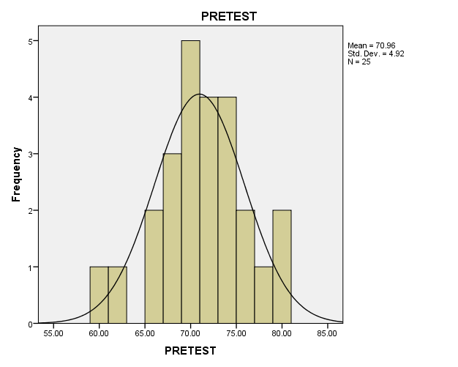
It can be seen from chart 4.1 that the mean of pre test experimental class was 70.96 and 4.92 was standard deviation from 25 students. Beside that we can be seen that there was 1 student who got score 60, 1 student who got score 62, 2 students who got score 65, 3 students who got 68, 5 students who got 70, 2 students who got 71, 2 students who got 72, 3 students who got 73, 1 student who got 74, 1 student who got 75, 1 student who got 76, 1 student who got 78, and 2 students who got 80.
Besides, the total score of pre-test from control group was1629 while the highest score was 75 and the lowest score was 54.

The Histogram of Pre Test of Control Class
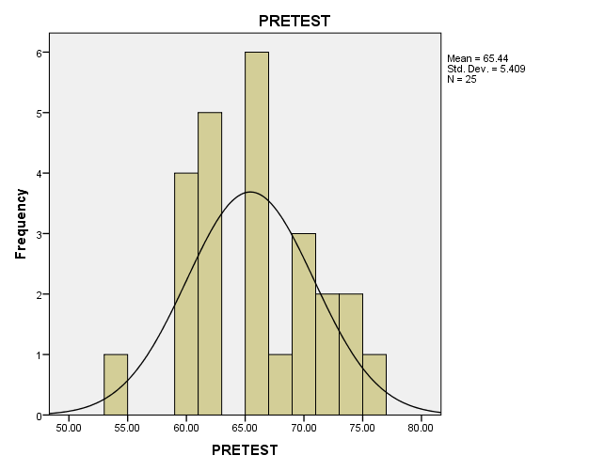
It can be seen from chart 4.3 that the mean of pre test control class was 65.44 and 5.40 was standard deviation from 25 students. Beside that it can be seen that that 1 student got score 54, 2 students got score 59, 2 students got score 60, 1 student got score 61, 4 studentd got score 62, 3 students got score 65, 3 students got score 66, 1 student got score 67, 3 students got score 70, 1 student got score 71, 1 student got score 72, 1 student got score 73, 1 student got score 74, and 1 student who got score 75.
. In the research, the total score of post-test from both of groups were significantly different. The total score of post-test from experiment group was 1892 while the highest score was 88 and the lowest score was 66.
The Histogram of Post-Test of Experimental Class
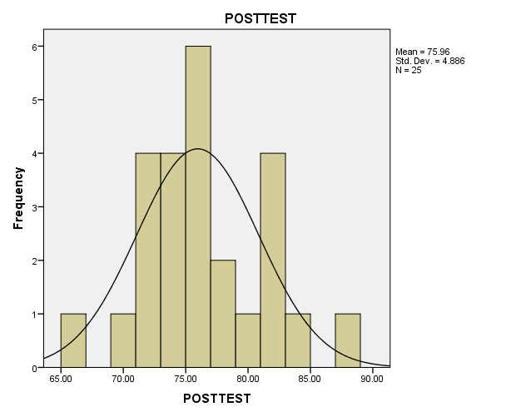
It can be seen from chart 4.2 that the mean of post test experimental class was 75.96 and 4.88 was standard deviation from 25 students. Beside that it can be seen that 1 student got score 66, 1 student got score 69, 2 students got score 71, 2 students got score 72, 1 student got score 73, 3 students got score 74, 3 students got score 75, 3 students got score 76, 1 student got score 77, 1 studentgot score 78, 1 student got score 79, 3 students got score 81, 1 studentgot score 82, 1 student got score 83, and 1 student got score 88.
Meanwhile, the total of post-test from control group was 1749 while the highest score was 76 and the lowest score was 60.

The Histogram of Post-Test of Control Class

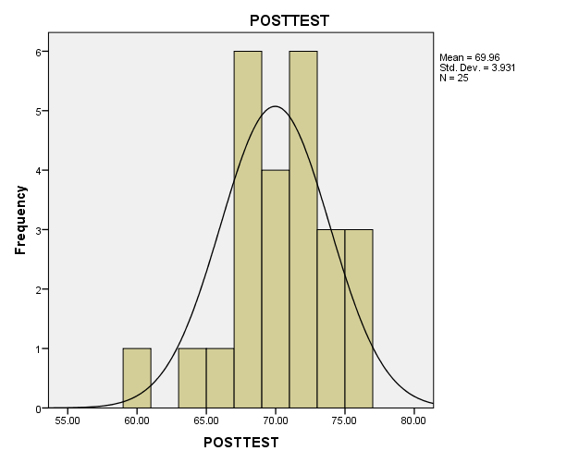
It can be seen from chart 4.4 that the mean of post test control class was 69.96 and 3.93 was standard deviation from 25 students. , it can be seen that 1 student got score 60, 1 student got score 63, 1 student got score 65, 4 students got score 67, 2 students got score 68, 4 students got score 70, 3 students got score 71, 3 students got score 72, 1 student got score 73, 2 student got score 74, 1 student got score 75 and 2 students got score 76.
Analyzed Observation List
No | Meetings | Indicators of Variable X
 |  | 1 | 2 | 3 | 4 | 5 | 6 | 7 | 8
1 | First meeting | √ | √ | √ | √ | √ | √ | - | -
2 | Second meeting | √ | √ | √ | √ | √ | √ | √ | -
3 | Third meeting | √ | √ | √ | √ | √ | √ | √ | -
4 | Fourth meeting | √ | √ | √ | √ | √ | √ | √ | -
5 | Fifth meeting | √ | √ | √ | √ | √ | √ | √ | √
6 | Sixth meeting | √ | √ | √ | √ | √ | √ | √ | √
Total |  | 6 | 6 | 6 | 6 | 6 | 6 | 5 | 2

From table it was found that in first meeting only 6 indicators that have done, second, third and fourth meeting there was 7 indicators that have done, and in fifth and sixth meeting all of indicators that have done.
According to Sudjiono (2010: 43), the following formula that can be used to get percentage of the observation list. So the writer used the formula:
$P=\frac{F}{N} x 100\%$
Where:
P :Percentage
F :Frequency of the score
N :Number of case
$$Percentage of 'Yes^{'}=\frac{43}{48} x 100\%=89,6\%Percentage of 'No'=\frac{5}{48} x 100\%=10,4\%$$
According to Arikunto (2011:245) the category of the observation list can be seen below:
- 76 – 100% = Very good
- 56 – 75% = Enough
- 40 – 55% = Less
- Less than 40% = Bad
The table shows that the result of observation of the effect in experimental class. The result of observation for answer ‘Yes’ was 89,6%, and it can be categorized in the level of very good, while for answer ‘No’ was 10,4%, it can be categorized into the level bad.

The Effect Size
According to Pallant (2005 : 208), effect size statistics provides an indication of the magnitude of the differences between the groups (not just whether the difference could have occurred by chance). The effect size was analyzed from the result of t test and degree of freedom. The t test was 4.784 and the degree of freedom was 48. It was obtained by using the formula as follows:
Eta squared =
= =
=
=0.322
Based on the result above, it is clear that the effect size is 0.32. The guidelines (proposed by Cohen, 1988) for interpreting this value are: 0.01 is small effect, 0.06 is moderate effect, and 0.14 is large effect. It means that the using buzz group technique has large effect on students’ writing ability in analytical exposition paragraph. Then the interpretation of the effect size of difference is considered Very Large.

Conclusion
Based on the data analysis explained at the CHAPTER VI, finally, the research about the effect of using Buzz Group Technique on students’ ability in writing analytical exposition at Private Senior High School YKPP DUMAI comes to conclusion as follows:
- The students’ ability in writing analytical exposition taught by using Buzz Group Technique in writing analytical exposition at Private Senior High School YKPP DUMAI is Categorized Good mean was 75.96.
- The students’ ability in writing analytical exposition paragraphs taught without using isBuzz Group Technique in writing analytical exposition at Private Senior High School YKPP DUMAI Enough Categorized with mean score was 69.96
- There was a significant effect in ability to write analytical exposition paragraph using buzz group technique. It can be shown the result of effect size, the result is 0.32. The percentage of effect size 32%, so Ha is accepted.

Suggestion
In this occasion, the writer would like to give some suggestion to the people who get benefit from this research. The writer suggests to:
- The English teacher of Private Senior High School YKPP DUMAI to use the effective strategy in teaching students. In teaching persuasive writing, in this case analytical exposition paragraphs, the writer suggests that the teacher can use buzz group technique because it can generate ideas, check on learning and develop projects to express their opinion in persuasive ways. In turn, the abilities can be applied in writing analytical exposition paragraphs.
- In teaching learning process, teacher can use media when they were teaching. Because students willbe attracted to pay attention to the lesson and they will not get bored when teacher explains the subject by using an interesting media.

References
Arikunto, Suharsimi. 2011. Dasar-Dasar Evaluasi Pendidikan, Jakarta: PT. Bumi Aksara.
Ary, Donald et al. 2010.Introduction to Research in Education. Canada: Wadsworth Cengage Learning.
Brewer, W. Ernest. 1997. Proven Ways to Get Your Massage Across: The Essential Reference for Teacher, Trainers, Presenters, and Speakers. United States of America: Corwin Press.
Brown, H. Douglas. 2003. Language Assessment: Principle and Classroom Practices. California: Longman
Creswell, John W. 2008. Educational Research: Planning Conducting and Evaluating Quantitative and Qualitative Research. New Jersey: Pearson Education Ltd.
Donald, Robert B.,et. Al 1991. Writing Clear Paragraphs, New Jersey: Prentice-Hall, Inc.
Gay, L.R and PetterAirasian.Educational Research. New Jersey: Prentice Hall. 2000
Hartono. 2008. StatistikUntukPenelitian. Pekanbaru: Zanafa.
Hasibuan, Kalayo. 2007. Teaching English as Foreign Language (TEFL). Pekanbaru: Alfa Riau Graha UNRI press.
Heinemann, Rigby. 2004. Writing Resouce Book.Westren Australia: Advance Press
Hughey, Jane .B. 1983. Teaching ESL Composition: Principles and Techniques. Massachusetts-Rowley: New Burge House Publisher.
Mason, David J. 1995. Trainer’s Toolbox of Training Technique. Kenya: International Labor Organization.
Medwell, Jane, David Wray, Hilary Minns, Elizabeth Coates, Vivienne Griffiths. 2009. Primary English: Teaching Theory and Practice. Fourth edition .southernhay East: Learning Matters Ltd
Nunan, David. 2003. Practical English Language Teaching. Singapore :McGraw Hill.
. 1992. Research Method in Language Learning. United States of Amerika: Cambrige University.
Pallant, Julie. 2003. SPSS Survival Manual: A Step by Step Guide to Data Analysis Using SPSS for Windows (Version 10 and 11). Maidenhead: Open University Press
Penny Ur. 1996. A Course in Language Teaching-Practice and Theory. United Kingdom: Cambridge University Press.
Sudjiono, Anas. 2010. Pengantar Statistik Pendidikan. Jakarta: Radja Grafindo Persada.
Syafi’i, Muhammad, M. FauzanAnsyari and Jonri Kasdi. 2013. The Affective Paragraph Developments: The Process of Writing for Classroom Setting. Pekanbaru: Kreasi Edukasi Publishing and Consulting Company.
Sylabuss of SMA YKPP DUMAI

