# *Appendix 1* : Results of Random Noise Seed Changes

|  |  |  |  |  |  |  |  |  |  |  |
| --- | --- | --- | --- | --- | --- | --- | --- | --- | --- | --- |
| No | RMSE | | | | | | | | | |
| Noise Seed | Ekuitas | Percobaan 1 | | Percobaan 2 | | Percobaan 3 | | Average | |
| Threshold at IMF 2 | | Threshold at IMF 2 | | Threshold at IMF 2 | | Threshold at IMF 2 | |
| XCEEMDAN-LSTM-Spline | XCEEMDAN-Bidirectional LSTM-Spline | XCEEMDAN-LSTM-Spline | XCEEMDAN-Bidirectional LSTM-Spline | XCEEMDAN-LSTM-Spline | XCEEMDAN Bidirectional LSTM-Spline | XCEEMDAN-LSTM-Spline | XCEEMDAN-Bidirectional LSTM-Spline |
| 1 | 12345 | PETR4 | 0,701492 | 0,655873 | 0,703684 | 0,704259 | 0,699844 | 0,650537 |  | |
| VALE3 | 1,251943 | 1,216536 | 1,245859 | 1,237446 | 1,274289 | 1,222048 |
| BOVA11 | 1,975055 | 1,966339 | 1,975793 | 1,979308 | 1,969492 | 1,922809 |
| ITUB4 | 0,639474 | 0,621454 | 0,637266 | 0,624173 | 0,636826 | 0,633453 |
| BBDC4 | 0,645617 | 0,646884 | 0,645012 | 0,656837 | 0,644256 | 0,644505 |
| B3SA3 | 0,412075 | 0,408277 | 0,41154 | 0,405244 | 0,417092 | 0,407236 |
| BBAS3 | 0,974368 | 0,934958 | 0,954191 | 0,914906 | 0,914101 | 0,935199 |
| ABEV3 | 0,334776 | 0,321272 | 0,340624 | 0,307307 | 0,335615 | 0,32604 |
| MGLU3 | 0,560603 | 0,55937 | 0,561631 | 0,560738 | 0,562762 | 0,561763 |
| VVAR3 | 0,587314 | 0,598092 | 0,593723 | 0,584135 | 0,582383 | 0,593449 |
| AVERAGE | | 0,8082717 | **0,7929055** | 0,8069323 | **0,7974353** | 0,803666 | **0,7897039** | 0,80629 | 0,793348233 |
| 2 | 648 | PETR4 | 0,704146 | 0,658876 | 0,712141 | 0,650456 | 0,720478 | 0,689758 |  | |
| VALE3 | 1,236895 | 1,237163 | 1,232685 | 1,231602 | 1,234033 | 1,233581 |
| BOVA11 | 1,977485 | 2,032314 | 1,984316 | 1,961951 | 1,986897 | 2,00791 |
| ITUB4 | 0,640782 | 0,634009 | 0,636441 | 0,625634 | 0,638054 | 0,629464 |
| BBDC4 | 0,645531 | 0,647525 | 0,64855 | 0,641288 | 0,642765 | 0,638051 |
| B3SA3 | 0,416842 | 0,409921 | 0,409168 | 0,412027 | 0,412515 | 0,404854 |
| BBAS3 | 1,01543 | 1,033211 | 1,012409 | 1,037577 | 1,036527 | 0,994007 |
| ABEV3 | 0,333103 | 0,335626 | 0,334432 | 0,331195 | 0,347921 | 0,319919 |
| MGLU3 | 0,568666 | 0,568073 | 0,569783 | 0,569043 | 0,568082 | 0,570368 |
| VVAR3 | 0,599557 | 0,577957 | 0,598319 | 0,603573 | 0,596264 | 0,579683 |
| AVERAGE | | 0,8138437 | **0,8134675** | 0,8138244 | **0,8064346** | 0,8183536 | **0,8067595** | 0,81534057 | 0,8088872 |
| 3 | 8754 | PETR4 | 0,724179 | 0,698494 | 0,709484 | 0,690263 | 0,704905 | 0,731013 |  | |
| VALE3 | 1,234942 | 1,224122 | 1,231718 | 1,245717 | 1,252041 | 1,351991 |
| BOVA11 | 1,983712 | 2,010184 | 1,985576 | 1,928004 | 1,982787 | 1,920845 |
| ITUB4 | 0,638941 | 0,612833 | 0,642083 | 0,634263 | 0,637558 | 0,639784 |
| BBDC4 | 0,644542 | 0,643929 | 0,644679 | 0,642719 | 0,649631 | 0,647162 |
| B3SA3 | 0,412738 | 0,418146 | 0,422119 | 0,440547 | 0,410978 | 0,411358 |
| BBAS3 | 0,967682 | 0,951077 | 0,957402 | 0,959314 | 0,963621 | 0,992353 |
| ABEV3 | 0,337223 | 0,342818 | 0,332448 | 0,325225 | 0,336655 | 0,321128 |
| MGLU3 | 0,564049 | 0,565245 | 0,564237 | 0,566023 | 0,564857 | 0,564062 |
| VVAR3 | 0,607985 | 0,615865 | 0,608246 | 0,585975 | 0,608433 | 0,603429 |
| AVERAGE | | 0,8115993 | **0,8082713** | 0,8097992 | **0,801805** | **0,8111466** | 0,8183125 | 0,81084837 | 0,809462933 |
| 4 | 10310 | PETR4 | 0,695053 | 0,625773 | 0,705983 | 0,675178 | 0,694544 | 0,612566 |  | |
| VALE3 | 1,236526 | 1,217645 | 1,22853 | 1,316873 | 1,230405 | 1,225497 |
| BOVA11 | 2,019754 | 1,975483 | 1,976263 | 1,973668 | 1,979614 | 1,975892 |
| ITUB4 | 0,646363 | 0,630842 | 0,637968 | 0,6447 | 0,636396 | 0,614027 |
| BBDC4 | 0,651506 | 0,64504 | 0,651005 | 0,637307 | 0,647721 | 0,674256 |
| B3SA3 | 0,415698 | 0,425826 | 0,412644 | 0,406142 | 0,412318 | 0,410771 |
| BBAS3 | 1,007292 | 0,982277 | 1,013102 | 0,992743 | 0,998324 | 0,957161 |
| ABEV3 | 0,343351 | 0,326022 | 0,337668 | 0,326995 | 0,33631 | 0,322292 |
| MGLU3 | 0,567023 | 0,570197 | 0,56442 | 0,568171 | 0,564448 | 0,564711 |
| VVAR3 | 0,598264 | 0,579166 | 0,593263 | 0,585844 | 0,583459 | 0,592737 |
| AVERAGE | | 0,818083 | **0,7978271** | **0,8120846** | 0,8127621 | 0,8083539 | **0,794991** | 0,8128405 | 0,801860067 |
| 5 | 476114 | PETR4 | 0,701012 | 0,674235 | 0,709268 | 0,696516 | 0,705113 | 0,66201 |  | |
| VALE3 | 1,230789 | 1,227347 | 1,230131 | 1,27251 | 1,2454 | 1,230981 |
| BOVA11 | 1,978667 | 1,977038 | 2,005485 | 1,964823 | 1,98705 | 1,981154 |
| ITUB4 | 0,647435 | 0,631744 | 0,632191 | 0,619458 | 0,644336 | 0,610842 |
| BBDC4 | 0,643552 | 0,633821 | 0,643638 | 0,643244 | 0,643879 | 0,647898 |
| B3SA3 | 0,411222 | 0,481457 | 0,414827 | 0,411209 | 0,409816 | 0,406083 |
| BBAS3 | 1,006455 | 0,980922 | 1,024056 | 1,003242 | 1,008662 | 0,986398 |
| ABEV3 | 0,336493 | 0,333768 | 0,342089 | 0,339876 | 0,335866 | 0,337216 |
| MGLU3 | 0,561291 | 0,560189 | 0,561817 | 0,559876 | 0,560659 | 0,561671 |
| VVAR3 | 0,596106 | 0,594757 | 0,602705 | 0,595432 | 0,574793 | 0,586828 |
| AVERAGE | | 0,8113022 | **0,8095278** | 0,8166207 | **0,8106186** | 0,8115574 | **0,8011081** | 0,8131601 | 0,807084833 |
| 6 | 847459393 | PETR4 | 0,712085 | 0,70026 | 0,705577 | 0,712441 | 0,717159 | 0,694005 |  | |
| VALE3 | 1,204541 | 1,201437 | 1,211268 | 1,225243 | 1,208112 | 1,253998 |
| BOVA11 | 2,011641 | 1,944427 | 1,971678 | 1,929179 | 1,976582 | 1,965555 |
| ITUB4 | 0,640969 | 0,637082 | 0,645563 | 0,620491 | 0,642175 | 0,630319 |
| BBDC4 | 0,635583 | 0,631943 | 0,633784 | 0,637955 | 0,634121 | 0,647362 |
| B3SA3 | 0,417709 | 0,453057 | 0,416506 | 0,417949 | 0,414202 | 0,414451 |
| BBAS3 | 0,967919 | 0,941111 | 0,952879 | 0,956168 | 0,954278 | 0,966867 |
| ABEV3 | 0,337309 | 0,312893 | 0,337275 | 0,33001 | 0,33244 | 0,307534 |
| MGLU3 | 0,558937 | 0,567618 | 0,567627 | 0,569312 | 0,569409 | 0,567987 |
| VVAR3 | 0,59254 | 0,582271 | 0,598228 | 0,595491 | 0,588626 | 0,585712 |
| AVERAGE | | 0,8079233 | **0,7972099** | 0,8040385 | **0,7994239** | 0,8037104 | **0,803379** | 0,80522407 | 0,800004267 |
| 7 | 3580345544 | PETR4 | 0,699446 | 0,697596 | 0,69138 | 0,651222 | 0,702774 | 0,677118 |  | |
| VALE3 | 1,244772 | 1,204035 | 1,208198 | 1,204483 | 1,20525 | 1,220199 |
| BOVA11 | 1,967007 | 1,956996 | 1,988745 | 1,974009 | 1,984137 | 1,967958 |
| ITUB4 | 0,637165 | 0,621293 | 0,637094 | 0,634123 | 0,659242 | 0,637371 |
| BBDC4 | 0,645303 | 0,632191 | 0,634411 | 0,635638 | 0,641606 | 0,630046 |
| B3SA3 | 0,43455 | 0,418815 | 0,428614 | 0,414017 | 0,411243 | 0,41351 |
| BBAS3 | 0,978949 | 0,985682 | 0,991293 | 0,942316 | 0,979014 | 0,97344 |
| ABEV3 | 0,333648 | 0,332959 | 0,34305 | 0,325197 | 0,348317 | 0,331293 |
| MGLU3 | 0,565137 | 0,561524 | 0,564658 | 0,561424 | 0,560432 | 0,56158 |
| VVAR3 | 0,627634 | 0,590942 | 0,60915 | 0,587665 | 0,599849 | 0,591313 |
| AVERAGE | | 0,8133611 | **0,8002033** | 0,8096593 | **0,7930094** | 0,8091864 | **0,8003828** | 0,8107356 | 0,797865167 |
| 8 | 4022411438 | PETR4 | 0,699144 | 0,708128 | 0,704668 | 0,652068 | 0,704044 | 0,682657 |  | |
| VALE3 | 1,20305 | 1,192926 | 1,203347 | 1,224599 | 1,209119 | 1,20324 |
| BOVA11 | 1,9886 | 1,9727 | 1,984059 | 1,974156 | 1,992915 | 1,970442 |
| ITUB4 | 0,648213 | 0,638044 | 0,632946 | 0,624301 | 0,638369 | 0,633032 |
| BBDC4 | 0,636653 | 0,634918 | 0,654209 | 0,635819 | 0,643516 | 0,636022 |
| B3SA3 | 0,418058 | 0,418844 | 0,415112 | 0,423155 | 0,417315 | 0,54909 |
| BBAS3 | 1,016522 | 1,014705 | 1,01695 | 0,985029 | 1,020865 | 1,012581 |
| ABEV3 | 0,32975 | 0,323638 | 0,33251 | 0,343222 | 0,343945 | 0,328446 |
| MGLU3 | 0,56814 | 0,568294 | 0,567774 | 0,568005 | 0,567131 | 0,568064 |
| VVAR3 | 0,600491 | 0,59388 | 0,591647 | 0,587281 | 0,589391 | 0,588356 |
| AVERAGE | | 0,8108621 | **0,8066077** | 0,8103222 | **0,8017635** | **0,812661** | 0,817193 | 0,81128177 | 0,8085214 |
| 9 | 3102976445 | PETR4 | 0,710687 | 0,676569 | 0,702275 | 0,740601 | 0,706108 | 0,728633 |  | |
| VALE3 | 1,213481 | 1,223353 | 1,20595 | 1,192123 | 1,20627 | 1,204678 |
| BOVA11 | 2,010793 | 1,922837 | 1,985995 | 1,925539 | 1,985285 | 1,954205 |
| ITUB4 | 0,652555 | 0,605369 | 0,64634 | 0,630318 | 0,642051 | 0,642111 |
| BBDC4 | 0,63659 | 0,636529 | 0,637462 | 0,628837 | 0,638246 | 0,65315 |
| B3SA3 | 0,430171 | 0,405885 | 0,406647 | 0,408331 | 0,415993 | 0,558714 |
| BBAS3 | 0,990863 | 0,944562 | 0,972975 | 0,966303 | 1,012306 | 0,95446 |
| ABEV3 | 0,332672 | 0,336243 | 0,339109 | 0,359609 | 0,338791 | 0,325387 |
| MGLU3 | 0,564844 | 0,571187 | 0,567921 | 0,566767 | 0,566401 | 0,564889 |
| VVAR3 | 0,589219 | 0,586685 | 0,591839 | 0,586458 | 0,599094 | 0,595695 |
| AVERAGE | | 0,8131875 | **0,7909219** | 0,8056513 | **0,8004886** | **0,8110545** | 0,8181922 | 0,80996443 | 0,8032009 |
| 10 | 2397416255 | PETR4 | 0,70477 | 0,637999 | 0,710538 | 0,686632 | 0,705132 | 0,673136 |  | |
| VALE3 | 1,230307 | 1,199596 | 1,218004 | 1,22345 | 1,221814 | 1,199458 |
| BOVA11 | 2,026792 | 1,908079 | 2,17312 | 2,01961 | 1,988688 | 1,992664 |
| ITUB4 | 0,637443 | 0,637556 | 0,639937 | 0,647571 | 0,638162 | 0,630678 |
| BBDC4 | 0,646623 | 0,637774 | 0,643492 | 0,667231 | 0,636559 | 0,63507 |
| B3SA3 | 0,412689 | 0,411918 | 0,410533 | 0,410311 | 0,413757 | 0,443157 |
| BBAS3 | 0,963999 | 1,015554 | 0,974289 | 0,94264 | 0,963048 | 0,924545 |
| ABEV3 | 0,331257 | 0,323585 | 0,332716 | 0,320825 | 0,348436 | 0,323127 |
| MGLU3 | 0,56382 | 0,563451 | 0,563872 | 0,565015 | 0,572106 | 0,563676 |
| VVAR3 | 0,589184 | 0,583101 | 0,588523 | 0,58468 | 0,591832 | 0,576268 |
| AVERAGE | | 0,8106884 | **0,7918613** | 0,8255024 | **0,8067965** | 0,8079534 | **0,7961779** | 0,81471473 | 0,798278567 |
| 11 | 877884397 | PETR4 | 0,652482 | 0,681571 | 0,699691 | 0,651467 | 0,703965 | 0,686603 |  | |
| VALE3 | 1,226371 | 1,212212 | 1,216405 | 1,208223 | 1,225043 | 1,231609 |
| BOVA11 | 1,974454 | 1,979849 | 1,974086 | 2,29566 | 2,017809 | 1,966123 |
| ITUB4 | 0,635008 | 0,620847 | 0,642823 | 0,621718 | 0,639721 | 0,591493 |
| BBDC4 | 0,63976 | 0,636108 | 0,633943 | 0,629563 | 0,634906 | 0,639262 |
| B3SA3 | 0,477429 | 0,408766 | 0,410134 | 0,4087 | 0,414384 | 0,406894 |
| BBAS3 | 1,009196 | 1,008411 | 0,995582 | 0,999439 | 0,989514 | 0,992927 |
| ABEV3 | 0,335764 | 0,33482 | 0,334965 | 0,329112 | 0,330748 | 0,334521 |
| MGLU3 | 0,56573 | 0,57164 | 0,56871 | 0,56554 | 0,566406 | 0,5658 |
| VVAR3 | 0,593818 | 0,58825 | 0,594721 | 0,586744 | 0,595074 | 0,586638 |
| AVERAGE | | 0,8110012 | **0,8042474** | **0,807106** | 0,8296166 | 0,811757 | **0,800187** | 0,80995473 | 0,811350333 |
| 12 | 502275570 | PETR4 | 0,645523 | 0,723232 | 0,716296 | 0,664969 | 0,702499 | 0,710285 |  | |
| VALE3 | 1,20759 | 1,21714 | 1,240154 | 1,202686 | 1,221697 | 1,278433 |
| BOVA11 | 1,978222 | 1,97362 | 1,982102 | 1,973399 | 2,00157 | 2,009747 |
| ITUB4 | 0,637005 | 0,614717 | 0,645795 | 0,634678 | 0,635595 | 0,630059 |
| BBDC4 | 0,641904 | 0,656823 | 0,648343 | 0,634671 | 0,637492 | 0,641391 |
| B3SA3 | 0,434599 | 0,415091 | 0,41428 | 0,413314 | 0,420261 | 0,409895 |
| BBAS3 | 0,991161 | 0,999168 | 1,017643 | 1,007584 | 1,006316 | 0,972491 |
| ABEV3 | 0,334147 | 0,323545 | 0,334692 | 0,321832 | 0,353994 | 0,329215 |
| MGLU3 | 0,57388 | 0,569079 | 0,574431 | 0,569432 | 0,568621 | 0,568698 |
| VVAR3 | 0,59384 | 0,577413 | 0,594016 | 0,599433 | 0,595705 | 0,59117 |
| AVERAGE | | **0,8037871** | 0,8069828 | 0,8167752 | **0,8021998** | 0,814375 | **0,8141384** | 0,81164577 | 0,807773667 |
| 13 | 2487001655 | PETR4 | 0,701337 | 0,677106 | 0,721697 | 0,691122 | 0,697223 | 0,678952 |  | |
| VALE3 | 1,205461 | 1,207039 | 1,226944 | 1,203611 | 1,211271 | 1,214366 |
| BOVA11 | 2,006524 | 2,01576 | 1,977456 | 1,940274 | 1,990867 | 1,976715 |
| ITUB4 | 0,64594 | 0,648373 | 0,650117 | 0,623854 | 0,640356 | 0,63105 |
| BBDC4 | 0,657454 | 0,638438 | 0,645473 | 0,664063 | 0,639676 | 0,664286 |
| B3SA3 | 0,415301 | 0,413133 | 0,426934 | 0,413731 | 0,41615 | 0,416182 |
| BBAS3 | 0,958317 | 0,989527 | 0,961114 | 0,939806 | 0,964723 | 0,943565 |
| ABEV3 | 0,335018 | 0,310104 | 0,349482 | 0,347328 | 0,343968 | 0,339389 |
| MGLU3 | 0,568651 | 0,56499 | 0,564444 | 0,564276 | 0,565973 | 0,563999 |
| VVAR3 | 0,582963 | 0,570597 | 0,588325 | 0,586167 | 0,586425 | 0,57945 |
| AVERAGE | | 0,8076966 | **0,8035067** | 0,8111986 | **0,7974232** | 0,8056632 | **0,8007954** | 0,80818613 | 0,8005751 |
| 14 | 3575834324 | PETR4 | 0,702056 | 0,673861 | 0,707001 | 0,679764 | 0,720485 | 0,683505 |  | |
| VALE3 | 1,206647 | 1,206331 | 1,207985 | 1,21209 | 1,241565 | 1,220867 |
| BOVA11 | 1,994247 | 1,969217 | 1,994391 | 1,992357 | 2,024194 | 2,003013 |
| ITUB4 | 0,63771 | 0,63893 | 0,65064 | 0,625631 | 0,643552 | 0,633889 |
| BBDC4 | 0,636511 | 0,630917 | 0,632121 | 0,627253 | 0,63561 | 0,631157 |
| B3SA3 | 0,413854 | 0,414808 | 0,418532 | 0,415688 | 0,413683 | 0,404898 |
| BBAS3 | 1,004963 | 0,95863 | 0,995897 | 1,091618 | 0,986748 | 0,967348 |
| ABEV3 | 0,368707 | 0,320155 | 0,357794 | 0,337226 | 0,339102 | 0,317301 |
| MGLU3 | 0,570617 | 0,567665 | 0,567657 | 0,566694 | 0,567692 | 0,572941 |
| VVAR3 | 0,599844 | 0,591443 | 0,606074 | 0,631317 | 0,591965 | 0,60019 |
| AVERAGE | | 0,8135156 | **0,7971957** | 0,8138092 | **0,8179638** | 0,8164596 | **0,8035109** | 0,8145948 | 0,806223467 |
| 15 | 398048047 | PETR4 | 0,694084 | 0,702511 | 0,752222 | 0,693803 | 0,710466 | 0,740127 |  | |
| VALE3 | 1,232228 | 1,222882 | 1,22237 | 1,210569 | 1,226779 | 1,243773 |
| BOVA11 | 2,047721 | 1,971444 | 1,967344 | 1,962192 | 1,973561 | 1,991794 |
| ITUB4 | 0,635097 | 0,634931 | 0,642543 | 0,637383 | 0,636009 | 0,63329 |
| BBDC4 | 0,641831 | 0,637316 | 0,637267 | 0,63409 | 0,634546 | 0,637421 |
| B3SA3 | 0,408247 | 0,418964 | 0,443841 | 0,408351 | 0,415728 | 0,414257 |
| BBAS3 | 0,99948 | 0,953906 | 0,976456 | 0,938938 | 0,988659 | 0,995944 |
| ABEV3 | 0,334951 | 0,324548 | 0,336568 | 0,333244 | 0,338765 | 0,31021 |
| MGLU3 | 0,561326 | 0,560599 | 0,560415 | 0,561343 | 0,560601 | 0,559752 |
| VVAR3 | 0,60867 | 0,597219 | 0,604467 | 0,598671 | 0,526899 | 0,587795 |
| AVERAGE | | 0,8163635 | **0,802432** | 0,8143493 | **0,7978584** | **0,8012013** | 0,8114363 | 0,81063803 | 0,8039089 |
| 16 | 2572482085 | PETR4 | 0,730437 | 0,680502 | 0,703599 | 0,688227 | 0,705226 | 0,690791 |  | |
| VALE3 | 1,226376 | 1,207901 | 1,221947 | 1,18822 | 1,204631 | 1,205023 |
| BOVA11 | 1,99454 | 1,942819 | 1,989297 | 1,989687 | 2,039838 | 1,957231 |
| ITUB4 | 0,640922 | 0,631271 | 0,637062 | 0,631606 | 0,63824 | 0,601896 |
| BBDC4 | 0,644066 | 0,641501 | 0,638344 | 0,638478 | 0,636394 | 0,643795 |
| B3SA3 | 0,417463 | 0,414885 | 0,416896 | 0,424399 | 0,411076 | 0,410096 |
| BBAS3 | 1,068191 | 1,023006 | 1,011578 | 0,98654 | 1,045813 | 0,992227 |
| ABEV3 | 0,334883 | 0,318525 | 0,339867 | 0,323663 | 0,338479 | 0,333816 |
| MGLU3 | 0,559953 | 0,560964 | 0,565373 | 0,565518 | 0,558355 | 0,559844 |
| VVAR3 | 0,588231 | 0,579502 | 0,599106 | 0,596276 | 0,58851 | 0,593047 |
| AVERAGE | | 0,8205062 | **0,8000876** | 0,8123069 | **0,8032614** | 0,8166562 | **0,7987766** | 0,81648977 | 0,800708533 |
| 17 | 3698665810 | PETR4 | 0,74353 | 0,68532 | 0,712026 | 0,66201 | 0,709237 | 0,629444 |  | |
| VALE3 | 1,21246 | 1,273087 | 1,218794 | 1,303052 | 1,2086 | 1,217696 |
| BOVA11 | 1,973615 | 1,963467 | 1,974639 | 1,960643 | 1,974332 | 1,921382 |
| ITUB4 | 0,656645 | 0,597145 | 0,636315 | 0,61919 | 0,639925 | 0,626962 |
| BBDC4 | 0,634904 | 0,631113 | 0,64094 | 0,642628 | 0,674513 | 0,642301 |
| B3SA3 | 0,415521 | 0,404308 | 0,41932 | 0,415662 | 0,422394 | 0,409083 |
| BBAS3 | 1,013786 | 1,027677 | 1,022662 | 1,010329 | 1,009269 | 1,008205 |
| ABEV3 | 0,341548 | 0,333668 | 0,341002 | 0,337961 | 0,336437 | 0,32078 |
| MGLU3 | 0,570414 | 0,563865 | 0,564007 | 0,563602 | 0,564435 | 0,562767 |
| VVAR3 | 0,591195 | 0,583205 | 0,591794 | 0,583811 | 0,720693 | 0,595037 |
| AVERAGE | | 0,8153618 | **0,8062855** | 0,8121499 | **0,8098888** | 0,8259835 | **0,7933657** | 0,81783173 | 0,80318 |
| 18 | 759774810 | PETR4 | 0,711681 | 0,713023 | 0,707645 | 0,650087 | 0,717569 | 0,707088 |  | |
| VALE3 | 1,215384 | 1,213329 | 1,223444 | 1,213483 | 1,208365 | 1,212067 |
| BOVA11 | 1,9625 | 1,967263 | 1,985131 | 1,915756 | 2,001814 | 1,9685 |
| ITUB4 | 0,643458 | 0,659855 | 0,644288 | 0,641887 | 0,645507 | 0,627695 |
| BBDC4 | 0,636642 | 0,633112 | 0,636766 | 0,638725 | 0,638566 | 0,649034 |
| B3SA3 | 0,412089 | 0,409002 | 0,427836 | 0,417464 | 0,415338 | 0,41104 |
| BBAS3 | 0,975283 | 0,94035 | 0,981127 | 1,01835 | 0,971644 | 0,971964 |
| ABEV3 | 0,349817 | 0,335101 | 0,341172 | 0,33415 | 0,331089 | 0,319624 |
| MGLU3 | 0,564674 | 0,566589 | 0,565234 | 0,566685 | 0,569838 | 0,565832 |
| VVAR3 | 0,59182 | 0,59168 | 0,57698 | 0,580335 | 0,598629 | 0,583613 |
| AVERAGE | | 0,8063348 | **0,8029304** | 0,8089623 | **0,7976922** | 0,8098359 | **0,8016457** | 0,80837767 | 0,8007561 |
| 19 | 7781442 | PETR4 | 0,702923 | 0,743826 | 0,761023 | 0,669636 | 0,720611 | 0,712742146 |  | |
| VALE3 | 1,271357 | 1,232171 | 1,240598 | 1,204562 | 1,206632 | 1,209851161 |
| BOVA11 | 2,01156 | 1,977841 | 2,041586 | 1,915919 | 1,997049 | 1,958672779 |
| ITUB4 | 0,640186 | 0,636443 | 0,639453 | 0,604888 | 0,639154 | 0,637686879 |
| BBDC4 | 0,644583 | 0,626153 | 0,634341 | 0,635121 | 0,640251 | 0,63360924 |
| B3SA3 | 0,415748 | 0,407925 | 0,420445 | 0,409047 | 0,421736 | 0,409382395 |
| BBAS3 | 1,015182 | 0,95922 | 1,009009 | 1,014097 | 1,012907 | 0,991842059 |
| ABEV3 | 0,336755 | 0,319841 | 0,336641 | 0,338111 | 0,336538 | 0,32108883 |
| MGLU3 | 0,569172 | 0,567454 | 0,56808 | 0,567639 | 0,568899 | 0,574376103 |
| VVAR3 | 0,596875 | 0,599679 | 0,600883 | 0,602816 | 0,605687 | 0,596399465 |
| AVERAGE | | 0,8204341 | **0,8070553** | 0,8252059 | **0,7961836** | 0,8149464 | **0,804565106** | 0,82019547 | 0,802601335 |
| 20 | 998909803 | PETR4 | 0,706279 | 0,645036 | 0,647554 | 0,66178 | 0,713316 | 0,676722 |  | |
| VALE3 | 1,216269 | 1,216614 | 1,218017 | 1,214084 | 1,233882 | 1,208852 |
| BOVA11 | 2,012199 | 1,987672 | 2,017715 | 2,003554 | 1,989829 | 1,982476 |
| ITUB4 | 0,638185 | 0,662474 | 0,63797 | 0,598321 | 0,639655 | 0,638142 |
| BBDC4 | 0,635642 | 0,629572 | 0,635109 | 0,635966 | 0,636618 | 0,6421 |
| B3SA3 | 0,410153 | 0,404572 | 0,419877 | 0,406108 | 0,422356 | 0,408505 |
| BBAS3 | 0,963768 | 0,965135 | 0,965761 | 0,960373 | 0,976772 | 0,996009 |
| ABEV3 | 0,324884 | 0,32602 | 0,325603 | 0,311816 | 0,324145 | 0,32085 |
| MGLU3 | 0,568447 | 0,566061 | 0,565448 | 0,565507 | 0,565905 | 0,565281 |
| VVAR3 | 0,603053 | 0,593418 | 0,607332 | 0,588288 | 0,615819 | 0,616921 |
| AVERAGE | | 0,8078879 | **0,7996574** | 0,8040386 | **0,7945797** | 0,8118297 | **0,8055858** | 0,80791873 | 0,799940967 |
| 21 | 2214797360 | PETR4 | 0,708902 | 0,706563 | 0,717163 | 0,647281 | 0,659816 | 0,712851 |  | |
| VALE3 | 1,210468 | 1,204714 | 1,221268 | 1,209057 | 1,207714 | 1,197854 |
| BOVA11 | 1,989505 | 1,976034 | 1,977198 | 1,959358 | 1,975071 | 1,976097 |
| ITUB4 | 0,645649 | 0,638323 | 0,665121 | 0,639504 | 0,637728 | 0,642179 |
| BBDC4 | 0,637869 | 0,634992 | 0,641741 | 0,638315 | 0,63714 | 0,651806 |
| B3SA3 | 0,412141 | 0,415003 | 0,41759 | 0,411648 | 0,411104 | 0,432818 |
| BBAS3 | 0,979632 | 0,953723 | 0,9805 | 0,94886 | 0,965408 | 0,99485 |
| ABEV3 | 0,336136 | 0,335819 | 0,346301 | 0,330977 | 0,333347 | 0,325772 |
| MGLU3 | 0,564136 | 0,565474 | 0,565806 | 0,565533 | 0,56406 | 0,570387 |
| VVAR3 | 0,595836 | 0,599652 | 0,595277 | 0,610918 | 0,601643 | 0,600925 |
| AVERAGE | | 0,8080274 | **0,8030297** | 0,8127965 | **0,7961451** | 0,7993031 | **0,8105539** | 0,806709 | 0,8032429 |
| 22 | 869201902 | PETR4 | 0,702486 | 0,642784 | 0,723976 | 0,676713 | 0,710895 | 0,679371 |  | |
| VALE3 | 1,208301 | 1,197324 | 1,20917 | 1,221563 | 1,211156 | 1,205244 |
| BOVA11 | 1,992011 | 1,938716 | 1,993037 | 2,010261 | 1,983356 | 1,971608 |
| ITUB4 | 0,643114 | 0,62048 | 0,636478 | 0,585258 | 0,650148 | 0,624842 |
| BBDC4 | 0,633852 | 0,633015 | 0,634683 | 0,635474 | 0,638986 | 0,632639 |
| B3SA3 | 0,412051 | 0,41114 | 0,416281 | 0,455433 | 0,410119 | 0,481289 |
| BBAS3 | 0,988474 | 1,020252 | 0,998873 | 0,966223 | 0,981613 | 0,990378 |
| ABEV3 | 0,341174 | 0,311651 | 0,334004 | 0,327196 | 0,333796 | 0,332235 |
| MGLU3 | 0,570306 | 0,568667 | 0,567112 | 0,566714 | 0,569009 | 0,568505 |
| VVAR3 | 0,604969 | 0,598978 | 0,604772 | 0,580305 | 0,590974 | 0,604859 |
| AVERAGE | | 0,8096738 | **0,7943007** | 0,8118386 | **0,802514** | 0,8080052 | **0,809097** | 0,8098392 | 0,801970567 |
| 23 | 847055484 | PETR4 | 0,677594 | 0,686514 | 0,703163 | 0,696457 | 0,698786 | 0,729241 |  | |
| VALE3 | 1,209104 | 1,208424 | 1,208005 | 1,185892 | 1,212832 | 1,20924 |
| BOVA11 | 1,964964 | 1,910954 | 2,009539 | 1,946244 | 1,961813 | 1,929413 |
| ITUB4 | 0,635423 | 0,613503 | 0,648328 | 0,60833 | 0,639845 | 0,647772 |
| BBDC4 | 0,628944 | 0,618648 | 0,630128 | 0,627766 | 0,629993 | 0,628754 |
| B3SA3 | 0,416576 | 0,419526 | 0,415755 | 0,4837 | 0,424925 | 0,415602 |
| BBAS3 | 1,094724 | 1,007883 | 1,017728 | 1,007649 | 1,010152 | 1,008238 |
| ABEV3 | 0,339182 | 0,328608 | 0,334879 | 0,325694 | 0,33827 | 0,330009 |
| MGLU3 | 0,565395 | 0,564626 | 0,563843 | 0,565348 | 0,563945 | 0,563858 |
| VVAR3 | 0,593114 | 0,586494 | 0,591979 | 0,599065 | 0,597791 | 0,582002 |
| AVERAGE | | 0,812502 | **0,794518** | 0,8123347 | **0,8046145** | 0,8078352 | **0,8044129** | 0,81089063 | 0,8011818 |
| 24 | 312333679 | PETR4 | 0,700754429 | 0,706005689 | 0,689087 | 0,704996 | 0,709921 | 0,759943 |  | |
| VALE3 | 1,210088031 | 1,201265487 | 1,24122 | 1,205439 | 1,210281 | 1,218022 |
| BOVA11 | 1,988344666 | 2,015814264 | 2,018472 | 2,076147 | 1,986229 | 2,008727 |
| ITUB4 | 0,631465313 | 0,640045548 | 0,66079 | 0,625367 | 0,638095 | 0,617263 |
| BBDC4 | 0,635801289 | 0,63988873 | 0,635262 | 0,634496 | 0,642036 | 0,636173 |
| B3SA3 | 0,410563431 | 0,409853097 | 0,411816 | 0,405495 | 0,408423 | 0,406247 |
| BBAS3 | 1,003126445 | 0,963414375 | 1,006543 | 0,981167 | 1,004374 | 0,947395 |
| ABEV3 | 0,333679208 | 0,335412323 | 0,330868 | 0,332499 | 0,335933 | 0,336671 |
| MGLU3 | 0,564507949 | 0,564574269 | 0,565192 | 0,565072 | 0,563709 | 0,562629 |
| VVAR3 | 0,59111344 | 0,586061697 | 0,596732 | 0,58114 | 0,600366 | 0,577768 |
| AVERAGE | | 0,80694442 | **0,806233548** | 0,8155982 | **0,8111818** | 0,8099367 | **0,8070838** | 0,81082644 | 0,808166383 |
| 25 | 20301983 | PETR4 | 0,705597 | 0,710774 | 0,714616 | 0,777797 | 0,704606 | 0,681727 |  | |
| VALE3 | 1,24713 | 1,288565 | 1,211902 | 1,216584 | 1,237641 | 1,205398 |
| BOVA11 | 1,948304 | 1,928362 | 1,949012 | 1,980894 | 1,962791 | 1,872234 |
| ITUB4 | 0,633407 | 0,633419 | 0,638101 | 0,632317 | 0,647802 | 0,631229 |
| BBDC4 | 0,640436 | 0,636227 | 0,636011 | 0,631529 | 0,629443 | 0,626957 |
| B3SA3 | 0,410264 | 0,433202 | 0,409466 | 0,415657 | 0,430108 | 0,416658 |
| BBAS3 | 0,962049 | 0,96731 | 0,955968 | 1,004341 | 1,017058 | 1,168974 |
| ABEV3 | 0,330235 | 0,323659 | 0,341231 | 0,336253 | 0,336496 | 0,345341 |
| MGLU3 | 0,560699 | 0,560317 | 0,561914 | 0,563875 | 0,567715 | 0,562471 |
| VVAR3 | 0,599585 | 0,583135 | 0,595001 | 0,581298 | 0,588159 | 0,580704 |
| AVERAGE | | 0,8037706 | **0,806497** | 0,8013222 | **0,8140545** | 0,8121819 | **0,8091693** | 0,80575823 | 0,809906933 |
| 26 | 2049262079 | PETR4 | 0,740219 | 0,688466 | 0,718473 | 0,770265 | 0,707508 | 0,69409 |  | |
| VALE3 | 1,214447 | 1,242437 | 1,212189 | 1,259139 | 1,295371 | 1,472595 |
| BOVA11 | 1,961474 | 1,943193 | 1,992594 | 1,893646 | 1,970267 | 1,885056 |
| ITUB4 | 0,650938 | 0,631126 | 0,657881 | 0,622053 | 0,636173 | 0,655994 |
| BBDC4 | 0,636627 | 0,636511 | 0,633055 | 0,632277 | 0,637322 | 0,6379 |
| B3SA3 | 0,407387 | 0,412415 | 0,417325 | 0,472446 | 0,41749 | 0,412316 |
| BBAS3 | 1,00942 | 0,991731 | 0,998097 | 1,009068 | 0,996148 | 0,993389 |
| ABEV3 | 0,333286 | 0,3351 | 0,332393 | 0,336886 | 0,332926 | 0,314144 |
| MGLU3 | 0,57264 | 0,572088 | 0,571263 | 0,571661 | 0,572532 | 0,572749 |
| VVAR3 | 0,603685 | 0,591553 | 0,607339 | 0,585792 | 0,605573 | 0,580424 |
| AVERAGE | | 0,8130123 | **0,804462** | 0,8140609 | **0,8153233** | 0,817131 | **0,8218657** | 0,81473473 | 0,813883667 |
| 27 | 1835658684 | PETR4 | 0,702819 | 0,697793 | 0,694014 | 0,677815 | 0,705346 | 0,684255 |  | |
| VALE3 | 1,209885 | 1,21838 | 1,233952 | 1,198598 | 1,226685 | 1,268927 |
| BOVA11 | 1,969324 | 1,928731 | 1,974073 | 1,962844 | 1,970641 | 1,966771 |
| ITUB4 | 0,635906 | 0,618318 | 0,637138 | 0,635781 | 0,639973 | 0,644729 |
| BBDC4 | 0,636098 | 0,639925 | 0,634877 | 0,634673 | 0,640471 | 0,667027 |
| B3SA3 | 0,447581 | 0,404296 | 0,409776 | 0,406152 | 0,406452 | 0,416721 |
| BBAS3 | 0,983849 | 0,978257 | 0,989733 | 0,997621 | 0,982126 | 0,949129 |
| ABEV3 | 0,333413 | 0,348229 | 0,332084 | 0,325733 | 0,33056 | 0,313538 |
| MGLU3 | 0,56336 | 0,564955 | 0,567603 | 0,564028 | 0,564245 | 0,565904 |
| VVAR3 | 0,540373 | 0,607356 | 0,589386 | 0,593034 | 0,591092 | 0,581266 |
| AVERAGE | | 0,8022608 | **0,800624** | 0,8062636 | **0,7996279** | 0,8057591 | **0,8058267** | 0,80476117 | 0,8020262 |
| 28 | 2214797360 | PETR4 | 0,700238 | 0,68839 | 0,701966 | 0,656449 | 0,74152 | 0,6754 |  | |
| VALE3 | 1,209765 | 1,2121 | 1,207451 | 1,205986 | 1,214305 | 1,267426 |
| BOVA11 | 1,968404 | 1,929989 | 1,980036 | 1,932372 | 1,995288 | 1,935641 |
| ITUB4 | 0,64637 | 0,620245 | 0,639334 | 0,626665 | 0,64926 | 0,630329 |
| BBDC4 | 0,637694 | 0,628622 | 0,639736 | 0,633239 | 0,639409 | 0,635383 |
| B3SA3 | 0,407542 | 0,40847 | 0,411738 | 0,408271 | 0,418063 | 0,407328 |
| BBAS3 | 0,984495 | 1,00117 | 0,998798 | 0,935554 | 0,979379 | 0,973357 |
| ABEV3 | 0,335226 | 0,329547 | 0,33916 | 0,331557 | 0,332352 | 0,329735 |
| MGLU3 | 0,566735 | 0,566412 | 0,566751 | 0,563978 | 0,564517 | 0,56476 |
| VVAR3 | 0,605402 | 0,588218 | 0,608644 | 0,610846 | 0,6174 | 0,60428 |
| AVERAGE | | 0,8061871 | **0,7973163** | 0,8093614 | **0,7904917** | 0,8151493 | **0,8023639** | 0,8102326 | 0,796723967 |
| 29 | 3421847641 | PETR4 | 0,717615 | 0,665414 | 0,698266 | 0,700775 | 0,705425 | 0,703889 |  | |
| VALE3 | 1,256163 | 1,225273 | 1,231327 | 1,212728 | 1,232228 | 1,226343 |
| BOVA11 | 1,985895 | 1,922685 | 1,984457 | 2,006358 | 1,988587 | 2,058963 |
| ITUB4 | 0,647536 | 0,639957 | 0,654364 | 0,637374 | 0,643721 | 0,654334 |
| BBDC4 | 0,635488 | 0,636087 | 0,643137 | 0,653598 | 0,641248 | 0,641779 |
| B3SA3 | 0,400046 | 0,399059 | 0,402694 | 0,406166 | 0,406843 | 0,399703 |
| BBAS3 | 1,005925 | 0,99941 | 1,015652 | 1,000008 | 1,037797 | 0,981782 |
| ABEV3 | 0,335431 | 0,333719 | 0,334041 | 0,316071 | 0,341381 | 0,334646 |
| MGLU3 | 0,563844 | 0,561253 | 0,567143 | 0,562093 | 0,561904 | 0,565117 |
| VVAR3 | 0,605389 | 0,604321 | 0,594197 | 0,581684 | 0,607996 | 0,604166 |
| AVERAGE | | 0,8153332 | **0,7987178** | 0,8125278 | **0,8076855** | 0,816713 | **0,8170722** | 0,814858 | 0,807825167 |
| 30 | 2602217941 | PETR4 | 0,689006 | 0,652934 | 0,71697 | 0,700907 | 0,707009 | 0,6785 |  | |
| VALE3 | 1,222282 | 1,233939 | 1,207165 | 1,239259 | 1,211535 | 1,226455 |
| BOVA11 | 1,989778 | 1,961292 | 1,987876 | 1,970562 | 1,977143 | 1,981079 |
| ITUB4 | 0,643476 | 0,635847 | 0,658387 | 0,637996 | 0,643449 | 0,632496 |
| BBDC4 | 0,665106 | 0,637711 | 0,660495 | 0,640194 | 0,637604 | 0,635942 |
| B3SA3 | 0,409579 | 0,410386 | 0,458288 | 0,464933 | 0,416673 | 0,408392 |
| BBAS3 | 0,985406 | 0,964621 | 0,979663 | 0,964289 | 1,008459 | 1,001546 |
| ABEV3 | 0,332942 | 0,322802 | 0,337306 | 0,321498 | 0,346921 | 0,349475 |
| MGLU3 | 0,565258 | 0,563214 | 0,564693 | 0,570735 | 0,564272 | 0,565687 |
| VVAR3 | 0,584797 | 0,602157 | 0,591704 | 0,605093 | 0,584791 | 0,581622 |
| AVERAGE | | 0,808763 | **0,7984903** | 0,8162547 | **0,8115466** | 0,8097856 | **0,8061194** | 0,8116011 | 0,805385433 |
| 31 | 75739528 | PETR4 | 0,683501 | 0,697928 | 0,701981 | 0,701743 | 0,701572 | 0,792798 |  | |
| VALE3 | 1,215864 | 1,19614 | 1,226428 | 1,238666 | 1,214508 | 1,223707 |
| BOVA11 | 1,971268 | 1,920293 | 1,97644 | 1,948228 | 1,970998 | 1,887537 |
| ITUB4 | 0,662034 | 0,640075 | 0,634003 | 0,609112 | 0,641125 | 0,651955 |
| BBDC4 | 0,633345 | 0,632382 | 0,640939 | 0,625183 | 0,636569 | 0,633542 |
| B3SA3 | 0,416512 | 0,414801 | 0,413462 | 0,407445 | 0,409776 | 0,410764 |
| BBAS3 | 0,959051 | 0,933861 | 0,987038 | 0,961296 | 0,95829 | 0,950195 |
| ABEV3 | 0,333966 | 0,329238 | 0,334308 | 0,33421 | 0,332972 | 0,322561 |
| MGLU3 | 0,570163 | 0,570504 | 0,56866 | 0,570867 | 0,569194 | 0,568846 |
| VVAR3 | 0,58273 | 0,580715 | 0,596594 | 0,586899 | 0,592279 | 0,589992 |
| AVERAGE | | 0,8028434 | **0,7915937** | 0,8079853 | **0,7983649** | 0,8027283 | **0,8031897** | 0,804519 | 0,7977161 |
| 32 | 2388411218 | PETR4 | 0,699546 | 0,671617 | 0,695956 | 0,691619 | 0,702832 | 0,700006 |  | |
| VALE3 | 1,212827 | 1,221912 | 1,214049 | 1,204499 | 1,210181 | 1,206024 |
| BOVA11 | 1,963571 | 1,904203 | 1,969693 | 1,963637 | 1,971562 | 1,905344 |
| ITUB4 | 0,647453 | 0,600828 | 0,643881 | 0,62048 | 0,65237 | 0,637203 |
| BBDC4 | 0,64296 | 0,636129 | 0,637197 | 0,633057 | 0,635105 | 0,633835 |
| B3SA3 | 0,408859 | 0,407648 | 0,409229 | 0,401999 | 0,410556 | 0,406359 |
| BBAS3 | 0,960869 | 0,944937 | 0,989728 | 0,961182 | 0,987264 | 0,957633 |
| ABEV3 | 0,334307 | 0,306635 | 0,334579 | 0,316763 | 0,332104 | 0,322304 |
| MGLU3 | 0,563896 | 0,563449 | 0,562875 | 0,565526 | 0,562797 | 0,563413 |
| VVAR3 | 0,607752 | 0,580108 | 0,583609 | 0,585276 | 0,592232 | 0,617979 |
| AVERAGE | | 0,804204 | **0,7837466** | 0,8040796 | **0,7944038** | 0,8057003 | **0,79501** | 0,8046613 | 0,791053467 |
| 33 | 2315666833 | PETR4 | 0,701967 | 0,682281 | 0,704986 | 0,735266 | 0,704676 | 0,702817 |  | |
| VALE3 | 1,206916 | 1,240064 | 1,206006 | 1,227851 | 1,205987 | 1,204085 |
| BOVA11 | 1,970802 | 1,896706 | 1,982243 | 1,966197 | 1,986678 | 1,973598 |
| ITUB4 | 0,635802 | 0,622212 | 0,646625 | 0,633405 | 0,634097 | 0,624754 |
| BBDC4 | 0,637535 | 0,635372 | 0,637622 | 0,637326 | 0,640294 | 0,623547 |
| B3SA3 | 0,424442 | 0,409305 | 0,403289 | 0,408114 | 0,414816 | 0,406735 |
| BBAS3 | 0,992444 | 0,990804 | 0,992143 | 0,978768 | 0,997806 | 0,971708 |
| ABEV3 | 0,332445 | 0,315671 | 0,340378 | 0,328174 | 0,337104 | 0,327908 |
| MGLU3 | 0,559871 | 0,560428 | 0,561439 | 0,55901 | 0,563453 | 0,559338 |
| VVAR3 | 0,604243 | 0,593134 | 0,612677 | 0,602625 | 0,596933 | 0,577891 |
| AVERAGE | | 0,8066467 | **0,7945977** | 0,8087408 | **0,8076736** | 0,8081844 | **0,7972381** | 0,8078573 | 0,799836467 |
| 34 | 123270304 | PETR4 | 0,707886 | 0,668876 | 0,723704 | 0,685067 | 0,716483 | 0,69726 |  | |
| VALE3 | 1,210241 | 1,194034 | 1,218576 | 1,217907 | 1,207462 | 1,204414 |
| BOVA11 | 1,981823 | 1,967809 | 1,996819 | 1,977541 | 2,003251 | 1,974865 |
| ITUB4 | 0,627523 | 0,633955 | 0,645825 | 0,63173 | 0,637685 | 0,637957 |
| BBDC4 | 0,634667 | 0,631849 | 0,64235 | 0,640368 | 0,639204 | 0,641314 |
| B3SA3 | 0,49349 | 0,407124 | 0,408218 | 0,408757 | 0,407094 | 0,410454 |
| BBAS3 | 0,964052 | 0,966162 | 0,964904 | 0,945312 | 0,962847 | 0,950666 |
| ABEV3 | 0,338328 | 0,338473 | 0,345575 | 0,346987 | 0,332825 | 0,327033 |
| MGLU3 | 0,565477 | 0,564329 | 0,563926 | 0,563728 | 0,564185 | 0,565649 |
| VVAR3 | 0,58312 | 0,583043 | 0,53029 | 0,572695 | 0,589427 | 0,576536 |
| AVERAGE | | 0,8106607 | **0,7955654** | 0,8040187 | **0,7990092** | 0,8060463 | **0,7986148** | 0,80690857 | 0,7977298 |
| 35 | 2826796014 | PETR4 | 0,705868 | 0,6994157 | 0,700329 | 0,680857 | 0,702576 | 0,700626 |  | |
| VALE3 | 1,211858 | 1,2255069 | 1,210255 | 1,198116 | 1,221963 | 1,220649 |
| BOVA11 | 1,985523 | 1,9302478 | 1,988689 | 1,980221 | 1,984338 | 1,992984 |
| ITUB4 | 0,649591 | 0,6307276 | 0,640871 | 0,636646 | 0,635779 | 0,655457 |
| BBDC4 | 0,633559 | 0,6355199 | 0,64106 | 0,634843 | 0,635092 | 0,63161 |
| B3SA3 | 0,403321 | 0,4084552 | 0,406176 | 0,416416 | 0,406119 | 0,396097 |
| BBAS3 | 1,016948 | 0,9898290 | 1,017702 | 0,966049 | 1,019317 | 0,998942 |
| ABEV3 | 0,336547 | 0,3153407 | 0,335279 | 0,335815 | 0,333625 | 0,330235 |
| MGLU3 | 0,565781 | 0,5643618 | 0,565872 | 0,567214 | 0,565481 | 0,564099 |
| VVAR3 | 0,595168 | 0,5879472 | 0,592762 | 0,589815 | 0,597293 | 0,574396 |
| AVERAGE | | 0,8104164 | **0,798735189** | 0,8098995 | **0,8005992** | 0,8101583 | **0,8065095** | 0,81015807 | 0,801947963 |
| 36 | 317668668 | PETR4 | 0,71662 | 0,667512 | 0,700826 | 0,705311 | 0,702009 | 0,69341 |  | |
| VALE3 | 1,21118 | 1,232245 | 1,208597 | 1,261282 | 1,208249 | 1,20746 |
| BOVA11 | 1,975618 | 1,976013 | 1,97992 | 1,924655 | 1,991821 | 1,980758 |
| ITUB4 | 0,610856 | 0,617833 | 0,637192 | 0,618201 | 0,643346 | 0,633823 |
| BBDC4 | 0,642752 | 0,633019 | 0,66695 | 0,641199 | 0,655587 | 0,631771 |
| B3SA3 | 0,407664 | 0,406564 | 0,416296 | 0,402604 | 0,406002 | 0,408402 |
| BBAS3 | 0,990252 | 0,970461 | 0,988147 | 0,995414 | 0,993421 | 0,98441 |
| ABEV3 | 0,334176 | 0,337254 | 0,355428 | 0,324097 | 0,334003 | 0,326067 |
| MGLU3 | 0,572845 | 0,567357 | 0,566236 | 0,572433 | 0,569709 | 0,571547 |
| VVAR3 | 0,538591 | 0,586794 | 0,601585 | 0,592926 | 0,598506 | 0,590804 |
| AVERAGE | | 0,8000554 | **0,7995052** | 0,8121177 | **0,8038122** | 0,8102653 | **0,8028452** | 0,80747947 | 0,8020542 |
| 37 | 466618176 | PETR4 | 0,686749 | 0,684296 | 0,703386 | 0,689487 | 0,697012 | 0,725639 |  | |
| VALE3 | 1,20975 | 1,211468 | 1,218375 | 1,224172 | 1,355552 | 1,205734 |
| BOVA11 | 2,073642 | 1,99553 | 2,032902 | 2,033204 | 2,000782 | 1,959323 |
| ITUB4 | 0,645074 | 0,640693 | 0,644127 | 0,640216 | 0,638247 | 0,621929 |
| BBDC4 | 0,635869 | 0,637998 | 0,636869 | 0,635793 | 0,648479 | 0,640304 |
| B3SA3 | 0,424358 | 0,409892 | 0,418273 | 0,414419 | 0,416883 | 0,438046 |
| BBAS3 | 0,968622 | 0,937542 | 0,992575 | 0,957237 | 0,963848 | 0,928959 |
| ABEV3 | 0,35992 | 0,313121 | 0,339955 | 0,332906 | 0,337272 | 0,341381 |
| MGLU3 | 0,566591 | 0,565126 | 0,566745 | 0,563964 | 0,565816 | 0,564653 |
| VVAR3 | 0,600789 | 0,592361 | 0,604015 | 0,594706 | 0,603434 | 0,591254 |
| AVERAGE | | 0,8171364 | **0,7988027** | 0,8157222 | **0,8086104** | 0,8227325 | **0,8017222** | 0,81853037 | 0,8030451 |
| 38 | 3652025911 | PETR4 | 0,646089883 | 0,696781895 | 0,705129527 | 0,677177347 | 0,717267248 | 0,671558979 |  | |
| VALE3 | 1,208553634 | 1,192068449 | 1,211783088 | 1,209933726 | 1,223709052 | 1,205900818 |
| BOVA11 | 1,984720795 | 1,912624651 | 1,977588748 | 1,970177889 | 1,979788691 | 1,882249445 |
| ITUB4 | 0,639685521 | 0,605746061 | 0,639635631 | 0,639083072 | 0,645748928 | 0,664899727 |
| BBDC4 | 0,636478784 | 0,652178749 | 0,636131084 | 0,641595083 | 0,635784199 | 0,6336801 |
| B3SA3 | 0,473244699 | 0,406426977 | 0,407305214 | 0,403903771 | 0,408534679 | 0,409608624 |
| BBAS3 | 1,005474426 | 0,973510903 | 1,006695393 | 0,991493015 | 1,008334398 | 1,010779456 |
| ABEV3 | 0,340015435 | 0,345619319 | 0,33493017 | 0,320005274 | 0,336206821 | 0,336721341 |
| MGLU3 | 0,563792786 | 0,56359277 | 0,564568199 | 0,564114051 | 0,563048262 | 0,562903679 |
| VVAR3 | 0,59556929 | 0,580782643 | 0,59085119 | 0,578001972 | 0,578928087 | 0,602358564 |
| AVERAGE | | 0,809362525 | **0,792933242** | 0,807461824 | **0,792933242** | 0,809735036 | **0,798066073** | 0,80885313 | 0,794644185 |
| 39 | 3923414613 | PETR4 | 0,711761 | 0,702251 | 0,697257 | 0,755571 | 0,651187 | 0,680341 |  | |
| VALE3 | 1,206478 | 1,201043 | 1,226249 | 1,204346 | 1,201564 | 1,206837 |
| BOVA11 | 1,989345 | 1,987505 | 1,991351 | 1,940635 | 2,063308 | 1,944007 |
| ITUB4 | 0,632876 | 0,635211 | 0,63514 | 0,631169 | 0,642233 | 0,619 |
| BBDC4 | 0,636045 | 0,636595 | 0,637443 | 0,634105 | 0,647927 | 0,629594 |
| B3SA3 | 0,412649 | 0,415082 | 0,432647 | 0,418647 | 0,410268 | 0,406472 |
| BBAS3 | 0,972945 | 0,938093 | 0,967334 | 0,970591 | 0,970145 | 0,961076 |
| ABEV3 | 0,336154 | 0,330191 | 0,34099 | 0,334351 | 0,337251 | 0,339943 |
| MGLU3 | 0,565342 | 0,5617 | 0,560445 | 0,559445 | 0,559025 | 0,558973 |
| VVAR3 | 0,545663 | 0,602925 | 0,601778 | 0,594625 | 0,594182 | 0,590652 |
| AVERAGE | | 0,8009258 | **0,8010596** | 0,8090634 | **0,8043485** | 0,807709 | **0,7936895** | 0,8058994 | 0,7996992 |
| 40 | 3343038556 | PETR4 | 0,70808 | 0,712812 | 0,71933 | 0,686703 | 0,713488 | 0,697266 |  | |
| VALE3 | 1,24802 | 1,229914 | 1,252127 | 1,221401 | 1,234481 | 1,255185 |
| BOVA11 | 1,985218 | 1,95789 | 1,970248 | 1,962207 | 2,269888 | 1,958335 |
| ITUB4 | 0,638555 | 0,612198 | 0,636997 | 0,61859 | 0,643783 | 0,612412 |
| BBDC4 | 0,636907 | 0,63469 | 0,636875 | 0,63439 | 0,636791 | 0,650659 |
| B3SA3 | 0,406455 | 0,420875 | 0,403703 | 0,4021 | 0,408565 | 0,408679 |
| BBAS3 | 0,972074 | 0,935613 | 0,96454 | 0,942295 | 0,998268 | 0,93314 |
| ABEV3 | 0,334765 | 0,335375 | 0,334694 | 0,325783 | 0,333809 | 0,333611 |
| MGLU3 | 0,566011 | 0,564688 | 0,564392 | 0,564282 | 0,564207 | 0,563683 |
| VVAR3 | 0,589767 | 0,571935 | 0,587987 | 0,576888 | 0,584781 | 0,57548 |
| AVERAGE | | 0,8085852 | **0,797599** | 0,8070893 | **0,7934639** | 0,8388061 | **0,798845** | 0,8181602 | 0,796635967 |
| 41 | 1570202524 | PETR4 | 0,704839 | 0,74897 | 0,704922 | 0,72715 | 0,706326 | 0,658315 |  | |
| VALE3 | 1,206173 | 1,220447 | 1,333958 | 1,278249 | 1,206526 | 1,204706 |
| BOVA11 | 2,020332 | 2,021149 | 1,972065 | 1,957505 | 2,013202 | 1,934673 |
| ITUB4 | 0,644953 | 0,64349 | 0,636825 | 0,627753 | 0,656088 | 0,63029 |
| BBDC4 | 0,635714 | 0,632897 | 0,634058 | 0,634628 | 0,648685 | 0,648905 |
| B3SA3 | 0,419481 | 0,41091 | 0,408399 | 0,408593 | 0,423588 | 0,420281 |
| BBAS3 | 1,06711 | 0,998256 | 1,010048 | 1,023348 | 1,009247 | 0,989731 |
| ABEV3 | 0,350783 | 0,327697 | 0,330539 | 0,316979 | 0,328431 | 0,315872 |
| MGLU3 | 0,562065 | 0,568113 | 0,564927 | 0,563998 | 0,563226 | 0,564041 |
| VVAR3 | 0,602038 | 0,591275 | 0,588515 | 0,591294 | 0,599677 | 0,596043 |
| AVERAGE | | 0,8213488 | **0,8163204** | 0,8184256 | **0,8129497** | 0,8154996 | **0,7962857** | 0,81842467 | 0,8085186 |
| **42** | **3877415934** | PETR4 | 0,701814 | 0,67898 | 0,715463 | 0,680163 | 0,704952 | 0,649905 |  | |
| VALE3 | 1,210702 | 1,270737 | 1,244588 | 1,207637 | 1,213115 | 1,199466 |
| BOVA11 | 1,989451 | 1,85838 | 1,97576 | 1,970455 | 2,018762 | 1,965231 |
| ITUB4 | 0,637178 | 0,586044 | 0,639757 | 0,613489 | 0,639778 | 0,628426 |
| BBDC4 | 0,644026 | 0,631874 | 0,631963 | 0,614951 | 0,632967 | 0,655483 |
| B3SA3 | 0,402818 | 0,405103 | 0,41136 | 0,409148 | 0,460429 | 0,419547 |
| BBAS3 | 0,960169 | 0,937716 | 0,956389 | 0,906524 | 0,967221 | 0,934611 |
| ABEV3 | 0,335785 | 0,321673 | 0,337479 | 0,316394 | 0,330523 | 0,337036 |
| MGLU3 | 0,560878 | 0,561473 | 0,563026 | 0,561144 | 0,564697 | 0,560606 |
| VVAR3 | 0,583737 | 0,574291 | 0,593928 | 0,583903 | 0,593092 | 0,576025 |
| AVERAGE | | 0,8026558 | **0,7826271** | 0,8069713 | **0,7863808** | 0,8125536 | **0,7926336** | 0,80739357 | 0,787213833 |
| 43 | 1240864836 | PETR4 | 0,722009 | 0,699171 | 0,706747 | 0,662271 | 0,699338 | 0,666703 |  | |
| VALE3 | 1,240307 | 1,218633 | 1,204637 | 1,202187 | 1,208631 | 1,224848 |
| BOVA11 | 2,004034 | 2,022706 | 1,99483 | 1,953279 | 1,998815 | 1,95662 |
| ITUB4 | 0,637752 | 0,629099 | 0,638457 | 0,648163 | 0,635701 | 0,603845 |
| BBDC4 | 0,638204 | 0,649072 | 0,636488 | 0,629543 | 0,637693 | 0,632381 |
| B3SA3 | 0,410166 | 0,40066 | 0,411874 | 0,410353 | 0,413617 | 0,406537 |
| BBAS3 | 1,009427 | 1,000659 | 1,012239 | 1,004789 | 1,010336 | 1,003879 |
| ABEV3 | 0,336806 | 0,324632 | 0,34242 | 0,346556 | 0,334322 | 0,334092 |
| MGLU3 | 0,562214 | 0,56177 | 0,563075 | 0,562056 | 0,561847 | 0,566837 |
| VVAR3 | 0,584271 | 0,598163 | 0,60836 | 0,616923 | 0,604696 | 0,58777 |
| AVERAGE | | 0,814519 | **0,8104565** | 0,8119127 | **0,803612** | 0,8104996 | **0,7983512** | 0,81231043 | 0,8041399 |
| 44 | 1831814659 | PETR4 | 0,702423 | 0,678377 | 0,717339 | 0,713229 | 0,702482 | 0,970755 |  | |
| VALE3 | 1,222042 | 1,240281 | 1,21638 | 1,213697 | 1,221042 | 1,205339 |
| BOVA11 | 1,989791 | 1,943672 | 1,972262 | 1,897962 | 1,972974 | 1,917074 |
| ITUB4 | 0,644706 | 0,636338 | 0,632667 | 0,634241 | 0,63398 | 0,628246 |
| BBDC4 | 0,633762 | 0,625935 | 0,635335 | 0,636257 | 0,634568 | 0,630236 |
| B3SA3 | 0,402796 | 0,40337 | 0,404441 | 0,407928 | 0,419082 | 0,41155 |
| BBAS3 | 1,00974 | 0,960622 | 0,992412 | 0,973897 | 1,005023 | 0,936255 |
| ABEV3 | 0,340267 | 0,34504 | 0,339766 | 0,346146 | 0,335225 | 0,315269 |
| MGLU3 | 0,56175 | 0,563817 | 0,563227 | 0,564839 | 0,562499 | 0,561578 |
| VVAR3 | 0,55633 | 0,575407 | 0,587446 | 0,579737 | 0,573794 | 0,584262 |
| AVERAGE | | 0,8063607 | **0,7972859** | 0,8061275 | **0,7967933** | 0,8060669 | **0,8160564** | 0,80618503 | 0,803378533 |
| 45 | 51429610 | PETR4 | 0,710406 | 0,678348 | 0,644122 | 0,668629 | 0,70281 | 0,692764 |  | |
| VALE3 | 1,219715 | 1,220905 | 1,30438 | 1,207857 | 1,229838 | 1,24676 |
| BOVA11 | 2,014087 | 1,994291 | 1,985126 | 2,040242 | 1,974804 | 1,85162 |
| ITUB4 | 0,637888 | 0,650949 | 0,647091 | 0,646185 | 0,644361 | 0,631178 |
| BBDC4 | 0,668294 | 0,639468 | 0,636718 | 0,633449 | 0,635601 | 0,634848 |
| B3SA3 | 0,415352 | 0,408135 | 0,419043 | 0,404279 | 0,404494 | 0,413082 |
| BBAS3 | 1,038443 | 1,013082 | 0,967199 | 0,990972 | 1,030196 | 1,032209 |
| ABEV3 | 0,33948 | 0,311711 | 0,332933 | 0,324947 | 0,341164 | 0,344373 |
| MGLU3 | 0,571438 | 0,567423 | 0,564609 | 0,567772 | 0,568501 | 0,567898 |
| VVAR3 | 0,556547 | 0,601047 | 0,59993 | 0,594837 | 0,624414 | 0,604843 |
| AVERAGE | | 0,817165 | **0,8085359** | 0,8101151 | **0,8079169** | 0,8156183 | **0,8019575** | 0,81429947 | 0,806136767 |
| 46 | 2678083308 | PETR4 | 0,701873 | 0,668485 | 0,711523 | 0,699132 | 0,705015 | 0,734664 |  | |
| VALE3 | 1,234828 | 1,34253 | 1,219104 | 1,211109 | 1,230672 | 1,205758 |
| BOVA11 | 1,973918 | 1,975602 | 1,976971 | 1,949464 | 1,978316 | 1,939158 |
| ITUB4 | 0,635955 | 0,617024 | 0,638807 | 0,634306 | 0,645108 | 0,636384 |
| BBDC4 | 0,64768 | 0,64489 | 0,636858 | 0,635774 | 0,637299 | 0,628728 |
| B3SA3 | 0,413809 | 0,413258 | 0,414748 | 0,408155 | 0,41841 | 0,419163 |
| BBAS3 | 0,965482 | 0,948872 | 0,961952 | 0,922309 | 0,971673 | 0,951801 |
| ABEV3 | 0,332718 | 0,31862 | 0,328672 | 0,33434 | 0,324835 | 0,336095 |
| MGLU3 | 0,566396 | 0,565168 | 0,566491 | 0,566266 | 0,566884 | 0,565112 |
| VVAR3 | 0,614873 | 0,604697 | 0,607326 | 0,619043 | 0,605515 | 0,5948 |
| AVERAGE | | 0,8087532 | **0,8099146** | 0,8062452 | **0,7979898** | 0,8083727 | **0,8011663** | 0,80779037 | 0,803023567 |
| 47 | 2243003283 | PETR4 | 0,706331 | 0,680819 | 0,704319 | 0,681345 | 0,709755 | 0,712082 |  | |
| VALE3 | 1,244363 | 1,210939 | 1,218408 | 1,231785 | 1,218074 | 1,243374 |
| BOVA11 | 2,023561 | 1,917152 | 1,995945 | 1,985832 | 1,996675 | 1,982764 |
| ITUB4 | 0,64368 | 0,637403 | 0,636572 | 0,641294 | 0,649502 | 0,629268 |
| BBDC4 | 0,635787 | 0,633987 | 0,635107 | 0,63018 | 0,635209 | 0,638391 |
| B3SA3 | 0,410762 | 0,419938 | 0,412686 | 0,40923 | 0,408659 | 0,412566 |
| BBAS3 | 0,9906 | 0,993188 | 0,987864 | 0,980601 | 1,009429 | 1,018145 |
| ABEV3 | 0,332895 | 0,316291 | 0,344331 | 0,342746 | 0,334693 | 0,330664 |
| MGLU3 | 0,561459 | 0,563309 | 0,562936 | 0,56221 | 0,563215 | 0,560336 |
| VVAR3 | 0,607887 | 0,604847 | 0,596957 | 0,588872 | 0,60586 | 0,606191 |
| AVERAGE | | 0,8157325 | **0,7977873** | 0,8095125 | **0,8054095** | 0,8131071 | **0,8133781** | 0,81278403 | 0,805524967 |
| 48 | 2083061937 | PETR4 | 0,70323 | 0,688157 | 0,703668 | 0,68014 | 0,710509 | 0,707091 |  | |
| VALE3 | 1,275605 | 1,205138 | 1,212218 | 1,209076 | 1,217044 | 1,224369 |
| BOVA11 | 1,96252 | 1,956629 | 2,031858 | 1,972608 | 1,945009 | 1,960935 |
| ITUB4 | 0,645567 | 0,593208 | 0,633621 | 0,625946 | 0,63836 | 0,679042 |
| BBDC4 | 0,633019 | 0,635915 | 0,632918 | 0,632924 | 0,636388 | 0,626018 |
| B3SA3 | 0,412079 | 0,407988 | 0,412916 | 0,410047 | 0,409689 | 0,424625 |
| BBAS3 | 1,034803 | 1,006132 | 1,016956 | 1,009612 | 1,024866 | 0,999596 |
| ABEV3 | 0,336804 | 0,321087 | 0,336477 | 0,330109 | 0,336175 | 0,328673 |
| MGLU3 | 0,571954 | 0,57312 | 0,578326 | 0,570645 | 0,569388 | 0,570359 |
| VVAR3 | 0,58187 | 0,582163 | 0,595953 | 0,598025 | 0,590096 | 0,594009 |
| AVERAGE | | 0,8157451 | **0,7969537** | 0,8154911 | **0,8039132** | 0,8077524 | **0,8114717** | 0,8129962 | 0,804112867 |
| 49 | 2638726079 | PETR4 | 0,6936 | 0,671526 | 0,700467 | 0,636478 | 0,696596 | 0,683292 |  | |
| VALE3 | 1,205983 | 1,224769 | 1,21749 | 1,198978 | 1,205241 | 1,200734 |
| BOVA11 | 1,999121 | 1,974559 | 2,021407 | 2,000406 | 1,99331 | 1,92651 |
| ITUB4 | 0,647336 | 0,615468 | 0,634432 | 0,68088 | 0,635776 | 0,628488 |
| BBDC4 | 0,634453 | 0,631644 | 0,637225 | 0,662637 | 0,636042 | 0,657199 |
| B3SA3 | 0,415847 | 0,40192 | 0,402463 | 0,407336 | 0,406906 | 0,405939 |
| BBAS3 | 1,016119 | 1,009596 | 0,993007 | 0,960226 | 1,007657 | 0,996583 |
| ABEV3 | 0,341893 | 0,310229 | 0,333551 | 0,331039 | 0,332247 | 0,331793 |
| MGLU3 | 0,568091 | 0,56754 | 0,576224 | 0,569042 | 0,568471 | 0,569804 |
| VVAR3 | 0,60495 | 0,592051 | 0,580754 | 0,612226 | 0,601869 | 0,588201 |
| AVERAGE | | 0,8127393 | **0,7999302** | 0,809702 | **0,8059248** | 0,8084115 | **0,7988543** | 0,81028427 | 0,801569767 |
| 50 | 528508131 | PETR4 | 0,705798 | 0,685236 | 0,702523 | 0,662779 | 0,661469 | 0,73019 |  | |
| VALE3 | 1,271125 | 1,261061 | 1,226012 | 1,223865 | 1,238266 | 1,378782 |
| BOVA11 | 1,967127 | 1,929056 | 1,975349 | 1,956711 | 1,969651 | 1,973964 |
| ITUB4 | 0,638135 | 0,632559 | 0,663028 | 0,615272 | 0,633211 | 0,636443 |
| BBDC4 | 0,640862 | 0,6412 | 0,647668 | 0,632056 | 0,654194 | 0,636414 |
| B3SA3 | 0,41138 | 0,450482 | 0,412101 | 0,407831 | 0,409617 | 0,41003 |
| BBAS3 | 1,009447 | 1,029293 | 1,014059 | 1,014245 | 1,021984 | 1,00889 |
| ABEV3 | 0,335136 | 0,318563 | 0,33402 | 0,321858 | 0,341509 | 0,334644 |
| MGLU3 | 0,563506 | 0,561364 | 0,560796 | 0,560964 | 0,564927 | 0,562156 |
| VVAR3 | 0,606059 | 0,584001 | 0,618996 | 0,603568 | 0,606701 | 0,599902 |
| AVERAGE | | 0,8148575 | **0,8092815** | 0,8154552 | **0,7999149** | 0,8101529 | **0,8271415** | 0,81348853 | 0,812112633 |
| 42 | 3877415934 | RESULT rata - rata RMSE Terbaik | | | | | | | 0,80739357 | 0,787213833 |
|

# Appendix 2: Graph of Test

* 1. **PETR4** The graph of the PETR4 test results can be seen in figure below

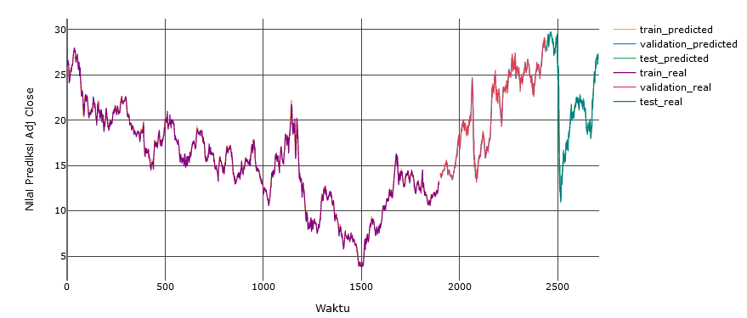

* 1. **VALE3**

The graph of the VALE3 test results can be seen in figure below

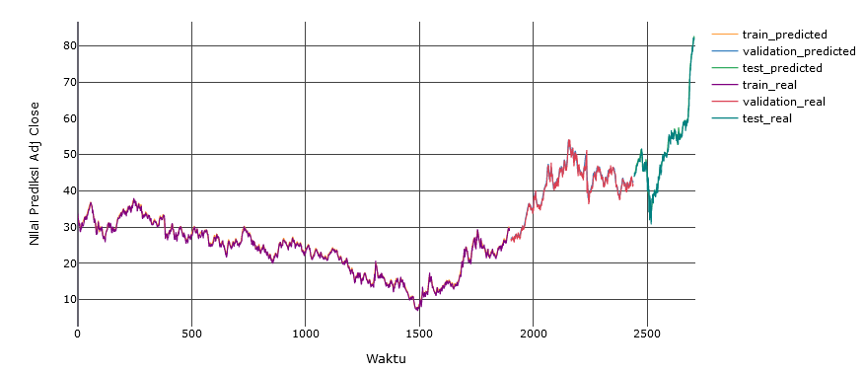

* 1. **BOVA11**

The graph of the BOVA11 test results can be seen in figure below

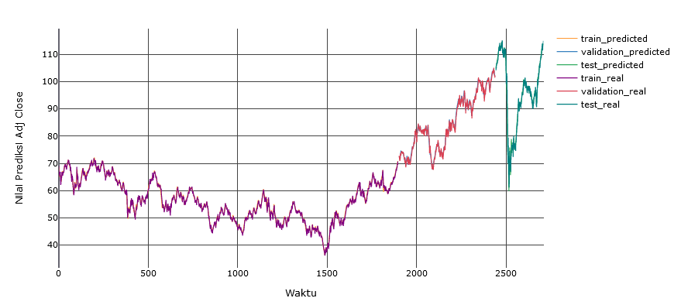

* 1. **ITUB4**

The graph of the ITUB4 test results can be seen in figure below

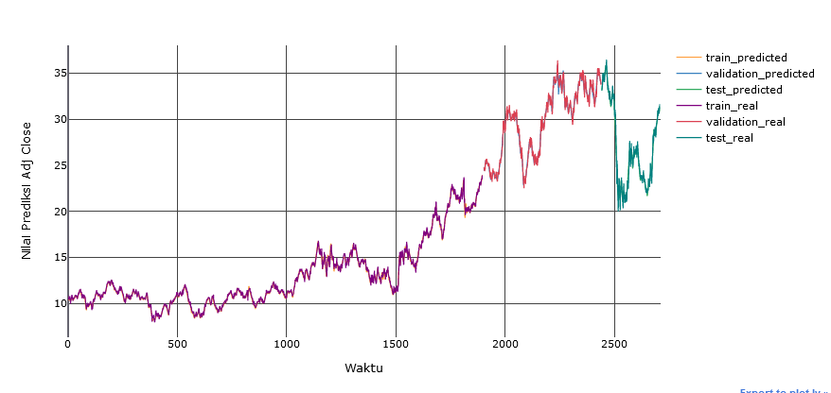

* 1. **BBDC4**

The graph of the **BBDC4** test results can be seen in figure below

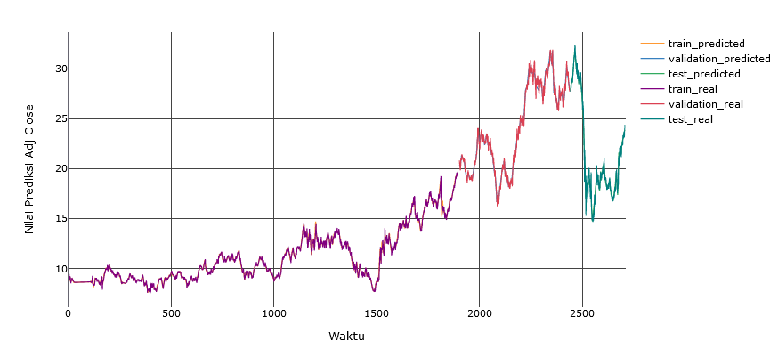

* 1. **B3SA3**

The graph of the **B3SA3**test results can be seen in figure below

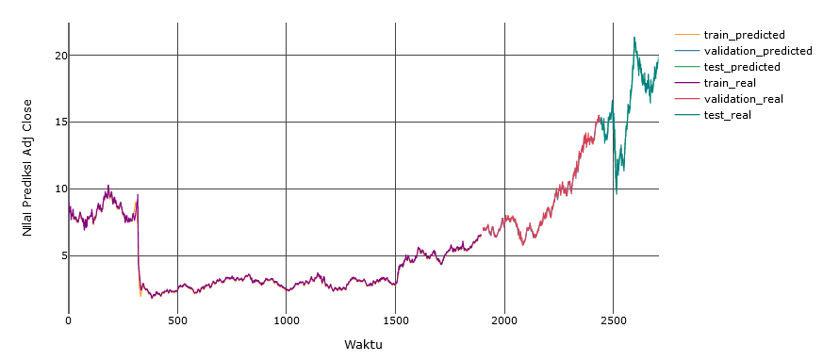

* 1. **BBAS3**

The graph of the **BBAS3 test** results can be seen in figure below

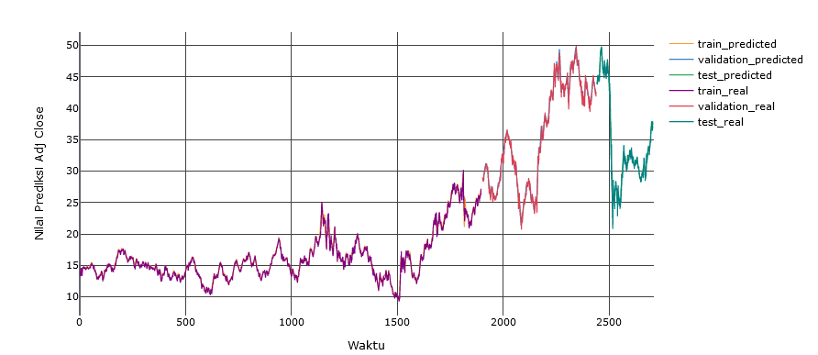

* 1. **ABEV3**

The graph of the **ABEV3 test** results can be seen in figure below

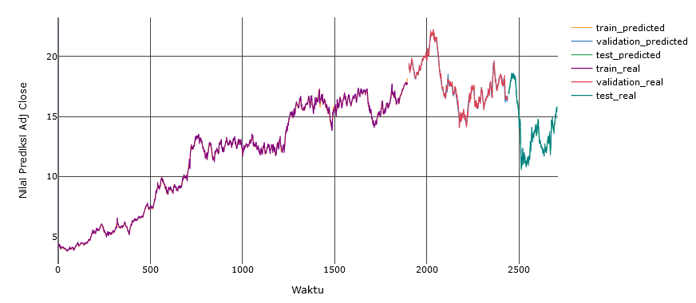

* 1. **MGLU3**

The graph of the **MGLU3test** results can be seen in figure below

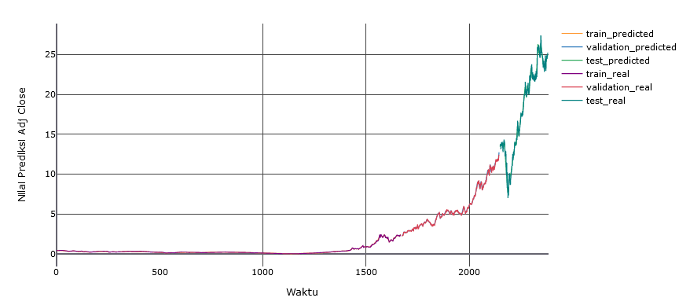

* 1. **VVAR3**

The graph of the **VVAR3 test** results can be seen in figure below

